NSW Department of Education

Diversity, Inclusion & Belonging Strategy

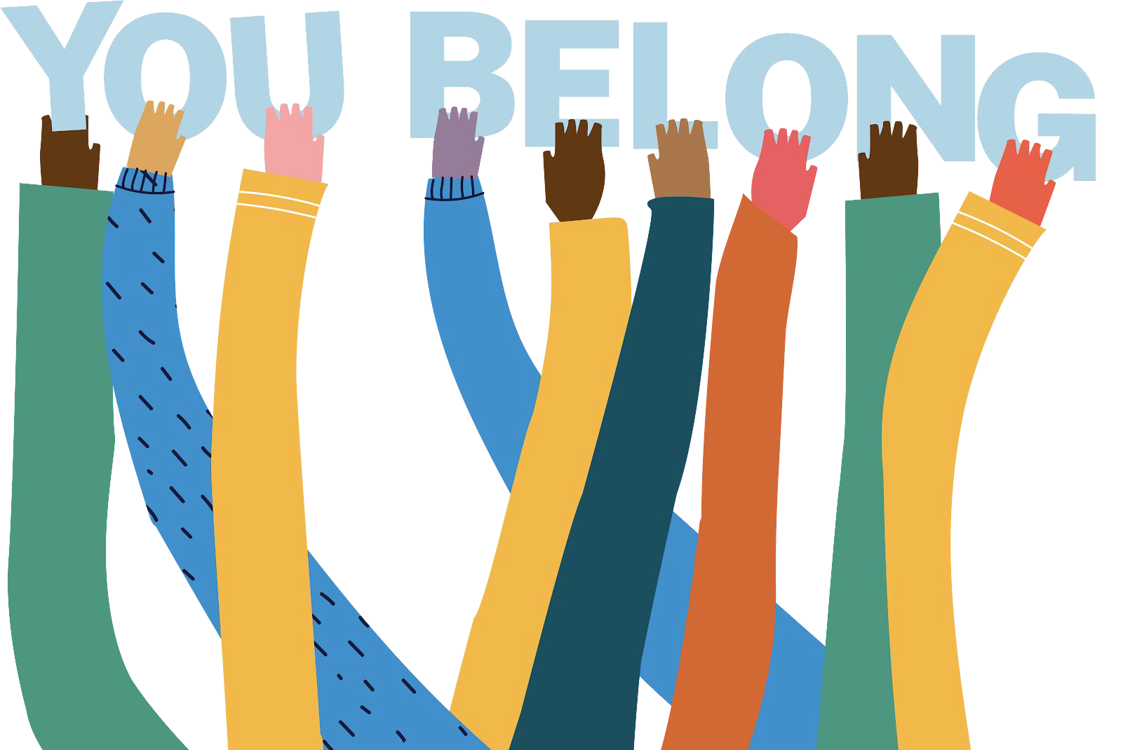
2023-2026

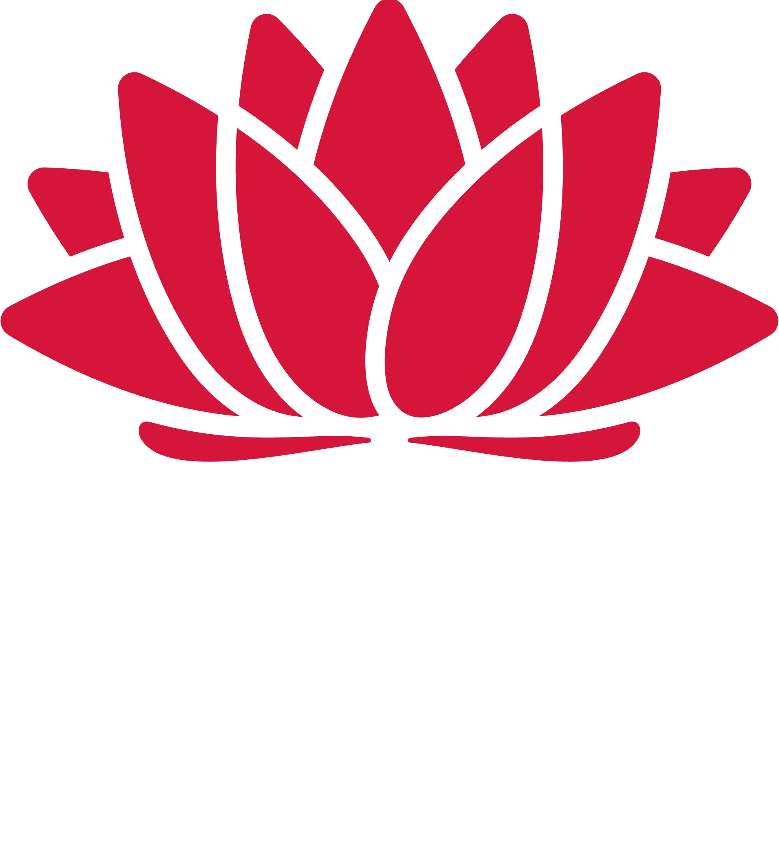

NSW Department of Education

We acknowledge the Traditional Custodians of the lands where we work and the places in which we live. We celebrate the First Peoples’ unique cultural and spiritual relationship to Country, and their rich contribution to Australia. We pay respect to Ancestors and Elders past, present and future.

2

Abortighi

The department recognises that by acknowledging our past, we are laying the groundwork for a future that embraces all Australians; a future based on mutual respect and shared responsibility.
NSW Department of Education

Our Reconciliation Action Plan (RAP) demonstrates the department's commitment to an inclusive workplace. The RAP program provides structured ways for the department to actively promote reconciliation throughout our sphere of inﬂuence and advance reconciliation across our corporate and educational settings by focusing on relationships, respect and outcomes for Aboriginal and Torres Strait Islander peoples.

The artwork featured throughout our Reconciliation Action Plan represents the themes of community, school, friendship and family. Suzanna, a student from Boggabilla Central School, created the artwork. The school sits on Gamilaraay Country, near the Queensland border in the North East of NSW. It is a small yet active school for the community of Boggabilla.

Acknowledgement of lived experience The voices of people with lived experience were crucial building this Strategy. Lived experience is at the heart of all we do, and we used inclusive co-design principles to create this Strategy.
Contributions to the Consultation Report We express our sincere gratitude to everyone who contributed to this Strategy and acknowledge the value of their individual and collective contributions.
3

NSW Department of Education

You belong

Strategy on a page

4

Bringing diversity, inclusion and belonging to life

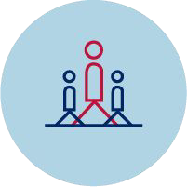
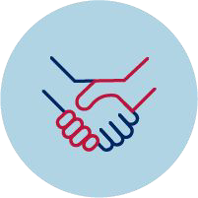
We create workplaces around NSW in which every colleague
We focus on 3 areas to empower inclusion
and belonging:
Community
We’re building an accountable, leader-led and grassroots fed culture of belonging.
Capability
We’re empowering our people by uplifting system-wide capability.
Commitment
We’re connecting, amplifying, expanding and delivering on commitments.

of the department feels they are:
- Represented and connected –the workplace reﬂects and respects them and the communities they serve
- Included and safe –they feel empowered to bring their whole self to work, grow their capability and ask for support
- Valued and inspired –they are committed because the employee experience is world class, particularly in moments that matter
This is what it takes to belong. What does success look like:
- A culture of inclusion and belonging is embedded in everything we do
- Ampliﬁed voices of people with diverse, lived experience
- Empowered and connected Staff Diversity Networks, programs and initiatives
- Safety and compliance for every person
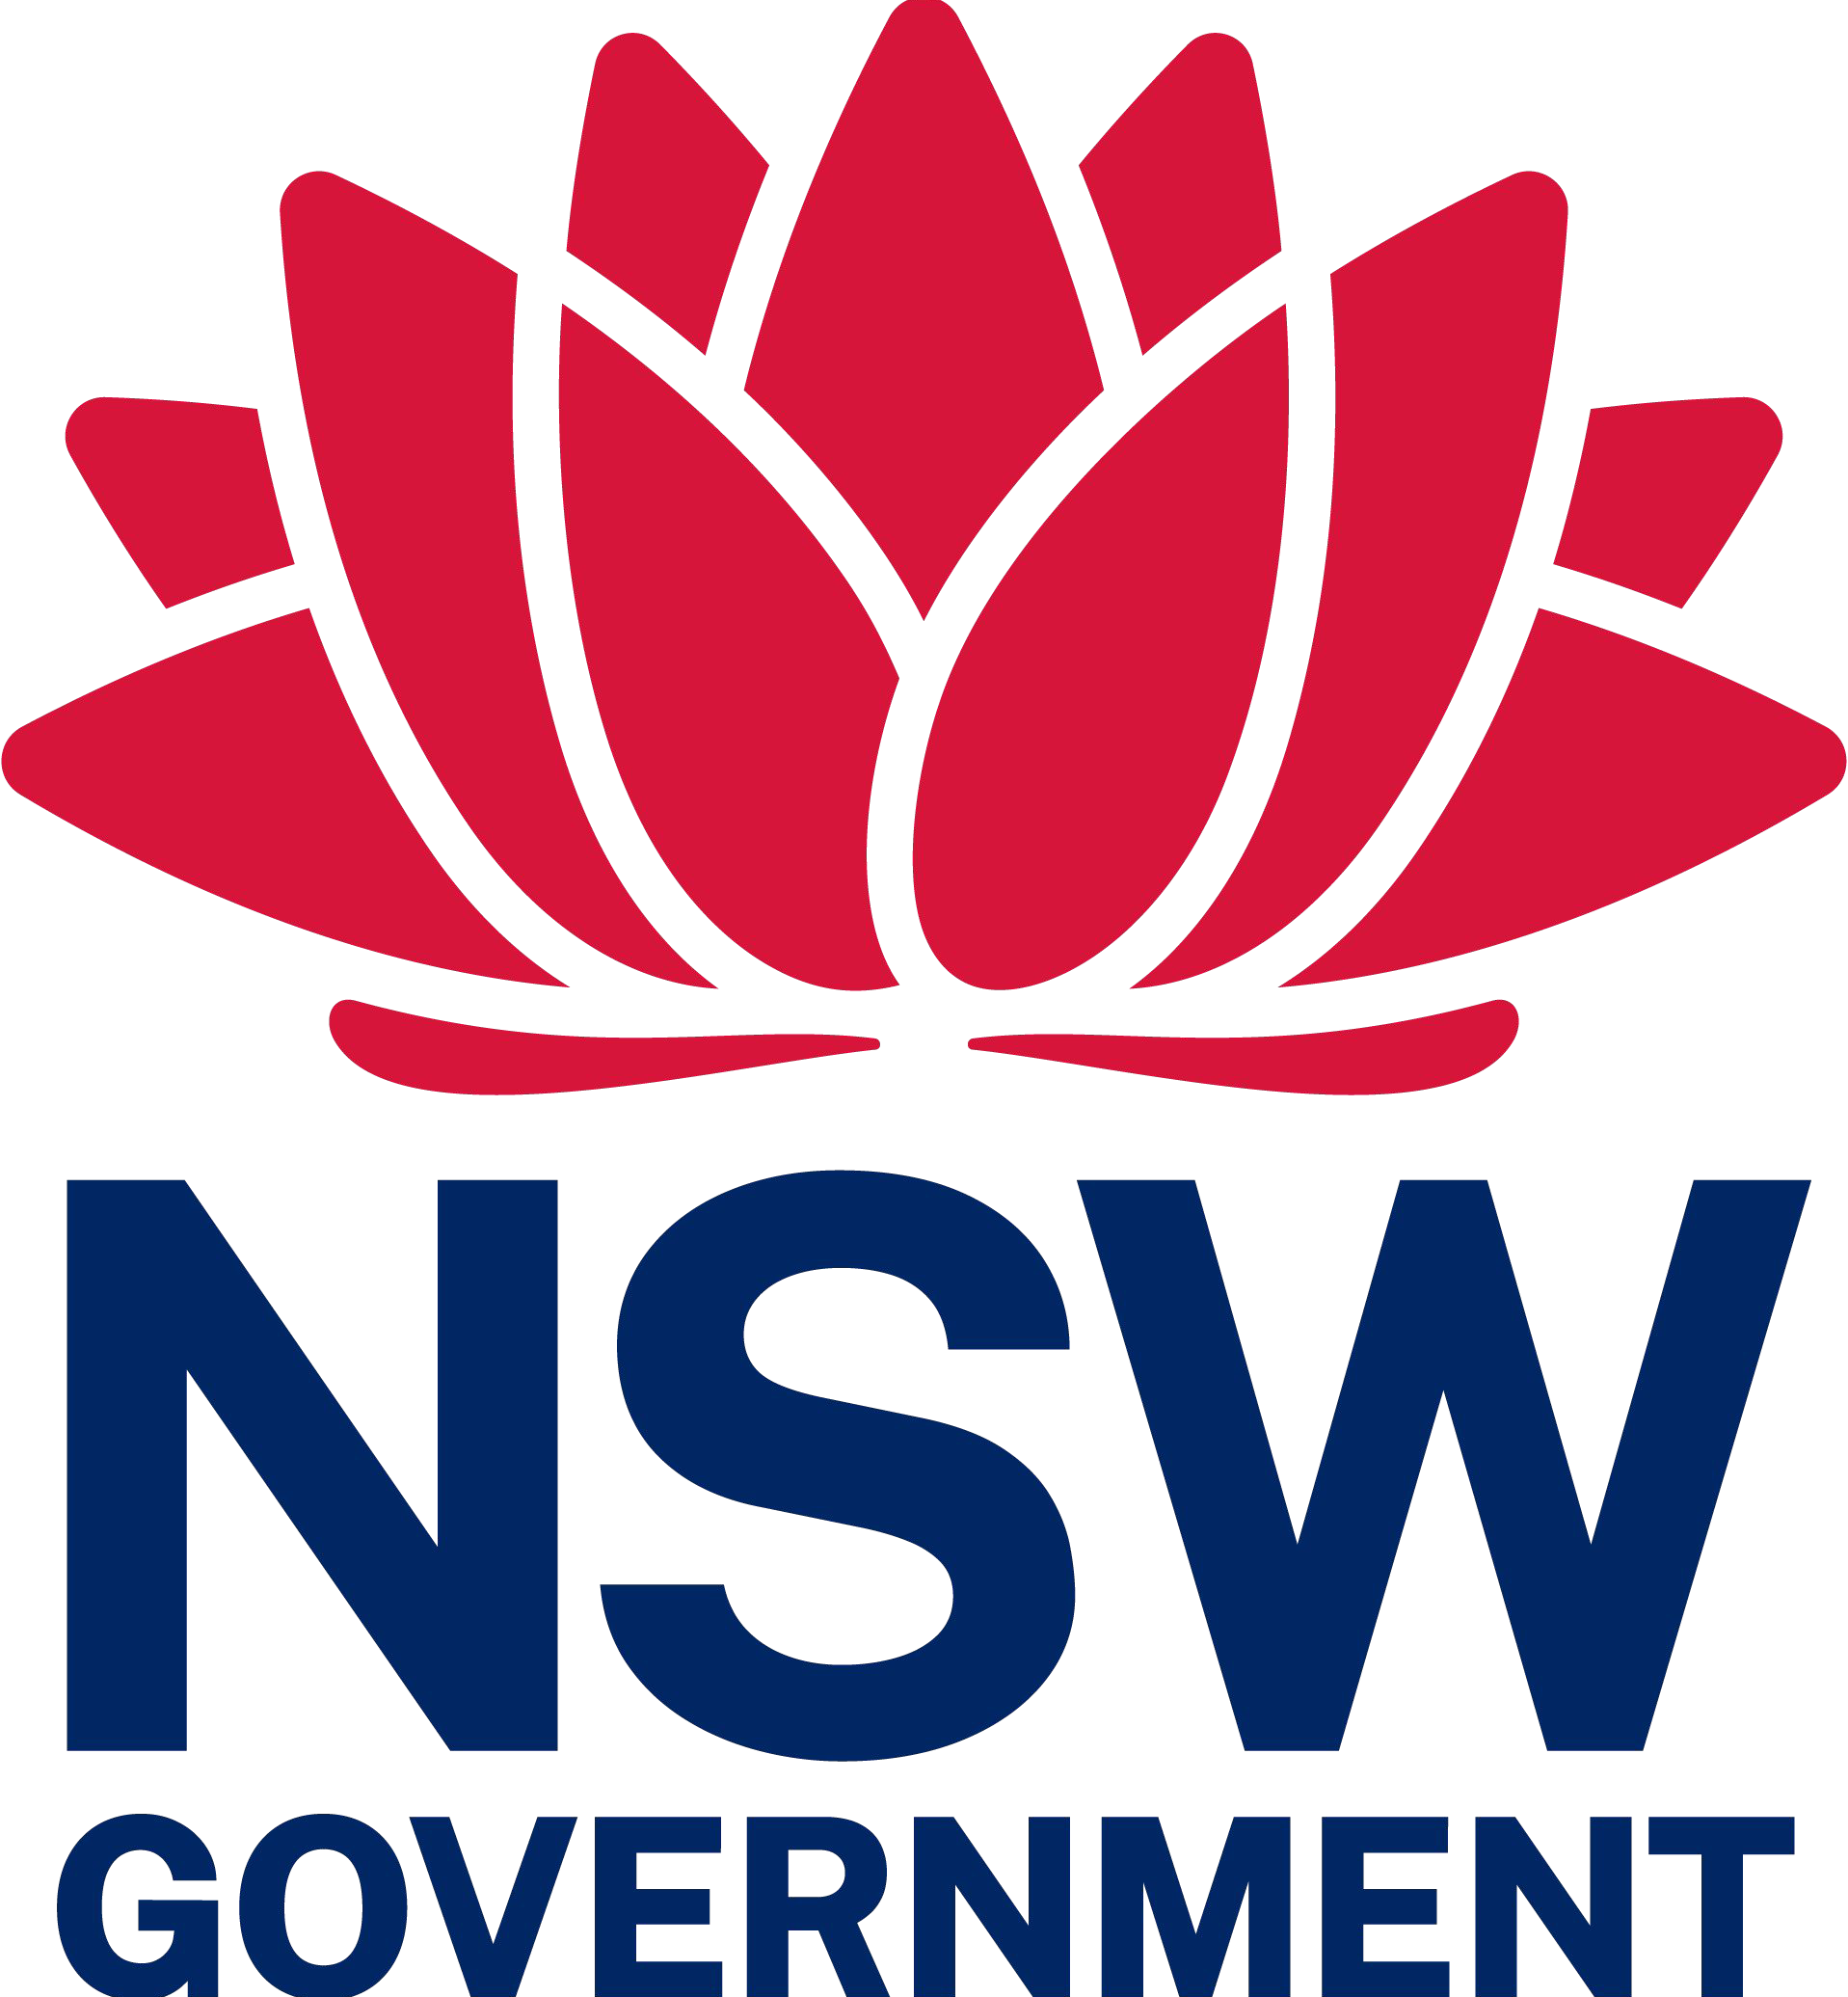
- Robust department-wide systems and processes that enable inclusion and belonging.

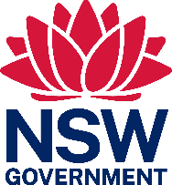

NSW Department of Education

We all play a role Inclusion and belonging is everyone’s responsibility.
Our Focus Employee Communities
Aboriginal and/or Torres Strait Islander people | We recognise Aboriginal and/or Torres Strait Islander people in schools and workplaces. Representation gives people a strong sense of belonging around their identity, language and culture.
Culturally and Linguistically Diverse people | We celebrate difference by utilising the diverse range of knowledge, skills and experiences of our multicultural workforce, enabling us to deliver appropriate services that meet the needs of our departmental community.
LGBTQIA+ community | We create environments where our employees can proudly bring their true selves to work so they are comfortable to perform and engage to the best of their ability.
Multigenerational | We know that more individuals are choosing to work beyond the typical retirement age. The diversity of ages in the current workforce is at its widest ever. We meet the different needs of each generation and encourage cross-generational learning.
People with Disability | We aim to provide a working culture where everyone will thrive under the same rights, access and opportunities to employment.
Women | We create environments where all genders are equal in their rights and opportunities in all employment pathways, enabling them to lead balanced lives and participate fully.
Intersectionality | We understand intersectionality is a cornerstone of diversity. We all have many layers to identity and all those intersections will be respected, catered to and celebrated equally in our workplaces.

This is your call to action.

Be curious... Be involved...

Be part of the journey... Be the difference!
To understand how you can take action, please visit the Diversity, Inclusion and Belonging Strategy - IDEAs (Inclusion, Diversity and Equity Actions) Intranet page.

5

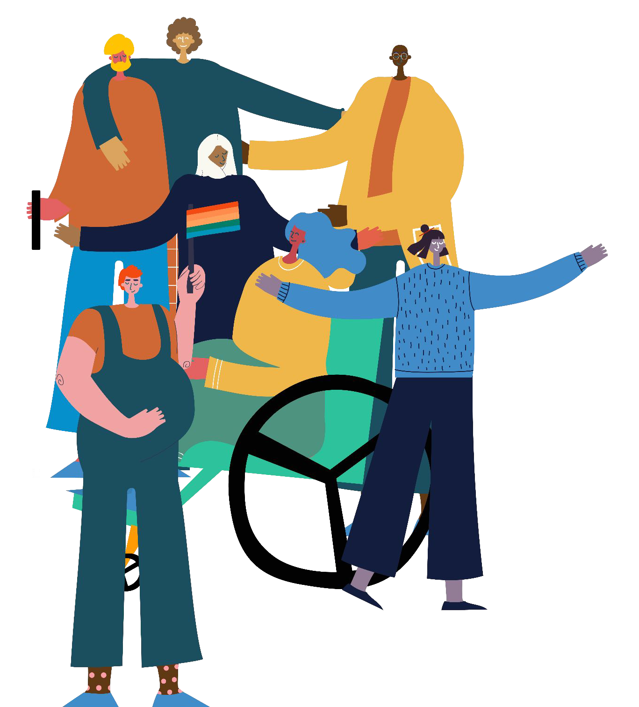

NSW Department of Education

Table of contents

Bringing diversity, inclusion and belonging to life 4
Letter from the Secretary 7
Our journey 8
Why do diversity, inclusion and belonging matter? 10
What does belonging look like to you? 11
Deﬁning and measuring our success 12
Community 15
Capability 16
Commitment 17
Inclusion and Belonging is everyone’s responsibility 18
Our Focus Employee Communities 19
Governance 20

6

NSW Department of Education

Le ter from the Secretary

Creating schools and workplaces where people belong is central to a world-leading education system. Our research and evidence demonstrate that a diverse teaching workforce, which represents our student population, can improve academic and behavioural outcomes for our students –but that to attract and retain that diverse workforce, we have a lot to do. This strategy formalises our focus on embedding inclusion and belonging within the department.
This is not a new conversation for us. Across all levels, individuals and teams work to create fair and equitable workplaces. This strategy acknowledges that work ampliﬁes the best of what’s taking place across the department, and raises the bar.
We have an opportunity to bring our work together and share a clear path for diversity and inclusion. We can always continue to learn and grow.
This strategy will increase the opportunity, inclusion and support provided to existing and future employees.
We all want a positive workplace where all employees are safe, valued and feel they belong.
Everyone can make a difference, both inside and outside the school gate. We’re conscious how complex and busy schools are so we’re making it as simple as possible to participate. There is a clear set of Inclusion, Diversity and Equality Actions (IDEAs) for schools, education providers, and corporate teams.
Let’s create workplaces across NSW where individuals feel represented, included and valued, so we have a positive impact on the communities we serve every day.
We want everyone to belong in education.
Murat Dizdar

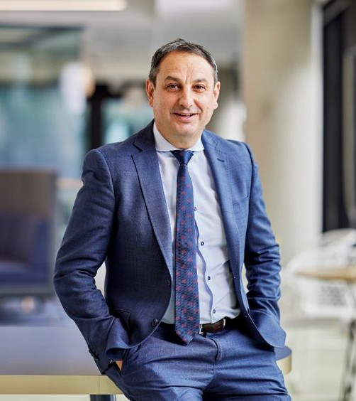

7

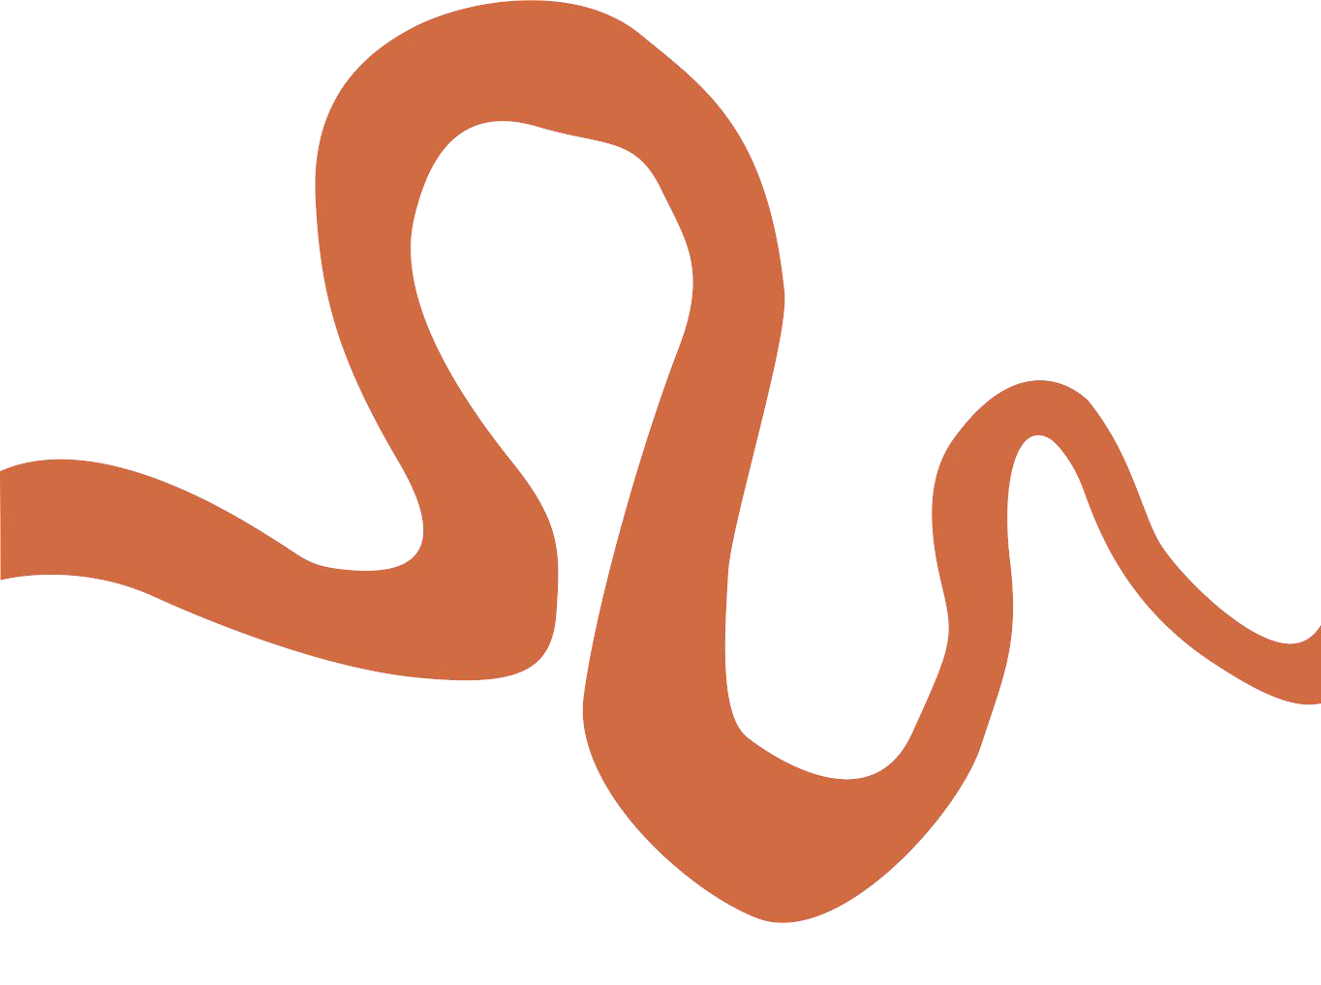

NSW Department of Education

Our journey

We strive for greater representation so our workplaces represent

the communities we serve. We should represent those who have traditionally not

had an equal seat at the table.

How do we get there?

8

NSW Department of Education

Safety and inclusion must be front of mind
Safety and respect are foundations of inclusion. Our department should be a workplace in which all employees feel safe, a place of cultural safety and wellbeing where we can speak up and know our voice is valued and trusted. Our leaders will be committed to safety and inclusion, with robust systems and processes ready to support employees every step of the way.
Belonging, intersectionality and listening to the voices of lived experience
Belonging means feeling accepted and valued for your individuality. When you belong, you are unencumbered and able to contribute your best every day.

We appreciate identity doesn’t ﬁt into neat boxes. Many people have multiple lived experiences or identities. For example, someone can be an Aboriginal person, a carer, and LGBTIQ+. This diverse mix will likely shape someone’s unique perspectives, which inﬂuence their experiences of work and life.
Such interconnected social categorisations are known as intersectionality.

While the department has multiple initiatives to support speciﬁc communities and identities, we will continue to expand our understanding of diversity and recognise we will continuously learn about and embrace the aspects of intersectionality that deﬁne our workforce and communities we serve. The voices of those with lived experience will always inform our approach.

9

NSW Department of Education

Why do diversity, inclusion and belonging matter?
Research demonstrates that
the presence of diverse teachers within school workforces has been associated with improved student outcomes, including academic achievement, reduced exclusions and dropout rates,
and higher aspirations for continued study.
Research also identiﬁed signiﬁcant barriers to participation for diverse teachers, including discrimination, tension in being fully identiﬁed in the workplace, and the additional workload of “representing”
their diversity. The Department’s Diversity, Inclusion and Belonging Strategy will work to dismantle those barriers and create a working environment where our workforce represents the community we serve,
and is able to perform to its full potential.

Education touches every person’s life at some stage, often crucially. That’s why the NSW Department of Education, in reﬂecting the communities it serves, must reﬂect and embrace every individual.

Our workplace must be open to everyone and encourage all staff to be as creative, productive and empowered as they can be. Only then will the NSW Department of Education attract the best talent, and best
serve and prepare our diverse learners for rewarding lives in a complex society.

A sense of safety and belonging among a diverse workforce will bring out the best in our people, leading to collaboration and innovation that will propel the NSW education system.

Everyone at the NSW Department of Education is unique. And every person should have the same rights, access and opportunities within the department. Together we are stronger and together we will deliver for our students.

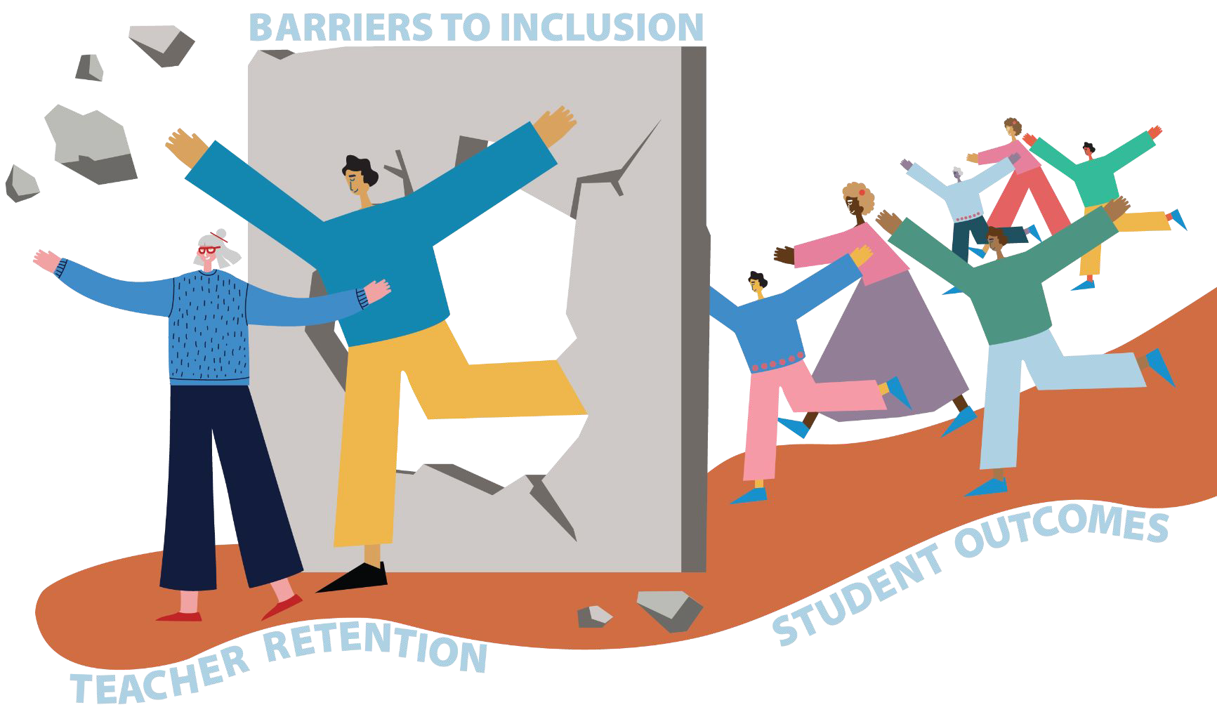

10

NSW Department of Education

What does belonging look like to you?

Valued and inspired

Represented and connected
The workplace reﬂects me and the communities
we serve
I’m committed because my workplace experience is
world class

In the development of this strategy, staff were able to provide feedback and here are some things they told us as to what belonging looks like to them.
- All individuals are accepted, equally valued, respected and represented in all areas of the department
- People from all backgrounds, cultures, languages and experiences collaborating to achieve a common goal
- Seeing the diversity of the NSW community mirrored in our workforce and in Leadership
- Inclusive leaders who are active allies that speak up and act
This has helped us to inform the focus of this strategy.

Included and safe
I feel empowered
to bring my whole self to work, grow my capability and ask
for support

11

NSW Department of Education

Deﬁning and measuring our success

Empowering diversity and inclusion in a complex environment such as the

NSW Department of Education requires multiple solutions.

We’ll succeed on different levels in varied timeframes with a range of measurements to ensure our progress.

12

NSW Department of Education

We aim to make progress to support belonging knowing foundational D&I must remain a focus.
What will success look like | How will we measure it
A culture of inclusion and belonging is embedded in everything we do | - Year on year increase in scores across People Matter Employee Survey (PMES) Metrics:  - Employee engagement overall score  - Job satisfaction  - Wellbeing  - Inclusion and diversity  - Employee voice  - Each employee network has 1-2 executive sponsors  - Year on year increase of Executive PDPs which include Diversity, Inclusion and Belonging (DIB) metrics (toward 100%)  - Year on year increase in Divisional People Plans which include DIB metrics (toward 100%)
Empowered and connected Staff Diversity Networks, programs and initiatives  Empowered and connected Staff Diversity Networks, programs and initiatives | - Workforce proﬁle and PMES data:  - Increase in Workforce proﬁle data completion  - Decrease in Prefer not to say responses across all diversity groups (PMES)  - Alignment between statistics reﬂected in PMES and Workforce Proﬁle Data  - Increase in Aboriginal and/or Torres Strait Islander staff across both data sources  - Increase in staff with disability across both data sources  - Staff Diversity Network engagement and membership  - Year on year increase in membership  - Each network has annual action plan  - Staff retention rates for people in Premier’s Priority groups match those of the whole of department  - Diversity data collected through recruitment processes show an increase in applications and acceptance for candidates in Premier’s Priority groups
Safety and compliance achieved for every person equally  Robust department-wide systems and processes enabling inclusion and belonging | - Year on year increase in scores across PMES metrics:  - Wellbeing  - Employee Voice  - PMES score –grievance handling  - Year on year increase in completion of non-compulsory DIB training

This includes:
- Building a safe environment for our people and maintaining compliance
- Changing mindsets and behaviours to support and empower our people
- Inclusion and belonging becoming intrinsic to how the department does business and treats people every day

13

NSW Department of Education

What we will notice

What our staff will say
Increased diversity representation
Improved and authentic employee engagement

“We reﬂect the communities we serve”

“Our employee experience is hard to beat”

Improved employee retention

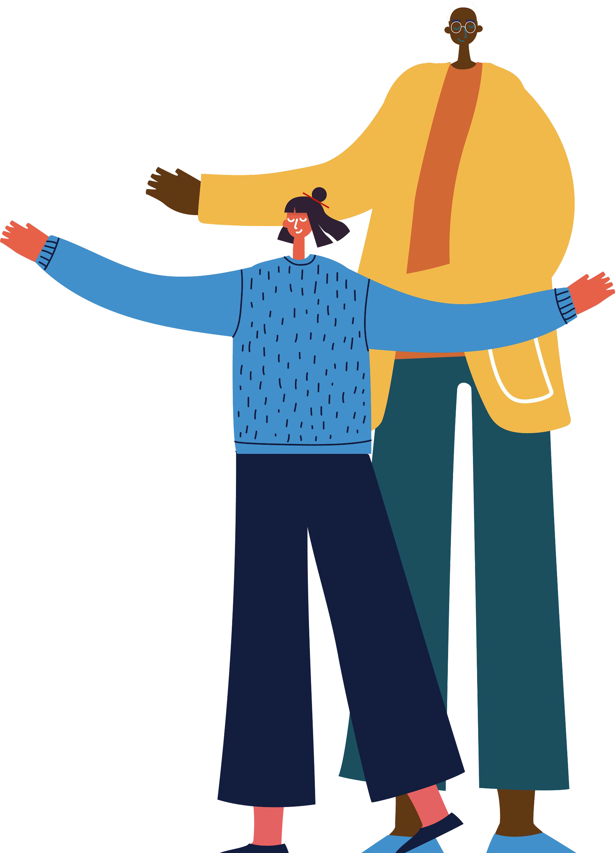
“Our workforce is committed to our purpose”
A supportive and collaborative workplace that promotes speak out culture and enables everyone to reach their full potential

“We are supported to be and do our best every day”

Ways of Working/Values embedded as a foundation as a culture of belonging

“I feel I belong here”

Improved wellbeing

“We are supported to care for ourselves, each other and the communities we serve”
A stronger sense of belonging and connection with a wider group of people

“I genuinely feel valued and inspired as an employee of the department”

Diversity of thought, innovation and departmental outcomes

“We come together to constructively challenge and think differently”

14

NSW Department of Education

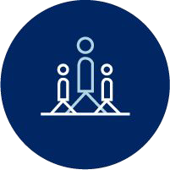
Community

The Success of this Strategy relies on the whole NSW Department of Education community getting involved. Be part of the journey...
Be curious... Be involved...
Be the difference!
We’re building an accountable, collaborative culture of belonging. Leaders, teams and individuals across the department know the role they can play and sign up to IDEAs (Inclusion, Diversity and Equality Actions).

We will focus on:
- Empowering staff diversity networks
- Increasing communication and awareness of our ideals across the department
- Equipping leaders and sponsors, allies and advocates with the tools to lead
- Improving the experience of all employees, particularly those from marginalised communities
- Acknowledging our progress and successes

Prioritised actions:
- Continue to celebrate and expand on Days of Signiﬁcance
- Grow Staff Diversity Networks, improve governance and increase membership
- Develop and launch a guide on barrier free recruitment
- Develop and launch D&I resources including case studies, storytelling, guides and examples of best practice

What does success look like?
- A culture of inclusion and belonging is embedded in everything we do
- Ampliﬁed voices of people with diverse, lived experience
- Empowered and connected Staff Diversity Networks, programs and initiatives

15

NSW Department of Education

Capability

We’re empowering our people by uplifting system-wide capability.
We will lift capability in a range of key areas.
Some actions can have an immediate system-wide impact, while others may ripple outwards, progressively touching people’s lives and will improve people’s experience at work every day.

We will focus on:
- Building leadership capability and a culture of inclusion and belonging
- Improving our feedback, safety and complaints processes
- Creating meaningful and transparent workforce diversity data
- Connecting and building partnerships across the department
- Continuing to improve our training and awareness
- Continuing to improve our HR and IT systems and policies

Prioritised actions:
- Deliver inclusive and collaborative leadership workshops and resources
- Establish a new team and implement a strong internal staff complaints process
- Expand the range of optional training related to Diversity and Inclusion (Capability Uplift)
- Establish new data sources, including recruitment information, onboarding and offboarding to continue to improve analysis of Workforce Proﬁle and regular surveys
- Develop and implement speciﬁc development programs for identiﬁed identities and communities

What does success look like?
- A culture of inclusion and belonging is embedded in everything we do
- Safety and compliance for every person
- Robust department-wide systems and processes that enable inclusion and belonging.

16

NSW Department of Education

Commitment

We’re connecting, amplifying, expanding and delivering our commitments.
We boost and link signiﬁcant diversity and inclusion work across the department, so everyone supports, engages and champions a culture of inclusion and belonging.
Prioritised Actions:
- Strengthen the Disability Inclusion Action Plan (DIAP) governance, reporting and implementation
- Embed this strategy and actions into divisional People Plans
- Identify Executive Sponsors for staff networks and focus employee communities

What does success look like?
- A culture of inclusion and belonging is embedded in everything we do
- Empowered and connected Staff Diversity Networks, programs and initiatives
- Safety and compliance for every person

17
We will focus on:
NSW Public Sector Commitments:
- Premier’s Priorities
- NSW PSC Belonging and Inclusion Strategy
- NSW Women’s Strategy 2018-2022
- NSW Disability Inclusion Plan
- The NSW Carers Strategy: Caring in NSW 2020-2030
- Aging Well in NSW
- NSW Multicultural Policies and Services Program Framework

NSW Department of Education Commitments:
- Disability Inclusion Action Plan
- Reconciliation Action Plan
- NSW Aboriginal Education Consultative Group Commitments
- Anti-racism Policy
- Aboriginal Workforce and Leadership Strategy
- Rural and Remote Education Strategy
- Australian Workplace Equality Index

Emerging Commitments:
As knowledge and practice of Diversity, Equity and Inclusion evolves, we will update and prioritise our commitments and collaborate with the sector to remain at the forefront of current inclusion and belonging practices.

NSW Department of Education

Inclusion and Belonging is everyone’s responsibility

We all have a role to play in creating a culture of inclusion and belonging for everyone equally.

We can lead and be responsible by:
- Role modelling inclusive behaviours and having courageous conversations; respectfully calling out behaviours, processes and practices that don’t support an inclusive culture
- Connecting and collaborating with everyone equally
- Being active allies and advocates to amplify the voice of our diverse communities and identities
- Constructively challenging people to help create an inclusive environment and culture of belonging.

Be yourself, because you have an important part to play in creating an inclusive environment.

Every action in the workplace, no matter how small, might make a difference.

Ask yourself what you can do to foster a culture of belonging. Is it something as simple as a ‘hello’ in the corridor, or is it joining a network or seeking new information? Or is it holding leaders or peers accountable for leading or contributing to diverse and safe teams?

We encourage people at all levels and workplaces across the department to sign up to IDEAs (Inclusion, Diversity and Equality Actions), a list of optional actions for individuals, teams and leaders. These actions will be refreshed every year and will be complemented by quarterly Belonging Bites (bite sized all staff communications outlining planned work and ways to get involved) and an Annual Action plan that targets key projects in the three focus areas: Community, Capability and Commitment.

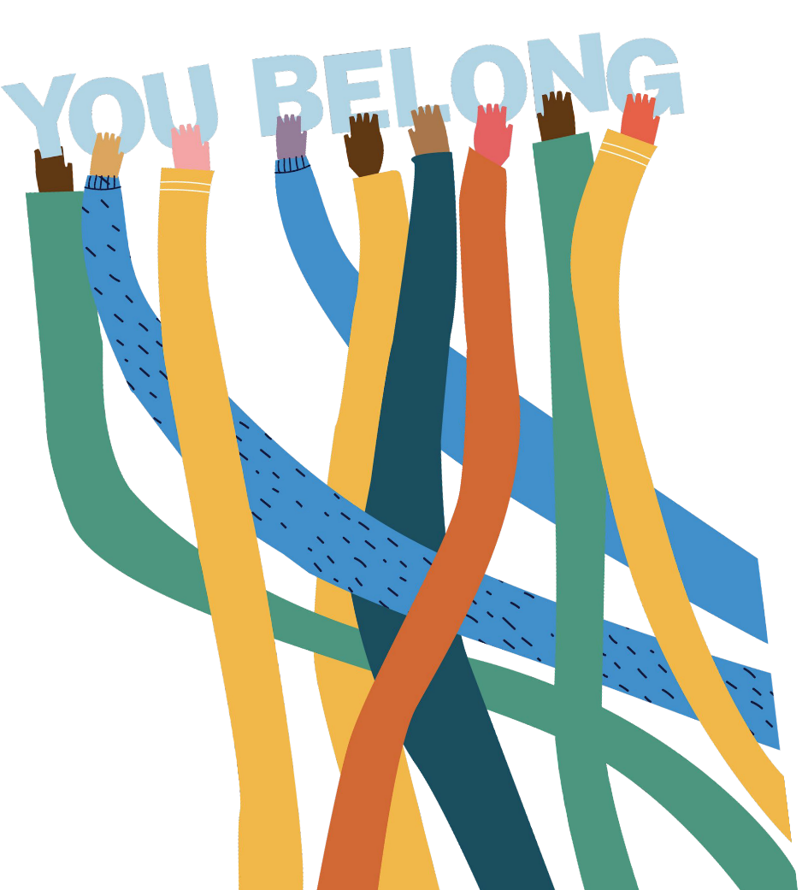

18

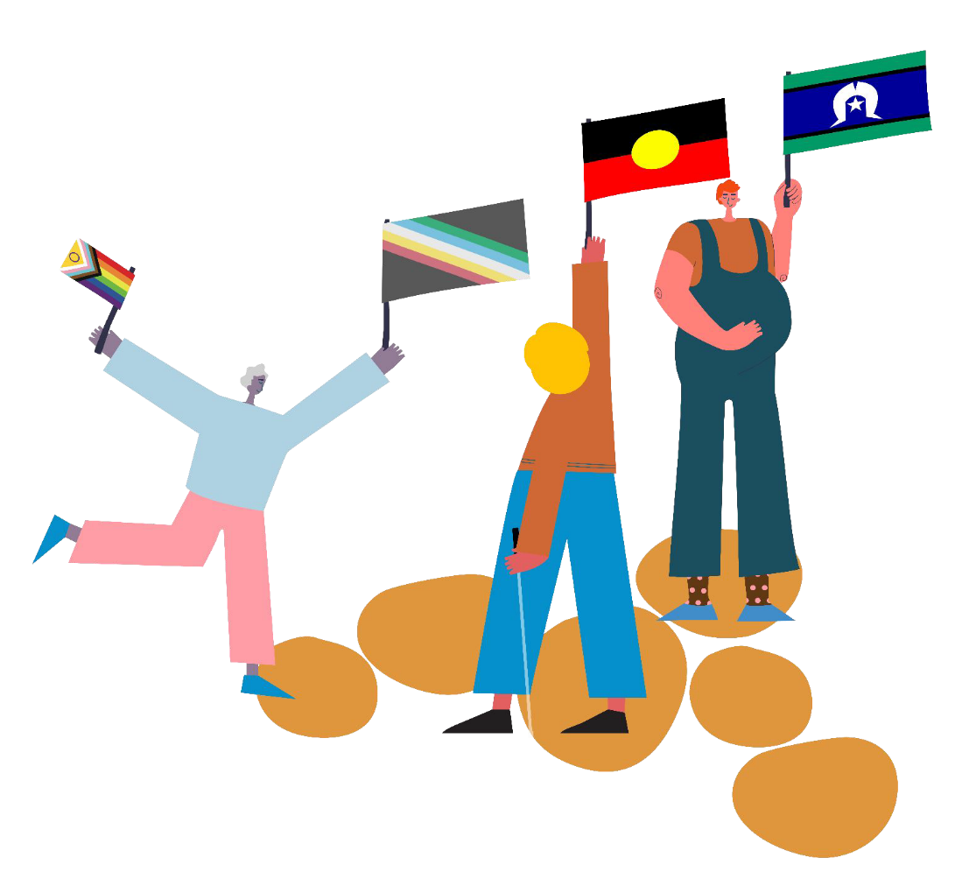

NSW Department of Education

Internally, the department works with Staff Diversity Networks to support the needs of Employee Communities. The Networks listed currently exist or are forming; staff may choose to start their own networks as they identify a need.
Our Staff Networks
Aboriginal Employee Network | We recognise Aboriginal and/or Torres Strait Islander people in schools and workplaces. Representation gives people a strong sense of belonging around their identity, language and culture.
Culturally and Linguistically Diverse Network | We celebrate difference by utilising the diverse range of knowledge, skills and experiences of our multicultural workforce, to enable us to deliver appropriate services that meet the needs of our departmental community.
Disability Employee Network | We aim to provide a working culture where everyone will thrive by having the same rights, access and opportunities to employment.
Pride in Education Network | We encourage our employees to proudly bring their true selves to work so they feel comfortable to perform and engage to the best of their ability, with a strong sense of wellbeing as a foundation.
Women’s Network | We foster a working environment where all genders have equal footing in their rights and opportunities in all employment pathways, enabling them to lead balanced lives and participate fully in our workplaces.
Young Professionals Network | We focus on the future leaders of the department, ensuring they are set up for success with the right opportunities for development and connections, and are empowered to be involved.

19

NSW Department of Education

Governance

The governing body for Diversity, Inclusion and Belonging is the Diversity and Inclusion Council.
Support Services Sub-Executive
Diversity and Inclusion Council
Staff Networks
Working Groups
It was formed in 2021 to provide clear governance, accountability and resourcing, is led by the Chief People Ofﬁcer, and is responsible for:
Diversity and Inclusion Team
- Making inclusion and belonging part of everything the department does
- Amplifying the voice of lived experiences through staff network representation
- Empowering Staff Diversity Networks to meet with executives quarterly to understand their issues, plans, and enable progress
- Overseeing the building of robust department-wide systems and processes enabling inclusion and belonging

20

NSW Department of Education

You belong

