
October 2026

2026 Using the VALID School Test Administrator platform

Validation of Assessment for Learning and Individual Development (VALID)

VALID Science 8
VALID Science 10
Contents
2026 Using the VALID School Test Administrator platform 1
Missing Students 2
Contacts 3
Logging on 3
STA Dashboard 4
Task 1: Checking student lists 5
Task 2: Printing student codes 5
Selecting students 6
Printing options 7
Task 3: Manage Attempts 7
Changing student status in bulk for no longer enrolled, exempt, complete, withdrawn, and absent 8
No longer enrolled, refused to attempt, exempt, complete, withdrawn and absent 10
Special Provisions 11
Task 4: Activity Summary Report 12
MS Teams Support Page 13

Missing Students
Please email the VALID team (valid.program@det.nsw.edu.au) with a list of missing students.
Include:
- First name
- Middle name
- Last name
- Date of birth
- Gender
- (SRN – if you know it)

Contacts
VALID Support Telephone: 02 7814 3837
VALID Support Email: valid.program@det.nsw.edu.au
MS Teams: 2026 VALID Trial Tests | VALID School Test Administration
Website: https://education.nsw.gov.au/teaching-and-learning/student-assessment/assessment-and-reporting

VALID team:
Jennifer English, VALID Coordinator
Nes Atmali, Assessment & Development Advisor
Charlene Pose, Assessment & Development Advisor
Aaron Prestridge, Assessment & Development Advisor

Logging on
You have been sent an email with your username and a link to create your password.
The STA URL is https://sta.valid.nsw.edu.au
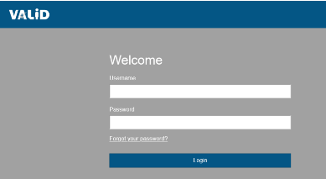

STA Dashboard
The test platform will open on the ‘STA Dashboard’.
This landing page shows the number of students enrolled, the number of students participating (not marked as exempt, withdrawn or no longer enrolled) and the progress of student attempts. Test Attempt Information for each student can be viewed.
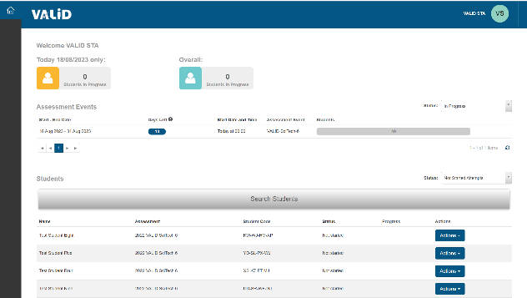

Ten administration tabs can be accessed by clicking on the Home icon  to reveal the tab.
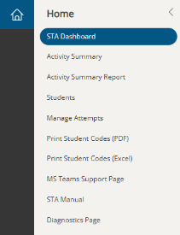

Task 1: Checking student lists
Select the ‘Student’ tab from the home menu.
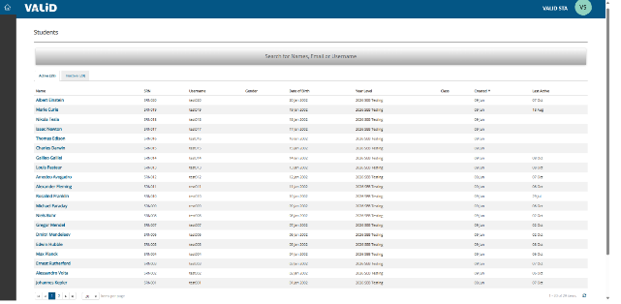
This is a display page only.
Students can be sorted by clicking on the ‘Name’ or ‘Event’ headings in the table.
Individual student records can be accessed by clicking on the student’s name.
If you would like to export an Excel spreadsheet of your student list prior to passcodes being issued, use the ‘Activity Summary Report’ tab.

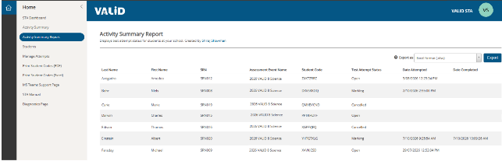
Instructions for missing students can be found on page 2
This list can be exported from here using the export button at the top right of screen

Task 2: Printing student codes
The VALID team will email STAs when students codes are available.
Student codes can now easily be printed in smaller batches such as class groups, by selecting individual students.
Please note due to the diversity of ways in which school store class data, we are unable to extract class groups for you. However, you can now select students to form your own class or session group for printing.

Printing student codes (PDF) for every student
Select the ‘Print Student Codes’.
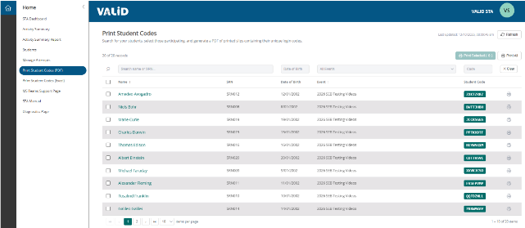

Select the relevant event (such as VALID Science 8 2026 or VALID Science 10 2026) using the drop-down menu.
Click on the ‘Print All’ button.
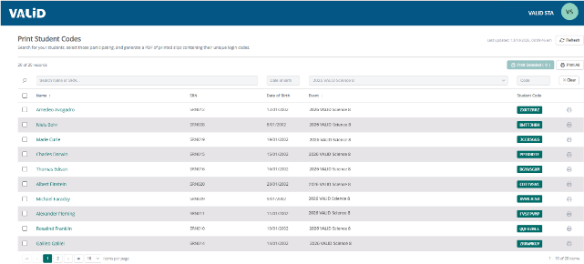

Printing student codes (PDF) for a class or small group
Use the check boxes to manually select students in a class group or a smaller group.
Click on the ‘Print Selected’ option.
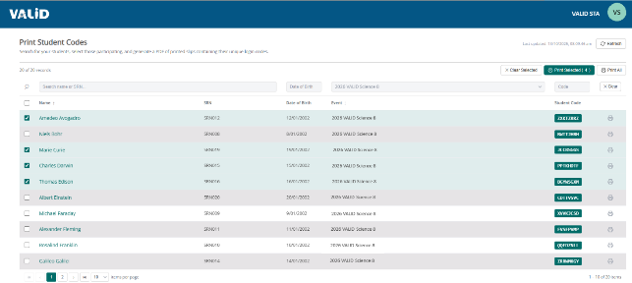

Printing options
Select the layout for student code cards and click ‘Generate PDF’.
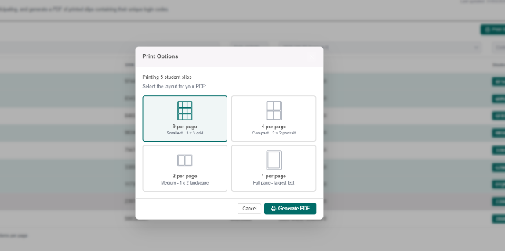

Printing student codes (Excel)via spreadsheet
Select the ‘Print student codes (Excel) from the home icon’.
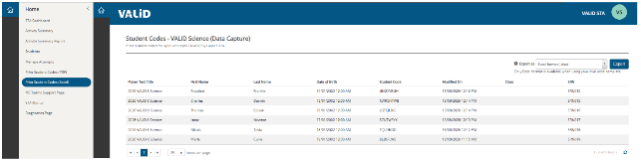
Click on the export button on the top right of the screen.
The export button will download an Excel spread sheet with two tabs:
- RawData
- StudentCards
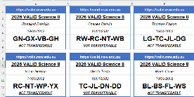
Note that to see data you may first click Enable Editing
The RawData worksheet can be used to sort the student code cards, as required.
Class details can be added to the RawData worksheet. This will allow you to sort by class codes. Class details will then be printed on the student code cards. You can also change student First and Last Name from their legal name to their preferred name in this spreadsheet so this is printed on their card. The final individual student report from VALID will use the legal name.
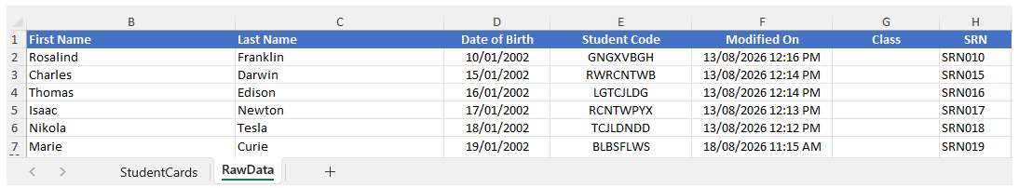
The student code cards are formatted to suit the majority of printers for A4 paper. If the cards do not fit on a page, your printer settings will need to be adjusted.

Task 3: Manage Attempts
The ‘Manage Attempts’ page is where you can change the status of open tests.
STAs will need to indicate the following for students

- No longer enrolled
- Refused to attempt
- Exempt
- Withdrawn
- Absent
- Special provisions
- Complete open tests
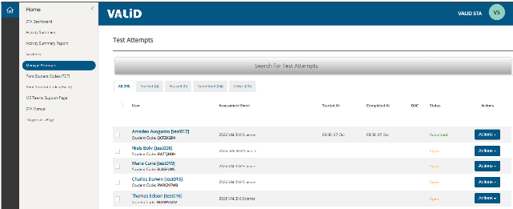

Changing student status in bulk for no longer enrolled, exempt, complete, withdrawn, and absent
The test platform now allows STAs to select multiple students for each action. Please note that special provisions must still be added for individual students, one at a time.
Select multiple students by clicking the box on the left side of their name.
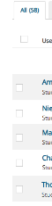

At the bottom of the page there is a drop-down menu for selecting a bulk action. Use the drop-down menu to select ‘Manage Attempts’.
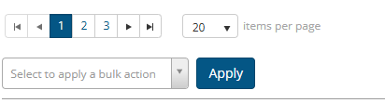

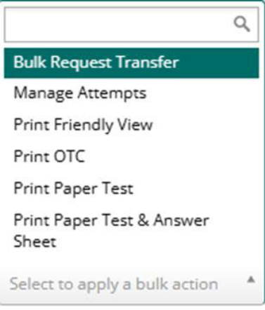

Then click ‘Apply’
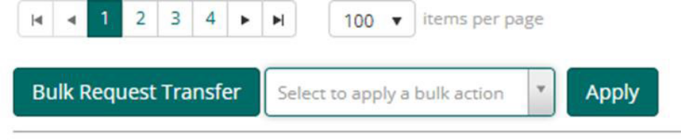

Then select the ‘Change’ drop-down menu from the dialogue box. It will indicate the number of students you have selected.
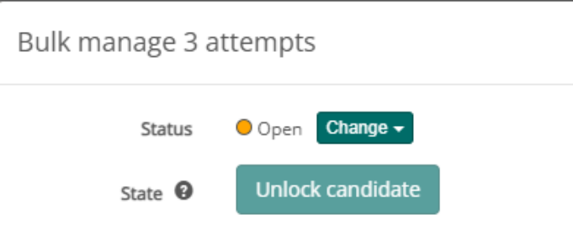

Then select the action you wish to change. No longer enrolled, Exempt, Complete, Withdrawn and Absent are the only options that are active for VALID. All other options do not apply to VALID.
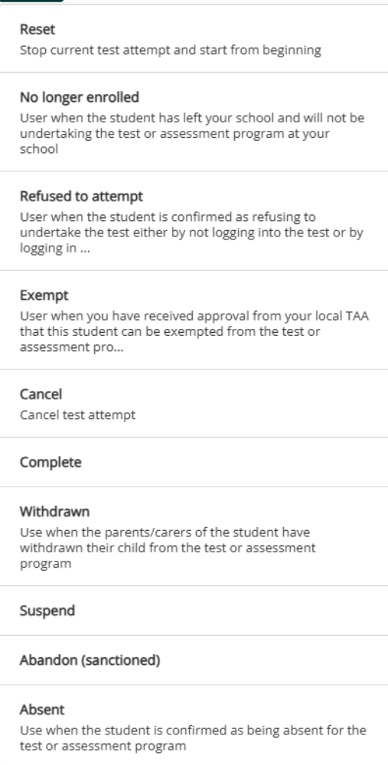

No longer enrolled, refused to attempt, exempt, complete, withdrawn and absent
Clicking on the eye is a quick way to change the status of a student by using the change drop down menu.
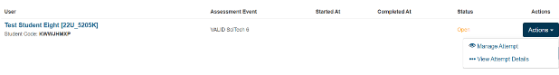
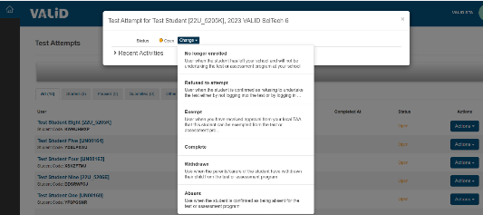

Special Provisions
Students who regularly access Special Provisions in the classroom are entitled to access them during the test.
Click onto the three dots (ellipsis).
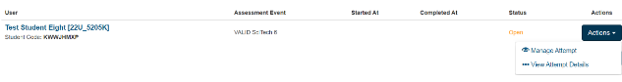

The Special Provisions menu is at the bottom of the page that opens. You may need to scroll.

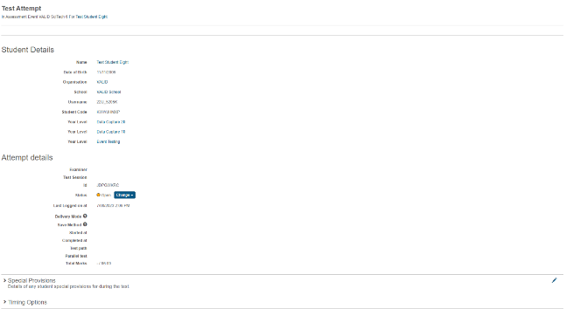

The Special Provisions menu is at the bottom of the page that opens. You may need to scroll.
Click on the pen icon, on the far right, to edit the Special Provisions menu.
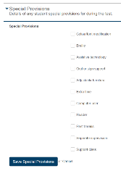

Select all special provisions that are appropriate, then click 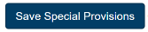 button.

Task 4: Activity Summary Report
The Activity Summary Report is to be used to export a summary of your student’s attempts and details at the end of the test, for your school records. This will assist in resolving missing report issues that may arise when the individual student reports are available to schools.
Click onto “Activity Summary Report tab”
Click onto the Export button to download a copy of your school’s activity summary.
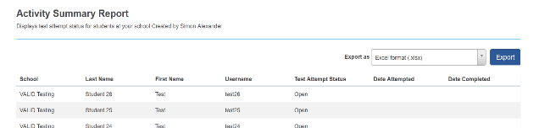

MS Teams Support Page
This will take you to the VALID School Administration Team where you can find information and contact the VALID team for help with any aspect of administration of VALID.

2026 VALID Trial Tests | VALID School Test Administration

