Quick Reference Guide for the 2022 HSC teacher support entry in SPaRO

Table 1 – Accessing the screens and DEL/Principal confirmations
Table 2 – Entering HSC teacher support information

Table 1 – Accessing the screens and DEL/Principal confirmations
All | In SPaRO select the Curriculum and Policy tab
All | Select HSC on the left-hand menu and then select HSC teacher support when it appears.  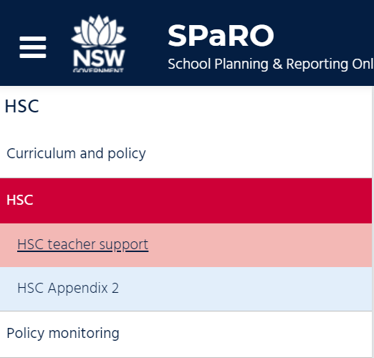
Principal  NIL return confirmation | All schools are required to complete the HSC teacher support entry in SPaRO.  Principals should submit a NIL return if there are no teachers who are teaching an HSC course for the first time (inexperienced teachers) AND no teachers who have no direct supervision or support from a head teacher with relevant subject and HSC expertise (unsupervised teachers).  Principals should click the Nil return check box AND click the Principal confirmation check box to submit a Nil return.  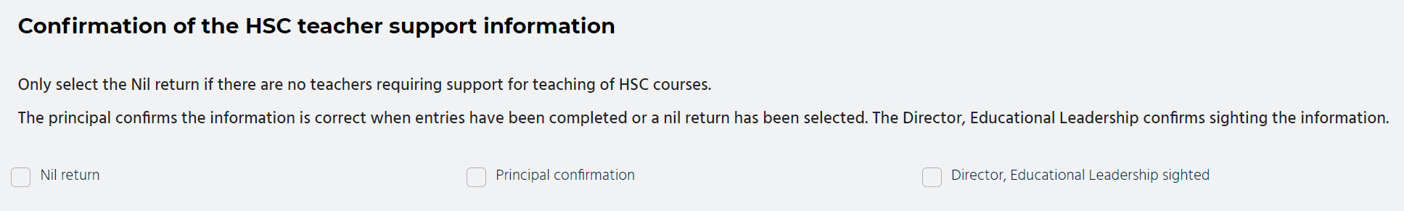
Principal confirmation | Principals must confirm entries have been completed after the school executive enter support for all inexperienced and unsupervised HSC teachers.  Click the Principal confirmation check box to confirm entries are complete. The form is now locked for data entry
DEL confirmation | View the information entered and discuss any issues with the principal.  Scroll to the bottom of the screen to see the confirmation checkboxes.  Click the Director, Educational Leadership sighted check box to confirm that you have sighted the information. This locks the form. The principal will need to ask you to uncheck the box if they have to add or change entries.
Table 2 – Entering HSC teacher support information
Principal  Executive | To enter teacher support information, select + Add entry located above Confirmation of the HSC teacher support information.  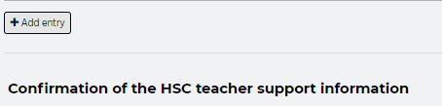  A new row will appear in the teacher support summary table.
 | Click in any column of the summary table to generate the popup form.
Click on the course entry box and start typing part of the course name. You are only able to select one course per entry.
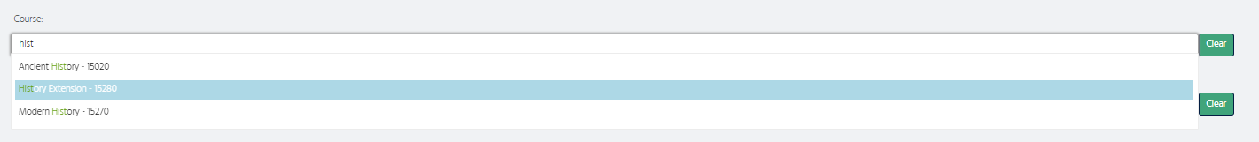
The selected course will appear under the course entry box.
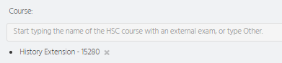
The course list includes most Board Developed Courses. If the course you want does not appear in the search, select Other – specify in comments and type the name of the course in the notes field adjacent to Other in Reason for support. Courses without external examinations could be listed here.

Click on the teacher entry box and start typing the email address of the teacher. Select the correct teacher.
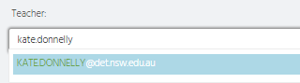
The selected teacher will appear under the course entry box. You are able to enter multiple teachers in this field.
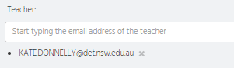
You may need to enter the full email address of the teacher (or Head Teacher) the first time that teacher’s email is used in SPaRO.
Use the same process for the Head Teacher entry.
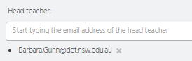
Make sure you have access to your school’s staff directory for an accurate list of email addresses the first time you use this SPaRO function.
Scroll down to enter information about the teacher support.
Check all the boxes that apply, to indicate reason(s) for support.
Check ‘Other’ to use the text box. If the subject requiring support is not available, enter it in the text box here.
Check all the boxes that apply, to indicate who is providing the support.
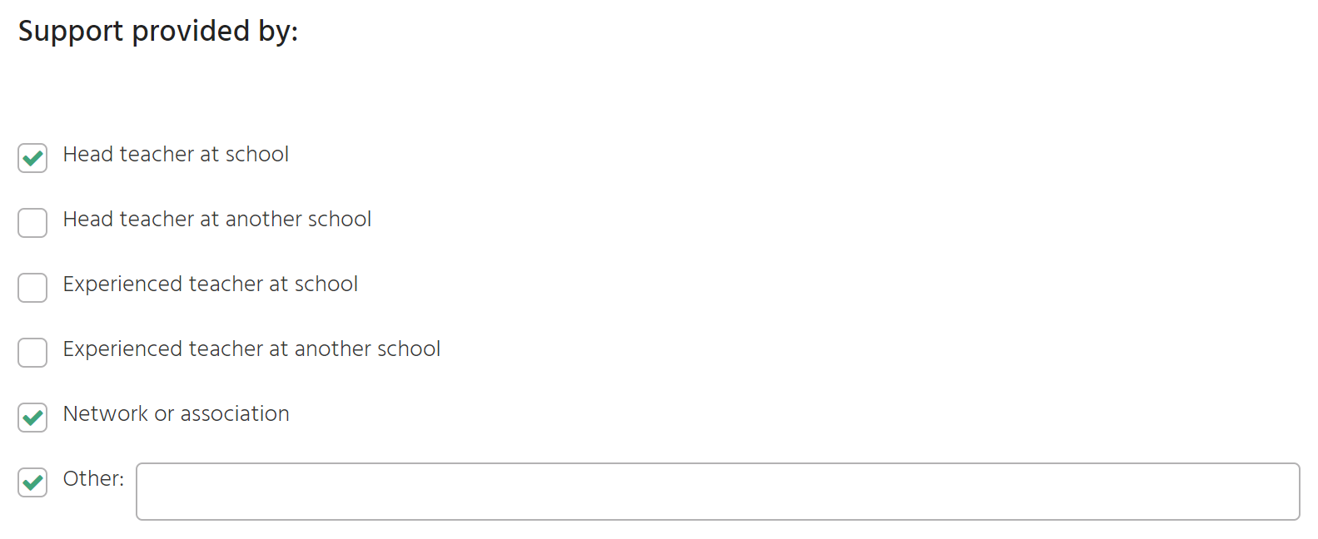
Check other to use the text box (optional). Use the text box to specify the network or association or the name of any other school providing support.
Check all the boxes that apply for the type of support provided.
Check other to use the text box (optional). You can specify statewide staffrooms in the text box.
Select Close button (bottom right of screen) to save your information and return to the summary screen.
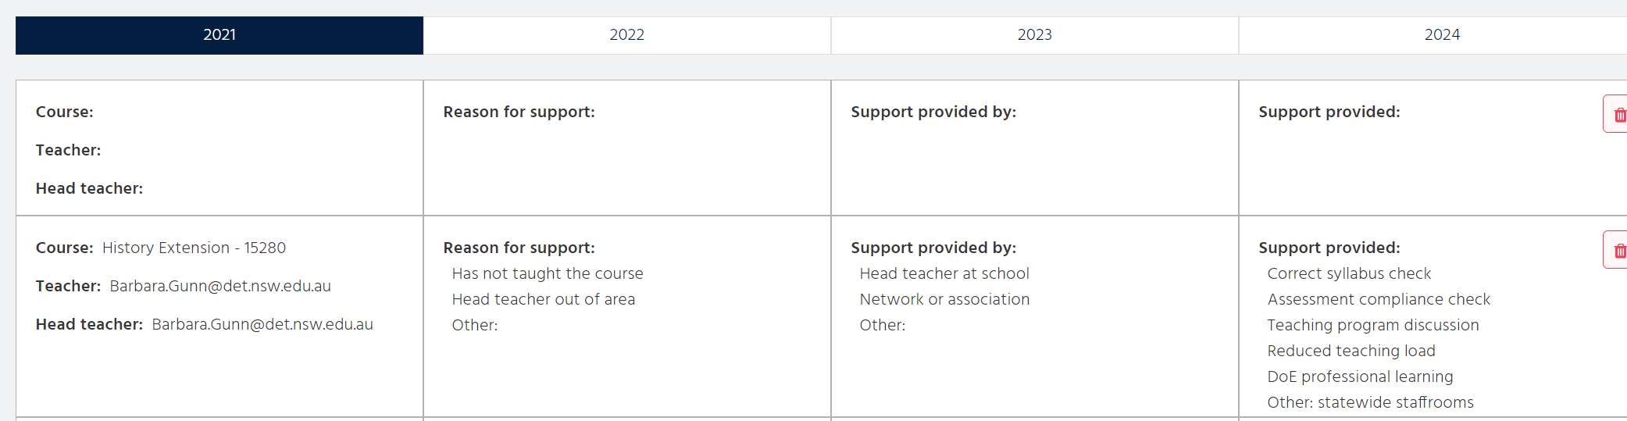
To delete a row, select the bin icon. You will be asked to confirm the deletion.
 | Continue to select + Add entry to complete the support page for each inexperienced or unsupervised teacher.
For advice on curriculum support contact Curriculum Secondary Learners
E: SecondaryEducationUnit@det.nsw.edu.au

