Quick Reference Guide for Appendix 2 2022 HSC monitoring confirmation in SPaRO

All | In SPaRO select the Curriculum and Policy tab
All | Select HSC on the left-hand menu and then select HSC Appendix 2 when it appears.  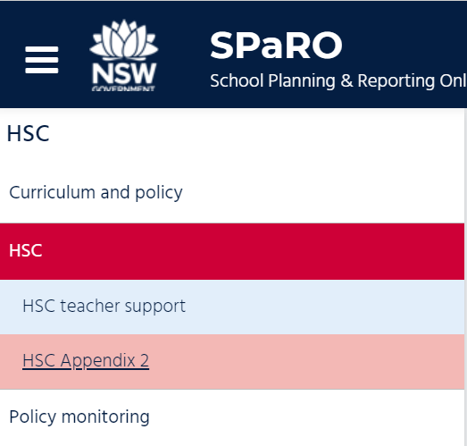
The Appendix 2 HSC monitoring confirmation page will appear. Complete either the Nil return section OR the HSC monitoring declaration section
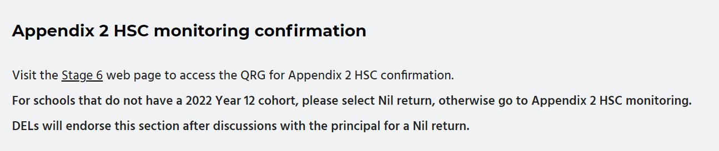
Principal | Use the HSC Nil return section if your school does not have a Year 12 cohort in the year of monitoring. This may occur in smaller schools and schools in specialist settings for example. Check the box for Nil return confirmed by Principal.  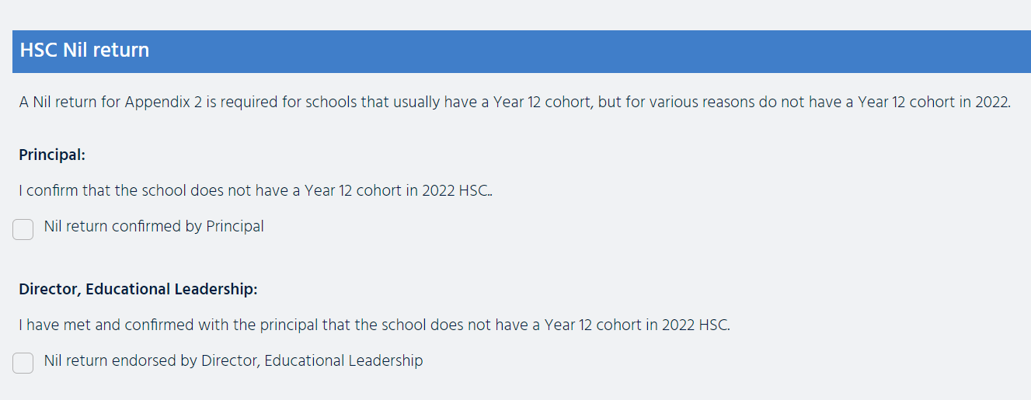
Principal | If you have a Year 12 cohort in the year of monitoring, read the section that shows Appendix 2 of the HSC monitoring advice.  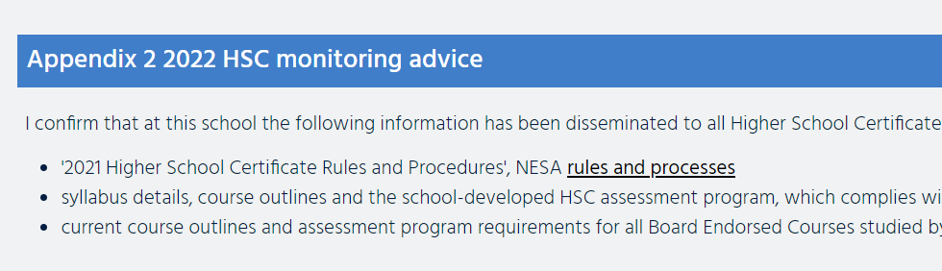
Principal | When you are satisfied that you have met the requirements of the declaration, use your mouse to check the box for Confirmed by Principal.
DEL | When you are satisfied that you have met the requirements of the declaration, use your mouse to check the box for Endorsed by Director, Educational Leadership.
You can view Appendix 2 in context in the 2022 HSC monitoring advice document.
A copy of the advice document is available on the Stage 6 web page:
For advice and support in monitoring HSC requirements, principals can contact:
- their Director, Educational Leadership
- NESA Liaison Officer
- Director, Curriculum Secondary Learners
- Director, Inclusive Education.
Support may also be accessed from Curriculum Advisors located in Strategic Delivery teams.
The contact details for the Curriculum Secondary Learners, Stage 6 Advisor are available on the Stage 6 web page.

