My Place – 1868 Minna
ABC ME screening details: Thursday 14 May 2020 at 10:45am
This episode can also be viewed on ABC iView after the scheduled screening time.
Key learning areas: English and history
Level: upper primary
About: Minna and her friends start a game of who can scare each other the most. However, one night, Minna goes too far.

Resources
- Family artefacts (photographs, family albums, birth certificates, special awards) or a family member who can act as a source for information.

Before the episode
- Create a timeline to show all the significant events in your life. Include key information about family or friends involved in events, key dates and information about the places where these events happened.
A timeline of my life
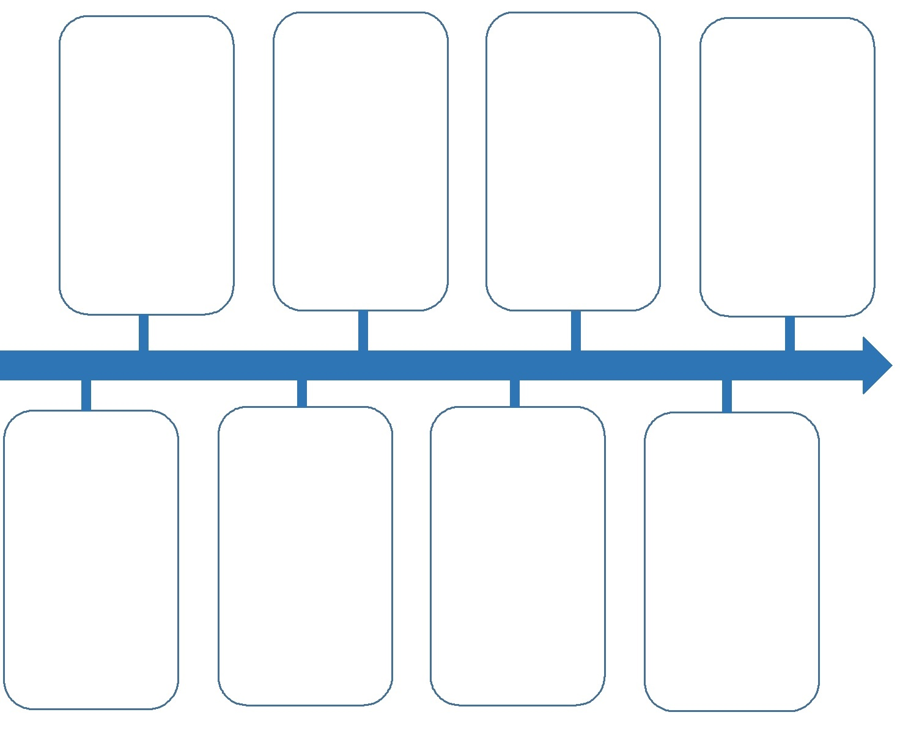

During the episode
The past: Use the Venn diagram below to take notes about what life was like for Minna in 1868 (e.g., clothing worn, games played, home life, technology and communication, built and natural environment, spoken language and phrases etc.). Record your observations under the heading 1868.

After the episode
- Change: How has life today changed from when Minna was a little girl in 1868? Record your ideas under the year 2020.
- Continuity: Have some ways of life continued on from 1868 to today? Record these where the circles overlap.
Follow-up activity: Interview an older family member or friend, to find out what life was like when they were little and make a timeline to show the important events in their life. First think of some interview questions that you would like to ask them. Also consider asking if they have some artefacts from their past that they could share with you (for example, photographs, old toys, special trinkets etc.).

NSW teacher notes
This is an optional standalone resource that could supplement student learning. The activities align with syllabus outcomes across stages and can be modified to meet the needs of your students. Students can complete the activities while learning at home and in the classroom. All activities can be completed without access to the internet or a device. Teachers could collect student work to offer feedback and as evidence of learning.

Learning intentions
- To understand the History concept ‘continuity and change’.
- To identify some of the ways life in Australia has changed over time or remained the same.
- To sequence significant events in chronological order by developing a timeline.

NSW History K-10 Syllabus outcomes
Stage 2 | Stage 3
Community and Remembrance  describes and explains how significant individuals, groups and events contributed to changes in the local community over time (HT2-2)  applies skills of historical inquiry and communication (HT2-5) | The Australian colonies  describes and explains the significance of people, groups, places and events to the development of Australia (HT3-1)  describes and explains different experiences of people living in Australia over time (HT3-2)  applies a variety of skills of historical inquiry and communication (HT3-5)

NSW English K-10 Syllabus outcomes
 | Stage 2 | Stage 3
Writing and representing | plans, composes and reviews a range of texts that are more demanding in terms of topic, audience and language (EN2-2A) | composes, edits and presents well-structured and coherent texts (EN3-2A)
History K-10 Syllabus © 2012 and English K-10 Syllabus © 2012 NSW Education Standards Authority (NESA) for and on behalf of the Crown in right of the State of New South Wales. See the NESA website for additional copyright information.

