MathXplosion – Pop Up Paper!
ABC ME screening details: Tuesday 19 May 2020 at 11:40am
This episode can also be viewed on ABC iView after the scheduled screening time.
Key learning areas: mathematics
Level: upper primary
About: This episode introduces paper engineering: the art of following a specific sequence of origami folding instructions using a standard sheet of paper, a few cuts and reverse folds to construct a 3D object.

Before the episode
- Have you ever folded paper to make something? Draw or write what you have done and how you did it.

After the episode
- In the episode, we saw a chicken, an octopus, a shark, a dinosaur, a lion and a tiger. Time for you to have a go! What animal would you like to make? Draw the face of your animal.

After the episode
- Follow these instructions to make your own Pop Up animal card.
Pop Up card instructions
Choose two pieces of coloured paper. Fold the first piece of paper in half. | Make the mouth by cutting a small line (about 5cm) in the middle of the card.  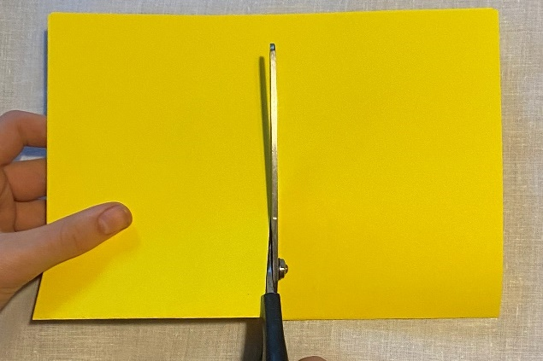
Two flaps will be formed near the cut. Fold these to form two triangles.  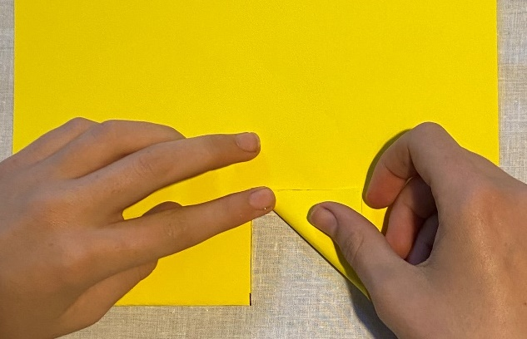 | Unfold the card. With your finger, lift the triangles to form a mouth shape.  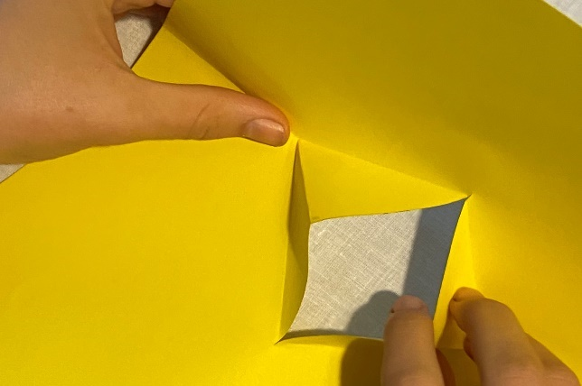
Close the card with the triangles folded inside. | Fold the second piece of paper and glue it to the back of your card.  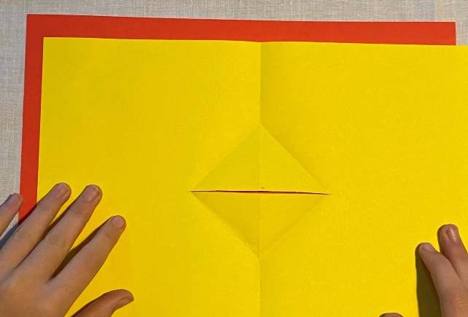
Fold your card. You should see coloured paper through the open mouth.  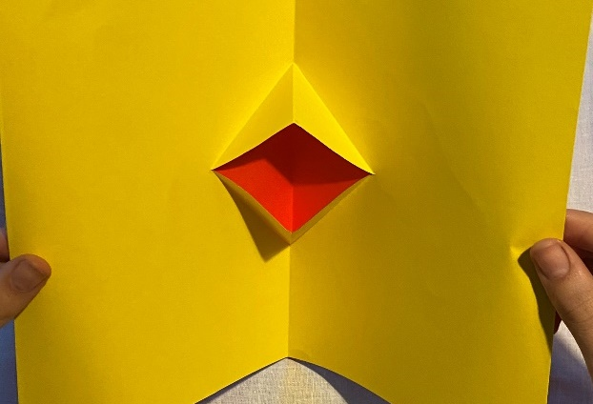 | Decorate your card. Draw an animal’s face around the mouth. Make sure your drawing is symmetrical (the same on both sides).  Describe your animal: What shapes and lines can you see? Is your animal closer to a two-dimensional shape or a three-dimensional object?
Follow-up activity: Experiment with other pop up card designs.

NSW teacher notes
This is an optional standalone resource that could supplement student learning. The activities align with syllabus outcomes across stages and can be modified to meet the needs of your students. Students can complete the activities while learning at home and in the classroom. All activities can be completed without access to the internet or a device. Teachers could collect student work to offer feedback and as evidence of learning.

Learning intentions
- To create a symmetrical Pop Out animal card.
- To describe the Pop Out animal using mathematical language.

NSW Mathematics K-10 Syllabus outcomes
 | Stage 2 | Stage 3
Working mathematically | describes mathematical situations and methods using everyday and some mathematical language, actions, materials, diagrams and symbols (MA1-1WM) | describes and represents mathematical situations in a variety of ways using mathematical terminology and some conventions (MA3-1WM)
NSW Mathematics K-10 syllabus © 2012 NSW Education Standards Authority (NESA) for and on behalf of the Crown in right of the State of New South Wales. See the NESA website for additional copyright information.

