Look Kool – Probability
ABC ME screening details: Monday 11 May 2020 at 11:15am
This episode can also be viewed on ABC iView after the scheduled screening time.
Key learning areas: mathematics
Level: upper primary
About: Hamza can't figure out why Koolkatt always wins when they play Flip-the-coin. Can you use probability to predict the future? Hamza interviews a real-life playing card and find out what's so 'lucky' about the number seven.

After the episode
- In a far-away land, the lottery consists of four balls numbered 1 to 4, which are placed in a bag.
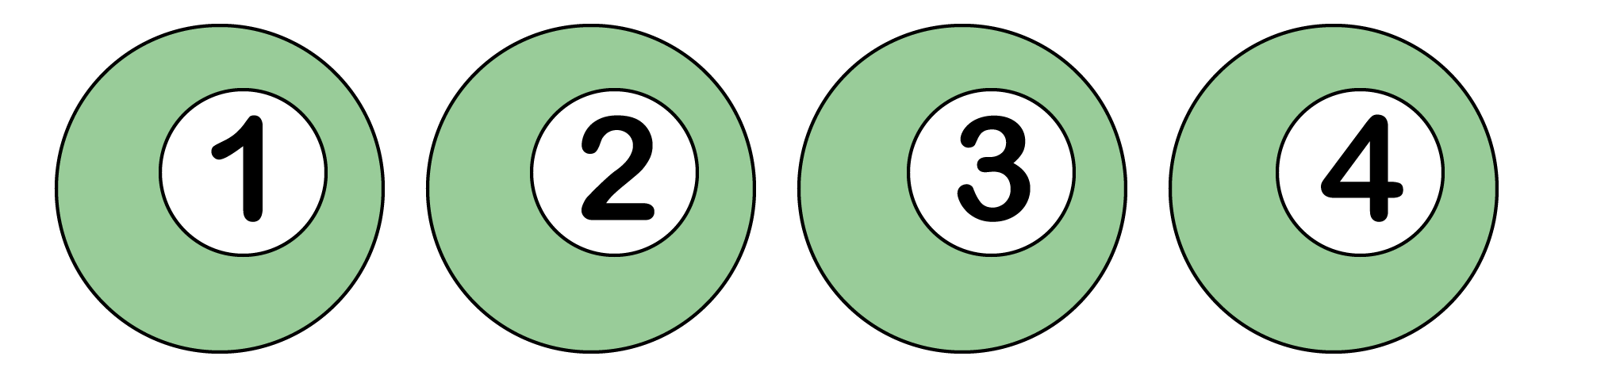
To enter, you choose one number.
To win, your number must match the number that is drawn from the bag.
What is the chance of winning this lottery? How do you know?

- The people running the lottery in this far-away land decide that it is too easy to win. So, they change their lottery game. In the new lottery, there are still four balls numbered 1 to 4, which are placed in a bag.
Now, to enter, you choose two numbers. To win, your numbers must match (in any order) the two numbers that are drawn from the bag.
What is the chance of winning this new lottery? How do you know?

- Have the organisers made it harder to win compared with their original version? How do you know?

- Create your own version of the lottery which would also be harder to win than the first game?

- How do you know that your game is harder?

Adapted from https://nrich.maths.org/
Follow-up activity: Play ‘rock-paper-scissors’. What chance do you have of winning? When you roll a dice each number is equally likely to occur. What other chance experiments do you know where each outcome is equally likely to happen?

NSW teacher notes
This is an optional standalone resource that could supplement student learning. The activities align with syllabus outcomes across stages and can be modified to meet the needs of your students. Students can complete the activities while learning at home and in the classroom. All activities can be completed without access to the internet or a device. Teachers could collect student work to offer feedback and as evidence of learning.

Learning intentions
- To identify the likelihood of an event occurring.
- To conduct a chance experiment.

NSW Mathematics K-10 Syllabus outcomes
 | Stage 2 | Stage 3
Probability and statistics | describes and compares chance events in social and experimental contexts (MA2-19SP) | conducts chance experiments and assigns probabilities as values between 0 and 1 to describe their outcomes (MA3-19SP)
Working mathematically | checks the accuracy of a statement and explains the reasoning used (MA2-3WM) | describes and represents mathematical situations in a variety of ways using mathematical terminology and some conventions (MA3-1WM)
NSW K-10 Mathematics Syllabus © 2012 NSW Education Standards Authority (NESA) for and on behalf of the Crown in right of the State of New South Wales. See the NESA website for additional copyright information.

