Look Kool – Mapping
ABC ME screening details: Monday 26 May 2020 at 11:15am
This episode can also be viewed on ABC iView.
Key learning areas: mathematics
Level: upper primary
About: Hamza thinks finding his way around is easy...until his smart phone breaks. Uh oh. Now he needs to use maps to get where he's going. Along the way, Hamza forms a marching band and gets travel tips from a gargoyle.

Before the episode
Are you good at following directions?
- Read the directions below and imagine yourself following this route.
- Walk 10 paces straight ahead.
- Turn right and walk 10 paces.
- Turn left and walk 5 paces.
- Turn left again, and this time walk 15 paces.
- Turn left and walk 15 paces.
- Turn left and walk 5 paces.
- Draw a picture to describe your route and where you will end up.

- Go outside and follow the directions to check whether your prediction was correct. If it wasn’t, can you explain why?

After the episode
- Here is a map of Border Town Zoo. There is treasure buried somewhere in the zoo!
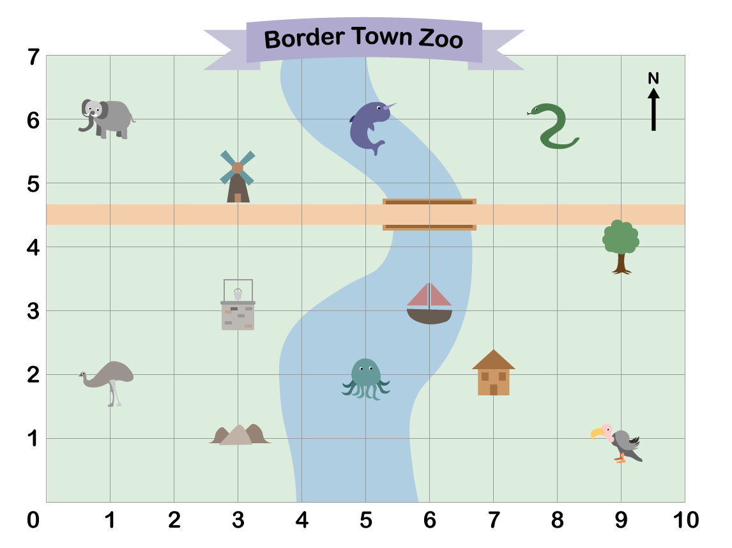
- When finding a landmark we look at the horizontal coordinate and then the vertical coordinate. For example, the house is located at 7, 2. Write down what you can see at the co-ordinates given below:
 | Landmark |  | Landmark
(8, 6) |  | (5, 6)
(1, 6) |  | (9, 4)
(9, 1) |  | (3, 3)
(1, 2) |  | (5, 2)
Adapted from https://nrich.maths.org/
Follow-up activity: The words from the previous activity can be used in a special way to find the coordinates of the buried treasure. Can you work out where it is?

NSW Teacher notes
This is an optional standalone resource that could supplement student learning. The activities align with syllabus outcomes across stages and can be modified to meet the needs of your students. Students can complete the activities while learning at home and in the classroom. All activities can be completed without access to the internet or a device. Teachers could collect student work to offer feedback and as evidence of learning.

Learning intentions
- To use a grid reference system to locate position on a map

NSW Mathematics K-10 Syllabus outcomes
Strands | Stage 2 | Stage 3
Working mathematically | uses appropriate terminology to describe, and symbols to represent, mathematical ideas (MA2-1WM) | describes and represents mathematical situations in a variety of ways using mathematical terminology and some conventions (MA3-1WM)
Measurement and geometry | uses simple maps and grids to represent position and follow routes, including using compass directions (MA2-17MG) | locates and describes position on maps using a grid-reference system (MA3-17MG)
NSW Mathematics K-10 Syllabus © 2012 NSW Education Standards Authority (NESA) for and on behalf of the Crown in right of the State of New South Wales. See the NESA website for additional copyright information.

