House of Sound – Woodwind
ABC ME screening details: Wednesday 13 May 2020 at 10:45am
This episode can also be viewed on ABC iView after the scheduled screening time.
Key learning areas: music, science and technology
Level: upper primary
About: Greg Foot and Fran Scott explain how woodwind instruments work and make all sorts of different sounds.

Before the episode
- Find an empty 1.25L or 2L plastic bottle. Rinse the bottle out and remove the lid. Can you blow across the top of the opening to create a tone? It might take some practice! You can also ask an adult to demonstrate the technique. Use lines on the illustration to explain where you think the air is travelling.
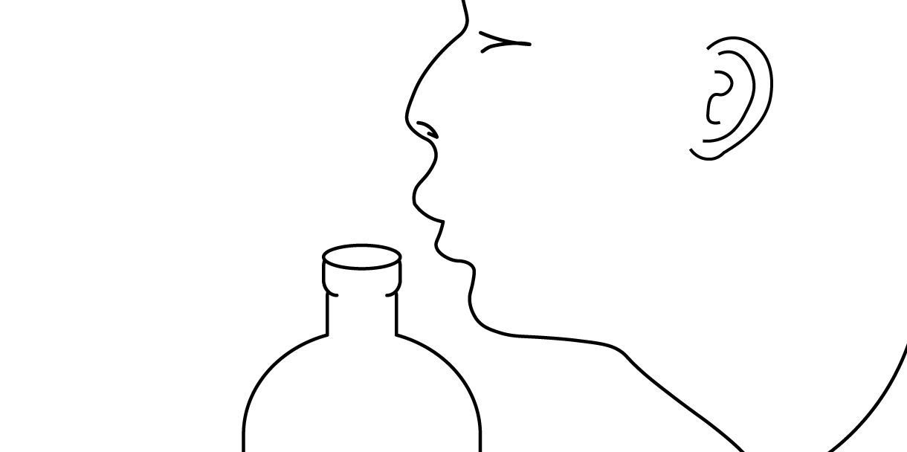

After the episode
- Look at the previous illustration. Were your lines close to the demonstration seen in the episode? If not, use a different colour to show direction that the air is travelling.
- Now fill up the bottle with some water and blow across the top again. What do you now notice about the new tone? Is it higher or lower than the original tone? Explain why you think the tone is different when water is added to the bottle?

- A woodwind instrument produces sound by splitting an exhaled stream of air on a sharp edge, such as a reed or a fipple. Circle the instruments below that you think belong to the woodwind family. Remember; they’re not always made of wood!
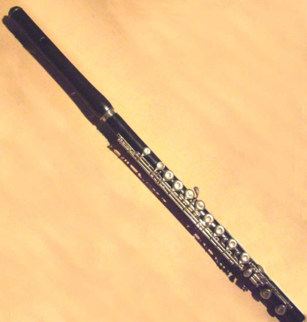  flute | bagpipes | 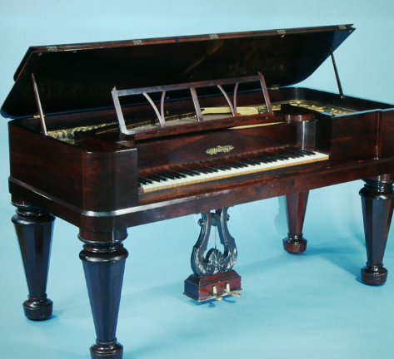  piano
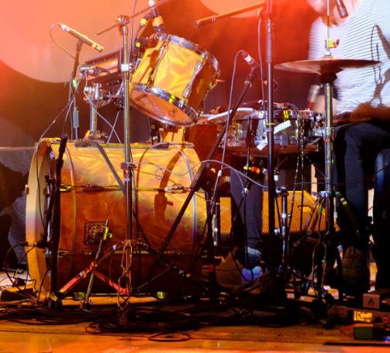  drum kit | 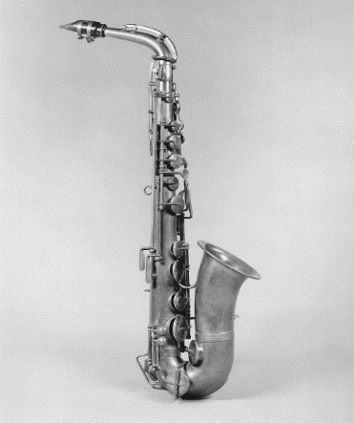  saxophone | electric guitar
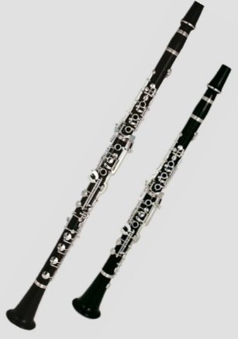  clarinet | 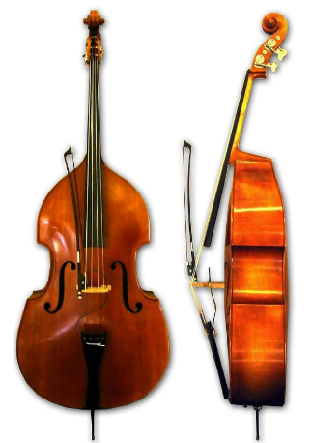  Double bass | 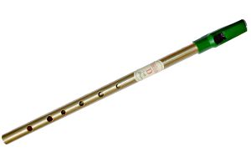  tin whistle
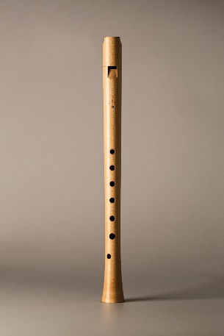  recorder | 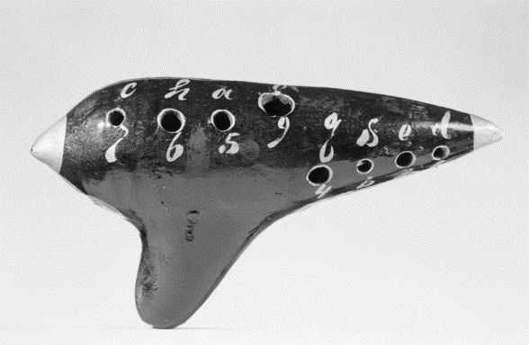  ocarina | 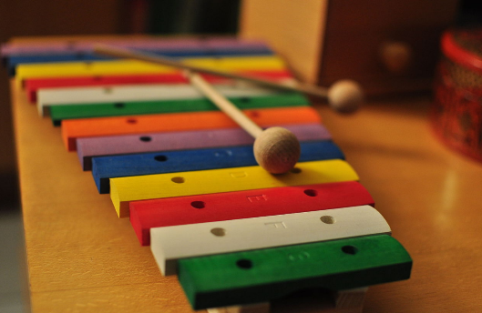  xylophone
Follow-up activity: Can you invent your own woodwind instrument? Use the ideas shown in this episode and the help of an adult to have a go.

NSW teacher notes
This is an optional standalone resource that could supplement student learning. The activities align with syllabus outcomes across stages and can be modified to meet the needs of your students. Students can complete the activities while learning at home and in the classroom. All activities can be completed without access to the internet or a device. Teachers could collect student work to offer feedback and as evidence of learning.

Learning intentions
- To identify how woodwind instruments produce sound
- To identify the similarities between woodwind instruments

NSW Creative Arts K-6 Syllabus outcomes
 | Stage 2 | Stage 3
Music | Sings, plays and moves to a range of music, demonstrating a basic knowledge of musical concepts (MUS2.1) | Sings, plays and moves to a range of music, individually and in groups, demonstrating a knowledge of musical concepts (MUS3.1)
NSW Creative Arts K-6 Syllabus© 2006 NSW Education Standards Authority (NESA) for and on behalf of the Crown in right of the State of New South Wales. See the NESA website for additional copyright information.

