.Full Proof – Mathematical Shapes
ABC ME screening details: Wednesday 20 May 2020 at 12:10pm
This episode can also be viewed on ABC iView after the scheduled screening time.
Key learning areas: mathematics
Level: upper primary
About: Idil lives in Istanbul & loves to draw. She visits the mosque near her home very often. Idil discovers that the beauty of the mosque has everything to do with mathematics.

Before the episode
- In today’s episode they explore circles. Here is a fun problem about circles. Below there are some circles which are coins, counters, and rings. 10 coins, 19 counters, and 12 rings have been used.
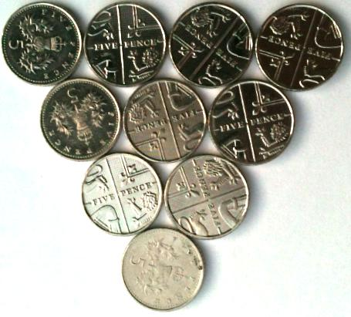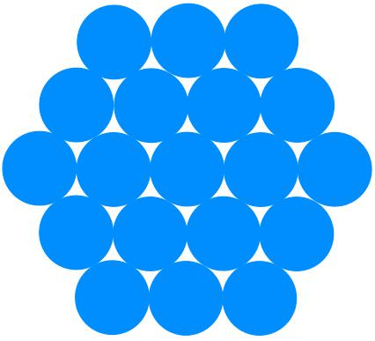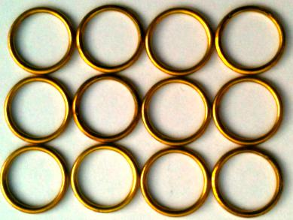
- Discuss the following questions with a friend or family member.
- What do you think the 'next size up' of each shape means?
- How many coins, counters, and rings would you need to make the next size up for each?
- The shapes are a triangle, a hexagon, and a rectangle.
- What shapes could you make by putting circles together?
- How many would you use?
- How many would you need for the next size up of each of your designs?

After the episode
We learnt about symmetry in today’s episode. Check out this symmetrical pattern. Charlie created a symmetrical pattern by shading in four squares on a 3 by 3 square grid:
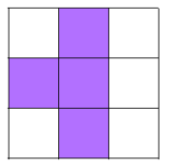
- Use the blank grids to make your own symmetrical patterns (you could draw some more grids or use grid paper if you would like to create extra patterns).
Here are some questions you might like to consider:
- How many different patterns can you make if you are only allowed to shade in one... two... three... four cells?
- Can you make patterns using more than one colour?
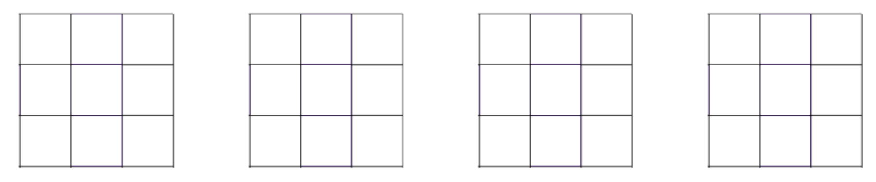
- How do you know that your patterns are symmetrical?
Adapted from https://nrich.maths.org/
Follow-up activity: Create a paper pattern like the ones you saw in the episode. Maybe you could fold the paper twice to make the pattern. You can make the pattern as simple or complex as you can. Hold the pattern up to a window or take it outside where the light can shine through it. Trace the shadow of the design onto another sheet of paper and colour. Describe and explain how you created the design you have made to a family member of friend.

Teacher notes [NSW]
This is an optional standalone resource that could supplement student learning. The activities align with syllabus outcomes across stages and can be modified to meet the needs of your students. Students can complete the activities while learning at home and in the classroom. All activities can be completed without access to the internet or a device. Teachers could collect student work to offer feedback and as evidence of learning.

Learning intentions
- To create a shape out of circles.
- To create symmetrical patterns.

NSW Mathematics K-10 Syllabus outcomes
 | Stage 2 | Stage 3
Working mathematically | uses appropriate terminology to describe, and symbols to represent, mathematical ideas (MA2-1WM) | describes and represents mathematical situations in a variety of ways using mathematical terminology and some conventions (MA3-1WM)
Measurement and Geometry | manipulates, identifies and sketches two-dimensional shapes, including special quadrilaterals, and describes their features (MA2-15MG) | identifies three-dimensional objects, including prisms and pyramids, on the basis of their properties, and visualises, sketches and constructs them given drawings of different views (MA3-14MG)
NSW Mathematics K-10 syllabus © 2012 NSW Education Standards Authority (NESA) for and on behalf of the Crown in right of the State of New South Wales. See the NESA website for additional copyright information.

