Art With Mati And Dada – Canaletto
ABC ME screening details: Monday 1 June 2020 at 10:35am
This episode can also be viewed on ABC iView.
Key learning areas: creative arts – visual arts
Level: upper primary
About: Mati and Dada are transported into a marvellous journey in Venice, on a Gondola together with Canaletto in person!

Before the episode
- Brainstorm: Think of all the different types of places that artists have based their landscape paintings and drawings on.
- Draw: After walking around the outside of your home, choose a small part of your building to sketch (stairs, roofline or brick wall). Focus on the different shapes, lines and angles you see. Sketch the part you have chosen in your workbook or on a piece of paper.
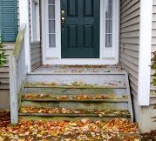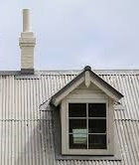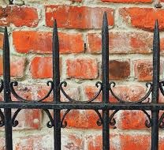

During the episode
- Write and draw in the boxes below information about the artist Canaletto and the artworks he created.
Canaletto | Artworks

After the episode
- Art making: Make your own landscape artwork like Canaletto by focusing on the built or natural landscapes views around your home (for example the houses in your street or a farm shed on your property).
- Walk around the area and choose a view point to draw from.
- Look closely at what types of features are in the foreground as these will need to be drawn larger and with more detail.
- Think about what features are in the background and will need to be drawn smaller and a little blurred.
- Consider what types of shapes, lines and angles you can see. Hold your pencil out in front to help you compare the sizes of different features or tip your pencil left or right, to look at the types of angles the different lines make.
- Sketch your landscape below. When you are happy with your sketches, have a go at drawing and painting your landscape artwork on some art paper.

Follow-up activity: Have a go at being a landscape photographer and capture some interesting views of your local environment. Experiment with taking photographs from different angles and heights.

NSW Teacher notes
This is an optional standalone resource that could supplement student learning. The activities align with syllabus outcomes across stages and can be modified to meet the needs of your students. Students can complete the activities while learning at home and in the classroom. All activities can be completed without access to the internet or a device. Teachers could collect student work to offer feedback and as evidence of learning.

Learning intentions
- To appreciate the different techniques artists use to create landscape artworks.
- To closely observe the details of different landscapes in the real world and to make artworks about these using various techniques such as proportion, perspective, and foreshortening.

NSW Creative Arts K-6 Syllabus outcomes
Artforms | Stage 2 | Stage 3
Visual Arts - Appreciating | Identifies connections between subject matter in artworks and what they refer to, and appreciates the use of particular techniques (VAS2.4) | Communicates about the ways in which subject matter is represented in artworks (VAS3.4)
Visual Arts - Making | Represents the qualities of experiences and things that are interesting or beautiful by choosing among aspects of subject matter (VAS2.1) | Investigates subject matter in an attempt to represent likenesses of things in the world (VAS3.1)
Creative Arts K-6 Syllabus © 2006 NSW Education Standards Authority (NESA) for and on behalf of the Crown in right of the State of New South Wales. See the NESA website for additional copyright information.

