Learning from home: ABC TV Education resources

Upper primary – week 4

18/05/2020 – 22/05/2020
Supplementary activities to support educational content broadcast on ABC ME during Term 2, 2020

About this resource
ABC Education, in collaboration with the NSW Department of Education, have planned a daily schedule of free to air educational programs supported by standalone resources that complement the ABC TV Education program airing during Term 2, 2020. All activities can be completed without access to the internet or a device and are suitable for lower primary, upper primary and secondary students.

Educational benefit
Student booklets include activities designed by curriculum experts to meet educational outcomes and are based on a selection of ABC programs that are of high educational value. Activities address topics from a range of subjects including: English; mathematics; science and technology; geography; history; PDHPE and creative arts.
These optional resources do not replace teaching and learning programs provided by schools but may be used by teachers and parents/carers to supplement student learning. Teachers may select activities relevant to their teaching and learning program and modify to meet student needs.

Recording student responses
Students complete activities before, during and after viewing selected daily episodes. Where appropriate, space is provided in each booklet for students to record their responses. Students may require additional writing paper or a separate workbook for some tasks. Completed student booklets may be collected by teachers and used as evidence of learning.

How to access ABC TV Education programs
The selected daily episodes can be viewed via the ABC TV Education broadcast on ABC ME (Channel 23) from 10am-3pm weekdays. Each day commences with programs suitable for lower primary students followed by upper primary and then secondary. Programs will also be available at abc.net.au/iview after the broadcast. A schedule of the selected episodes is included in each student booklet.

Episode schedule – week 4
The timetable below outlines the episode focus for each day. The full ABC TV Education program can be found at http://www.abc.net.au/tveducation/
 | Time | Program | Episode title | Key learning area | Pages
Monday  18/05/2020 | 10:45am | Dance With The Elements | Air | dance, music | 4-5
Monday  18/05/2020 | 11:20am | Look Kool | Measurement | mathematics | 6-7
Tuesday  19/05/2020 | 11:40am | MathXplosion | Pop Up Paper! | mathematics | 8-9
Wednesday  20/05/2020 | 12:10pm | Full Proof | Mathematical Shapes | mathematics | 10-11
Thursday  21/05/2020 | 11:10am | Back In Time For Dinner: Education Shorts | 1980s | history | 12-13
Friday  22/05/2020 | 11:10am | Bringing Books to Life | Jamie Johnson - The Kick Off | English | 14-15
© State of New South Wales (Department of Education), 2020
The copyright material published in this document is subject to the Copyright Act 1968 (Cth), and is owned by the NSW Department of Education or, where indicated, by a party other than the NSW Department of Education.
Copyright material available in this document is licensed under a Creative Commons Attribution 4.0 International (CC BY 4.0) licence.
See http://education.nsw.gov.au/about-us/copyright for further details.

Dance with the Elements – Air
ABC ME screening details: Monday 18 May 2020 at 10:45am
This episode can also be viewed on ABC iView after the scheduled screening time.
Key learning areas: dance and music
Level: upper primary
About: Three dancers dance to three pieces of classical music in animated, virtual environments - invoking the element air.

Before the episode
- Warmup activity: A good warm-up is designed to prepare the body so it can participate safely in dance activities. Get your body ready to dance by repeating the following ‘on the spot’ movements:0 star jumps, 10 squats, 10 forward lunges, 10 forward arm swings (both arms), 10 stretches up high then bend to touch your toes. Repeat the movement pattern for 5 minutes.

During the episode
- Carefully listen to how the music changes to represent the different ways the air moves and sounds. How do the dancers change their movements to respond to the changes in music to represent the different elements of air? Record your ideas by taking notes or drawing below.

After the episode
- Create your own dance to represent the element of ‘air’. Think of different body movements to represent the ‘air’ action words below. Draw stick figure shapes and write labels to explain the position of different body parts, to plan your movement for each action word.
drifting  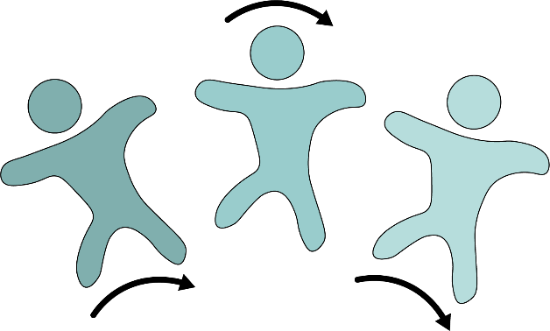  Large steps sideways while spinning whole body around. | floating | fluttering
blowing | rising | flying
swaying | twirling | falling
- Copy the body movements above onto blank squares of paper. You might like to have multiple copies of some movements. Then make your own dance composition by arranging the cards into an order of your choice. You might like to select a piece of music to perform your dance to.
Follow-up activity: Can you think of other body movements to create a dance about a different element of nature (e.g. a weather event like a storm or changes to the land caused by drought).

Look Kool – Measurement
ABC ME screening details: Monday 18 May 2020 at 11:20am
This episode can also be viewed on ABC iView after the scheduled screening time.
Key learning areas: mathematics
Level: upper primary
About: Hamza wants to measure everything about Koolkatt that has changed since he was a teeny-weeny little robot-kitten but how? Hamza finds out there are a lot of different ways to measure the world around us.

Before the episode
- What do you know about ‘measurement’? Draw, write or share your thinking.

After the episode
- In the Look Kool episode we learnt a lot about measurement. Time for you to be a mathematician!
- Three cars are about to go on a journey. You will need to collect the following items to see where and how far they travel:
- 3 toy cars
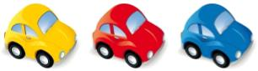
- a small ramp (what could you create a ramp out of?)
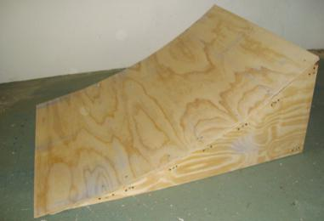
- If the ramp is wide enough, place all three cars at the top and LET GO! Or try one at a time. Which went the furthest? How do you know? How far did each one travel from the bottom of the slope?

- Try different ways of measuring how far the cars travelled. Record the ways that you used. Which way helped you measure accurately? How do you know?

- Here is part of a conversation between a group of children as they discuss a tall tree:
"I wonder how tall it is?" says Linus.
"I think we could find out" replies Raj.
"It could be difficult as it's very high." says Toby.
How do you think they each went about finding out the height of the tree?
Adapted from https://nrich.maths.org/

Follow-up activity: How would you find out how tall a large tree is?

MathXplosion – Pop Up Paper!
ABC ME screening details: Tuesday 19 May 2020 at 11:40am
This episode can also be viewed on ABC iView after the scheduled screening time.
Key learning areas: mathematics
Level: upper primary
About: This episode introduces paper engineering: the art of following a specific sequence of origami folding instructions using a standard sheet of paper, a few cuts and reverse folds to construct a 3D object.

Before the episode
- Have you ever folded paper to make something? Draw or write what you have done and how you did it.

After the episode
- In the episode, we saw a chicken, an octopus, a shark, a dinosaur, a lion and a tiger. Time for you to have a go! What animal would you like to make? Draw the face of your animal.

After the episode
- Follow these instructions to make your own Pop Up animal card.
Pop Up card instructions
Choose two pieces of coloured paper. Fold the first piece of paper in half. | Make the mouth by cutting a small line (about 5cm) in the middle of the card.  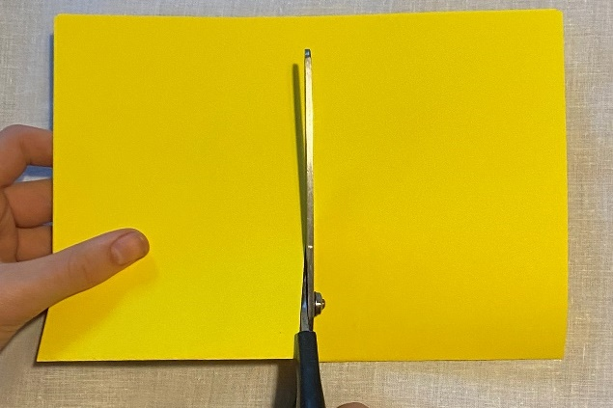
Two flaps will be formed near the cut. Fold these to form two triangles.  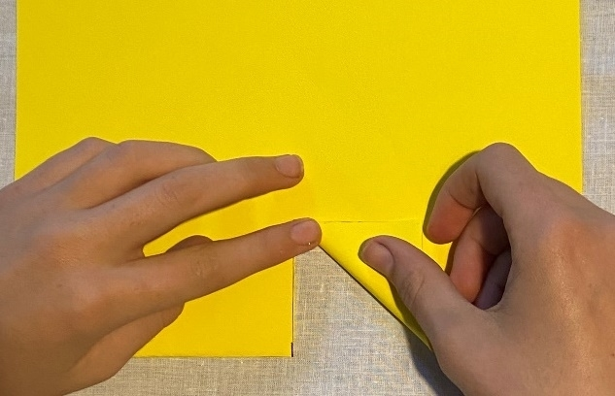 | Unfold the card. With your finger, lift the triangles to form a mouth shape.  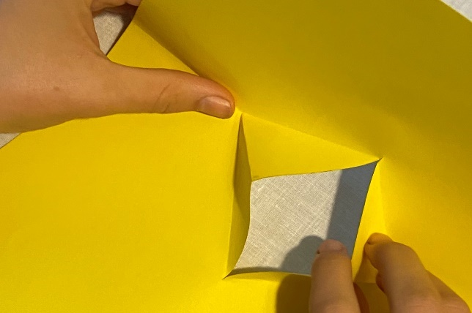
Close the card with the triangles folded inside. | Fold the second piece of paper and glue it to the back of your card.  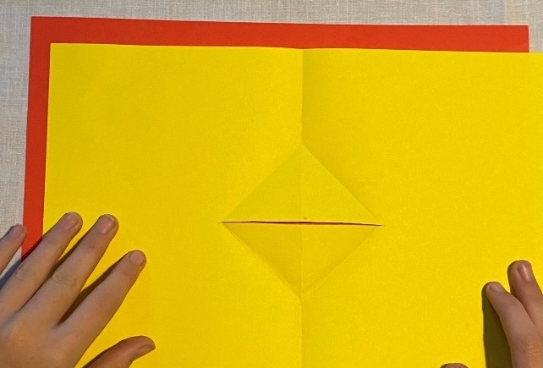
Fold your card. You should see coloured paper through the open mouth.  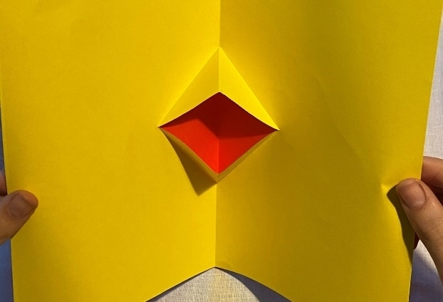 | Decorate your card. Draw an animal’s face around the mouth. Make sure your drawing is symmetrical (the same on both sides).  Describe your animal: What shapes and lines can you see? Is your animal closer to a two-dimensional shape or a three-dimensional object?
Follow-up activity: Experiment with other pop up card designs.

Full Proof – Mathematical Shapes
ABC ME screening details: Wednesday 20 May 2020 at 12:10pm
This episode can also be viewed on ABC iView after the scheduled screening time.
Key learning areas: mathematics
Level: upper primary
About: Idil lives in Istanbul & loves to draw. She visits the mosque near her home very often. Idil discovers that the beauty of the mosque has everything to do with mathematics.

Before the episode
- In today’s episode they explore circles. Here is a fun problem about circles. Below there are some circles which are coins, counters, and rings. 10 coins, 19 counters, and 12 rings have been used.
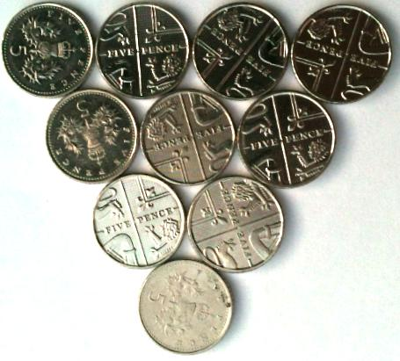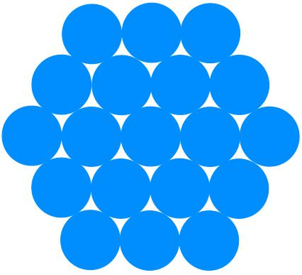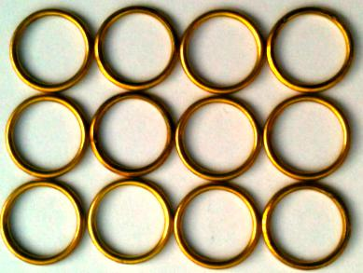
- Discuss the following questions with a friend or family member.
- What do you think the 'next size up' of each shape means?
- How many coins, counters, and rings would you need to make the next size up for each?
- The shapes are a triangle, a hexagon, and a rectangle.
- What shapes could you make by putting circles together?
- How many would you use?
- How many would you need for the next size up of each of your designs?

After the episode
- We learnt about symmetry in today’s episode. Check out this symmetrical pattern. Charlie created a symmetrical pattern by shading in four squares on a 3 by 3 square grid:
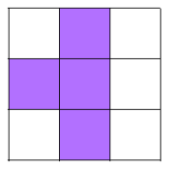
- Use the blank grids to make your own symmetrical patterns (you could draw some more grids or use grid paper if you would like to create extra patterns).
Here are some questions you might like to consider:
- How many different patterns can you make if you are only allowed to shade in one... two... three... four cells?
- Can you make patterns using more than one colour?
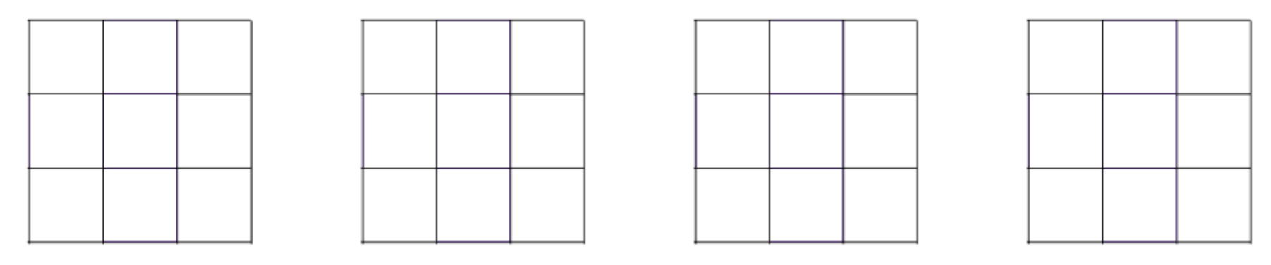
- How do you know that your patterns are symmetrical?
Adapted from https://nrich.maths.org/
Follow-up activity: Create a paper pattern like the ones you saw in the episode. Maybe you could fold the paper twice to make the pattern. You can make the pattern as simple or complex as you can. Hold the pattern up to a window or take it outside where the light can shine through it. Trace the shadow of the design onto another sheet of paper and colour. Describe and explain how you created the design you have made to a family member of friend.

Back in Time For Dinner – 1980s
ABC ME screening details: Thursday 21 May 2020 at 11:10am
This episode can also be viewed on ABC iView after the scheduled screening time.
Key learning areas: history
Level: upper primary
About: Come and visit a home from the 80s - Some familiar technology is starting to appear in homes; microwaves, computers and mobile phones, but they all look much bigger than what we use today!

Before the episode
- Write and draw what you know about life the 1980s. You might think about technology, fashion, people, popular culture and important events.

During the episode
- Take notes about the technology, fashion and food and cooking in this episode.
Technology | Fashion | Food and cooking

After the episode
- Explain how each of the items below made the lives of people living in the 1980s more convenient.
Item | How did it make life more convenient?
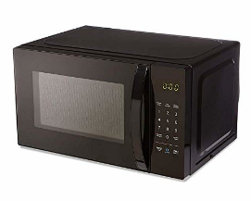
Microwave ovens
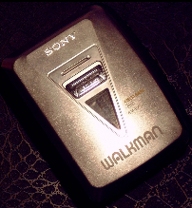
Portable music devices
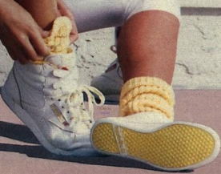
Aerobics on TV
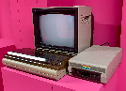
At-home video game machines
- What were some of the negative aspects that you observed about life in the 1980s?

Follow-up activity: Find somebody who was alive during the 1980s. Have a conversation with them about their life during this decade. What key historical events do they remember? How has Australian society changed since this time? If possible, record your conversation as part of a history podcast.

Bringing Books to Life – Jamie Johnson: The Kick Off
ABC ME screening details: Friday 22 May 2020 at 11:10am
This episode can also be viewed on ABC iView after the scheduled screening time.
Key learning areas: English
Level: upper primary
About: England Women's Football team player Eniola Aluko explains why she loves the book.

Before the episode
Action verbs express an action whether it be physical or mental. An action verb explains what the subject of a sentence is doing or has done (e.g. ‘Jamie kicked the football).
Adverbial phrases gives more information about the main idea in a sentence by explaining why, how, where, or when an action occurred. (e.g. ‘Jamie kicked the football, booting it all the way to the goal line).
- Brainstorm a list of action verbs that would be seen in some of your favourite sporting activities. Then create a sentence by adding an adverbial phrase to give more information about the action that is happening.
Sport | Action verbs | Sentence
netball | squinted, held, aimed | Katie squinted as she held the ball and aimed for the goal ring.

During the episode
- Take notes to record everything you learn about the setting, main character and storyline for the book ‘Jamie Johnson - The Kick Off’ by Dan Freedman.

After the episode
- Football player Gareth Barry reads an action packed passage from the book, where Jamie’s team is drawing one all with the other team. Write your own climatic scene about a sporting activity and character of your choice. Remember to use interesting verbs and adverbs to create a sense of excitement for readers.

Follow-up activity: Design a book cover for the passage you wrote in the previous activity. Think about what the title of your book will be and what image of the main character you will use on the cover to grab the attention of readers. Include details of the publishers you might use as well as your author name.

