Learning from home: ABC TV Education resources

Upper primary – week 3

11/05/2020 – 15/05/2020
Supplementary activities to support educational content broadcast on ABC ME during Term 2, 2020

About this resource
ABC Education, in collaboration with the NSW Department of Education, have planned a daily schedule of free to air educational programs supported by standalone resources that complement the ABC TV Education program airing during Term 2, 2020. All activities can be completed without access to the internet or a device and are suitable for lower primary, upper primary and secondary students.

Educational benefit
Student booklets include activities designed by curriculum experts to meet educational outcomes and are based on a selection of ABC programs that are of high educational value. Activities address topics from a range of subjects including: English; mathematics; science and technology; geography; history; PDHPE and creative arts.
These optional resources do not replace teaching and learning programs provided by schools but may be used by teachers and parents/carers to supplement student learning. Teachers may select activities relevant to their teaching and learning program and modify to meet student needs.

Recording student responses
Students complete activities before, during and after viewing selected daily episodes. Where appropriate, space is provided in each booklet for students to record their responses. Students may require additional writing paper or a separate workbook for some tasks. Completed student booklets may be collected by teachers and used as evidence of learning.

How to access ABC TV Education programs
The selected daily episodes can be viewed via the ABC TV Education broadcast on ABC ME (Channel 23) from 10am-3pm weekdays. Each day commences with programs suitable for lower primary students followed by upper primary and then secondary. Programs will also be available at abc.net.au/iview after the broadcast. A schedule of the selected episodes is included in each student booklet.

Episode schedule – week 3
The timetable below outlines the episode focus for each day. The full ABC TV Education program can be found at http://www.abc.net.au/tveducation/
 | Time | Program | Episode title | Key learning area | Pages
Monday  11/05/2020 | 11:15am | Look Kool | Probability | mathematics | 4-5
Tuesday  12/05/2020 | 12:45pm | Fierce Earth | World's Coldest Places | science and technology, geography | 6-7
Wednesday  13/05/2020 | 10:45am | House Of Sound | Woodwind | music, science and technology | 8-9
Thursday  14/05/2020 | 10:45am | My Place | 1868 Minna | English and history | 10-11
Friday  15/05/2020 | 11:20am | The Storybuilding Tool Kit | Setting | English | 12-13
© State of New South Wales (Department of Education), 2020
The copyright material published in this document is subject to the Copyright Act 1968 (Cth), and is owned by the NSW Department of Education or, where indicated, by a party other than the NSW Department of Education.
Copyright material available in this document is licensed under a Creative Commons Attribution 4.0 International (CC BY 4.0) licence.
See http://education.nsw.gov.au/about-us/copyright for further details.

Look Kool – Probability
ABC ME screening details: Monday 11 May 2020 at 11:15am
This episode can also be viewed on ABC iView after the scheduled screening time.
Key learning areas: mathematics
Level: upper primary
About: Hamza can't figure out why Koolkatt always wins when they play Flip-the-coin. Can you use probability to predict the future? Hamza interviews a real-life playing card and find out what's so 'lucky' about the number seven.

After the episode
- In a far-away land, the lottery consists of four balls numbered 1 to 4, which are placed in a bag.
To enter, you choose one number.
To win, your number must match the number that is drawn from the bag.
What is the chance of winning this lottery? How do you know?

- The people running the lottery in this far-away land decide that it is too easy to win. So, they change their lottery game. In the new lottery, there are still four balls numbered 1 to 4, which are placed in a bag.
Now, to enter, you choose two numbers. To win, your numbers must match (in any order) the two numbers that are drawn from the bag.
What is the chance of winning this new lottery? How do you know?

- Have the organisers made it harder to win compared with their original version? How do you know?

- Create your own version of the lottery which would also be harder to win than the first game?

- How do you know that your game is harder?

Adapted from https://nrich.maths.org/
Follow-up activity: Play ‘rock-paper-scissors’. What chance do you have of winning? When you roll a dice each number is equally likely to occur. What other chance experiments do you know where each outcome is equally likely to happen?

Fierce Earth – World's Coldest Places
ABC ME screening details: Tuesday 12 May 2020 at 12:45pm
This episode can also be viewed on ABC iView after the scheduled screening time.
Key learning areas: science and technology, geography
Level: upper primary
About: This Fierce Earth special takes viewers on a journey to one of the world's coldest and most hostile places on the planet - the Yukon Territory in Canada.

Before the episode
- Draw lines or colour to match the descriptions to the temperatures next to the thermometer.

Descriptions
The temperature inside your freezer.
A very cold day in Yukon, Canada.
The temperature at which water boils. Often called its “boiling point”.
The hottest temperature on Earth was recorded in El Azizia, Libya in 1922.
The temperature at which water freezes. Often called its “freezing point”.
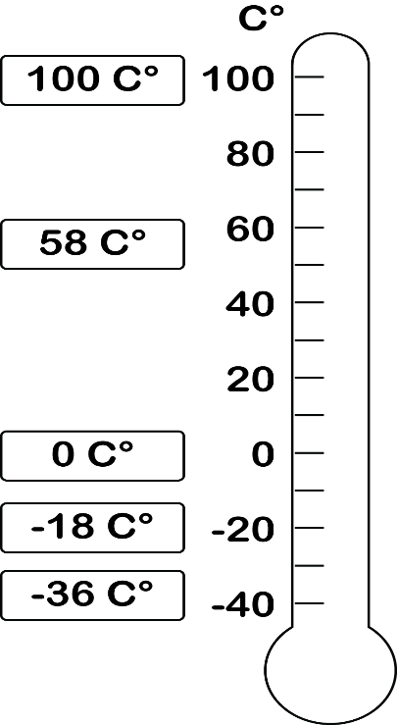

After the episode
- Sketch and label a drawing of the landscapes of Yukon, Canada from this episode. What were some of the natural and human features you observed?

- How important are animals for surviving in a place like Yukon, Canada? Write or draw some examples of how animals were used by humans to survive in this episode.

Follow-up activity: Write a short story or create a comic about a character who is forced to survive in the wilderness of Yukon, Canada. How does this character become stranded? What dangers do they face in the wild? What techniques will they use to survive?

House of Sound – Woodwind
ABC ME screening details: Wednesday 13 May 2020 at 10:45am
This episode can also be viewed on ABC iView after the scheduled screening time.
Key learning areas: music, science and technology
Level: upper primary
About: Greg Foot and Fran Scott explain how woodwind instruments work and make all sorts of different sounds.

Before the episode
- Find an empty 1.25L or 2L plastic bottle. Rinse the bottle out and remove the lid. Can you blow across the top of the opening to create a tone? It might take some practice! You can also ask an adult to demonstrate the technique. Use lines on the illustration to explain where you think the air is travelling.
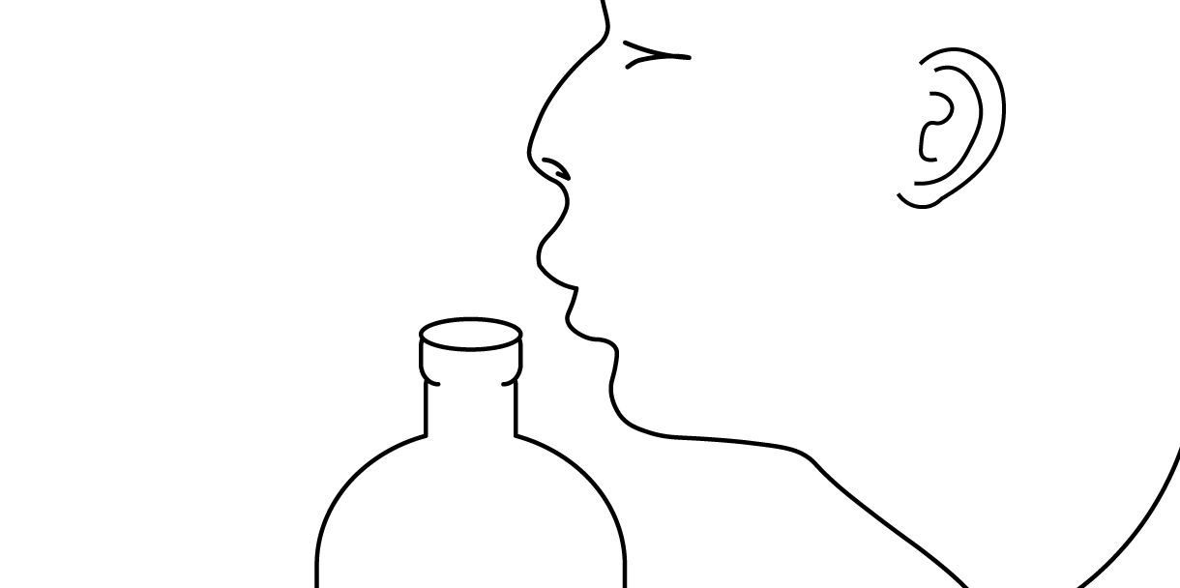

After the episode
- Look at the previous illustration. Were your lines close to the demonstration seen in the episode? If not, use a different colour to show direction that the air is travelling.
- Now fill up the bottle with some water and blow across the top again. What do you now notice about the new tone? Is it higher or lower than the original tone? Explain why you think the tone is different when water is added to the bottle?

- A woodwind instrument produces sound by splitting an exhaled stream of air on a sharp edge, such as a reed or a fipple. Circle the instruments below that you think belong to the woodwind family. Remember; they’re not always made of wood!
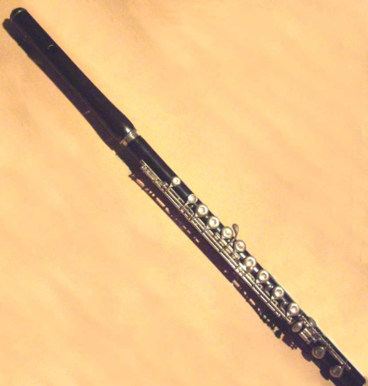  flute | bagpipes | 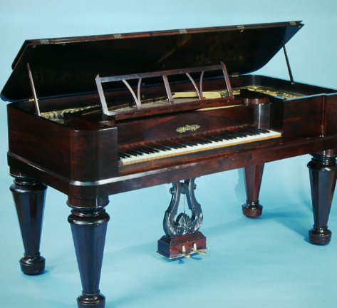  piano
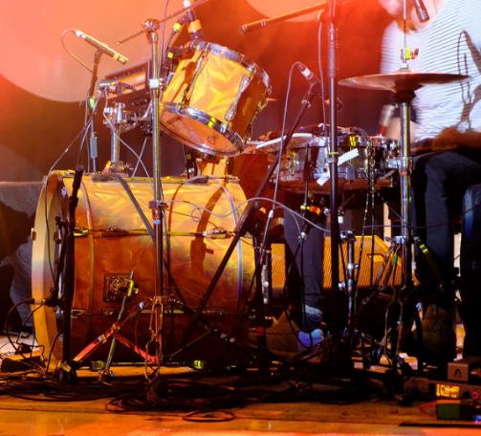  drum kit | 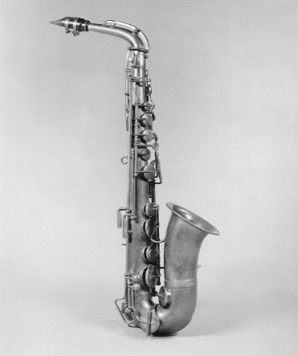  saxophone | electric guitar
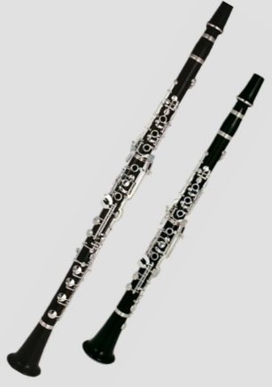  clarinet | 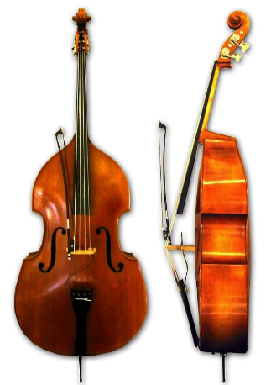  Double bass | 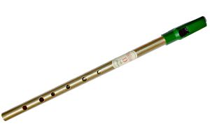  tin whistle
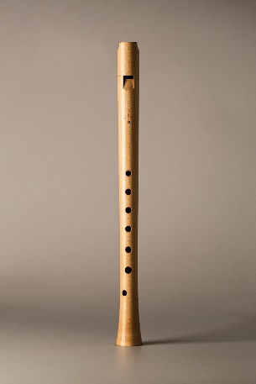  recorder | 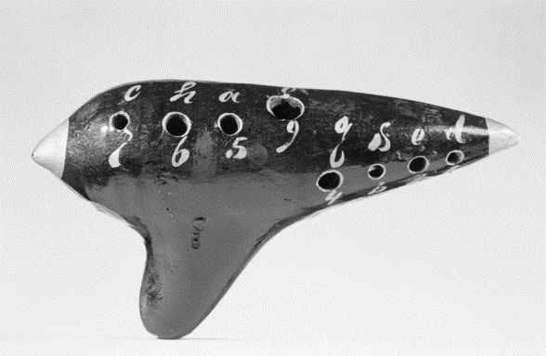  ocarina | 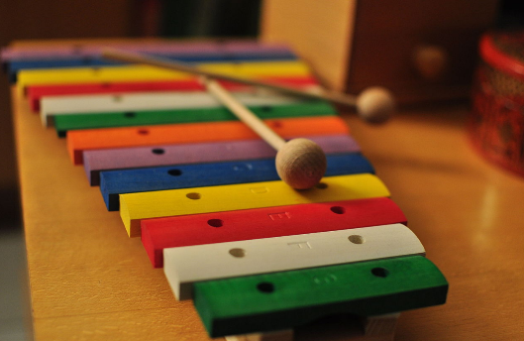  xylophone
Follow-up activity: Can you invent your own woodwind instrument? Use the ideas shown in this episode and the help of an adult to have a go.

My Place – 1868 Minna
ABC ME screening details: Thursday 14 May 2020 at 10:45am
This episode can also be viewed on ABC iView after the scheduled screening time.
Key learning areas: English and history
Level: upper primary
About: Minna and her friends start a game of who can scare each other the most. However, one night, Minna goes too far.

Resources
Family artefacts (photographs, family albums, birth certificates, special awards) or a family member who can act as a source for information.

Before the episode
- Create a timeline to show all the significant events in your life. Include key information about family or friends involved in events, key dates and information about the places where these events happened.
A timeline of my life
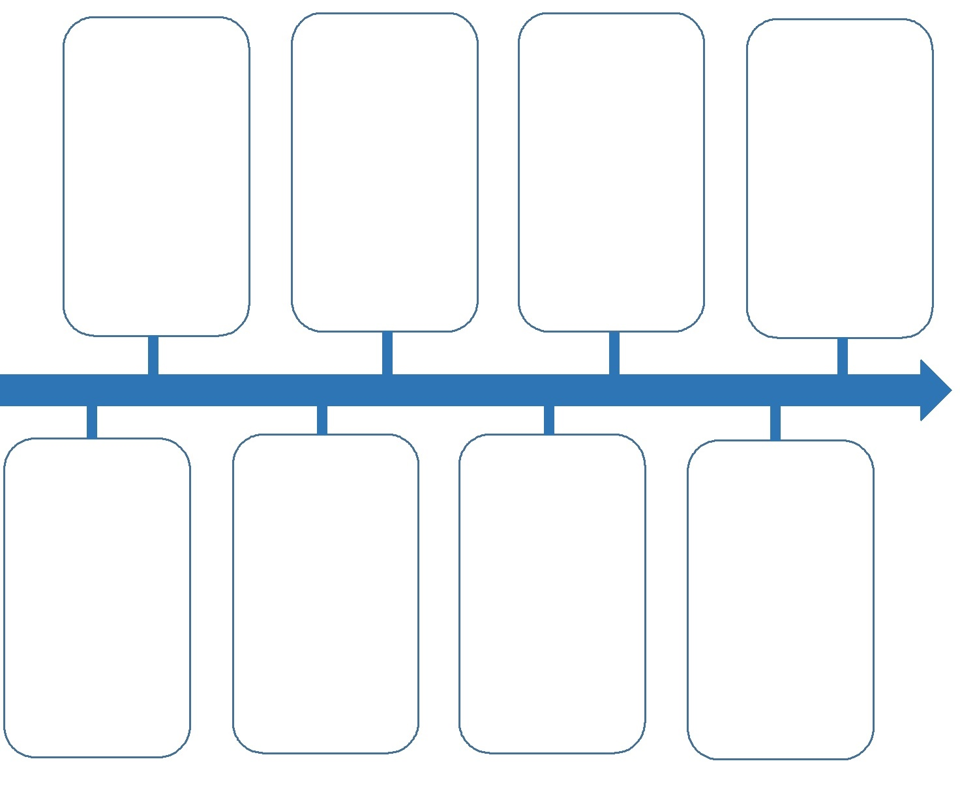

During the episode
- The past: Use the Venn diagram below to take notes about what life was like for Minna in 1868 (e.g., clothing worn, games played, home life, technology and communication, built and natural environment, spoken language and phrases etc.). Record your observations under the heading 1868.
After the episode
- Change: How has life today changed from when Minna was a little girl in 1868? Record your ideas under the year 2020.
- Continuity: Have some ways of life continued on from 1868 to today? Record these where the circles overlap.
Follow-up activity: Interview an older family member or friend, to find out what life was like when they were little and make a timeline to show the important events in their life. First think of some interview questions that you would like to ask them. Also consider asking if they have some artefacts from their past that they could share with you (for example, photographs, old toys, special trinkets etc.).

The Storybuilding Tool Kit – Setting
ABC Me screening details: Friday 15 May 2020 – 11:20am
This episode can also be viewed on ABC iView after the scheduled screening time.
Key learning areas: English
Level: upper primary
About: The 'setting' is an important story writing tool. Learn how it can help you to be more creative!

Before the episode
- What does ‘setting’ mean for story writing?
- Write and draw some settings from your favourite stories below. Think about how these settings made the story more interesting.

During the episode
- Look out for the ‘setting’ writing tips during the episode and make notes below:

After the episode
- A good story setting can help make your story interesting by:
- creating a certain atmosphere and mood for readers (spooky, suspenseful, mysterious, peaceful)
- placing characters in interesting places or stressful situations (inside a haunted house or a foreign planet floating in outer space)
- revealing the traits of characters as they come up against the ‘rules’ of the setting (the haunted house has a mind of its own or a lack of oxygen in outer space).
Think of some interesting story settings to create the following moods. First draw and write key words to describe the setting. Then think of the ‘rules’ for each setting and how these will challenge the story’s characters.
Mood | Peaceful | Mysterious
Draw and write
Setting rules & character challenges
Follow-up activity: Write an orientation for a story based on one of the settings you have created. An orientation is where you introduce the characters (who) and describe the setting (when, where), to create an atmosphere and mood for the story.

