Learning from home: ABC TV Education resources

Upper primary – week 6

01/06/2020 – 05/06/2020
Supplementary activities to support educational content broadcast on ABC ME during Term 2, 2020

About this resource
ABC Education, in collaboration with the NSW Department of Education, have planned a daily schedule of free to air educational programs supported by standalone resources that complement the ABC TV Education program airing during Term 2, 2020. All activities can be completed without access to the internet or a device and are suitable for lower primary, upper primary and secondary students.

Educational benefit
Student booklets include activities designed by curriculum experts to meet educational outcomes and are based on a selection of ABC programs that are of high educational value. Activities address topics from a range of subjects including: English; mathematics; science and technology; geography; history; PDHPE and creative arts.
These optional resources do not replace teaching and learning programs provided by schools but may be used by teachers and parents/carers to supplement student learning. Teachers may select activities relevant to their teaching and learning program and modify to meet student needs.

Recording student responses
Students complete activities before, during and after viewing selected daily episodes. Where appropriate, space is provided in each booklet for students to record their responses. Students may require additional writing paper or a separate workbook for some tasks. Completed student booklets may be collected by teachers and used as evidence of learning.

How to access ABC TV Education programs
The selected daily episodes can be viewed via the ABC TV Education broadcast on ABC ME (Channel 23) from 10am-3pm weekdays. Each day commences with programs suitable for lower primary students followed by upper primary and then secondary. Programs will also be available at abc.net.au/iview after the broadcast. A schedule of the selected episodes is included in each student booklet.

Episode schedule – week 6
The timetable below outlines the episode focus for each day. The full ABC TV Education program can be found at http://www.abc.net.au/tveducation/
 | Time | Program | Episode title | Key learning area | Pages
Monday  01/06/2020 | 12.45pm | Fierce Earth | World's Driest Place | HSIE - geography | 4-5
Monday  01/06/2020 | 10:35am | Art With Mati And Dada | Canaletto | creative arts – visual arts | 6-7
Tuesday  02/06/2020 | 11:20am | Look Kool | Tiling | mathematics | 8-9
Wednesday  03/06/2020 | 11:20am | Look Kool | Aerodynamics | mathematics | 10-11
Wednesday  03/06/2020 | 10:50am | My Place | 1818 Charles | HSIE – history | 12-13
Thursday  04/06/2020 | 12:10pm | Full Proof | Surface Tension | science and technology | 14-16
Friday  05/06/2020 | 11:20am | The Storybuilding Tool Kit | Fantasy | English | 17-19
© State of New South Wales (Department of Education), 2020
The copyright material published in this document is subject to the Copyright Act 1968 (Cth), and is owned by the NSW Department of Education or, where indicated, by a party other than the NSW Department of Education.
Copyright material available in this document is licensed under a Creative Commons Attribution 4.0 International (CC BY 4.0) licence.
See http://education.nsw.gov.au/about-us/copyright for further details.

Fierce Earth – World’s Driest Place
ABC ME screening details: Monday 1 June 2020 at 12:45pm
This episode can also be viewed on ABC iView.
Key learning areas: HSIE - geography
Level: upper primary
About: In this episode the team travel 6000 miles to the country of Chile and the Atacama Desert - officially the driest place in the world.

Before the episode
- Use the clues related to today’s episode to complete the crossword.
1 |  |  |  |  |  | 2
3 |  |  |  |  |  |  |  |  |  |  |  | 4
 |  |  |  |  |  | 5 |  |  | 6
 | 7
Clues
Across | Down
1 – The unit of measurement typically used to measure rainfall. | 1 – A drawing of a particular area. Can be used to find your way.
3 – Aloe vera is a type of _________ which can be used to treat injuries and sunburn. | 2 – An imaginary line drawn around the middle of the Earth.
5 – The ___________ Desert is known as the world’s driest place. | 4 – Essential for survival in extremely dry environments.
7 – A very dry biome. The Sahara, for example | 6 – A long, narrow country on South America’s western coast.

After the episode
- After watching the episode, complete any crossword clues that you couldn’t solve.
- This episode identifies three reasons why the Atacama Desert is the driest place on Earth. Use the images below to help identify these “rain blockers” and write a short summary of each.
Image | Summary
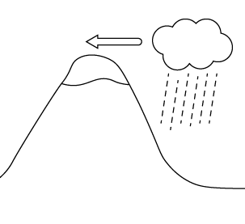
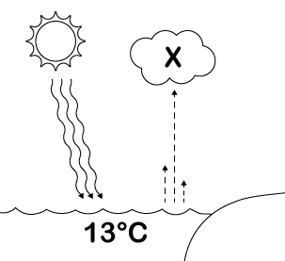
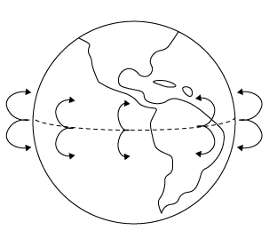
Follow-up activity: Find two plastic cups and half fill each with water. Use a pen to mark the water levels. Cover one cup with cling wrap but leave the other uncovered. Place both cups in a sunny place. What do you observe after a few hours? A few days? Explain to someone what you think is happening in this investigation.

Art With Mati And Dada – Canaletto
ABC ME screening details: Monday 1 June 2020 at 10:35am
This episode can also be viewed on ABC iView.
Key learning areas: creative arts – visual arts
Level: upper primary
About: Mati and Dada are transported into a marvellous journey in Venice, on a Gondola together with Canaletto in person!

Before the episode
- Brainstorm: Think of all the different types of places that artists have based their landscape paintings and drawings on.
- Draw: After walking around the outside of your home, choose a small part of your building to sketch (stairs, roofline or brick wall). Focus on the different shapes, lines and angles you see. Sketch the part you have chosen in your workbook or on a piece of paper.
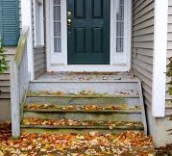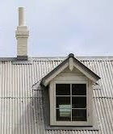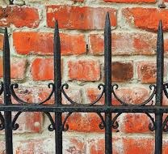

During the episode
- Write and draw in the boxes below information about the artist Canaletto and the artworks he created.
Canaletto | Artworks

After the episode
- Art making: Make your own landscape artwork like Canaletto by focusing on the built or natural landscapes views around your home (for example the houses in your street or a farm shed on your property).
- Walk around the area and choose a view point to draw from.
- Look closely at what types of features are in the foreground as these will need to be drawn larger and with more detail.
- Think about what features are in the background and will need to be drawn smaller and a little blurred.
- Consider what types of shapes, lines and angles you can see. Hold your pencil out in front to help you compare the sizes of different features or tip your pencil left or right, to look at the types of angles the different lines make.
- Sketch your landscape below. When you are happy with your sketches, have a go at drawing and painting your landscape artwork on some art paper.

Follow-up activity: Have a go at being a landscape photographer and capture some interesting views of your local environment. Experiment with taking photographs from different angles and heights.

Look Kool – Tiling
ABC ME screening details: Tuesday 2 June 2020 at 11:20am
This episode can also be viewed on ABC iView.
Key learning areas: mathematics
Level: upper primary
About: It's cold today, so Hamza snuggles by the window with his quilt. Hamza likes to do crafts on "indoor" days like this, and decides to replicate the patterns in his quilt with geometric shapes.

Before the episode
Tessellation (or tiling) is when we cover a surface with a pattern of shapes that fit perfectly together with no overlaps or gaps.
- Investigate tessellation in your environment. How many different examples can you find?
- Use this Frayer model to draw and write what you know about tessellation. Think about shapes you know that can tessellate. What shapes can’t tessellate?
What I know about tessellation
Shapes that can tessellate | Shapes that can’t tessellate

After the episode
Let’s explore tessellating triangles.
- Equilateral triangles have three sides the same length and three angles the same. Draw equilateral triangles like this one. Can you make them fit together without any gaps between them?

- Isosceles triangles have two equal sides. Can you tessellate this isosceles triangle?

- Time to explore! Draw different types of triangles on blank paper and see if you can find ways to tessellate them.
- Can all triangles tessellate? If your answer is no, can you give an example of a triangle which doesn't tessellate and explain why it doesn't?

Adapted from https://nrich.maths.org/
Follow-up activity: Go back to the Frayer model and use a different coloured pen to show what you have learned about tessellation.

Look Kool – Aerodynamics
ABC ME screening details: Wednesday 3 June 2020 at 11:20am
This episode can also be viewed on ABC iView.
Key learning areas: mathematics
Level: upper primary
About: To find out why some shapes go through air better than others, the gang is going to make a rocket with an astronaut, put bicycle "test pilots" to the test, and meet a rocket scientist who swims better than he walks.

Before the episode
- How do paper planes work? Write and draw to explain what helps them to fly.

After the episode
- Construct your own paper plane. You may want to these instructions for a basic dart or design your own. | 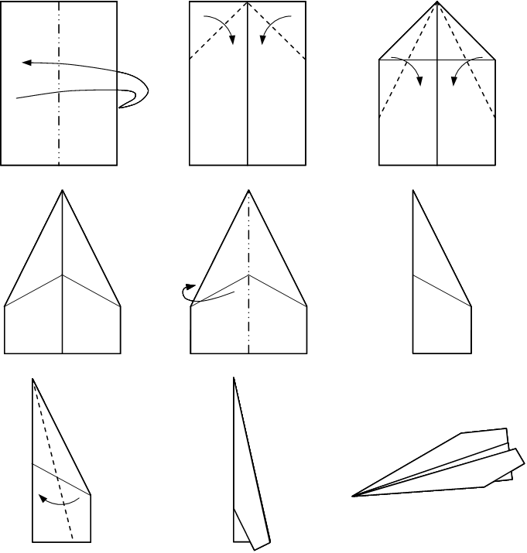
- How far can your plane fly? Use a tape measure to check.

After the episode
Hold your own paper plane flying competition! Which paper plane will fly the longest distance?
- Design and construct three different paper aeroplanes.
- Make a prediction. Which plane design do you think will fly the furthest and why? Draw and write to explain your reasoning.

- Test your planes. Measure and record the distances flown by each plane.
 | Test flight 1 | Test flight 2 | Test flight 3 | Total distance
Design 1
Design 2
Design 3
- Was your prediction correct?
Follow-up activity: What other paper plane variations can you create? What features are required for your plane to travel a long distance? Or do mid-air spin?

My Place – 1818 Charles
ABC ME screening details: Wednesday 3 June 2020 at 10:50am
This episode can also be viewed on ABC iView.
Key learning areas: HSIE – history
Level: upper primary
About: Charles strikes a deal with an escaped convict who agrees to help him in exchange for food and freedom. However, Charles finds himself being held to ransom by the increasing demands from the convict.

During the episode
- Take notes about the characters, their personalities, attitudes and actions.
Charles | Charles’ brother, John | Sam
The escaped convict | Charles’ mother | Sarah

After the episode
- Select one of the characters from the episode. Write a letter to a friend in England, or a diary entry. Include in your letter:
- a description of the farm
- how you feel about living and/or working on there
- your opinion of the other characters on the farm
- a list of the work you do.
Try and write in the style of your chosen character, using the language, tone, style and words most suitable to them.

Follow-up activity: Clothing was a theme throughout this episode. Select a character from the episode and draw and write about what they would wear today and what they would have worn in 1818. How have people’s attitudes toward clothing changed? What are some of the differences and similarities about the clothes from these two periods?

Full Proof – Surface Tension
ABC ME screening details: Thursday 4 June 2020 at 12:10pm
This episode can also be viewed on ABC iView.
Key learning areas: science and technology
Level: upper primary
About: Maureen is 12 years old & lives at a tulip plantation in North of the Netherlands. She regularly finds water on the surface of the tulip leaves. In Full Proof, she experiments with water drops and surface tension.

Before the episode
- Water is needed to sustain life. Without water, there is no life on Earth. Write or draw some of the ways we use water.

During the episode
- During the episode you will see an insect called a water strider. Make notes or draw a sketch to show what you notice about this insect on water.
Notes | Sketch

After the episode
- Challenge: Make an object walk on water
Introduction
In this episode Maureen explored a ‘property’ of water – surface tension. You might remember a ‘property’ describes how an object looks, feels or acts. For example, a property of a liquid like water is that it can flow. A property of clear glass is that it’s transparent – you can see through it.
You will model this property of water (surface tension) in your own investigation.
Materials
- Paper clips or similar item (safety pins)
- Container of water
- Strips of tissue paper
What to do
- When the water is very still, carefully lower a dry paper clip onto the surface of the water. You need to do this step very slowly. If you find this too hard, you can get a strip of tissue paper and place the paper clip on this and very carefully lower the strip of tissue with the paper clip on the water.
- If you can float one pin or paper clip, try another. How many could you float on the surface of the water before they all sank?
Draw a labelled picture/diagram of your investigation

Explanation
As Maureen explains in this episode, there is a ‘skin’ on the surface of the water where the water molecules hold on tight together. The paper clip is not really floating on the surface; it is sitting on the surface. It is being held up by the surface tension forces that exist between the water molecules. What happens to the surface tension if you modify the investigation by adding detergent, salt or oil? Find out by completing the next challenge.
- Repeating your investigation by changing variables
Materials
- Paper clips or similar items Salt
- Container of water Detergent
- Strips of tissue paper Oil
What to do
- Repeat the investigation in Activity 1, but this time, you will investigate what happens if something (variable) is changed. Remember, in science, you can only change one variable at a time. For example, if you add detergent and oil to the water at the same time and discover that you can’t float the paper clip, you won’t know if it is due to the detergent or oil.
- Make sure you only investigate one variable at a time.
- Before doing this investigation, you need to write the question you will investigate. For example: ‘What happens to the surface tension if I add detergent to the water?’
Recording your investigation
Question: What happens to the surface tension if …

Purpose: To find out

Materials: I used these things: …

Method: This is what I did (record this in steps)

Results: On a separate piece of paper describe and draw a picture to show what you found out

The Storybuilding Tool Kit – Fantasy
ABC ME screening details: Monday 5 June 2020 at 11:20am
This episode can also be viewed on ABC iView.
Key learning areas: English
Level: upper primary
About: Create a story world and send your hero on an adventure!

Before the episode
- Fantasy stories are not set in the real world. Think of all the Fantasy books you have enjoyed reading. What type of fantasy worlds did these stories take place in? Draw and write your ideas below.

During the episode
- Take notes about what types of unusual or everyday things inspired the different authors from the episode to create the imaginary worlds found in their books. Listen carefully to why authors make rules for these imaginary worlds.

After the episode
- Create your own interesting character by following the suggested steps used by the author Mike Barry. Design your character by drawing and writing below.
- Begin by thinking of a basic character that your story needs. For example, the main character who will be the story’s hero, the wise person to act as a mentor or the villain to cause complications.
- Then think of the ways that you can make this basic character more unique and interesting by changing or adding different features.

Follow-up activity: Create a world map for your fantasy characters to exist in. Place your hero at one end and their goal at the other. Add obstacles and challenges in every region for your main character to overcome. Think of where they might learn an important lesson. Then send your main character on a great adventure!

