Learning from home: ABC TV Education resources



* 1. **Upper primary – week 5**
     1. **25/05/2020 – 29/05/2020**

Supplementary activities to support educational content broadcast on ABC ME during Term 2, 2020

* 1. **About this resource**

ABC Education, in collaboration with the NSW Department of Education, have planned a daily schedule of free to air educational programs supported by standalone resources that complement the ABC TV Education program airing during Term 2, 2020. All activities can be completed without access to the internet or a device and are suitable for lower primary, upper primary and secondary students.

* 1. **Educational benefit**

Student booklets include activities designed by curriculum experts to meet educational outcomes and are based on a selection of ABC programs that are of high educational value. Activities address topics from a range of subjects including: English; mathematics; science and technology; geography; history; PDHPE and creative arts.

These optional resources do not replace teaching and learning programs provided by schools but may be used by teachers and parents/carers to supplement student learning. Teachers may select activities relevant to their teaching and learning program and modify to meet student needs.

* 1. **Recording student responses**

Students complete activities before, during and after viewing selected daily episodes. Where appropriate, space is provided in each booklet for students to record their responses. Students may require additional writing paper or a separate workbook for some tasks. Completed student booklets may be collected by teachers and used as evidence of learning.

* 1. **How to access ABC TV Education programs**

The selected daily episodes can be viewed via the ABC TV Education broadcast on ABC ME (Channel 23) from 10am-3pm weekdays. Each day commences with programs suitable for lower primary students followed by upper primary and then secondary. Programs will also be available at [abc.net.au/iview](https://iview.abc.net.au/) after the broadcast. A schedule of the selected episodes is included in each student booklet.

* 1. **Episode schedule – week 5**

The timetable below outlines the episode focus for each day. The full ABC TV Education program can be found at <http://www.abc.net.au/tveducation/>

|  |  |  |  |  |  |
| --- | --- | --- | --- | --- | --- |
|  | Time | Program | Episode title | Key learning area | Pages |
| **Monday**  **25/05/2020** | 10:45am | Dance With The Elements | Water | creative arts – dance, music | 4-5 |
| **Tuesday**  **26/05/2020** | 11:15am | Look Kool | Mapping | mathematics | 6-7 |
| **Wednesday**  **27/05/2020** | 11:45am | MathsXplosion | Pick a Block of Dates, Any Block | mathematics | 8-9 |
| **Thursday**  **28/05/2020** | 10:45am | My Place | 1828 Alice | HSIE – history | 10-11 |
| **Friday**  **29/05/2020** | 11:10am | Bringing Books to Life | Nellie the Monster Sitter | English | 12-13 |
| **Friday**  **29/05/2020** | 1:25pm | The Story Building Tool Kit | Mystery | English | 14-15 |

© State of New South Wales (Department of Education), 2020

The copyright material published in this document is subject to the Copyright Act 1968 (Cth), and is owned by the NSW Department of Education or, where indicated, by a party other than the NSW Department of Education.

Copyright material available in this document is licensed under a Creative Commons Attribution 4.0 International (CC BY 4.0) licence.

See <http://education.nsw.gov.au/about-us/copyright> for further details.

# Dance With The Elements – Water

**ABC ME screening details:** Monday 25 May 2020 at 10:45am

This episode can also be viewed on [ABC iView](https://iview.abc.net.au/show/dance-with-the-elements).

**Key learning areas:** creative arts – dance, music

**Level:** upper primary

**About:** Three dancers dance to three pieces of classical music in animated, virtual environments - invoking the element water.

## Before the episode

1. Warmup activity: A good warm-up is designed to prepare the body so it can participate safely in dance activities. Get your body ready to dance by repeating the following ‘on the spot’ movements: 10 star jumps, 10 squats, 10 forward lunges, 10 forward arm swings (both arms), 10 stretches up high then bend to touch your toes. Repeat the movement pattern for 5 minutes.

## During the episode

1. Carefully listen to how the music changes to represent the different ways water moves and sounds. How do the dancers also change their movements and respond to the music to represent the different elements of water? Record your ideas by taking notes or drawing below.

## After the episode

1. Create your own dance to represent the element of ‘water’. Think of different body movements to represent the ‘water’ action words below. Draw stick figure shapes and write labels to explain the position of different body parts, to plan your movement for each action word.

| Dance moves |  |  |
| --- | --- | --- |
| **still**  A character kneeling down with hands on ground  Kneeling down with head bowed and hands placed on the ground. | **drifting** | **bobbing** |
| **falling** | **sinking** | **diving** |
| **swimming** | **swirling** | **rising** |

1. Copy the body movements above onto blank squares of paper. You might like to have multiple copies of some movements. Then make your own dance composition by arranging the cards into an order of your choice. You might like to select a piece of music to perform your dance to.

**Follow-up activity:** Can you think of other body movements to create a dance about a different element of nature (for example seasons changing or the morning sunrise).

# Look Kool – Mapping

**ABC ME screening details:** Monday 26 May 2020 at 11:15am

This episode can also be viewed on [ABC iView](https://iview.abc.net.au/show/look-kool).

**Key learning areas:** mathematics

**Level:** upper primary

**About:** Hamza thinks finding his way around is easy...until his smart phone breaks. Uh oh. Now he needs to use maps to get where he's going. Along the way, Hamza forms a marching band and gets travel tips from a gargoyle.

## Before the episode

Are you good at following directions?

1. Read the directions below and **imagine** yourself following this route.

* Walk 10 paces straight ahead.
* Turn right and walk 10 paces.
* Turn left and walk 5 paces.
* Turn left again, and this time walk 15 paces.
* Turn left and walk 15 paces.
* Turn left and walk 5 paces.

1. Draw a picture to describe your route and where you will end up.
2. Go outside and follow the directions to check whether your prediction was correct. If it wasn’t, can you explain why?

## After the episode

1. Here is a map of Border Town Zoo. There is treasure buried somewhere in the zoo!

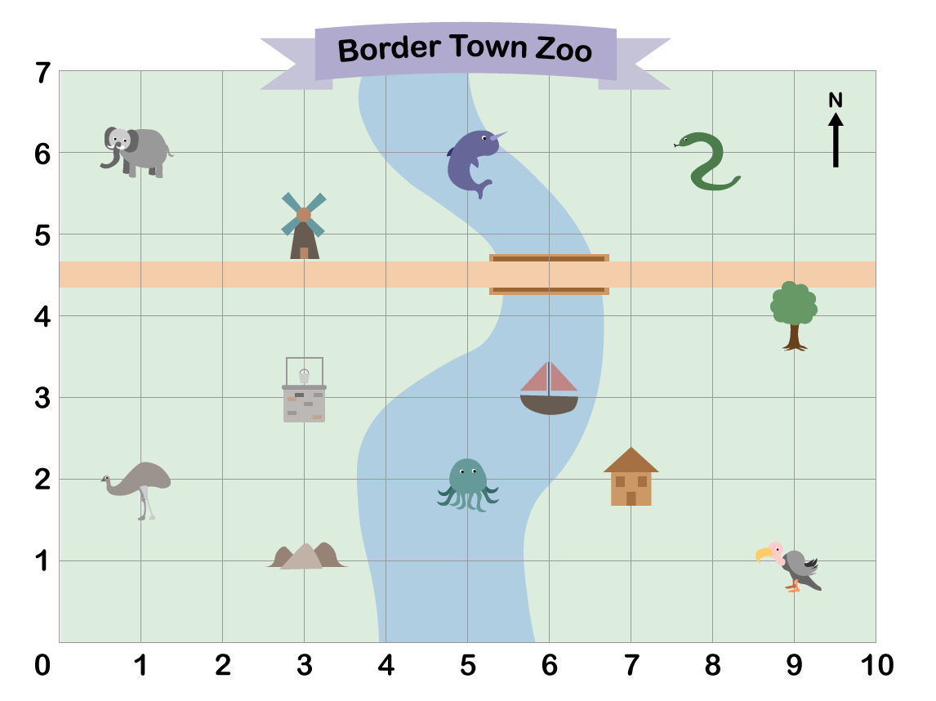

1. When finding a landmark we look at the horizontal coordinate and then the vertical coordinate. For example, the house is located at 7, 2. Write down what you can see at the co-ordinates given below:

|  | Landmark |  | Landmark |
| --- | --- | --- | --- |
| **(8, 6)** |  | **(5, 6)** |  |
| **(1, 6)** |  | **(9, 4)** |  |
| **(9, 1)** |  | **(3, 3)** |  |
| **(1, 2)** |  | **(5, 2)** |  |

Adapted from <https://nrich.maths.org/>

**Follow-up activity:** The words from the previous activity can be used in a special way to find the coordinates of the buried treasure. Can you work out where it is?

# MathXplosion – Pick A Block Of Dates, Any Block

**ABC ME screening details:** Wednesday 27 May 2020 at 11:45am

This episode can also be viewed on [ABC iView](https://iview.abc.net.au/show/mathxplosion).

**Key learning areas:** mathematics

**Level:** upper primary

**About:** A trick you can do by calculating the sum of a 3 by 3 block of dates on a calendar without using a calculator.

## Before the episode

1. What are some different ways you could complete this pattern?

| ___ | 5 | ___ | ___ | 20 | ___ |  |  |
| --- | --- | --- | --- | --- | --- | --- | --- |



1. Have a look at these growing and shrinking patterns. Can you work out what the pattern is?

| 3 | 6 | 9 | 12 | 15 | ___ | ___ | ___ |
| --- | --- | --- | --- | --- | --- | --- | --- |
| 2 | 4 | 8 | 16 | 32 | ___ | ___ | ___ |
| 1600 | 800 | 400 | 200 | 100 | ___ | ___ | ___ |

## After the episode

**Calendar Challenge**. Let’s explore ‘magical’ mathematical tricks you can do with a calendar.

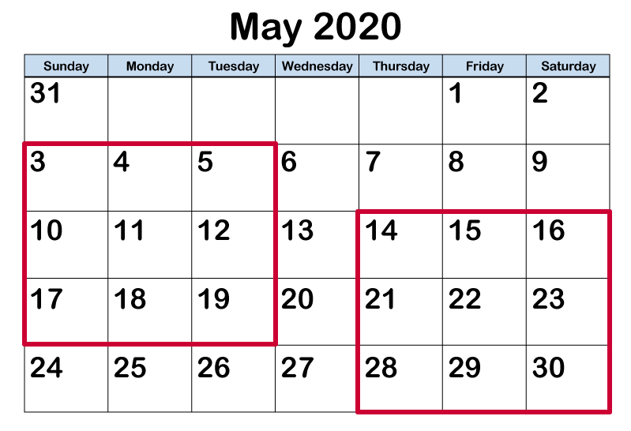

1. Choose a 3 by 3 square of dates from anywhere on the calendar.
2. Add the numbers in the four corners.
3. Try a few examples. What do you notice? Why do you think this happens?
4. Now try adding the numbers in each row, column and diagonal that passes through the centre number. What do you notice? Can you explain your results this time?

Adapted from <https://nrich.maths.org/>

**Follow-up activity:** How would your results change if you chose a 4 by 4 square? What other calendar patterns can you find?

# My Place – 1828 Alice

**ABC ME screening details:** Thursday 28 May 2020 at 10:45 am

This episode can also be viewed on [ABC iView](https://iview.abc.net.au/show/my-place).

**Key learning areas:** HSIE – history

**Level:** upper primary

**About:** Alice and her friend George decide to stage a piglet race and they'll stop at nothing, including pig swapping and doping, to win.

## Before the episode

1. Draw a line to match the artefacts from 1828 to the correct label.

| Artefact |  |  | Label |
| --- | --- | --- | --- |
| A photograph of a smelling salts jar from the 1800's. | Smelling salts |  | A silver coin also known as a tanner or half shilling which was used as currency in the 1800’s. |
| Photograph of an antique Cider Press from the 1860s. | Apple cider press |  | A mixture made from ammonia (with perfume added to mask the smell), which was used in the 1800’s to wake someone who had fainted or fallen unconscious. |
| Photograph of a sixpence coin. | Sixpence |  | A hand-operated machine used to make a drink for adults which was made by crushing apples and fermenting the juice. |

## During the episode

1. Take notes about what life was like for Alice, her friends and family, and the convict workers who lived in 1828.

| Alice and her family: | Friends: | Convict workers: |
| --- | --- | --- |
|  |  |  |

## After the episode

**Leisure** is the time when someone is considered not to be working and so has free time to enjoy something of their choice. Use the following prompts to think about how leisure activities have changed over time or continued to be the same:

1. **Change**: Record the types of leisure activities that Alice and others enjoyed under the 1828 heading. Think about the types of leisure activities you enjoy and record your ideas under the 2020 heading.
2. **Continuity**: What leisure activities have continued and stayed the same? Record these where the circles overlap.

**Follow-up activity:** Interview an older family member or friend, to find out what types of leisure activities they enjoyed as a child. First think of some interview questions that you would like to ask them. For example, what types of games, books, shows, or toys did they enjoy as a child? Consider asking if they have some artefacts from their past that they could share with you (for example old toys, books, or games). Then reflect on whether these leisure activities or items are still enjoyed today? Or consider how they have changed and why?

# Bringing Books to Life – Nellie the Monster Sitter

**ABC ME screening details:** Friday 29 May 2020 at 11:10 am

This episode can also be viewed on [ABC iView](https://iview.abc.net.au/show/bringing-books-to-life).

**Key learning areas:** English

**Level:** upper primary

**About:** Actress & comedian Sarah Hadland reads extracts from 'Nelly the Monster Sitter' by Kes Gray. She explains why she loves the book, how it captured her imagination, and why she loves to read.

## Before the episode

1. Look up the word ‘monster’ in dictionary. You will find that it has more than one meaning. Write sentences using the word in two different ways. Brainstorm and list words that use monster as a base word (for example, monstrous)? Think about how to use each word in a sentence. Is in a noun or an adjective?

## During the episode

1. Listen carefully for descriptive language in the reading from Nellie the Monster Sitter. List words and phrases the author used to describe Nellie and the monsters.

| Nellie | Monsters |
| --- | --- |
|  |  |

## After the episode

1. Draw a picture of a monster that needs baby-sitting and write instructions about how to care for your monster.
2. Write a paragraph describing your monster. Use alliteration and include a simile in your description. Use the examples below from Nellie the Monster Sitter to help you.

**Alliteration:** words beginning with the same sound. For example:

“…the slobbering, slabbering frenzy of snarls.”

**Simile:** two unlike things are compared as being like or as each other. For example:

“…their stiff black whiskers bristled like burnt sparklers.”

**Follow-up activity:** Create an advertisement to promote a monster babysitting service. Include the qualities that a monster babysitter might need in your advertisement.

# The Storybuilding Tool Kit – Mystery

**ABC ME screening details:** Friday 29 May 2020 at 1:25pm

This episode can also be viewed on [ABC iView](https://iview.abc.net.au/show/storybuilding-tool-kit).

**Key learning areas:** English

**Level:** upper primary

**About:** Keep your readers in suspense and make every character a suspect!

## Before the episode

1. Think of some mystery stories you have read or watched on TV. What particular event or item did the mystery centre on? For example, a missing person, a lost or stolen item or an unexplained event. Draw and list some of these ideas.

## During the episode

1. Listen carefully for tips about planning and writing a mystery and take notes on the steps you might take.

## After the episode

Use the visual organiser to plan a mystery and develop your ideas.

| Planning a mystery narrative | | | |
| --- | --- | --- | --- |
| 1. First, decide what your mystery will be about. | | | |
|  | | | |
| 1. Then draw each of your characters and create a possible motive for each character. Decide which of your characters will be the antagonist. | | | |
|  |  |  |  |
| 1. Build the world for your story. When and where is the story set? Is your story realistic fiction, fantasy, science fiction? Do your characters have any supernatural powers? | | | |
|  | | | |
| 1. What clues will you leave for your readers and the characters in your story? How will your readers and the characters discover the antagonist? | | | |
|  | | | |
| 1. How will you wrap the story up? | | | |
|  | | | |

**Follow-up activity:** Write and illustrate your story in detail. You could also learn more about the Caesar cipher and write a coded message to include as a clue in your mystery story.