Your Paintings: Joseph Wright of Derby
ABC ME screening details: Friday 1 May, 2020 at 2:00pm
This episode can also be viewed on ABC iView after the scheduled screening time.
Key learning areas: Visual Arts
Level: secondary
About: A statue comes to life in a gallery and climbs into the painting. She explores Wright of Derby's use of a single light source to draw attention to particular elements of the work, and discusses representation of the period of Enlightenment in works of art.

Before the episode
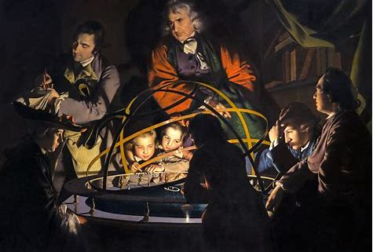
The Orrery by Joseph Wright of Derby (circa 1766) (Khan academy)
- This very large (147.3 cm × 203.2 cm) oil on canvas painting was created in 1766 in England. What do you know about life in Britain in the 18th century? Record your ideas. Consider social structures, hierarchy, values, employment/work, technology and clothing.

- Look closely at the subject matter of painting and make notes on the seven figures who are in the light moving from the small boy on the left through to the standing man on the right (do not describe the figure in silhouette). Briefly describe their pose, expression, style of dress and any distinctive features.

During the episode
- While watching the program-add to the notes on the key figures you described above. Which figure is the scientist? Which figures are looking at Saturn?
- What did Wright understand about the effects of light and how it can be used in paintings?

After the episode
- What artistic techniques can you identify in the artwork by Joseph Wright of Derby? What is the impact of these techniques?

- Create your own artwork using two of the techniques that you identified.
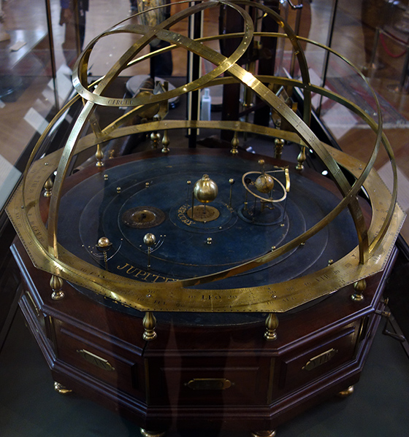
Orrey, C 1750 (British Museum)(Khan academy)
Follow-up activity: Make a quick pencil sketch of an orrery.

NSW teacher notes
This is an optional standalone resource that could supplement student learning. The activities align with syllabus outcomes across stages and can be modified to meet the needs of your students. Students can complete the activities while learning at home and in the classroom. All activities can be completed without access to the internet or a device. Teachers could collect student work to offer feedback and as evidence of learning.

Learning intentions
- To explore the use of a single light source in the work by Joseph Wright
- To explore the period of Enlightenment in works of art.

Resources
- Sketch book or paper
- Pencils

NSW Visual Arts 7-10 Syllabus outcomes
Area of content | Stage 4 | Stage 5
Practice | uses a range of strategies to explore different artmaking conventions and procedures to make artworks (VA4.1)  explores aspects of practice in critical and historical interpretations of art (VA4.7) | develops range and autonomy in selecting and applying visual arts conventions and procedures to make artworks (VA5.1)  applies their understanding of aspects of practice to critical and historical interpretations of art (VA5.7)
Conceptual framework | explores the function of and relationships between artist – artwork – world – audience (VA4.2) | makes artworks informed by their understanding of the function of and relationships between artist – artwork – world – audience(VA5.2)
Frames | makes artworks that involve some understanding of the frames (VA4.3) | makes artworks informed by an understanding of how the frames affect meaning (VA5.3)
NSW Visual Arts 7-10 Syllabus © NSW Education Standards Authority (NESA) for and on behalf of the Crown in right of the State of New South Wales 2003.

