Play School Story Time – The Very Itchy Bear
ABC Me screening details: Wednesday 13 May 2020 at 10:10am
This episode can also be viewed on ABC iView after the scheduled screening time.
Key learning areas: English
Level: lower primary
About: Don't miss Paralympic gold medalist and tennis player, Dylan Alcott as he reads Nick Bland's "The Very Itchy Bear" alongside Big Ted, Maurice and Little Ted!

Before the episode
- Draw or write about how you can make a friend. For example you may go up to some children and ask: ‘Can I play with you?’.

After the episode
- Flea was biting Bear because he wanted to say ‘Hello’ and be friends with him. What would you say to Flea to help him to make friends?

After the episode
- Finish the outline by drawing an expression on Bear’s face. Describe your drawing to someone and tell them why Bear is feeling that way.
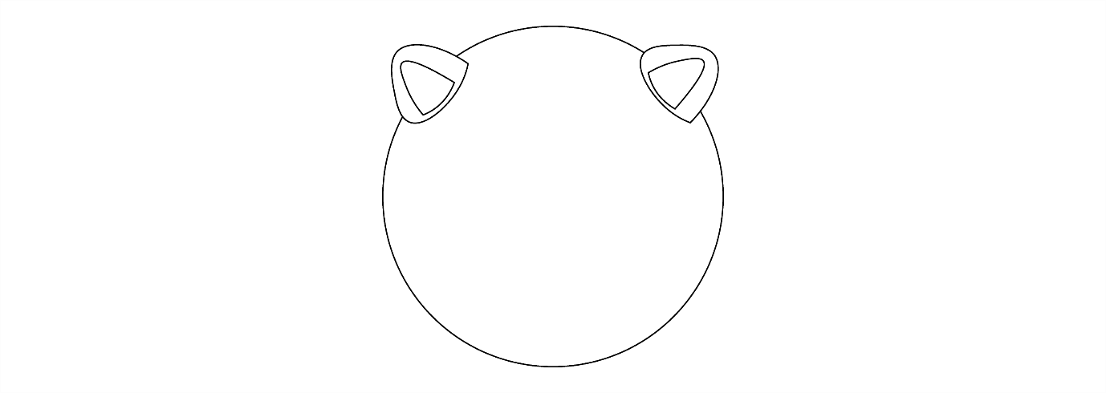
- The author has used rhyming words in The Very Itchy Bear. Trace and colour the rhyming words below. Add more words that rhyme below.
sea | see
be | flea
Follow-up activity: At the end of the story Bear and Flea go everywhere together. Write a story about you and a friend going somewhere special together. Where would you go with your friend? You could go to the park, beach, on a holiday or an adventure together. Draw some illustrations to go with your story. Tell your story to someone in your family, a friend or to a lucky listener.

NSW teacher notes
This is an optional standalone resource that could supplement student learning. The activities align with syllabus outcomes across stages and can be modified to meet the needs of your students. Students can complete the activities while learning at home and in the classroom. All activities can be completed without access to the internet or a device. Teachers could collect student work to offer feedback and as evidence of learning.

Learning intentions
- To develop an understanding of rhyming words.
- To develop an understanding of character development and identify a character’s emotions.
- To write a story about friendship, with a beginning, middle and end.

Resources
- paper
- coloured pencils

NSW English K-10 Syllabus outcomes
 | Stage Early Stage 1 | Stage 1
Thinking imaginatively and creatively | thinks imaginatively and creatively about familiar topics, simple ideas and the basic features of texts when responding to and composing texts (ENe-10c) | thinks imaginatively and creatively about familiar topics, ideas and texts when responding to and composing texts (EN1-10C)
Expressing themselves | responds to and composes simple texts about familiar aspects of the world and their own experiences (ENe-11D) | responds to and composes a range of texts about familiar aspects of the world and their own experiences (EN1-11D)
NSW English K-10 Syllabus © 2012 NSW Education Standards Authority (NESA) for and on behalf of the Crown in right of the State of New South Wales. See the NESA website for additional copyright information.

