Numberblocks – The three threes
ABC ME screening details: Monday 18 May 2020 at 10:00am
This episode can also be viewed on ABC iView after the scheduled screening time.
Key learning areas: mathematics
Level: lower primary
About: When Nine needs a helping hand, he turns into a talented trio of circus blocks, the Three Threes. Learn how to share 9 into equal parts with the Numberblocks.

Before the episode
- Let’s count in threes. Place your hands on your head and think ‘1’, place your hands on your shoulders and think ‘2’, place your hands on your knees and say the number ‘3’ out loud!
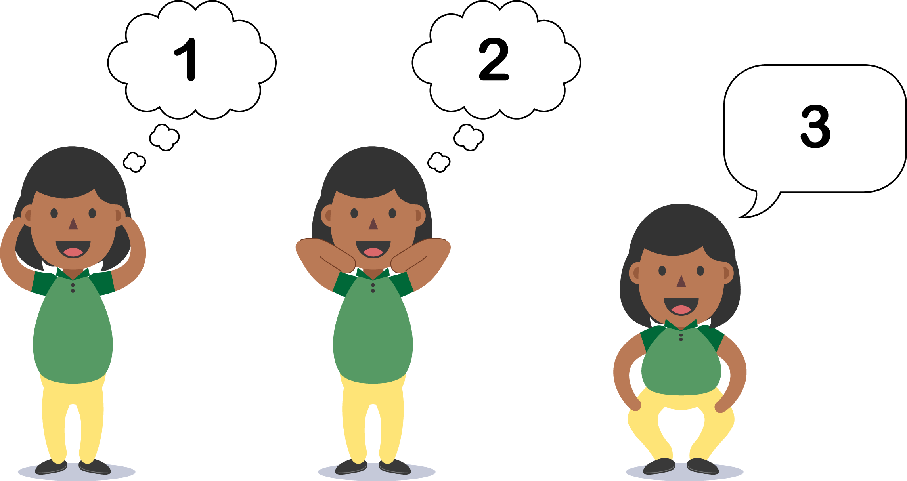
- Let’s keep counting along with the actions. Touch your head and think ‘4’, touch your shoulder and think 5’, touch your knees and say ‘6’! Continuing counting and write the numbers that you said every time you touched your knees.

After the episode
- We learnt that Nine is Three and Three and Three. What other numbers could you make only with Threes? Draw and record 5 numbers that you can make. Here’s one way you could show your thinking to get you started.
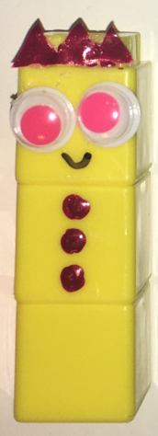 and andand is 12
- What was challenging or easy about making numbers with Threes? Share your thinking with a friend or family member.
Follow-up activity: Can you create actions to help you count in fives or sixes like we did when we counted in threes? You could stamp your legs or tap your toes when you are counting. Teach your counting actions to a friend.

NSW teacher notes
This is an optional standalone resource that could supplement student learning. The activities align with syllabus outcomes across stages and can be modified to meet the needs of your students. Students can complete the activities while learning at home and in the classroom. All activities can be completed without access to the internet or a device. Teachers could collect student work to offer feedback and as evidence of learning.

Learning intentions
- To count and add in threes.
- To record and explain answers using pictures, symbols and numbers.

NSW Mathematics K-10 Syllabus outcomes
 | Stage 1
Addition and subtraction | uses a range of strategies and informal recording methods for addition and subtraction involving one- and two-digit numbers (MA1-5NA)
Working mathematically | supports conclusions by explaining or demonstrating how answers were obtained (MA1-3WM)
NSW Mathematics K-10 © 2017 NSW Education Standards Authority (NESA) for and on behalf of the Crown in right of the State of New South Wales. See the NESA website for additional copyright information.

