Numberblocks – Now We Are 6 to 10
ABC ME screening details: Tuesday 2 June 2020 at 10:00am
This episode can also be viewed on ABC iView.
Key learning areas: mathematics
Level: lower primary
About: Are you sitting comfortably? Then we'll begin a bedtime story all about Numberblocks Six to Ten.

After the episode
- In today’s episode of Numberblocks, we learnt how you can count from Six to Ten by adding one each time. We also learnt how to count back from Ten to Six! Let’s count forwards to 20 and backwards from 20. Collect 20 items, for example pasta or blocks. Move your items in to a pile, one at a time, saying the count as you go until you reach 20. Now let’s count backwards. Move each item away until you reach zero! “Remember when you move away your first item you would say ‘19’ and then 18, 17, 16…..”.
- Time to have some more counting fun. Let’s make a number line! You will need the numbers 1 – 20. You could write each number on an old sock and peg the socks on a piece of hanging string or you could write number cards to place on the floor or to hang up. Here’s some pictures to help you.
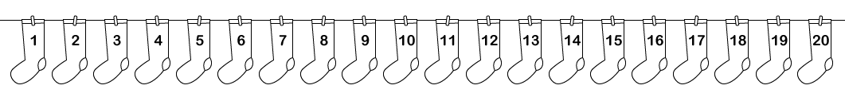
- Now that you have created your number line, follow these directions.
- Start at 6. Move forwards four steps. Count as you go. The first number you would say and move to is ‘7’ and then ‘8’, ‘9’ and ‘10’.
- Move three steps forwards from 10. What number did you land on?
- Try moving 7 steps back. Count back as you go if you can. Where did you end up? Was it where you started from?

- Time to have another go!
- Start at 15. Move forwards four steps. Say the numbers as you go. Which number are you at?
- Find the number that is one more than 7. Can you remember any clues from Numberblocks?
- Find the number that is one less than 10.
- How did you go? What was challenging or easy about following the directions? Draw, write or share your thinking with a family member or friend.

- Ask a family member or friend to play. Take turns directing each other. Here are some ways that you could ask your directions:
- Start at number ___ move forwards _____ steps. Say the numbers as you move.
- Start at number ____ move backwards ______ steps. Say the numbers as you move.
- Stand/point to the number that is one less than ____.
- Stand/point to the number that is one more than _______ .
Adpated from Developing Efficient Numeracy Strategies One http://www.resourcesformathematics.com.au/dens1/
Follow-up activity: How could you change this activity? Could you remove numbers from your washing line and ask a friend what is missing? Could you use larger numbers? Try making your directions more challenging. Draw or write how you changed the activity.

NSW Teacher notes
This is an optional standalone resource that could supplement student learning. The activities align with syllabus outcomes across stages and can be modified to meet the needs of your students. Students can complete the activities while learning at home and in the classroom. All activities can be completed without access to the internet or a device. Teachers could collect student work to offer feedback and as evidence of learning.

Learning intentions
- To create a number line.
- To follow and give directions to find numbers on a number line.

NSW Mathematics K-10 Syllabus outcomes
 | Early stage 1 | Stage 1
Number and Algebra | counts to 30, and orders, reads and represents numbers in the range 0-20 (MAe-4NA) | Applies place value, informally, to count, order, read and represent two- and three-digit numbers (MA1-4NA)
Working mathematically | describes mathematical situations using everyday language, actions, materials and informal recordings (MAe-1WM) | describes mathematical situations and methods using everyday and some mathematical language, actions, materials, diagrams and symbols (MA1-1WM)
NSW Mathematics K-10 Syllabus © 2012 NSW Education Standards Authority (NESA) for and on behalf of the Crown in right of the State of New South Wales. See the NESA website for additional copyright information.

