Art with Mati and Dada – Raphael
ABC ME screening details: Thursday 27 April 2020 at 10:35am
This episode can also be viewed on ABC iView after the scheduled screening time.
Key learning areas: creative arts
Level: lower primary
About: Muse Thalia is having fun kidding Dada...but she escapes from the Parnassus of Rafael, and Mati and Dada have to bring her back!

After the episode
- Mati and Dada met Raphael in today’s episode. What interesting things did you learn about him? Write or draw:

- Look at one of Raphael’s frescos, ‘The school of Athens’. 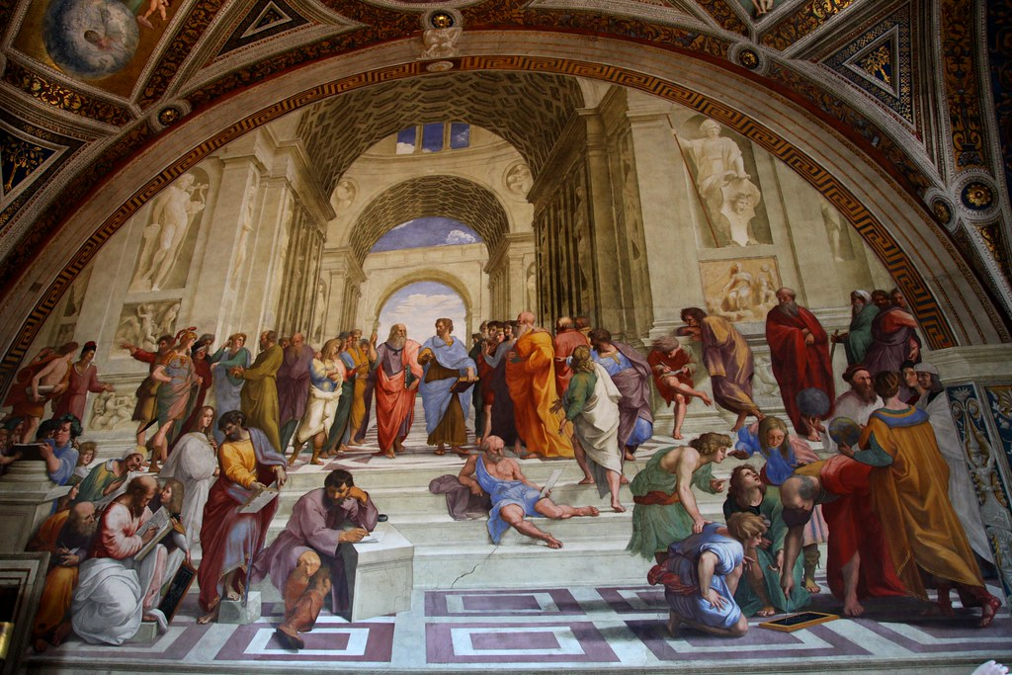
Discuss these questions with a friend or family member.
- If the people in this artwork could speak, what might they say?
- What do the things in the artwork tell us about the people?
- Why do you think Raphael chose to paint these people?
- What do you notice about where the people are positioned in the artwork? Are they close or far away?

After the episode
- Time to be inspired by Raphael! What would you like to look at on your bedroom ceiling or on a wall in your classroom? Could you paint the inside of a cardboard cubby house or create an artwork outside? Sketch your ideas.
- Collect what you might need. What space and materials do you have available? Could you use chalk outside or a roll of paper? Will you use pencils, pastels or paint? Could you use scraps of fabric or natural materials?
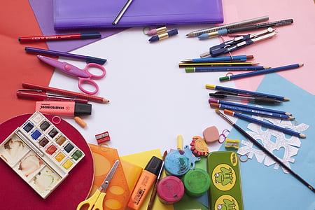
- Create your artwork! Who inspires you? Who might you create your artwork about? Start slow by outlining the objects, people or animals that you might include. What is surrounding them? Are they in space? A forest? Underwater?
Follow-up activity: Write a statement to go with your work. Include a title, what your artwork is about and why you created it.

NSW teacher notes
This is an optional standalone resource that could supplement student learning. The activities align with syllabus outcomes across stages and can be modified to meet the needs of your students. Students can complete the activities while learning at home and in the classroom. All activities can be completed without access to the internet or a device. Teachers could collect student work to offer feedback and as evidence of learning.

Learning intentions
- To share ideas about an artwork.
- To create an artwork in the style of a fresco.

NSW Creative Arts K-6 Syllabus outcomes
 | Early stage 1 | Stage 1
Visual arts | Making  Makes simple pictures and other kinds of artworks about things and experiences (VAES1.1)  Experiments with a range of media in selected forms (VAES1.2) | Making  Makes artworks in a particular way about experiences of real and imaginary things (VAS1.1)  Uses the forms to make artworks according to varying requirements (VAS1.2)
Visual arts | Appreciating  Recognises some of the qualities of different artworks and begins to realise that artists make artworks (VAES1.3)  Communicates their ideas about pictures and other kinds of artworks (VAES1.4) | Appreciating  Realises what artists do, who they are and what they make (VAS1.3)  Begins to interpret the meaning of artworks, acknowledging the roles of artist and audience (VAS1.4)
NSW Creative Arts K-6 Syllabus © 2006 NSW Education Standards Authority (NESA) for and on behalf of the Crown in right of the State of New South Wales. See the NESA website for additional copyright information.

