Learning from home: ABC TV Education resources

Lower primary – week 3

11/05/2020 – 15/05/2020
Supplementary activities to support educational content broadcast on ABC ME during Term 2, 2020

About this resource
ABC Education, in collaboration with the NSW Department of Education, have planned a daily schedule of free to air educational programs supported by standalone resources that complement the ABC TV Education program airing during Term 2, 2020. All activities can be completed without access to the internet or a device and are suitable for lower primary, upper primary and secondary students.

Educational benefit
Student booklets include activities designed by curriculum experts to meet educational outcomes and are based on a selection of ABC programs that are of high educational value. Activities address topics from a range of subjects including: English; mathematics; science and technology; geography; history; PDHPE and creative arts.
These optional resources do not replace teaching and learning programs provided by schools but may be used by teachers and parents/carers to supplement student learning. Teachers may select activities relevant to their teaching and learning program and modify to meet student needs.

Recording student responses
Students complete activities before, during and after viewing selected daily episodes. Where appropriate, space is provided in each booklet for students to record their responses. Students may require additional writing paper or a separate workbook for some tasks. Completed student booklets may be collected by teachers and used as evidence of learning.

How to access ABC TV Education programs
The selected daily episodes can be viewed via the ABC TV Education broadcast on ABC ME (Channel 23) from 10am-3pm weekdays. Each day commences with programs suitable for lower primary students followed by upper primary and then secondary. Programs will also be available at abc.net.au/iview after the broadcast. A schedule of the selected episodes is included in each student booklet.

Episode schedule – week 3
The timetable below outlines the episode focus for each day. The full ABC TV Education program can be found at http://www.abc.net.au/tveducation/
 | Time | Program | Episode title | Key learning area | Pages
Monday  11/05/2020 | 10:00am | Numberblocks | Ten | mathematics | 4-5
Monday  11/05/2020 | 10:15am | Wallykazam! | Hopgoblin | English | 6-7
Tuesday  12/05/2020 | 10:15am | Wallykazam! | Castle Cafe | English | 8-9
Wednesday  13/05/2020 | 10:00am | Numberblocks | Blast Off! | mathematics | 10-11
Wednesday  13/05/2020 | 10:10am | Play School Story Time | Dylan Alcott: The Very Itchy Bear | English | 12-13
Thursday  14/05/2020 | 10:35am | Art With Mati And Dada | Raphael | creative arts | 14-15
Friday  15/05/2020 | 10:10am | Play School Story Time | Adam Liaw: Little Red Hen And Grains Wheat | English | 16-17
© State of New South Wales (Department of Education), 2020
The copyright material published in this document is subject to the Copyright Act 1968 (Cth), and is owned by the NSW Department of Education or, where indicated, by a party other than the NSW Department of Education.
Copyright material available in this document is licensed under a Creative Commons Attribution 4.0 International (CC BY 4.0) licence.
See http://education.nsw.gov.au/about-us/copyright for further details.

Numberblocks – Ten
ABC ME screening details: Monday 11 May 2020 at 10:00am
This episode can also be viewed on ABC iView after the scheduled screening time.
Key learning areas: mathematics
Level: lower primary
About: Ten turns up to tell the team what it's like to be a perfect ten-block. Learn all about the number 10 with Numberblock Ten!

Before the episode
- Go on a ’10 hunt’ to find different ways of showing 10. You could collect 10 of your toys or draw 10 fingers or toes. Draw 4 ways that you found to show 10.

- How many ways did you find to show 10?
- How do you know that you have found collections of 10? Share your thinking with a family member or friend.

After the episode
- Did you notice the different ways that Ten organised himself? He showed himself as ‘5 and 5’ and also ‘2 and 2 and 2 and 2 and 2’. How many ways can you organise 10 items? Draw and record 3 different ways that you thought about one of your 10 collections.
.
- Were you surprised by how many ways that you can organise 10? What other numbers could you do this with? What if you had 20 items? Pick a number, collect your items and draw a way that you could organise your collection.

Follow-up activity: Play ‘race to 10’ with a friend or family member. Roll a dice, collect that number of items. Take turns rolling the dice until one of you reaches 10 items. Try the game by racing to a larger number like 20 or 30!

Wallykazam! – Hopgoblin
ABC ME screening details: Monday 11 May at 10:15 am
This episode can also be viewed on ABC iView after the scheduled screening time.
Key learning areas: English
Level: lower primary
About: When Bob Goblin rides Hattie the Witch’s broom without asking, she turns him into a bunny. Today’s sound is ‘sl’ as in slide and slippers.

Before the episode
- Think of a time when you have helped a friend solve a problem. Draw or write about the problem. If you cannot think of a time you can use your imagination and create a problem to be solved.

After the episode
- Bob Goblin was turned into a bunny by Hattie the Witch. What animal would you liked to be magically turned into? Draw you as the animal below. Describe it to someone when it is finished.

- There was a problem in today’s story. Bob Goblin was turned into a bunny. The friends worked together to solve the problem. Retell, using drawings, how the friends worked together to solve the problem.
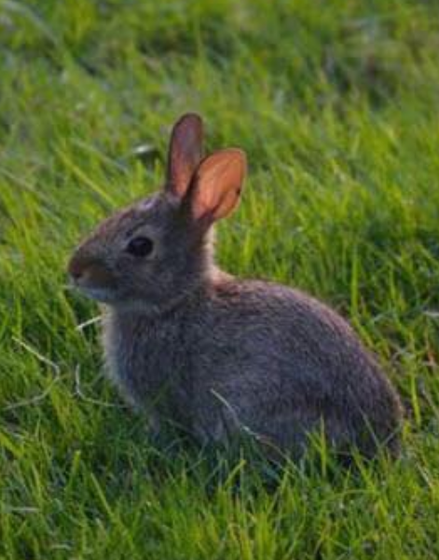
Follow-up activity: Wally was reading a story that started with ‘Once upon a time’. Draw or write a story starting with ‘Once upon a time’ that includes the animal that you have drawn. Share your story with someone you know.

Wallykazam – Castle Café
ABC Me screening details: Tuesday 12 May 10:15am
This episode can also be viewed on ABC iView after the scheduled screening time.
Key learning areas: English
Level: lower primary
About: Wally opens a restaurant in the castle and Libby Light Sprite is the waitress.

Before the episode
- Draw your favourite food to eat. Describe the food to someone and tell them why it is your favourite.

After the episode
- Draw what you think a dragon biscuit on toast looks like.

- What would you like to order at Wally’s café? Draw or write about the meal below. It can be anything you would like. Use your imagination.

- Wally pretended that he worked in a café. Pretend that you are working in a café. Create a menu of food that you would make. For example, you could work in a Monster Café and you serve sticks with bugs on top. You could serve mud slush as a drink.

Follow-up activity: Create a flyer for people to come to your café. You will need to think of a name and include the menu above. Be creative! Share your flyer with your family and friends.

Numberblocks – Blast off!
ABC ME screening details: Monday 13 May 2020 at 10:00am
This episode can also be viewed on ABC iView after the scheduled screening time.
Key learning areas: mathematics
Level: lower primary
About: Ten promises to take the others on a trip to the moon, but blasts off on her own. How will they get there? Find out which pairs of numbers add together to make ten with the Numberblocks.

After the episode
In Numberblocks today, we learned that some smaller numbers can sit inside Ten. Let’s play building towers to find smaller numbers that sit inside other numbers. If you would like to see the building towers game being played you can watch it here (internet access required) or follow the instructions.
You will need these items to play:
- number cards for each player with 5, 7, 11 and 3 on them.
- a dice
- some building bricks
Here is how to set up the game.
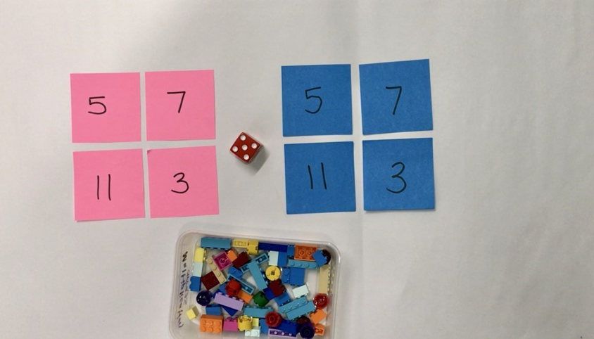

Building Towers
- Take turns to roll your dice and get that number of bricks to build up your towers.
- Towers can be built up in any way you choose.
- Build up your towers until one of you gets the exact roll to complete the last tower.
- Talk about how many you have, how many more you need.
- Here is a picture of some friends playing the game.
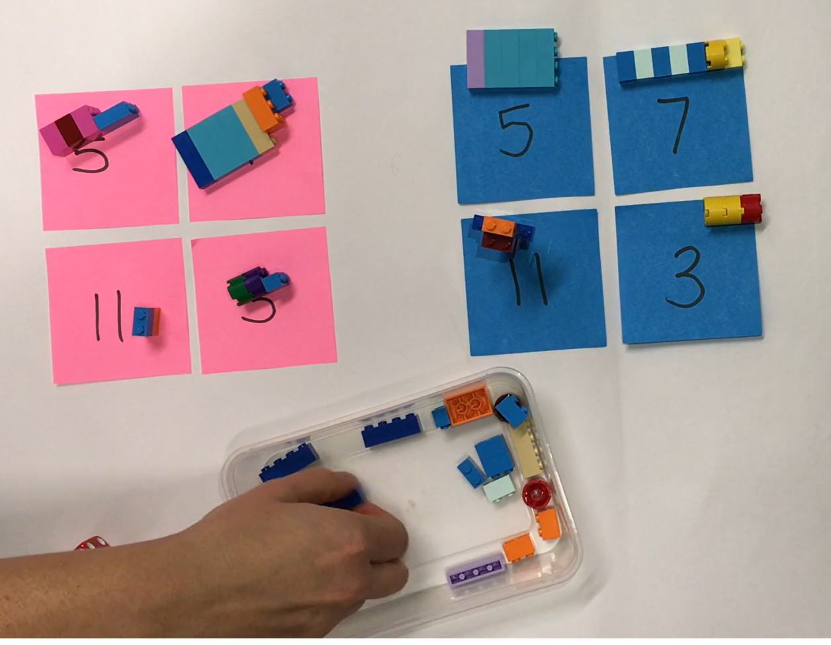
- Try playing the game in reverse by starting with complete towers. Take away blocks for each roll, until there are no blocks left. You could also play the game with larger numbers. Did this change the strategy you used?
- What did you find challenging about the game? What strategies helped you? Draw, write or share your thinking with a family member or friend.

Follow-up activity: Think of the tallest tower that you built. What numbers did you use to build the tower? Teach a friend how to play building towers.

Play School Story Time – The Very Itchy Bear
ABC Me screening details: Wednesday 13 May 2020 at 10:10am
This episode can also be viewed on ABC iView after the scheduled screening time.
Key learning areas: English
Level: lower primary
About: Don't miss Paralympic gold medalist and tennis player, Dylan Alcott as he reads Nick Bland's "The Very Itchy Bear" alongside Big Ted, Maurice and Little Ted!

Before the episode
- Draw or write about how you can make a friend. For example you may go up to some children and ask: ‘Can I play with you?’.

After the episode
- Flea was biting Bear because he wanted to say ‘Hello’ and be friends with him. What would you say to Flea to help him to make friends?

After the episode
- Finish the outline by drawing an expression on Bear’s face. Describe your drawing to someone and tell them why Bear is feeling that way.
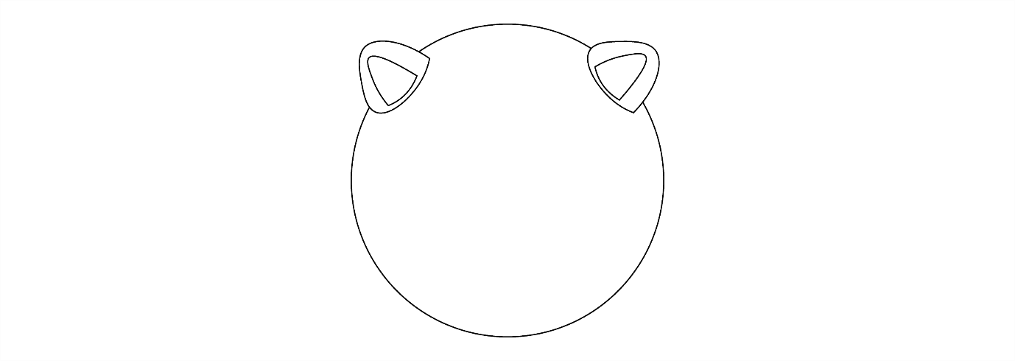
- The author has used rhyming words in The Very Itchy Bear. Trace and colour the rhyming words below. Add more words that rhyme below.
sea | see
be | flea
Follow-up activity: At the end of the story Bear and Flea go everywhere together. Write a story about you and a friend going somewhere special together. Where would you go with your friend? You could go to the park, beach, on a holiday or an adventure together. Draw some illustrations to go with your story. Tell your story to someone in your family, a friend or to a lucky listener.

Art with Mati and Dada – Raphael
ABC ME screening details: Thursday 27 April 2020 at 10:35am
This episode can also be viewed on ABC iView after the scheduled screening time.
Key learning areas: creative arts
Level: lower primary
About: Muse Thalia is having fun kidding Dada...but she escapes from the Parnassus of Rafael, and Mati and Dada have to bring her back!

After the episode
- Mati and Dada met Raphael in today’s episode. What interesting things did you learn about him? Write or draw:

- Look at one of Raphael’s frescos, ‘The school of Athens’.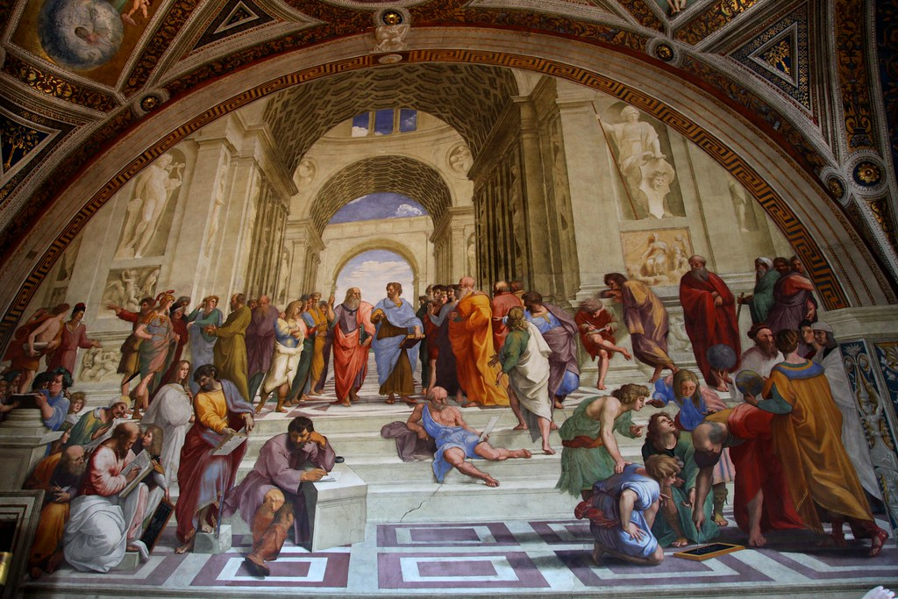
Discuss these questions with a friend or family member.
- If the people in this artwork could speak, what might they say?
- What do the things in the artwork tell us about the people?
- Why do you think Raphael chose to paint these people?
- What do you notice about where the people are positioned in the artwork? Are they close or far away?

After the episode
- Time to be inspired by Raphael! What would you like to look at on your bedroom ceiling or on a wall in your classroom? Could you paint the inside of a cardboard cubby house or create an artwork outside? Sketch your ideas.
- Collect what you might need. What space and materials do you have available? Could you use chalk outside or a roll of paper? Will you use pencils, pastels or paint? Could you use scraps of fabric or natural materials?
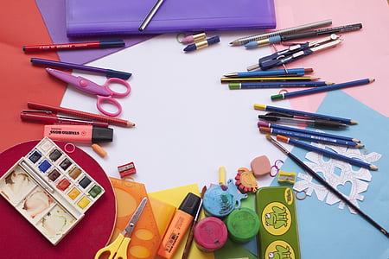
- Create your artwork! Who inspires you? Who might you create your artwork about? Start slow by outlining the objects, people or animals that you might include. What is surrounding them? Are they in space? A forest? Underwater?
Follow-up activity: Write a statement to go with your work. Include a title, what your artwork is about and why you created it.

Play School Story Time – Little Red Hen and Grains of Wheat
ABC ME screening details: Friday 15 May 2020 at 10:10am
This episode can also be viewed on ABC iView after the scheduled screening time.
Key learning areas: English
Level: lower primary
About: Join the fun as Adam Liaw and the Play School toys read the classic tale of "The Little Red Hen and the Grains of Wheat" by author L. R. Hen and illustrator Jago.

Before the episode
- Draw and write the ways that you help your family and friends. For example, you can draw yourself cleaning your room because this helps your family. Talk about your drawing with someone in your family or a friend.

After the episode
- Retell the Little Red Hen by drawing and writing the words you know from the story. Remember to tell what happened in the beginning, middle and end.
- The beginning of the map will be Little Red Hen finding the grains of wheat and the end would be Little Red Hen eating the bread with the miller and the baker.

After the episode
- Do you think it was fair when Little Red Hen did not share the bread with the cat, dog and goose? Tell someone in your family or a friend the story of the Little Red Hen using your story map.
- Draw the Little Red Hen eating the bread with the baker and the miller. You could add the cat, dog and goose watching them eating the bread.

Follow-up activity: Imagine you are the dog, cat or goose. Write a sorry letter to Little Red Hen. In the letter you are to say you are sorry and how you would help the Little Red Hen next time.

