Case Study: Oxley Park Public School
An example of one early childhood education service’s experience of supporting transition to school during COVID-19
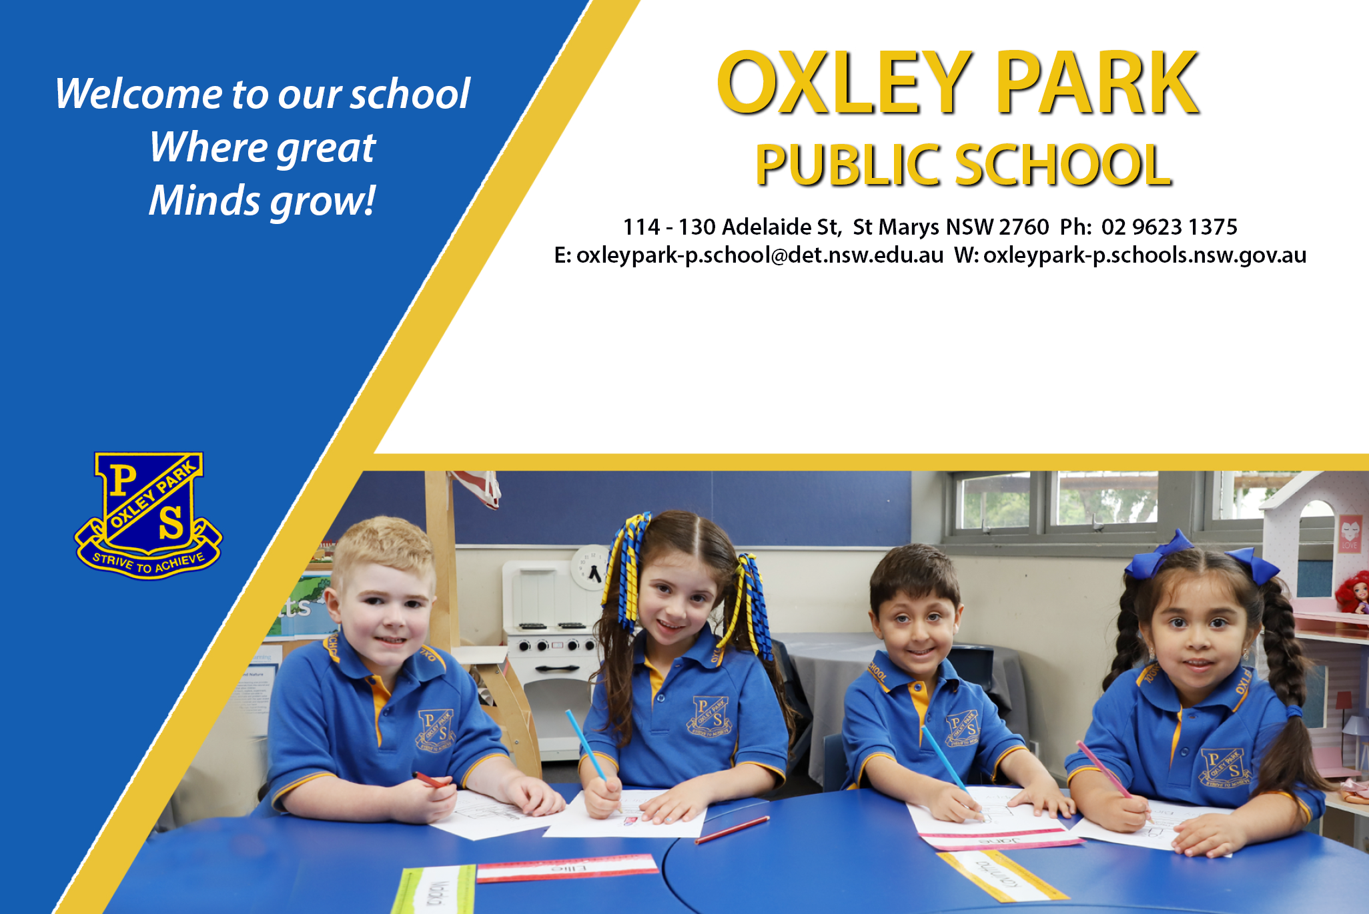
This year we are seeking to send our staff into the preschools to visit the students and develop relationships and connections due to current restrictions.
At Oxley Park Public school, we value effective transitions to school, within school and beyond school. Ensuring a positive start to formal learning for our children is crucial. The evidence supports that when positive connections are created for children and their families this has a long-lasting impact on positive outcomes at school.
This year we made some changes to our transition to school plans to support learning from home. We embraced the current situation and found ways to work around barriers to ensure that our families and students had opportunities for a great start to school.
Our transition to school involves rich connections with five local preschool and EC centres along with our own onsite Department of Education Pre School.
We endeavour to build on transition to school through actively communicating, connecting learning at home and at school, building community identity, recognising, and valuing the contributions of family, consultative decision making and full participation.

Communicating and Relationships
Our strengths: we make connections with local preschools – build relationships between our school and local EC services-we have a key person of contact. Normally children and educators from various centres come to us for visits. This year we are seeking to send our staff into the preschools to visit the students and develop relationships and connections due to current restrictions.
We provide information about Best Start and any other Department protocols and processes, particularly around students with additional needs, how to access services and support staff to ensure the best transition for our most vulnerable children.
Our Aboriginal Education leader connects with local EC services providing a welcome pack for our Aboriginal and Torres Strait Islander families, explaining what and how our school supports students through their learning.
Our English and Additional Language Teacher provides a welcome pack supporting families with additional resources and assistance in transition to school.
Our specialist Learning and Support teacher provides expert advice around specific processes used within the school to ensure inclusive practices are supporting students and families.
We reach out to our known families through connections with our local playgroups held at the school.
We promote our Kindergarten applications to enrol from early Term Two at local EC centres, our school Facebook, Class Dojo, Seesaw app and local shopping centre, local non gov support services, chaplain and electronic school sign.

Connecting with families and children for 2022 Kindergarten
Promotion of enrolment – regularly on all platforms and local venues. When parents apply to enrol and complete enrolment, they are provided with a link to the 2022 Class Dojo account – this is the communication platform that they upload pictures or videos of their child completing activities.
We use reply paid envelopes when posting information to parents that we request be returned. We accept and encourage all electronic communications from families.
We strongly encourage families to share their child’s transition to school statement. We use these statements to build a picture of the whole child. This statement compliments our interactions with children and allows us as teacher to make connections to important views held by children in their early years – this is a discussion with the OPPS teacher and the parent to talk through the statement.
Our transition to school dates were set early in the year. These have not changed just the format has. We communicate these dates to families about our drop and play sessions and our stay and play, these are advertised locally. For 2021 we have adapted our transition sessions to meet restrictions.
Our Drop (Stay) and Play sessions moved to Zoom – a few weeks before each date we send out themed activity packs for parents and carers to do with their child on their Zoom day with the staff at OPPS. Some of the themes include, dress ups, role plays, uniform day, school lunch day and craft-based activities. The last few Zoom sessions in Term Four will include the current Kindergarten students in their classroom connecting with the 2022 children engaging in a similar activity. These connections are important as the outgoing 2021 Kindergarten children will be buddies supporting the incoming 2022 students.
We connect by seeing the children engage in an activity with their parent/carer. These sessions are designed to increase connections for children to the teachers and see other children who will come to school. We encourage parents to take photos/videos and upload on the Dojo account to use when the children come to school the following year. We use these images to develop social stories for each child beginning school.
Using Microsoft Forms we are seeking input from families about how they wish to receive and engage in communication moving forward. Any questions, suggestions and comments can be shared with the staff.
During the Stay and Play sessions (this is what happens at Drop and Play)– parents would normally leave their children and the school would provide information sessions for the parents while they wait. This year we have organised Zoom sessions for parents about specific school information. To compliment this, we have a transition to school video on You Tube that provides extensive information about the school. The video has a time contents page to assist parents/carers to locate specific information about the school.
Kindergarten teachers will go to EC centres, by sending our staff they can engage and make connections to the children and provide information for families. If this is not possible then we would request to Zoom into the centre and connect with children in EC centres.
We follow up any family who has not been able to engage with any online session, we reach out and connect with them – we find ways that suit the families to stay connected – adopt a flexible time for working families if we can’t connect through the child’s EC centre.
Children will take part in a video interview at home with parents/carers and talk about their interests and what they believe or want school to be like. The parents are provided with a few question prompts, are asked to provide a short video of the child talking about themselves, our perspective is to see the child’s learner disposition come through about what they believe and want from school. This will be sent by the parents via Dojo for us to keep and show the children at the end of 2022 asking them the same questions so they can evaluate their first year of school.
Our core values at OPPS strongly encourage a play based pedagogical approach. Supporting students to develop their disposition of learning for life. We embed play based pedagogy into our K-2 classrooms supporting the belief that children develop so many skills through purposeful play where they develop their sense of self through resilience, exploration, engagement, inclusion.

