School Name

My new preschool
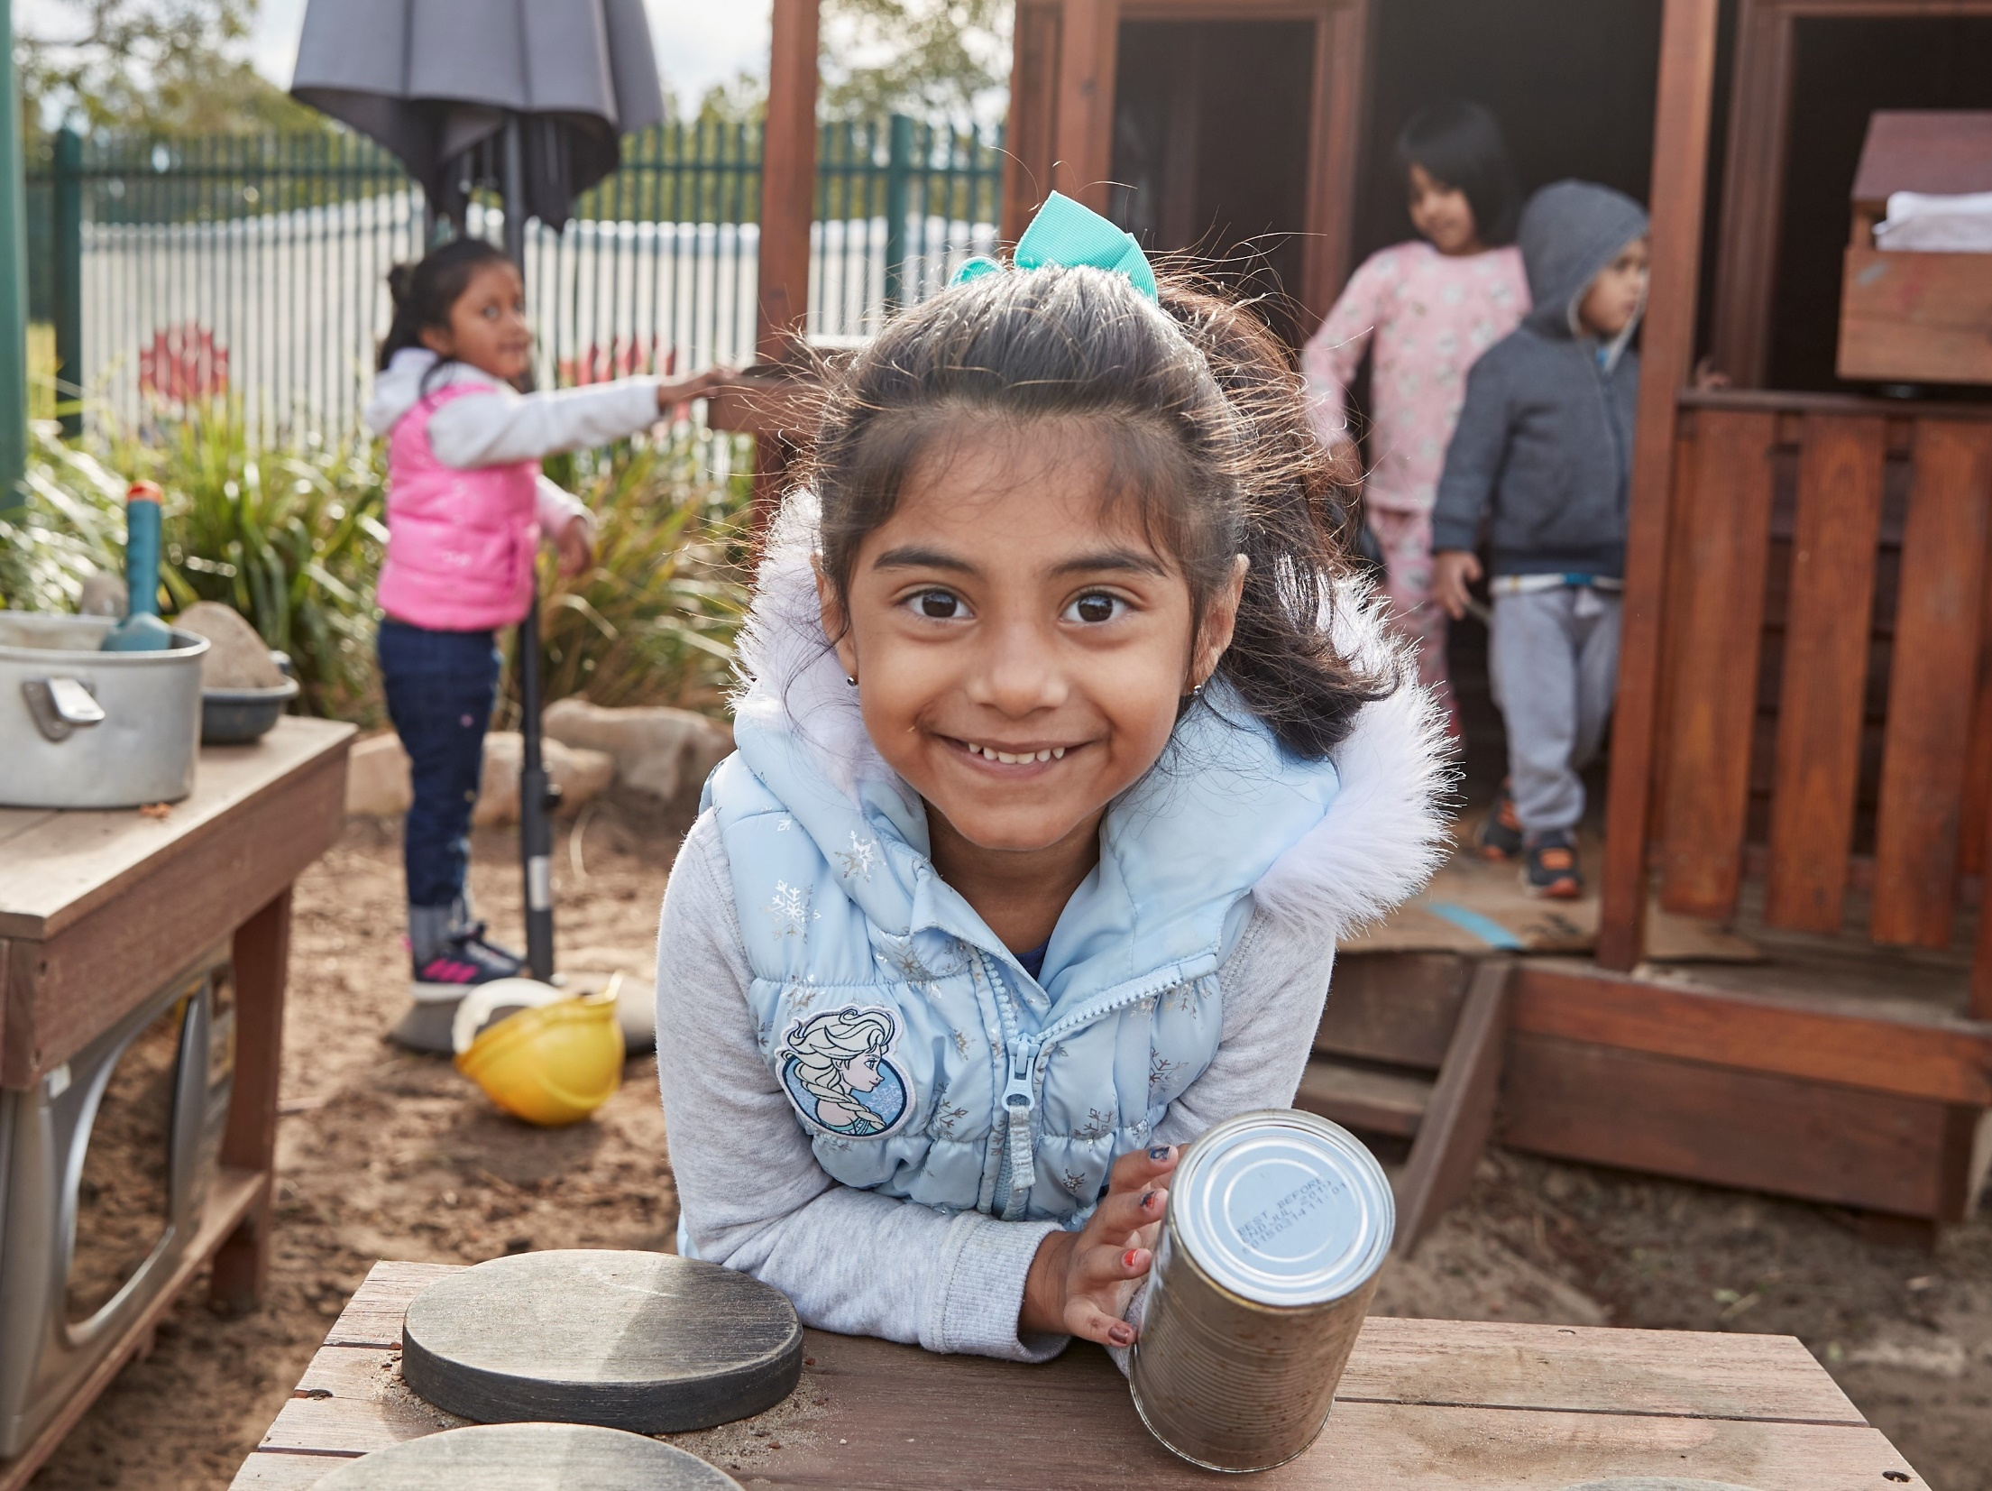
All images in this document are owned by the NSW Department of Education under the Copyright Act 1968 (Cth) or licensed under the iStock Getty Images Content License Agreement

This is the gate into my new preschool.
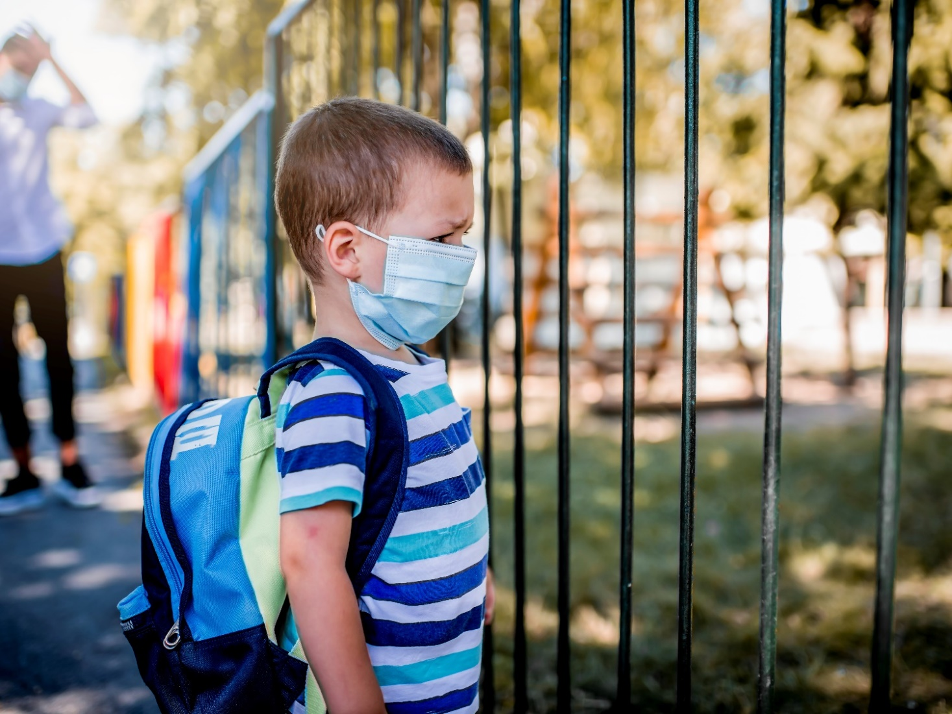

I have a preschool bag which I carry on my back. I put it in a special place when I arrive at preschool. 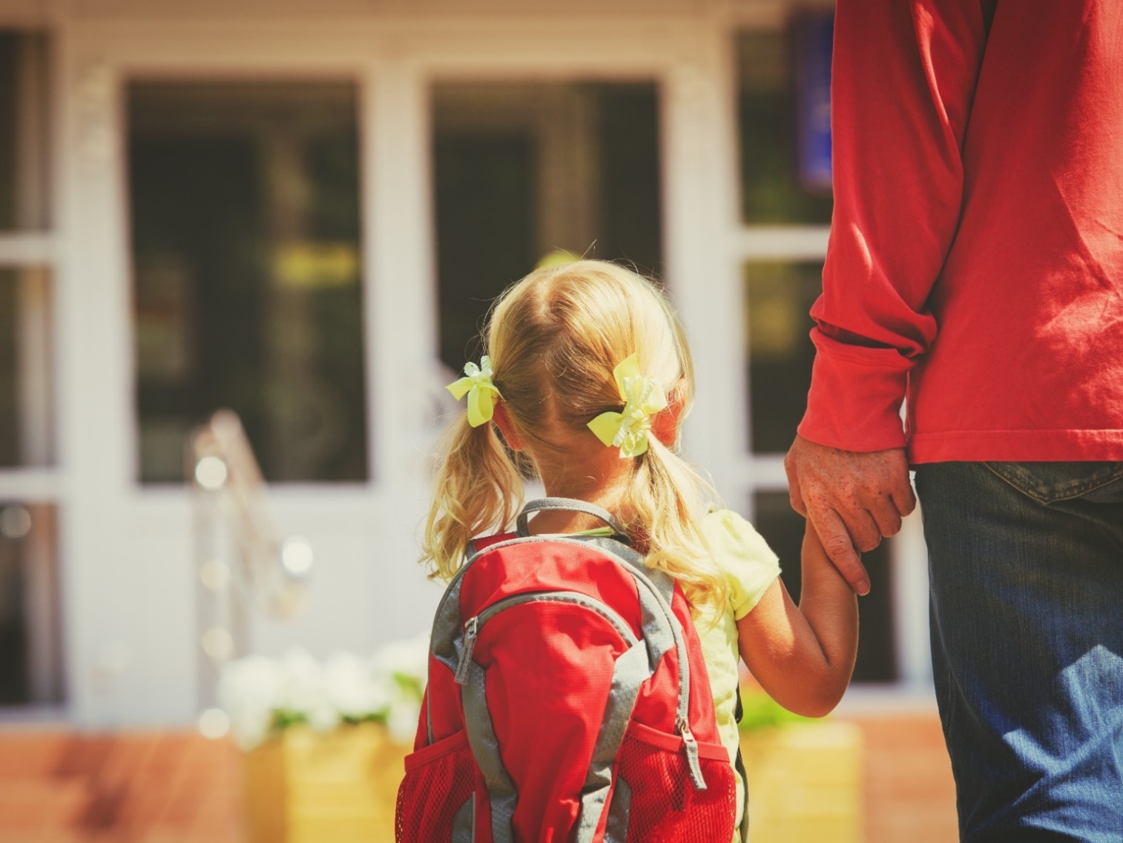

I take a lunch box and water bottle to preschool. When I’m thirsty, I get myself a drink of water.
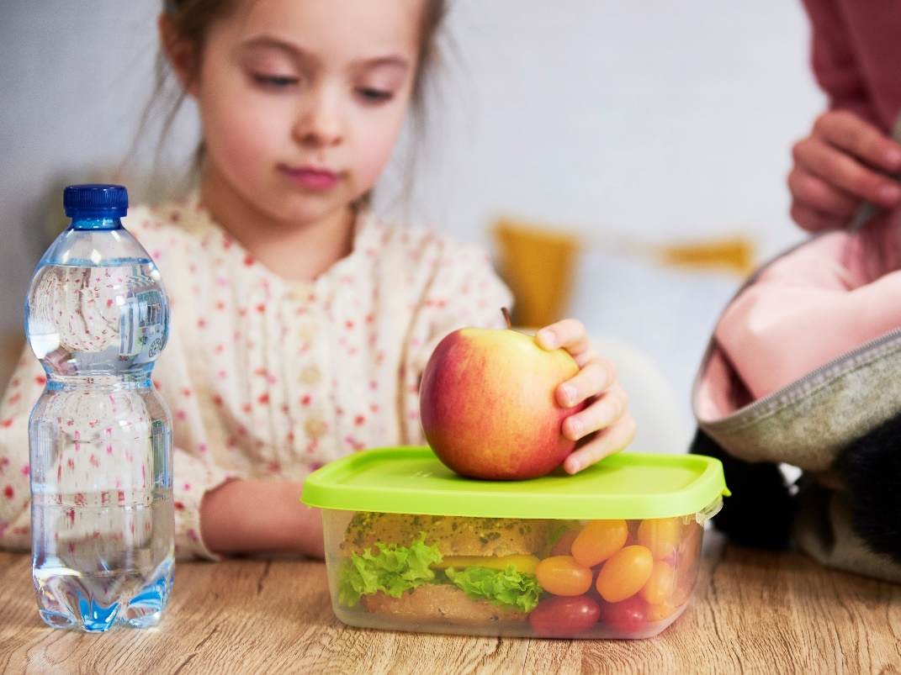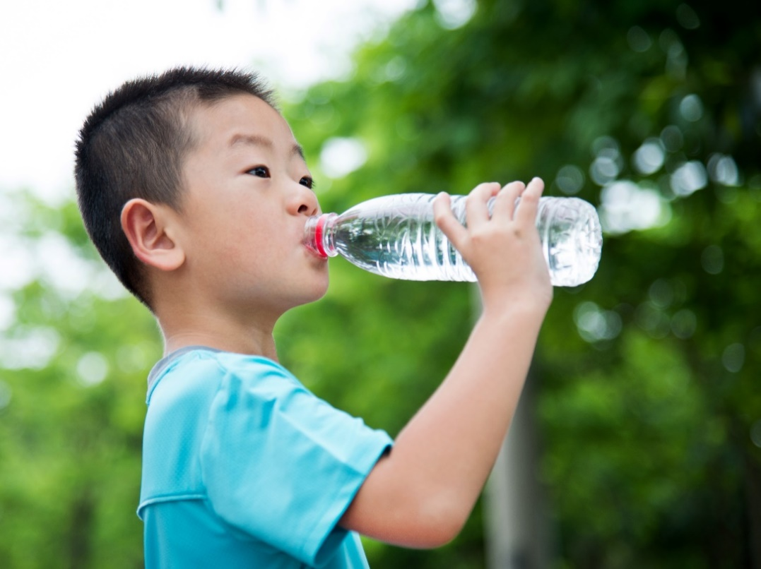

I have a hat to wear at preschool. I wear it when I play outside to protect me from the sun.
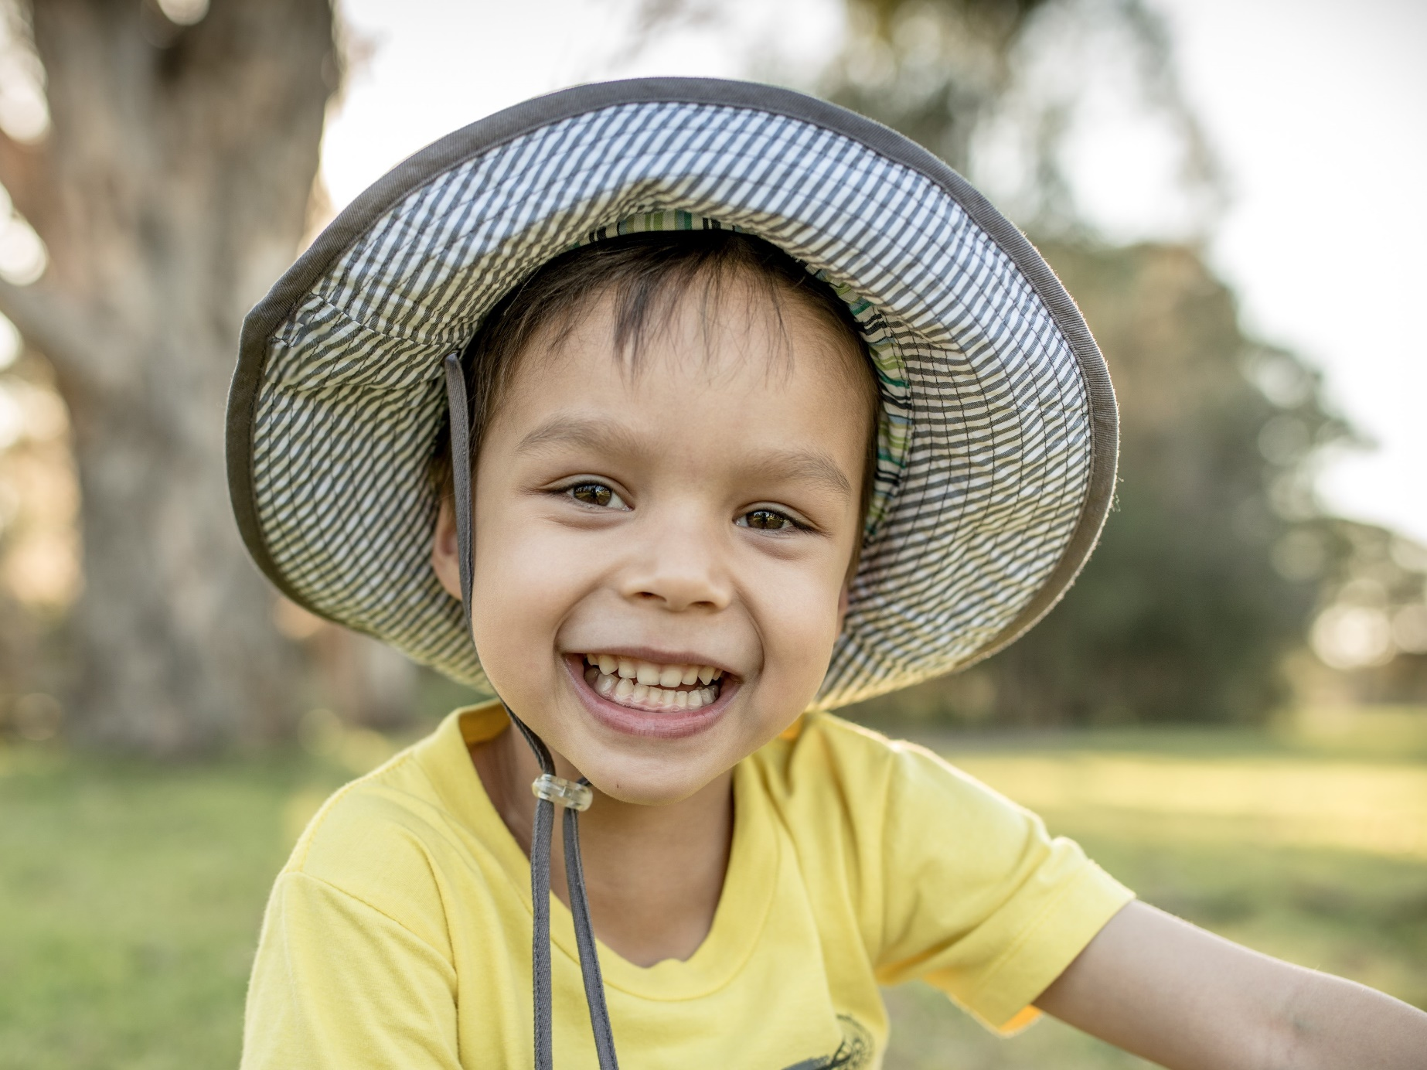

The grown-ups at my preschool look after me and help me learn. I tell them when I’m feeling sad and they help me feel better. The grown-ups remind everyone to be kind friends.
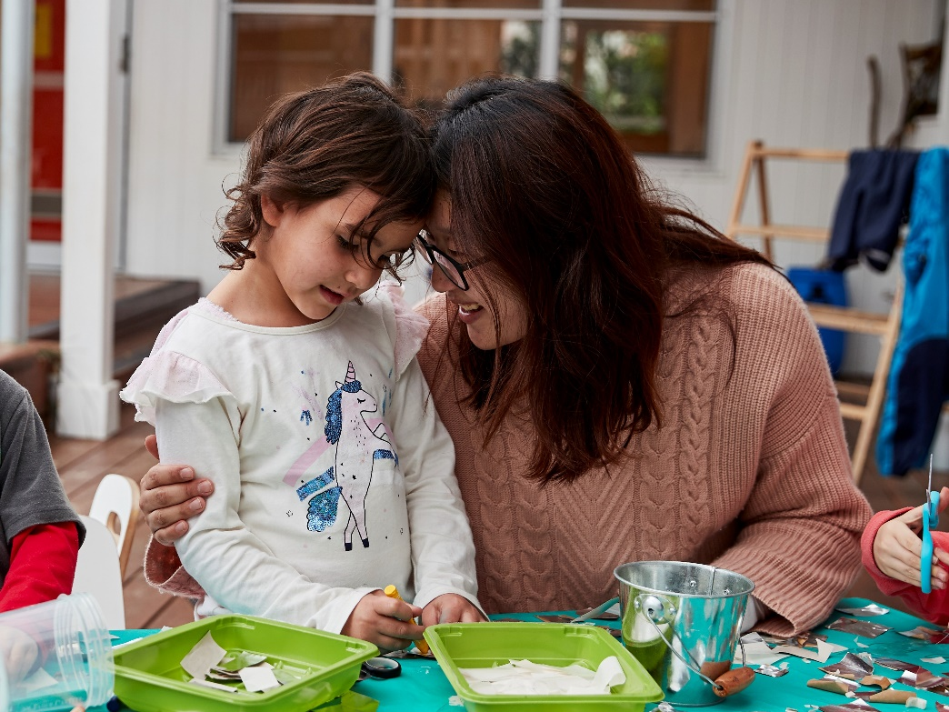

I have some old friends who I play with at preschool, and some new ones too. Some days, though, I feel like playing on my own.
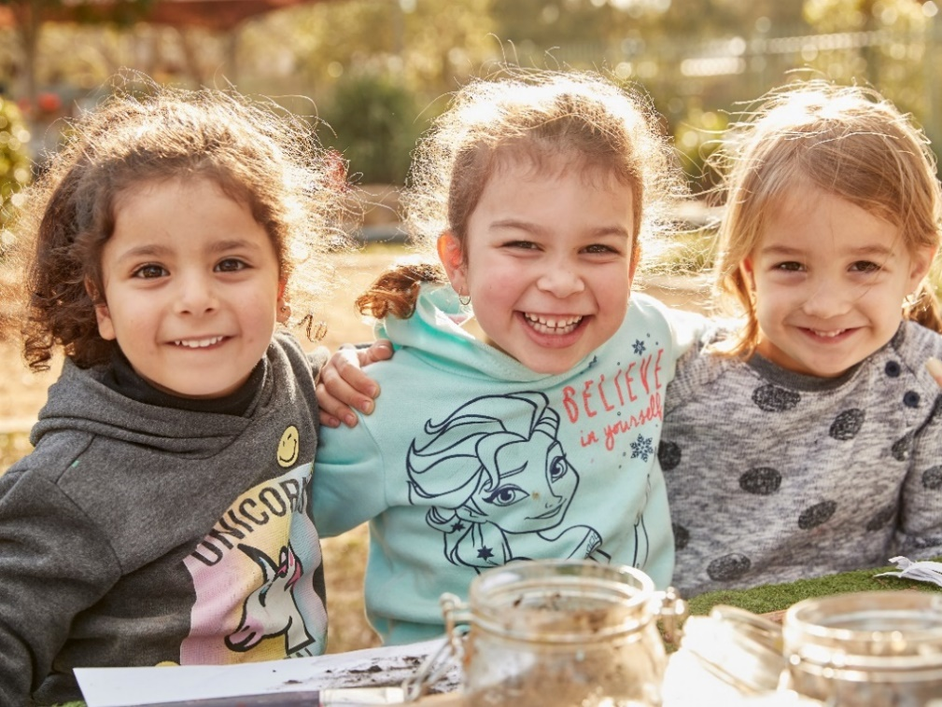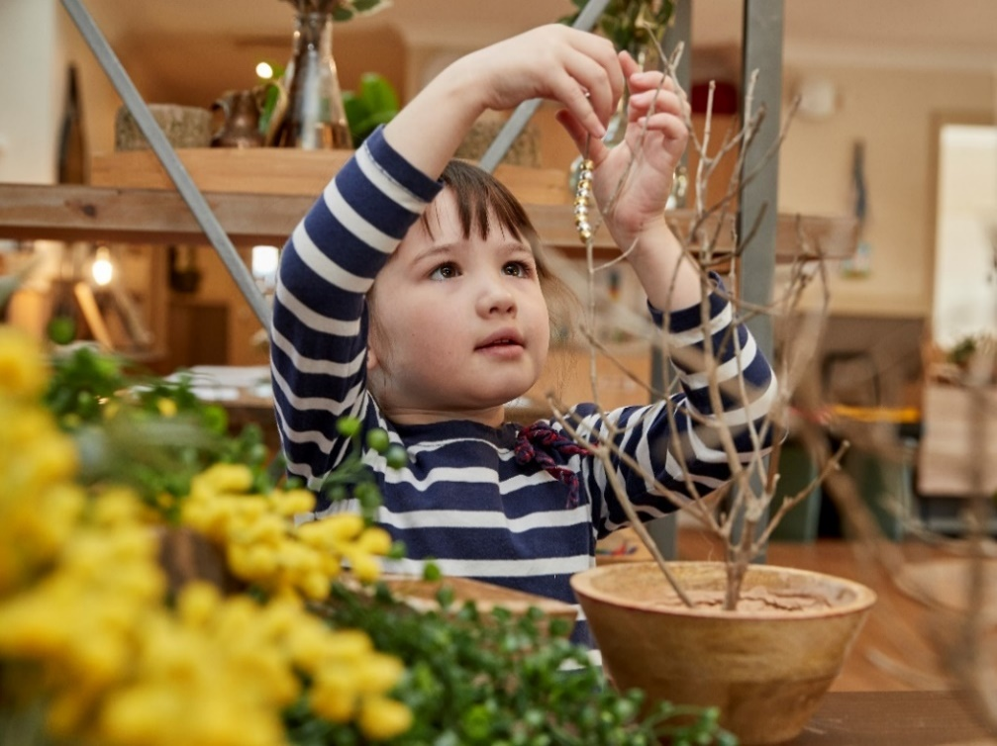

There are lots of different things to play with at preschool. Each day I choose what I want to do. I like to have fun and learn new things.
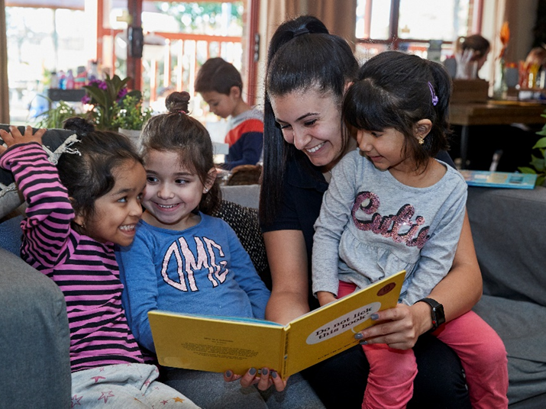
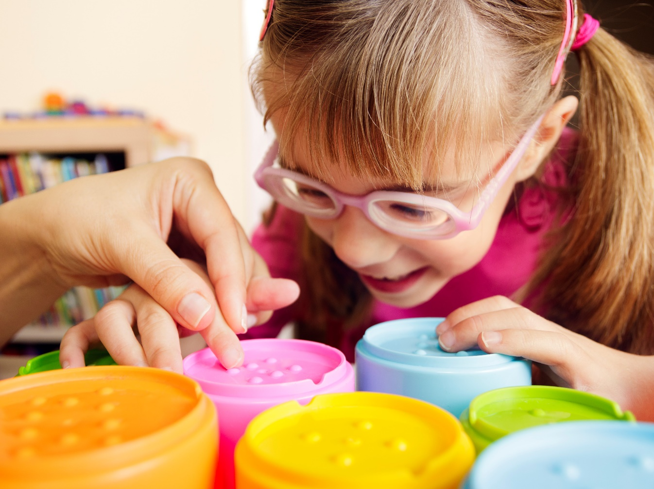

When I play inside, I like making things with paper and boxes. When I am feeling sad, I build with the blocks, like I do at home.
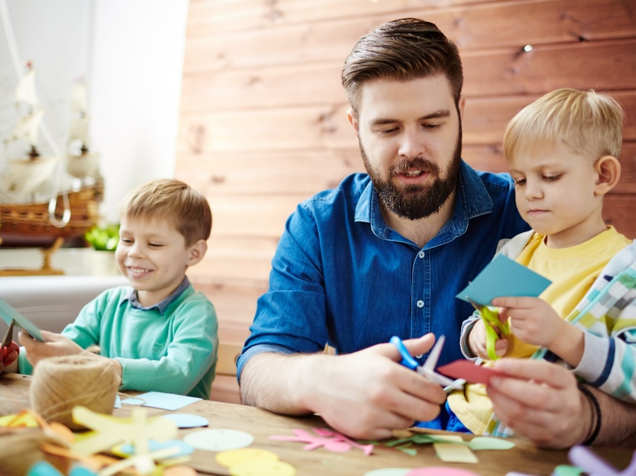

When I play outside, I like to run and climb up high on the equipment. I also like to play with the sand.
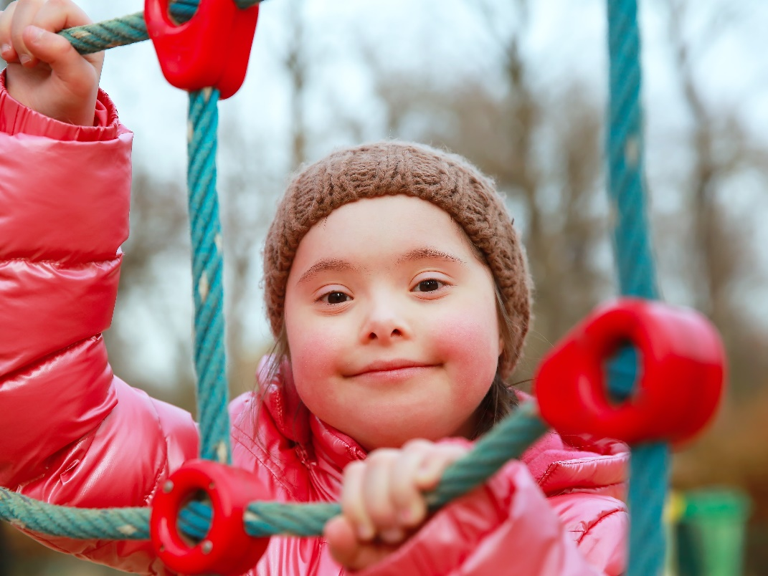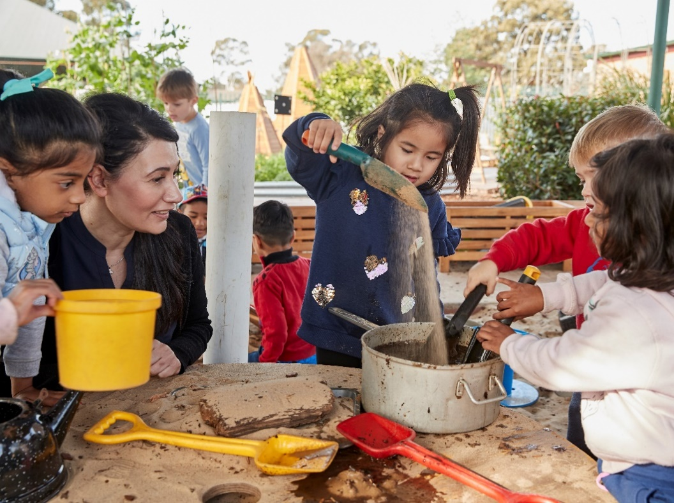

When play time finishes, I help pack away the toys. It’s good to look after our preschool and keep it tidy.
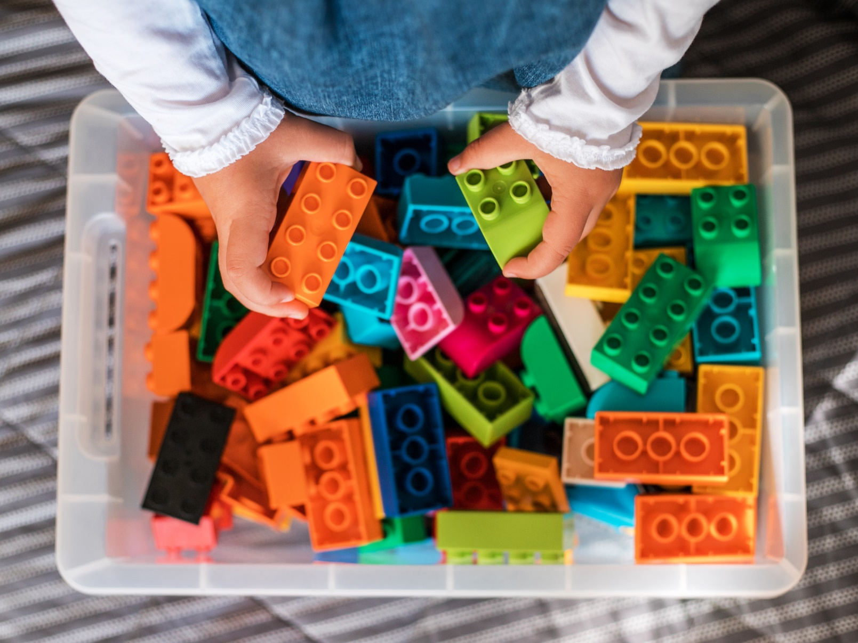

Sometimes, the children and grown-ups come together to learn new things and sing songs. We also enjoy sharing stories together, just like I do at home.
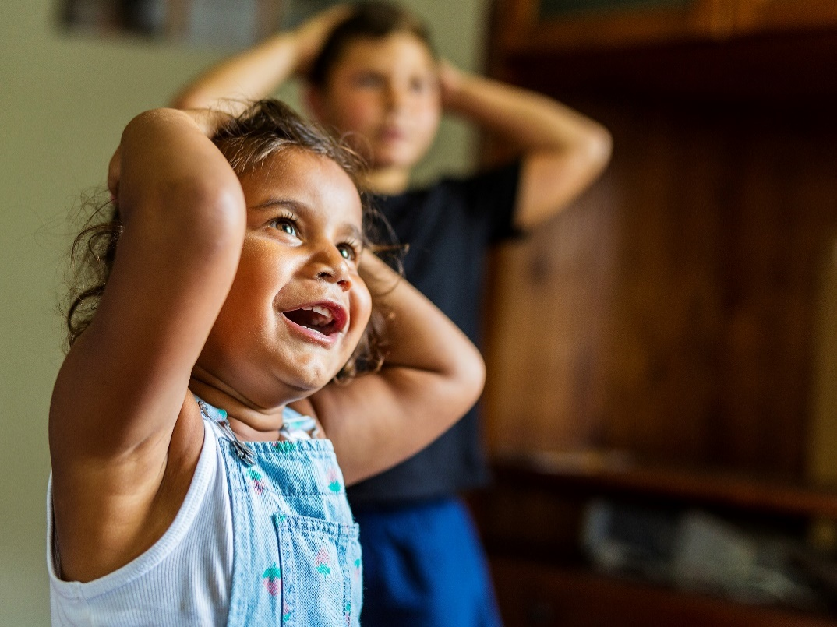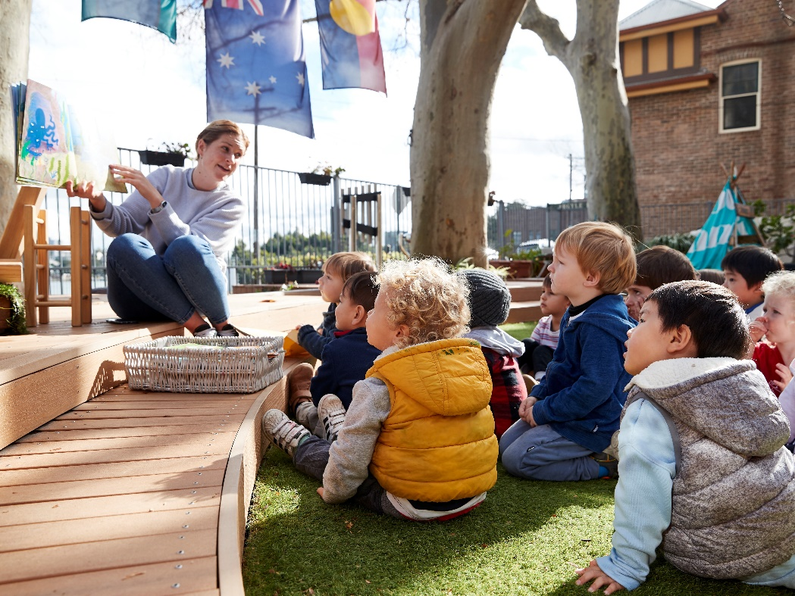

When my nose is runny, I get a tissue and blow it. After I finish, I remember to put the tissue in the bin and wash my hands.
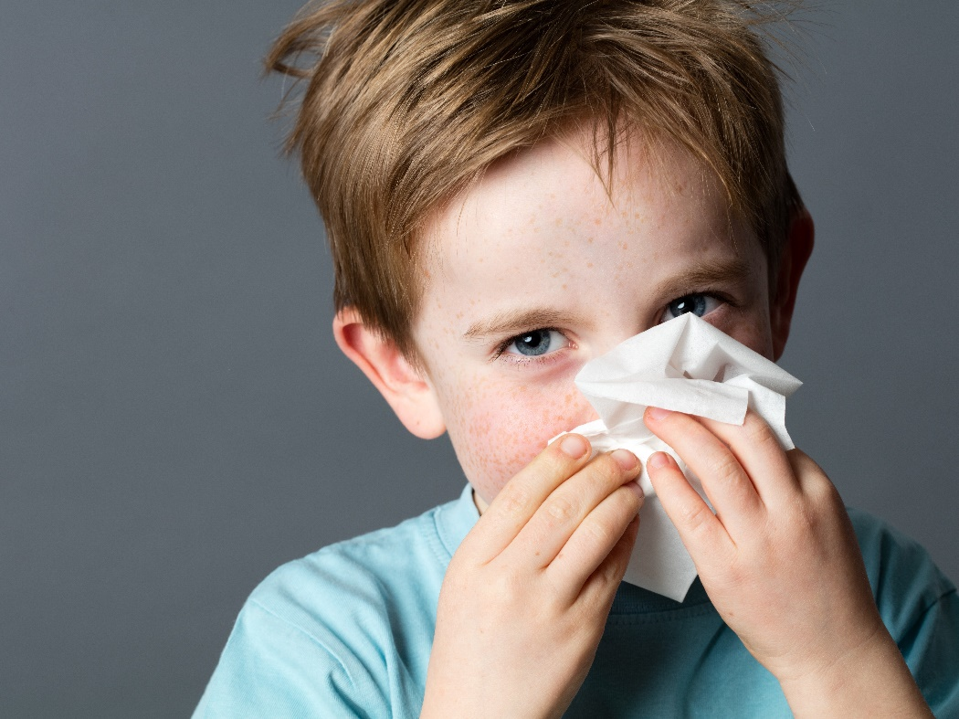

There is a big bathroom at my preschool. I go into the bathroom when I need to use the toilet. Then when I’m finished, I flush the toilet and wash my hands.
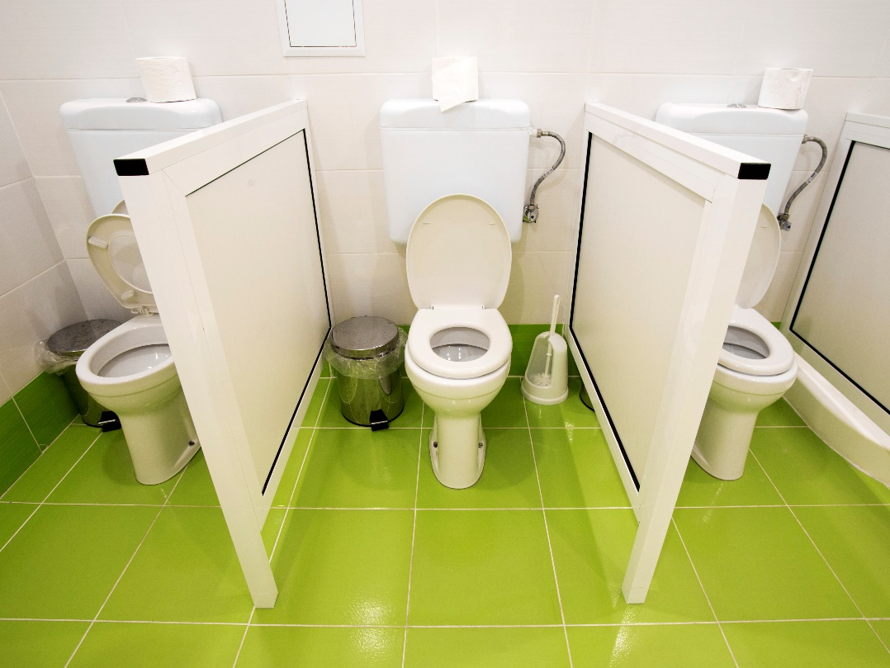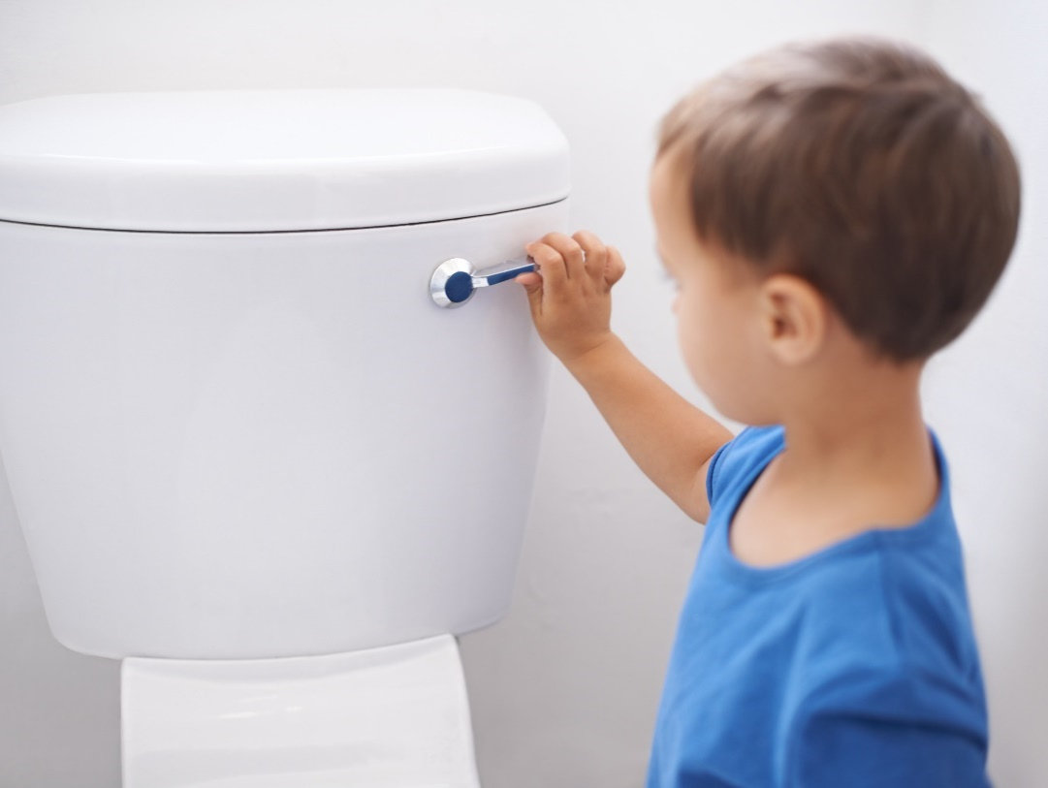

I wash my hands with soap and water and then dry them. I’m very good at remembering to wash my hands. I make sure I wash all the germs away so I stay healthy.
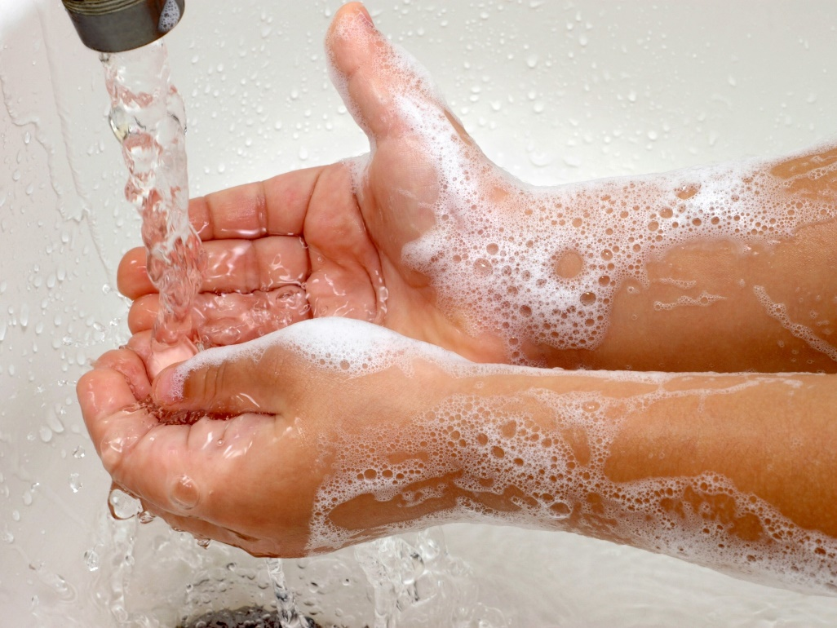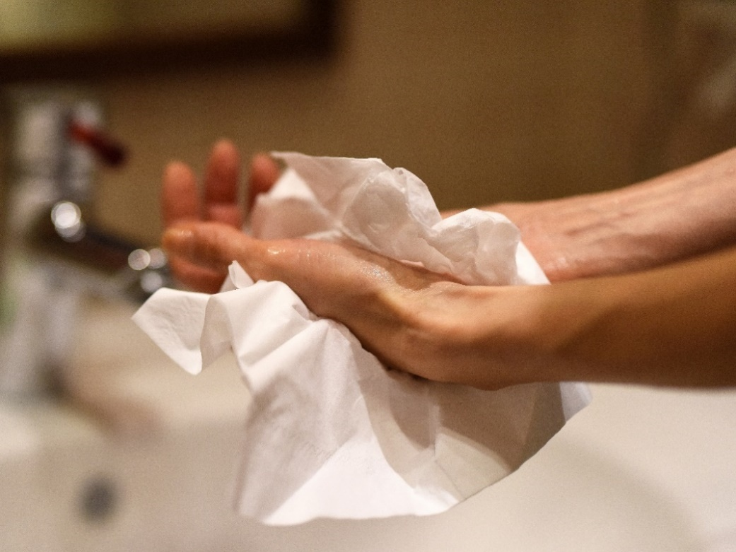

I eat my lunch with the other children. If I can’t unwrap my food, I ask a grown-up for help. I always eat my healthy food first so I am strong and healthy. If I don’t eat all my food, I pack up what is left and take it home.
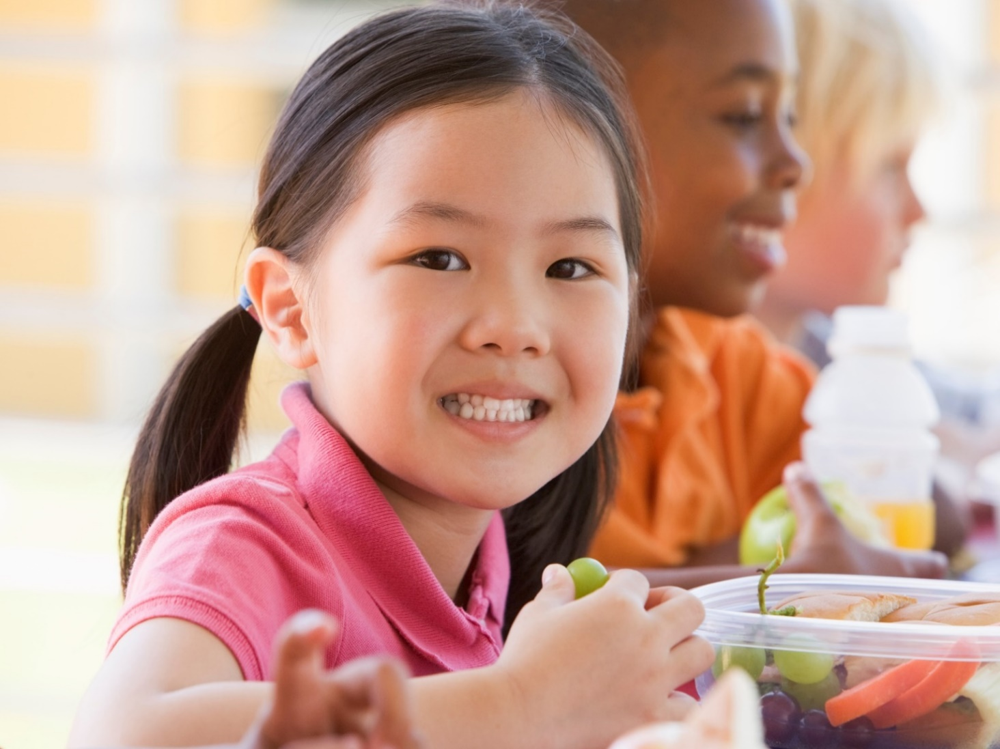

After we eat lunch, it’s quiet time. All the children do something quiet, like looking at a book, puzzles or drawing. Whenever my body is tired, I lie down and have a rest.
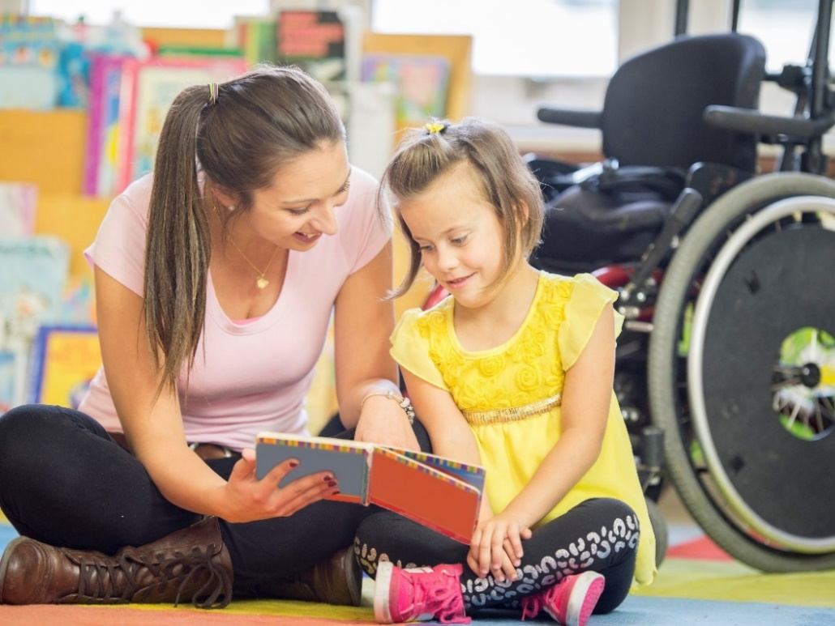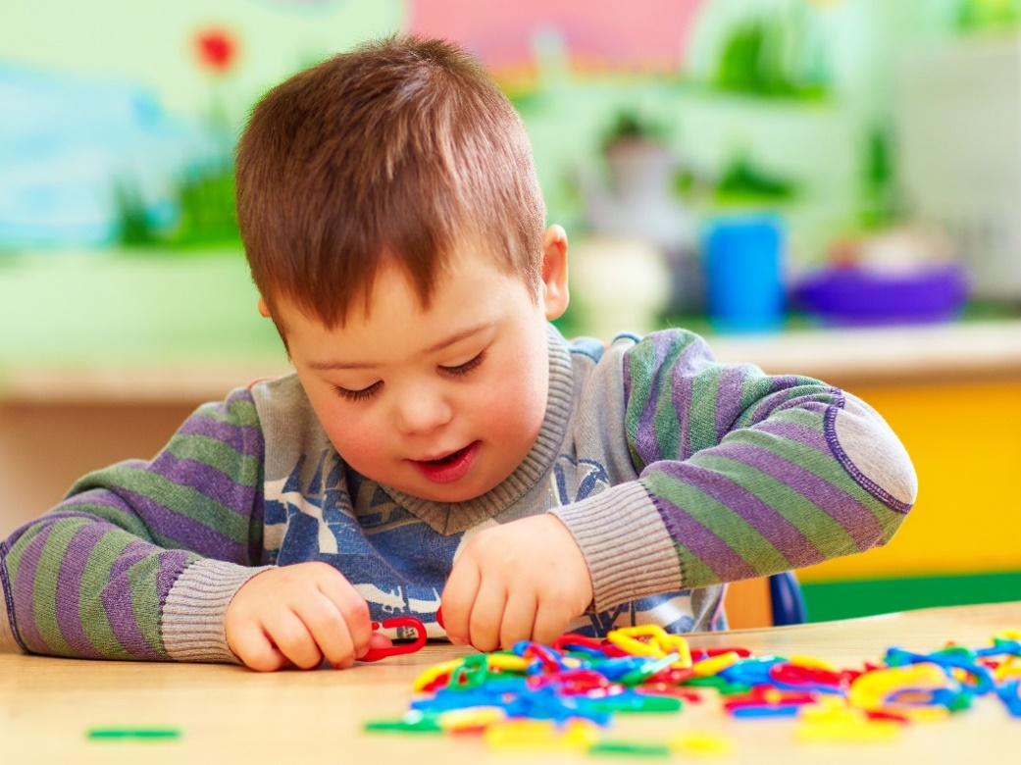

When it is nearly home time, I pack my bag and put it on my back, ready to go.
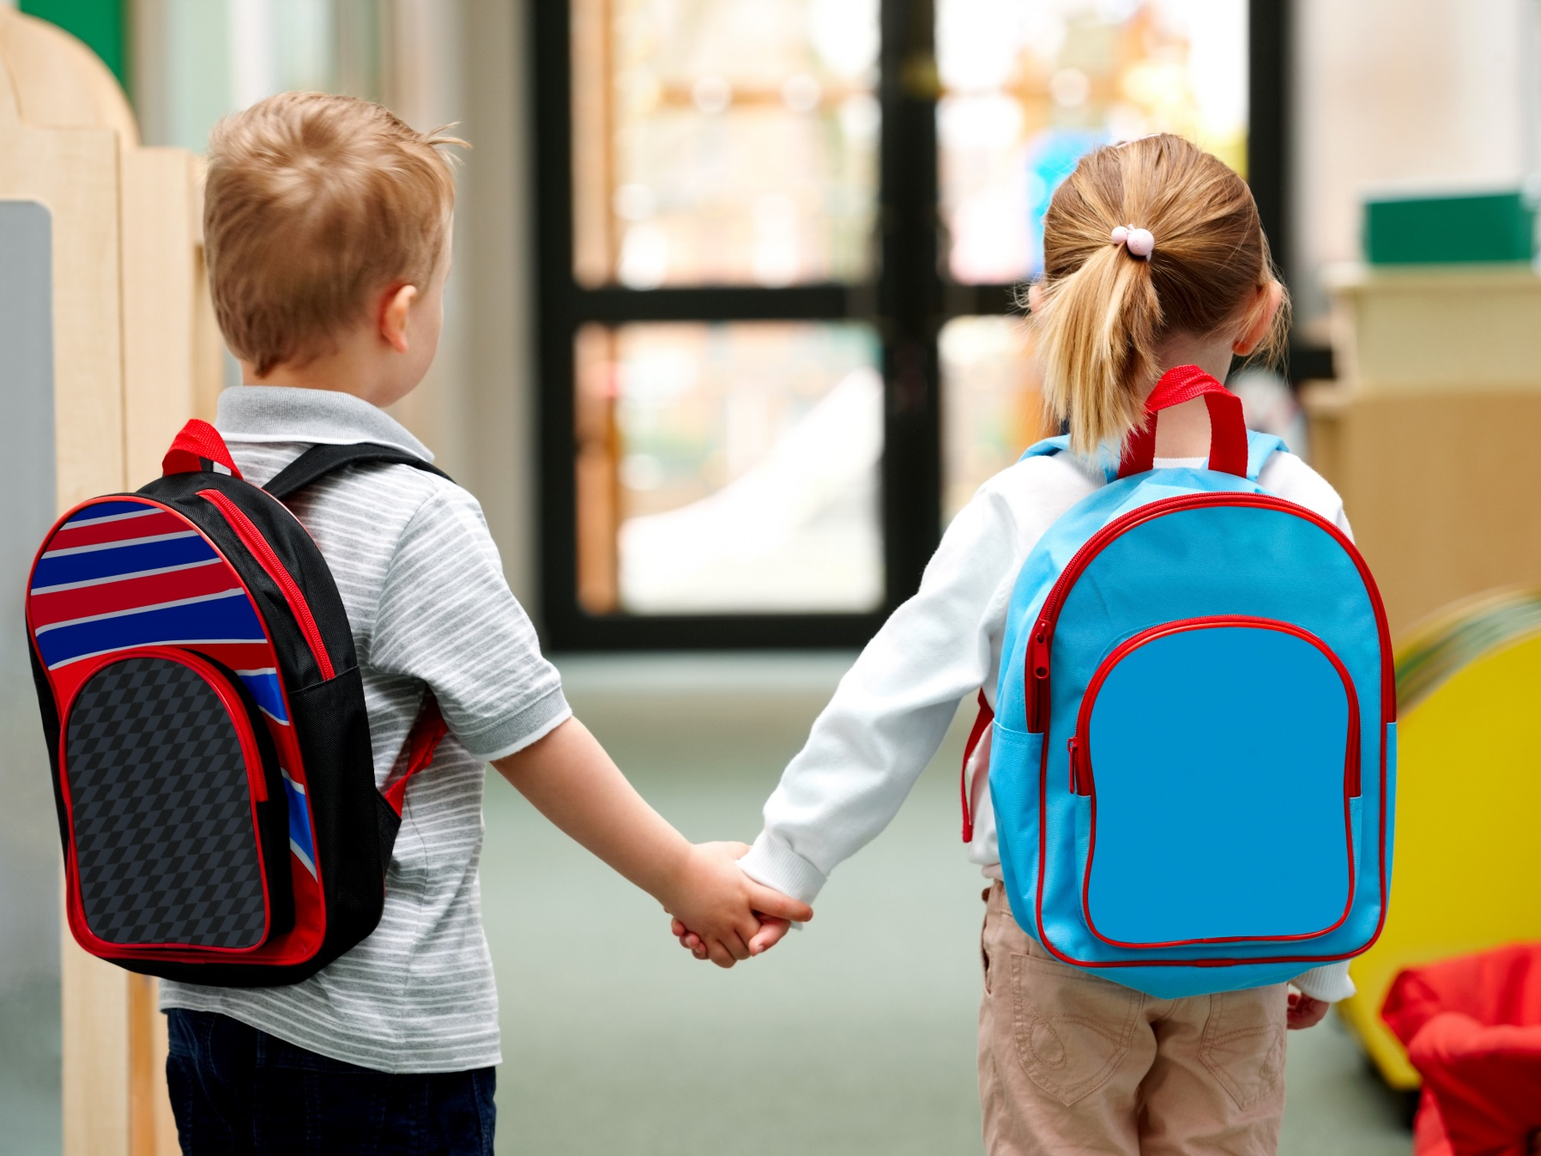
At the end of the preschool day, all the children have a grown-up who comes to pick them up.
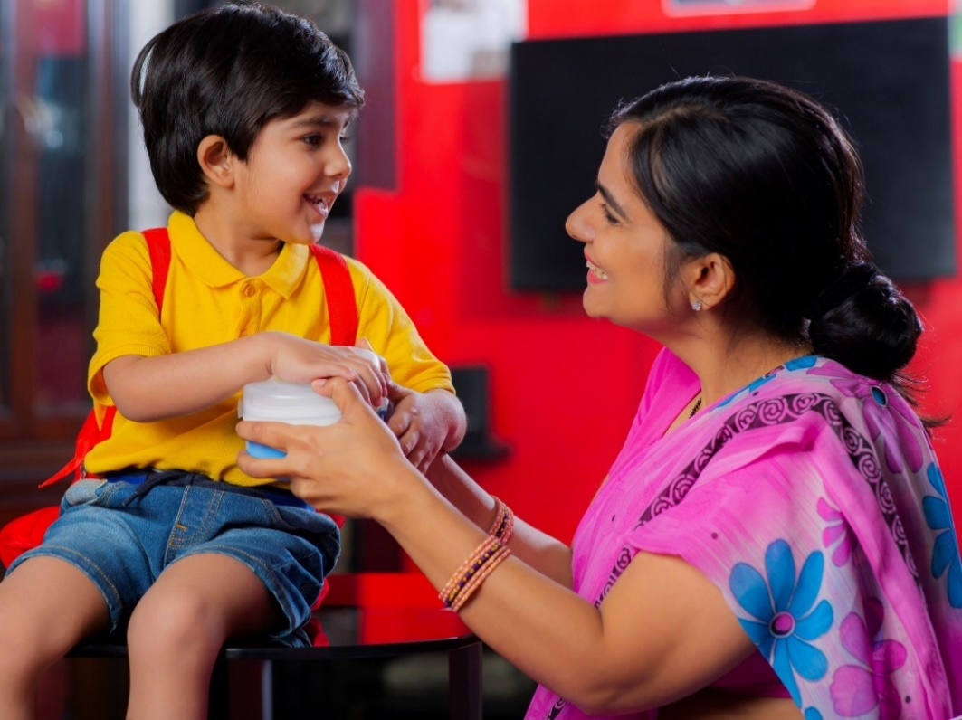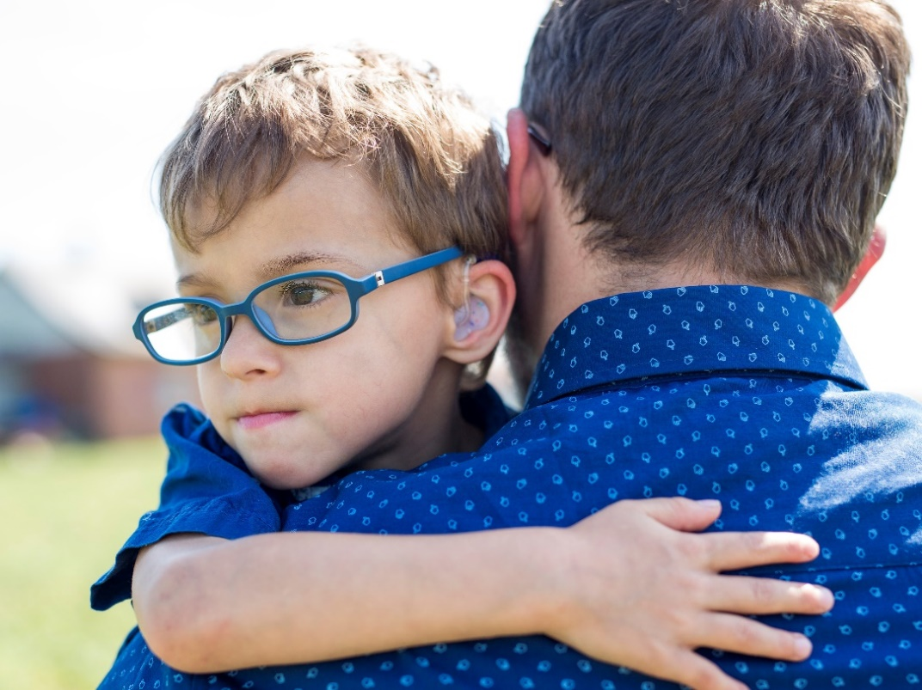

As I leave, I smile and say goodbye to the grown-ups and children. I say, “Thanks for playing, see you next time.” When everyone has left, my preschool closes.
