Setting up a Zoom meeting for people outside of the department
- Go to https://nsweducation.zoom.us. You may be asked to authenticate your account using your DoE credentials. Click on Sign In.
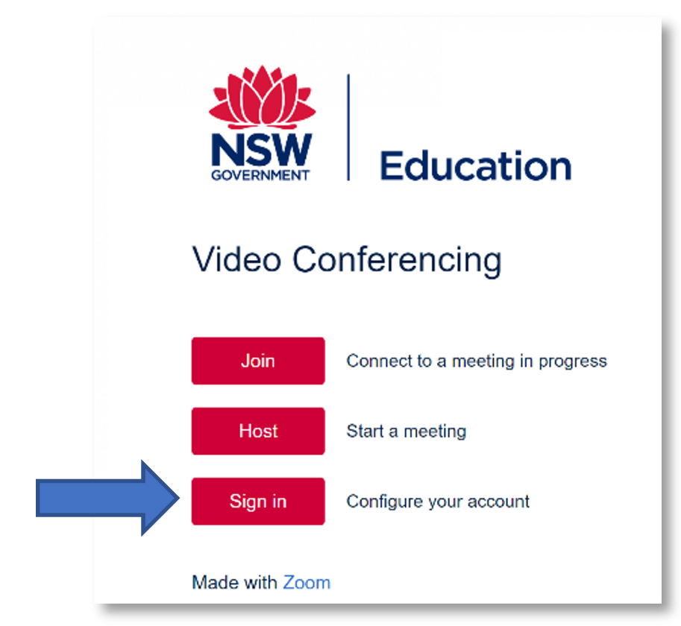
- Select Schedule a New Meeting.
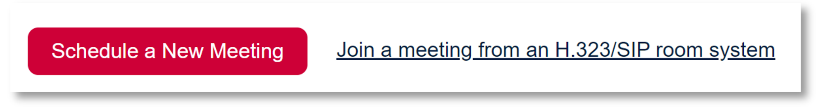
- Fill in your meeting details as required. Scroll down the page until you find the meeting options.
- In the section for Only authenticated users can join, it will say Sign in with DoE Single Sign-On by default.
- Select the arrow at the end of the box, and in the drop-down options select Sign in to Zoom.
- Your meeting will now be accessible for Independent schools and external parties with Zoom accounts.
