How people outside the department can join a Zoom meeting
Zoom is a cloud-based video communications service, which makes online communication and collaboration easy.
To ensure a safe online environment for everyone, certain features must be used in a Department of Education Zoom environment. One of these features is that Department of Education teachers and principals must only meet with authenticated users of Zoom.
For parents and community members who are joining a Department of Education school meetings, you will need to create a free Zoom account.
- On your computer.
Go to https://www.zoom.au
Click on the Sign up button.
- You will be asked to provide your date of birth, then your email address.
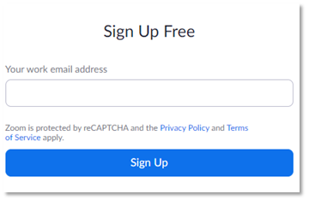
- You will be sent an email to the address provided to confirm that you want to create an account. Follow on the link in your email to activate.
- You will be asked to set up your account details. Fill out your details, as appropriate.
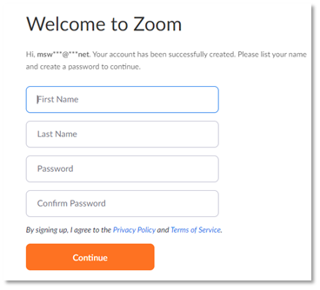
- You will be prompted to invite others – this is optional, and certainly not necessary to join in meetings with a Department of Education school. Click I am not a robot, then skip this step to move on.
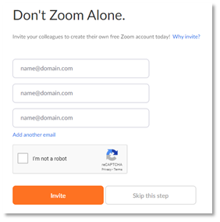
- Now you can go to your account and download the app.
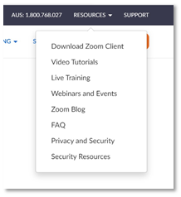
- From the app, you can join a meeting.
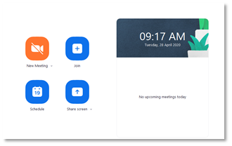
- Enter the Zoom Meeting ID sent to you and add your name. Click Join. You will be prompted to add a password.
