This booklet belongs to:

Week O– Wednesday

Day at a glance:
 | Reusing vegetable scraps | Count the dots | My favourite place | Skipping | Story time in different languages
Estimated time | 20 mins | 10 mins | 15 mins | 15 mins | 15 mins
Resources required |  |  | Something to draw on and draw with | Skipping rope

Reusing vegetable scraps
Learning goal: Children become conscious of living more sustainably.
When we cook food, a lot of fruit and vegetable scraps get thrown in the bin. This can be harmful for our environment because as the scraps rot away in landfill (the tip) they send out a gas that can make our earth too warm.
- Listen to this book about using fruit and veggie scraps via this QR code. If you can’t listen, go to step 2.
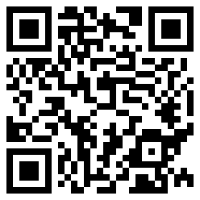
- What happens in your home to fruit and vegetable scraps?
- What are the different parts of fruit and vegetables that get thrown out?
- How can scraps be used, rather than throwing them in the bin?
- Draw your idea and put your plan into action next time you have scraps to use.

Count the dots
Learning goal: Children count small collections and recognise numerals.
Access an online maths activity via the QR code.
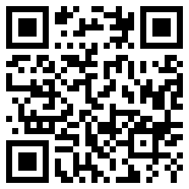
- After you have opened the activity, use your finger to drag the green dice into the middle of the blue work area below.
- Click the two white dice to roll the dice.
- Count the dots. How many?
- Repeat a number of times, each time counting the dots and saying how many.
- Click the arrow to clear the work area.
- Use your finger to drag the number 5 into the middle of the blue work area.
- Click the two dice to change the number.
- Say the number.
- Repeat a number of times, each time saying the new number.
If you can’t access the online activity, find one or more dice.
1. Roll the dice and count the dots. How many?
2. Repeat a number of times, each time counting the dots and saying how many.
3. With a pack of playing cards, pull one card out of the pack. What number is showing?
4. Repeat a number of times, each time saying the new number.
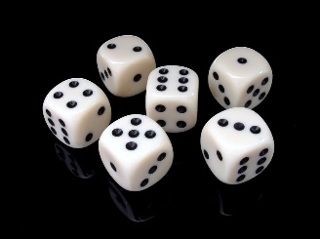
6-pieces-of-black-and-white-dice-by Pixabay, pexels.com

Is this activity too hard?
- Practice counting whatever is near you, for example:
  - Count a handful of blocks. How many?
  - Count the shoes on your feet. How many?
  - Count pieces of fruit. How many?

Is this activity too easy?
- Drag 2 dice onto the work area and:
  - count how many dots on each dice
  - count how many dots altogether
  - ay which dice has the largest number.

My favourite place
Learning goal: Children express a sense of belonging to their favourite place.
Watch the mindfulness video via this QR code. If you can’t access the video, start at step 1.
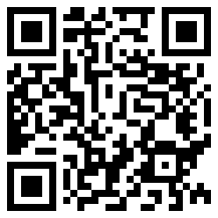
beach-hat-beautiful-book-child- by Pixabay, pexels.com
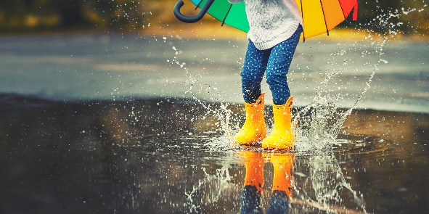
Image owned by the NSW Department of Education under the Copyright Act 1968 (Cth)
Image owned by the NSW Department of Education under the Copyright Act 1968 (Cth)
- Where is your favourite place? How does being in this place make you feel?
- Draw or paint your favourite place.

Is this activity too hard?
- Show someone your favourite place.
- Tell some about your favourite place.
- Draw a picture of the part of your home you like the best.

Is this activity too easy?
- What other places do you like to visit? Why?
- Ask people in your family where their favourite place is.

Take a break
Here are some things you might like to do:
- have a drink of water and a healthy snack
- play or have a rest
- go to the toilet and wash your hands.
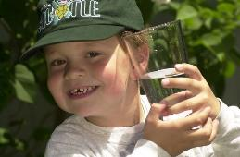
"Boy with glass of water, 2000" by Seattle Municipal Archives is licensed under CC BY 2.0
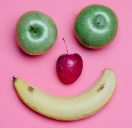
Smile made of ripe fruits by Any Lane, pexels.com
Photo by Andrea Piacquadio. pexels.com
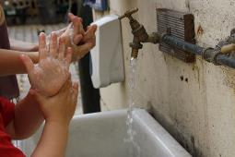
"Washing hands" by magnusfranklin is licensed under CC BY-NC 2.0

Skipping
Learning goal: Children participate in skipping to develop fitness and coordination.
Skipping is great fun and helps us stay fit and healthy. To find out if a rope is the right size for you, stand on the middle of it and pull the handles up. The handles should reach between your belly and armpits.
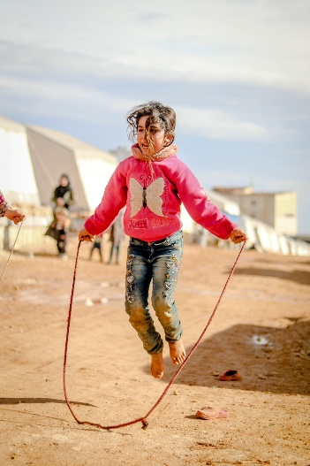
Girl in Jeans Jumping Rope by Ahmed Akacha, pexels.com
1. Watch the video via this QR code and follow the instructions to skip. If you can’t access the video, ask someone in your home to help you use a skipping rope or hoop to jump over.
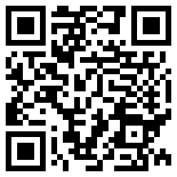

Is this activity too hard?
- Lay a rope on the ground and practise jumping over and back again. Practise big jumps first and then try small, quick jumps.
- When you feel confident doing this, try using a hoop to jump through, instead of a skipping rope.

Is this activity too easy?
- Try skipping backwards. It's the same movements, but in reverse.

Story time in different languages
Learning goal: Children make meaning from a text and respect diversity.
- Listen to a story in a different language via this QR code. Choose between:
- We're going on a bear hunt - told in Arabic
- The little red hen and the grains of wheat - told in Mandarin
- Diary of a wombat - told in Cantonese
- Too many pears - told in Japanese
- Guess how much I love you - told in Italian.
If you can’t access the stories, choose a story from home. Do you have a story in a different language?
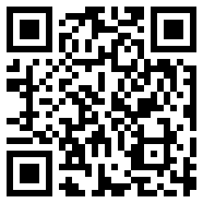
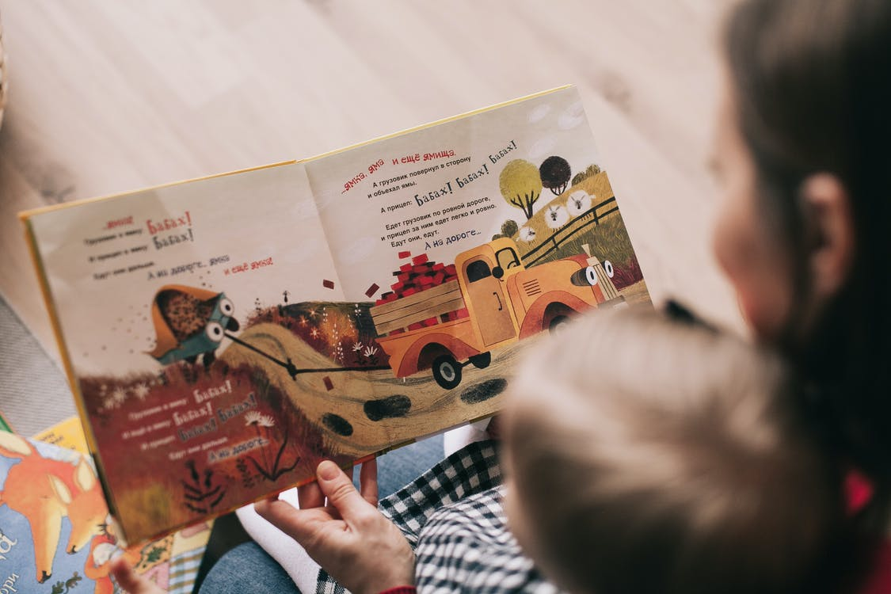
person-reading-a-book-with-a-child by Linda Kivaka, pexels.com
2. Think and talk about these questions:
- How did you find the story?
- Was it in a language you could understand?
- If not, did the pictures help you understand the words?
- What language/s does your family speak at home? Read your favourite story in your language.

Is this activity too hard?
- As you listen to the story of your choice, talk with someone about what you can see in the pictures.

Is this activity too easy?
- Listen to the story again. This time mute the sound and ask someone to read you the English subtitles.

Extra learning activities
Develop literacy concepts through the story, ‘The magic hat’ via this QR code. If you can’t access the story, read a story with someone and talk about the ideas listed below.
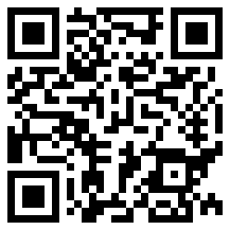
Story discussion:
- What was this story about?
- Who were the main characters?
- How did the story start?
- How did the story end?
© State of New South Wales (Department of Education), 2021
The copyright material published in this document is subject to the Copyright Act 1968 (Cth) and is owned by the NSW Department of Education or, where indicated, by a party other than the NSW Department of Education.
Copyright material available in this document is licensed under a Creative Commons Attribution 4.0 International (CC BY 4.0) licence.
See https://education.nsw.gov.au/about-us/copyright for further details.
