This booklet belongs to:

Week O – Tuesday

Day at a glance:
 | Animal dance | Playing with others | The sky | Caring for a pet | Name collage
Estimated time | 5 mins | 5-10 mins | 15-20 mins | 10-15 mins | 10-15 mins
Resources required |  |  |  |  | Magazines or catalogues, scissors, glue, cardboard

Animal dance
Learning goal: Children share humour and happiness with others.
Watch the video about animal dances and join in the actions via this QR code. If you can’t access the video, play your favourite song and do some of the actions, as listed below.
Animal dance actions:
- jump like a kangaroo
- stomp like a hippo
- waddle like a penguin
- paddle like a duck
- sway like an elephant
- swing like a cat.
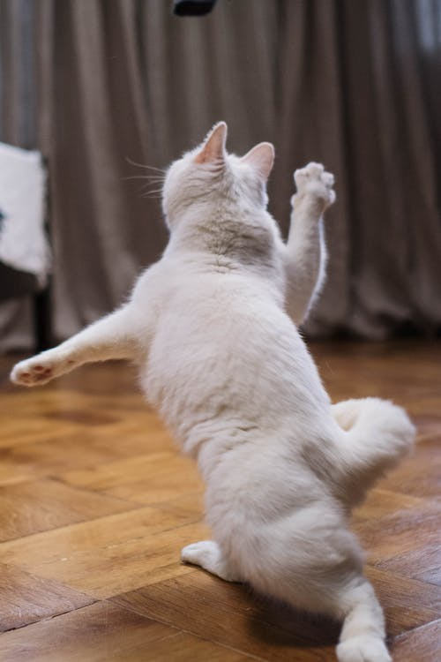
White Cat on Brown Wooden Floor by cottonbro, pexels.com
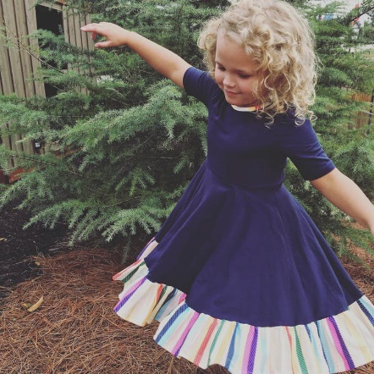
Photo of Girl Wearing Half-sleeved Dress by Jaime Chambers Fausnaugh, pexels.com

Is this activity too hard?
- Do the actions with your arms while seated.
- Do a short section of the video.
- Pause the video so that you have time to practice each move, then try it again.

Is this activity too easy?
- Make up actions for other animals.

Playing with others
Learning goal: Children understand how to initiate and join in play with others.
- Watch this video called 'Learn about play' with Keeko via this QR code. If you can’t access the video, talk with someone in your home about the story written below and go to step 2.
In this video Keeko makes up a game to play by himself because his friends are busy doing other things.
When Dog and Bird come to join the game with Keeko, they find the game a bit too scary and they leave Keeko by himself again! Keeko really wants to play with his friends.
He waves and smiles at his friends and he changes the game so that everyone feels comfortable to play together.
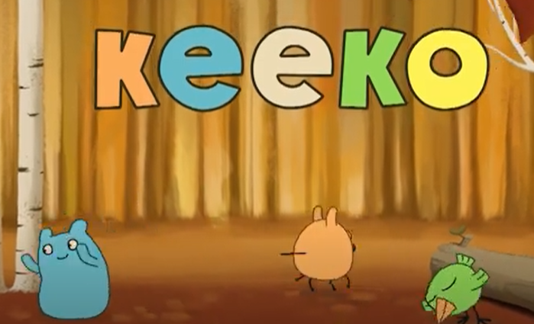
- Talk to someone about the following things:
- How did Keeko's game scare dog and bird away?
- What did Keeko do so all the friends could play together?
- What can you say to invite someone to join your game?

- Practice asking someone to join their game by saying 'Can I play with you please?'.
- What games do you like to play alone?
- What games do you like to play with others?

The sky
Learning goal: Children build an appreciation for the natural world.
Listen to the poem via this QR code, or ask someone in your home to read the poem below with you.
The Sky by Ruth Garlick
When I look up and see the sky
I cannot help but wonder why
And marvel how she came to be
The sky that looks down upon me.
Beyond tall trees and mountains high,
The blue of the day and black of night.
From calm to angry to quite polite,
The clouds of floss, soft whites and greys,
Or red hued sunsets to end the days.
The brooding charcoal thunder clouds,
Or veiled wet mists and foggy shrouds.
When I look up to see the sky
I cannot help but wonder why,
And marvel how she came to be,
The sky that looks down upon me.
- Go outside and lay down somewhere where you can look up into the sky (don't look directly at the sun).
- Think back to the poem and look at the pictures below. Is the sky you are looking at like any of these?
- Have another look at the book or the photos below. Does your sky today look like any of these?
- Take a photo, draw or paint a picture of the sky that you can see today.
- Do the same thing tomorrow. How is the sky the same or different?

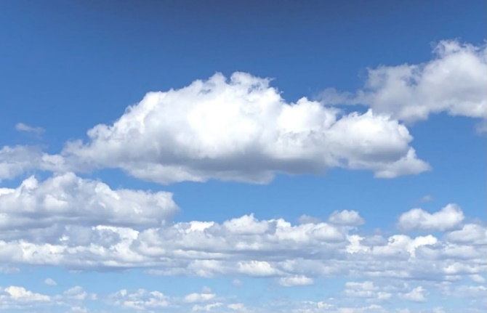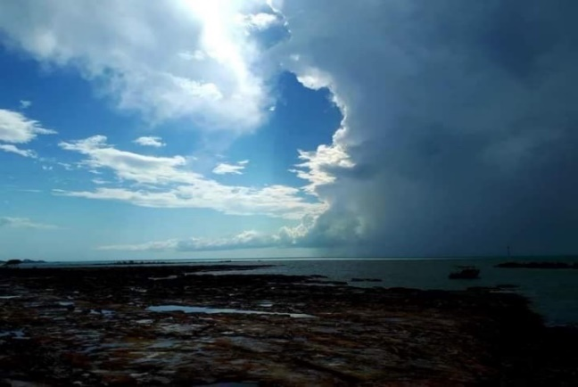

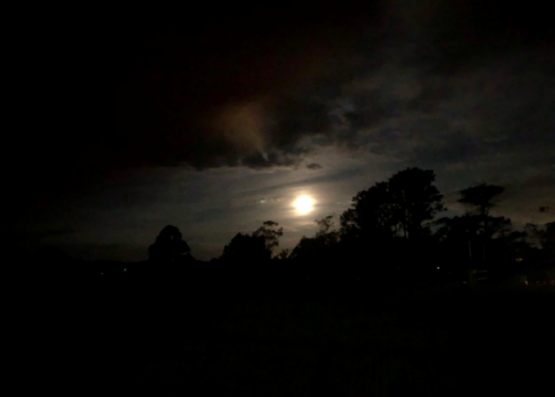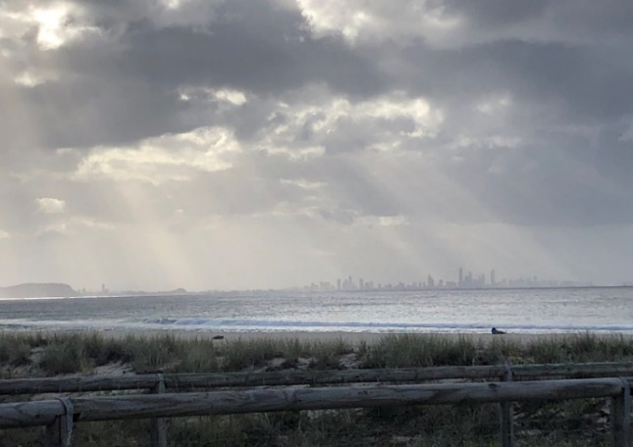

Is this activity too hard?
- Look outside. Tell someone what the sky looks like today.

Is this activity too easy?
- Think of some words to describe your drawing or painting of the sky. Ask someone to write these words on your picture or copy words from the poem.

Take a break
Here are some things you might like to do:
- have a drink of water and a healthy snack
- play or have a rest
- go to the toilet and wash your hands.

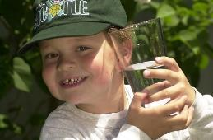
"Boy with glass of water, 2000" by Seattle Municipal Archives is licensed under CC BY 2.0
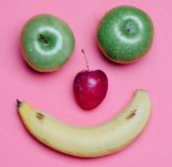
Smile made of ripe fruits by Any Lane, pexels.com
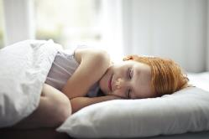
Photo by Andrea Piacquadio. pexels.com
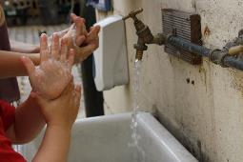
"Washing hands" by magnusfranklin is licensed under CC BY-NC 2.0

Caring for a pet
Learning goal: Children express interest in learning about living things.
Pets are an important part of many families. Unlike wild animals, pets need humans to keep them happy, healthy and safe.
1. Listen to the book about caring for pets via this QR code. If you can’t access the book, go to step 2.
2. Think about your own pet, or a pet that you would like to have in your family.
3. Draw or paint your pet looking happy, healthy and safe.
4. Add to your picture or draw a new picture of you taking care of your pet.
5. Ask someone to help you write about what you can do to take care of your pet.
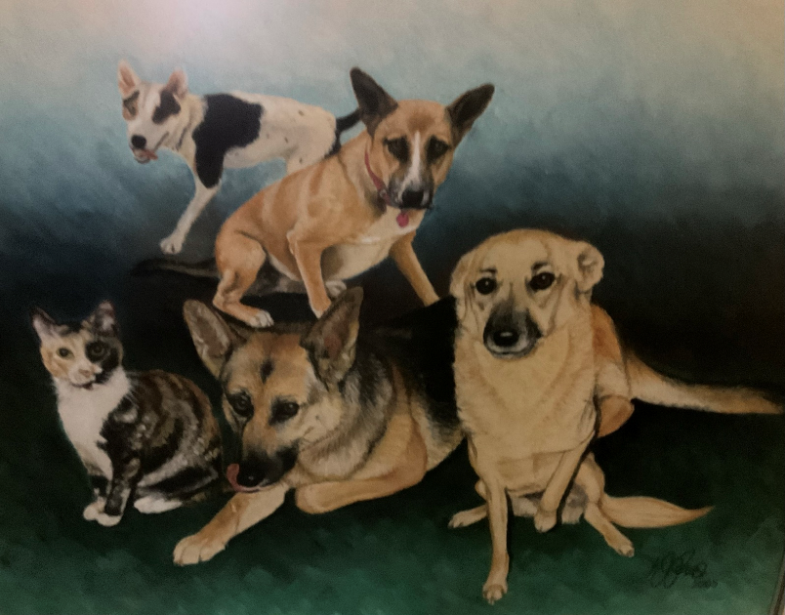
Art work by Kellie Power

Is this activity too hard?
- Draw a picture of your favourite pet.
- Think about its features.
- Draw something that it needs (think about water, food, shelter, love).

Is this activity too easy?
- Make a book about a pet. Include the things that it will need and ask someone to write your ideas on each page.

Name collage
Learning goal: Children recognise their written name.
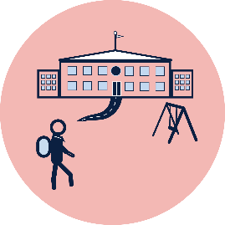
When you start school, you will need to be able to recognise your name so you can look after your belongings. Your name will be written on the things you take to school with you, for example, your books, pencils, lunch box and hat.
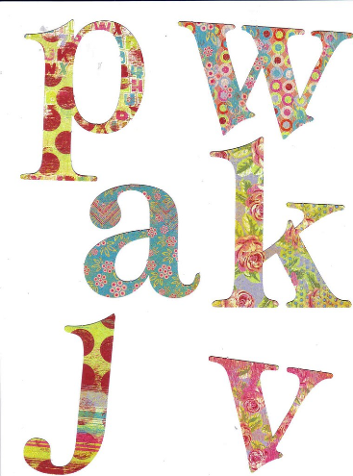
"Free letter collage sheet" by rubyblossom. is licensed under CC BY-NC-SA 2.0.
1. Look through catalogues and magazines for the letters in your name.
2. Cut each letter out.
3. Glue the letters on cardboard in the right order to spell your name.
4. Also glue down any pictures you found that you like.

Is this activity too hard?
- Ask someone to write each letter from your name on a piece of paper. Put the letters in the right order to spell your name.

Is this activity too easy?
- Find the letters to your last name also.
- Make your name in another way.

Extra learning activities
Choose one of the Penguin Books read aloud stories to enjoy via this QR code. If you can’t access the stories, choose one of your favourite books and ask someone to it read with you.
.
© State of New South Wales (Department of Education), 2021
The copyright material published in this document is subject to the Copyright Act 1968 (Cth) and is owned by the NSW Department of Education or, where indicated, by a party other than the NSW Department of Education.
Copyright material available in this document is licensed under a Creative Commons Attribution 4.0 International (CC BY 4.0) licence.
See https://education.nsw.gov.au/about-us/copyright for further details.

