# This booklet belongs to:

## Week O – Thursday

### Day at a glance:

|  |  |  |  |  |  |
| --- | --- | --- | --- | --- | --- |
|  | Crossing the road at school | Joke sharing | Shared story | Five finger starfish | Make an artwork |
| Estimated time | 30 mins | 10 mins | 30 mins | 5 mins | 30 mins |
| Resources required | Chalk, cardboard, toy cars |  |  |  | Natural materials |

## Crossing the road at school

Learning goal: Children learn how to cross the road safely.

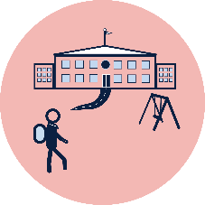

You will need to cross the road to get to your new school. It is important you know how to do this safely.

1. Always hold an adult's hand to cross the road. If your adult's hands are full, hold onto their bag, clothes or a pram.

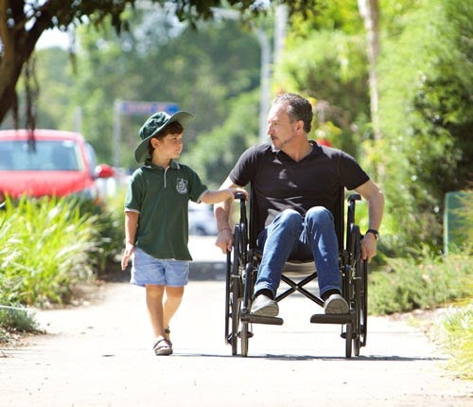

Image source: [safetytown.com.au](https://www.safetytown.com.au/)

1. Always remember to:

* STOP! one step back from the kerb.
* LOOK! continuously look both ways.
* LISTEN! for the sounds of approaching traffic.
* THINK! is it safe to cross?

1. As you walk to and from school, cross each road in the safest place. Safe places to cross the road include:

Pedestrian or zebra crossing

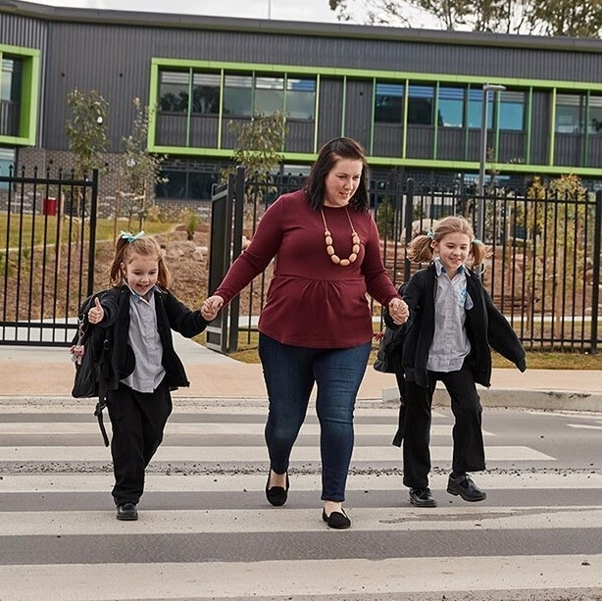

Image owned by the NSW Department of Education under the Copyright Act 1968 (Cth)​

Children's crossing with the help of an adult crossing supervisor

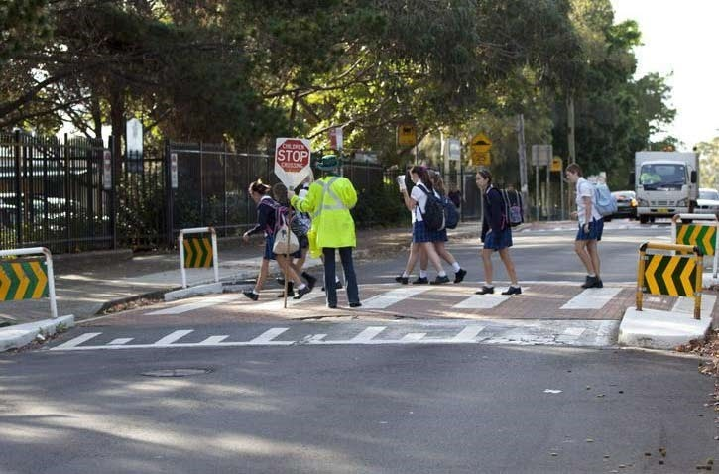

Image source: [safetytown.com.au](https://www.safetytown.com.au/)

Traffic lights when the green walk light is showing

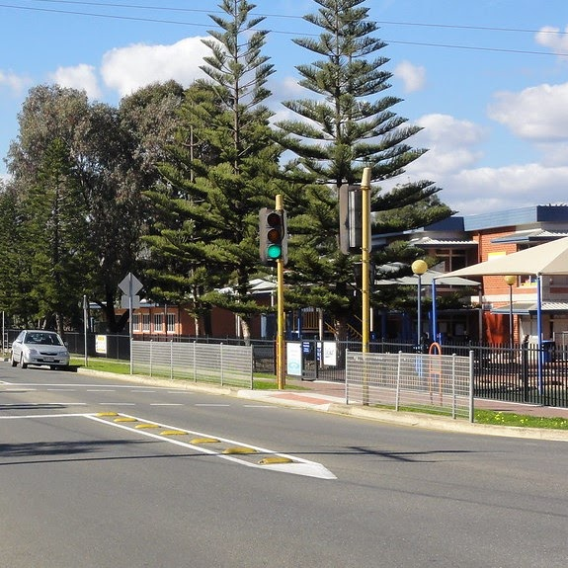

["Very old traffic lights still in use"](https://www.flickr.com/photos/49428593@N08/8348108981) by [RS 1990](https://www.flickr.com/photos/49428593@N08) is licensed under [CC BY-NC-SA 2.0](https://creativecommons.org/licenses/by-nc-sa/2.0/?ref=ccsearch&atype=rich)

Pedestrian refuge island

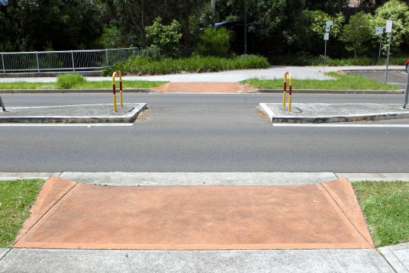

Image source: [safetytown.com.au](https://www.safetytown.com.au/)

1. On cardboard (or on cement with chalk), draw some roads. Draw other things near your roads, such as your new school, shops, houses and a park. Also draw some pedestrian or zebra crossings.
2. Drive your toy cars on the roads. Make sure the cars stop at each zebra crossing to let people cross the road safely.

For families:

* View the ‘Road safety: Tips for parents and carers’ web page via this QR code. If you can’t access the code, information can be found at your local Roads and Traffic Authority (RTA).

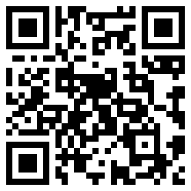

* View a video giving information about the driving road rules around crossings near schools via this QR code. If you can’t access the code, information can be found at your local Roads and Traffic Authority (RTA).

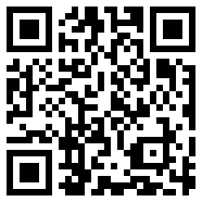

### Is this activity too hard?

* Next time you are out walking with an adult, each time you come to a road, talk about choosing the safest spot to cross.

### Is this activity too easy?

* Make a poster which tells other children how to cross the road safely.

## Joke sharing

Learning goal: Children share humour and happiness with others.

Everyone loves to laugh! It makes us feel really good. Listen to these jokes and then share them with other people to make them laugh.

1. How do we know that the ocean is friendly? It waves.
2. How are false teeth like stars? They come out at night.
3. How do you talk to a giant? Use big words.
4. What falls in winter but never gets hurt? Snow.
5. What do you call a dinosaur that is sleeping? A dino-snore.
6. What did the left eye say to the right eye? Between us, something smells.

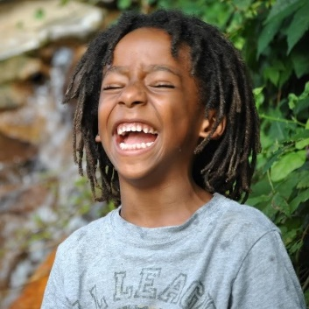

["Child laughing"](https://www.flickr.com/photos/12842205@N08/6019067180) by [cheriejoyful](https://www.flickr.com/photos/12842205@N08) is licensed under [CC BY 2.0](https://creativecommons.org/licenses/by/2.0/?ref=ccsearch&atype=rich)

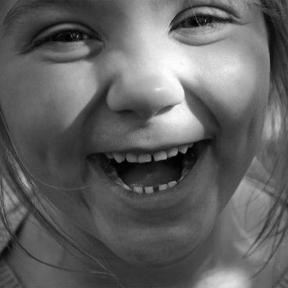

["Laughing"](https://www.flickr.com/photos/45635774@N00/5103671335) by [Clover_1](https://www.flickr.com/photos/45635774@N00) is licensed under [CC BY-NC 2.0](https://creativecommons.org/licenses/by-nc/2.0/?ref=ccsearch&atype=rich)

### Is this activity too hard?

* Listen to the jokes and decide which is the funniest one. Tell someone this joke.

### Is this activity too easy?

* Make up your own jokes. Share these with someone.

## Shared story- Magic Beach

Learning goal: Children engage in imaginative play to explore the environment.

Watch the video about the story “The Magic Beach” via this QR code. If you can’t access the video, start at step 4.

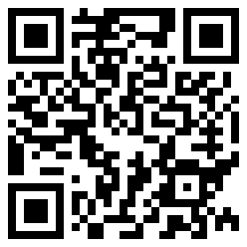

1. Alison Lestor used interesting words to describe the different things at the beach. She said the sea is sparkling and the rock pools are clear and warm.
2. Can you think of any more words to describe the pictures in the book?
3. The children in the story pretend that lots of magical things are happening at the beach like riding wild horses in the water, fighting a dragon in a sand castle and sailing towards far away islands.
4. If you go to the beach, what things do you like to do?
5. Pretend you are at the beach now. Make up a game about being at the beach. You could use blankets for the water and your toys for sea creatures.

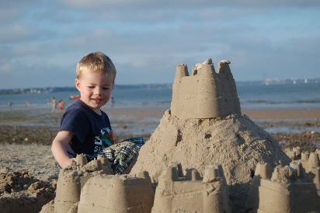

"[Building a Sand Castle](https://www.flickr.com/photos/lupinoduck/3859232864)" by [lupinoduck](https://www.flickr.com/photos/lupinoduck/) is licensed under CC BY-ND 2.0

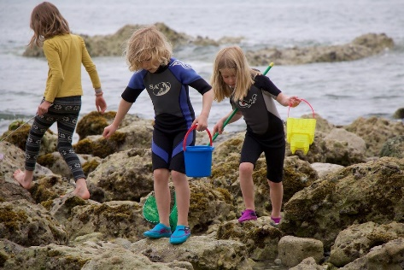

"[Seafood beachcombers](https://www.flickr.com/photos/dickdotcom/20287401674/in/photostream/)" by [Richard Leeming](https://www.flickr.com/photos/dickdotcom/) is licensed under CC BY-SA 2.0

## Take a break

Here are some things you might like to do:

* have a drink of water and a healthy snack
* play or have a rest
* go to the toilet and wash your hands.

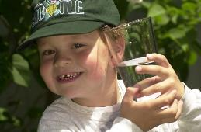

["Boy with glass of water, 2000"](https://www.flickr.com/photos/24256351@N04/4493850909) by [Seattle Municipal Archives](https://www.flickr.com/photos/seattlemunicipalarchives/) is licensed under [CC BY 2.0](https://creativecommons.org/licenses/by/2.0/?ref=ccsearch&atype=rich)

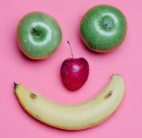

[Smile made of ripe fruits](https://www.pexels.com/photo/smile-made-of-ripe-fruits-5946078/) by [Any Lane](https://www.pexels.com/@any-lane?utm_content=attributionCopyText&utm_medium=referral&utm_source=pexels), [pexels.com](https://www.pexels.com/)

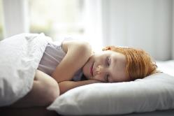

Photo by [Andrea Piacquadio](https://www.pexels.com/@olly?utm_content=attributionCopyText&utm_medium=referral&utm_source=pexels). [pexels.com](https://www.pexels.com/)

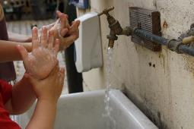

["Washing hands"](https://www.flickr.com/photos/37205550@N00/7917857524) by [magnusfranklin](https://www.flickr.com/photos/37205550@N00/with/7917857524/) is licensed under [CC BY-NC 2.0](https://creativecommons.org/licenses/by-nc/2.0/?ref=ccsearch&atype=rich)

## Five finger starfish

Learning goal: Children practice ways to calm themselves down.

Watch the video via the QR code and follow the instructions. If you can’t access the video, start at step 2.

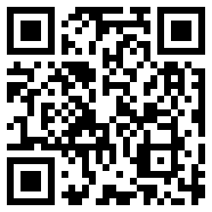

1. Practice starfish breathing next time you need to calm down.
2. Follow the arrows on the photo of the hand below to do ‘5 finger breathing’.

* Start by pointing a finger at the bottom of the thumb on your other hand.
* Breathe in and trace your finger up to the top of your thumb.
* Breathe out and trace your finger down the other side of your thumb.
* Breathe in as your finger traces up one side of the next finger, and then out as it traces down the other side of your finger.
* Continue, breathing in and out as you trace each of your fingers.

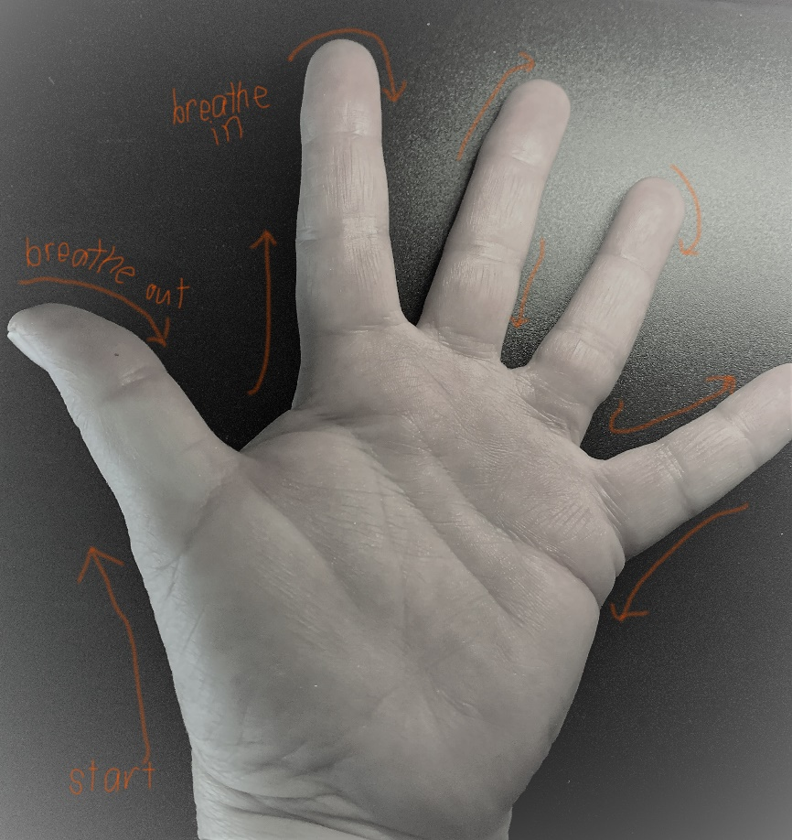

### Is this activity too hard?

* Pretend to be a starfish, take big breaths in and out.

### Is this activity too easy?

* Think of a time that you have needed to calm down. How did you calm yourself?
* Draw a picture of a starfish and hang it somewhere as a reminder to do your starfish breathing when you need.

## Make an artwork using natural materials

Learning goal: Children explore the natural world to create an artwork.

Nature gives us lots of things to enjoy. As you walk around outside, you'll find that nature has dropped things onto the ground that can be used to make artworks.

1. Read the book via this QR code. If you can’t access the book, use the pictures below to guide you from step 2.

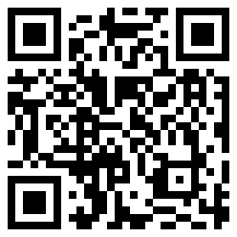

2. Think about what you could create using natural materials.

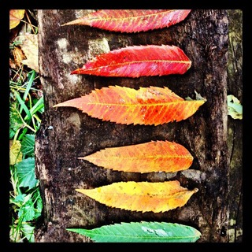

"[Nature Art](https://www.flickr.com/photos/groovenite/8321883040/in/photolist-dFnPU5)" by [renatomitra](https://www.flickr.com/photos/groovenite/8321883040/in/photolist-dFnPU5) is licensed under CC BY-SA 2.0

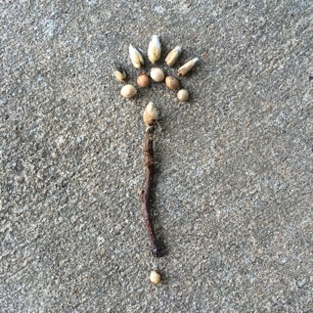

"[Nature art](https://www.flickr.com/photos/merwing/28377063851/in/photolist-KezSrz-TW4AQ3-8UpTAW-8UmPxV-TrxruU-NqLnJG-TWyEvo-U7RphN-mAU3qr-mATAfc-mAVdom-GEguqZ-Nnixr5-Zfzrpg-Jy5v2T-YPgPPs-JUqdVW-VAqSrN-UrhexB-VMEoJy-VELTVD-XmSk5p-C73xnj-Z8S6hm-C73ys5-Uyzr4E-bT7E7a-N7f7V4-Udiqqr-2h6oFa3-bzRsR4-8UmPvD-LPhyfQ-XXcyv2-KaekKR-Y8nwHW-YUexGN-YUevPj-YbWPYH-Nz37Y9-YPgULw-C73BZA-XXcsMD-XXcrMn-TYV3kn-eFwqXQ-XXcxjp-W2PtQZ-UZRZ6a-YVJ6Md)" by [merwing✿little dear](https://www.flickr.com/photos/merwing/48631551857/) is licensed under CC BY-NC-ND 2.0

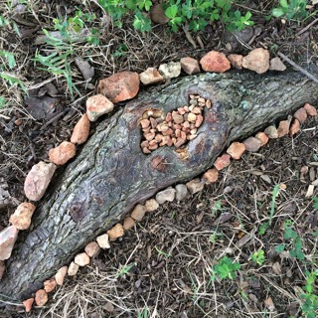

"[Nature art](https://www.flickr.com/photos/merwing/28160168232/)" by [merwing✿little dear](https://www.flickr.com/photos/merwing/48631551857/) is licensed under CC BY-NC-ND 2.0

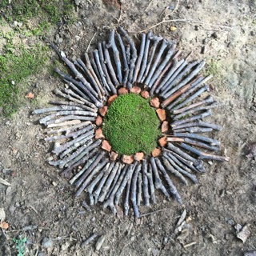

"[nature art](https://www.flickr.com/photos/merwing/37501324616/)" by [merwing✿little dear](https://www.flickr.com/photos/merwing/48631551857/) is licensed under CC BY-NC-ND 2.0

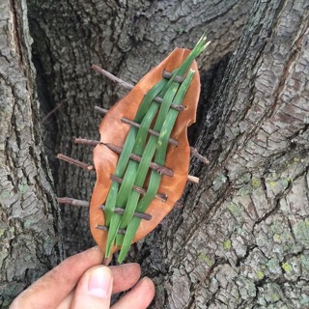

"[today's nature art](https://www.flickr.com/photos/merwing/27929990241/)" by [merwing✿little dear](https://www.flickr.com/photos/merwing/48631551857/) is licensed under CC BY-NC-ND 2.0

3. Go outside and create an artwork using things you find on the ground.

4. Ask an adult before you pick flowers or leaves from trees and bushes to add to your artwork.

### Is this activity too hard?

* Collect things from the ground and show someone what you found.
* Ask them to help you arrange the items you found in a line.

### Is this activity too easy?

* Take a photo of your artwork and think of words to describe it. Title your artwork and put it on display.

## Extra Learning activities

If you’re interested in animals:

* watch the Taronga Zoo [seal show](https://video.link/w/BouLc) via this QR code

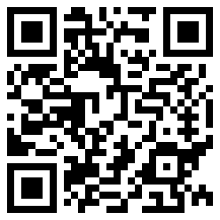

* watch the Taronga Zoo [bird show](https://video.link/w/hquLc) via this QR code.

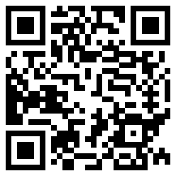

If you can’t access the codes, find an animal book in your home and read it with someone.

**© State of New South Wales (Department of Education), 2021**

The copyright material published in this document is subject to the Copyright Act 1968 (Cth) and is owned by the NSW Department of Education or, where indicated, by a party other than the NSW Department of Education.

Copyright material available in this document is licensed under a Creative Commons Attribution 4.0 International (CC BY 4.0) licence.

See <https://education.nsw.gov.au/about-us/copyright>for further details.

