# This booklet belongs to:

## Week O - Monday

### Day at a glance:

|  |  |  |  |  |  |
| --- | --- | --- | --- | --- | --- |
|  | Say hello in many languages | Three for the sea | Playdough maths | Simon says | Shared story |
| Estimated time | 5-10 mins | 15-20 mins | 15-20 mins | 5 mins | 10-15 mins |
| Resources required |  | Rubbish bag | Playdough | Chair |  |

## Say hello in many languages

Learning goal: Children learn greetings in a number of languages.

Watch the video and listen to the song via this QR code. In it children say hello in many different languages. If you can’t access the video, start at step 2.

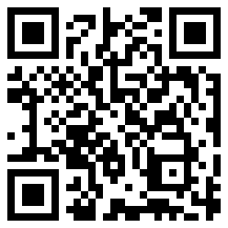

1. Watch the video again, this time copy the children to say 'hello' in different languages.
2. Which language/s do you speak at home?
3. How do you say 'hello' in your home language?

### Is this activity too hard?

* There are many ways to acknowledge or greet someone:
* use a gesture or keyword sign to say hello
* select a visual to say hello
* look at someone and smile
* say 'hi' instead of hello
* Practice saying 'hello.'
* Choose one language from the video and practice saying hello to someone in this language.

### Is this activity too easy?

* Start using one of the languages from the video to greet people at home.
* Ask someone to help you research how to say goodbye in the languages from the video.

## Three for the sea

Learning goal: Children are curious and enthusiastic participants in their learning.

Every bit of rubbish hurts our oceans. Plastic rubbish can be swept from the land into our drains. It then flows to the waterways and into the ocean. We can all help by taking '3 for the sea' every time we go out.

1. Watch the videos via these QR codes. If you can’t access the videos, start at step 2.

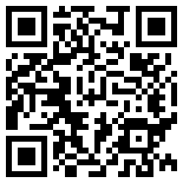

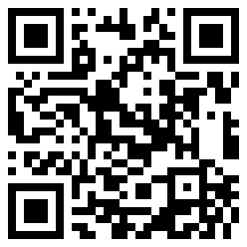

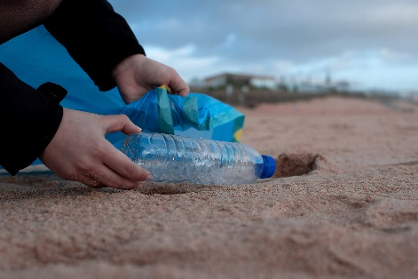

[Person Holding Clear Plastic Bottle](https://www.pexels.com/photo/person-holding-clear-plastic-bottle-3480494/) by Marta Ortigosa, pexels.com

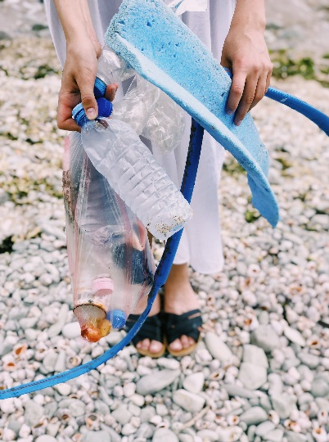

[Person Holding Plastic Bottles and Hose](https://www.pexels.com/photo/person-holding-plastic-bottles-and-hose-1201589/) by Daria Shevtsova, pexels.com

1. Next time you go for a walk, take a bag to collect plastic rubbish.
2. Pick up 3 pieces of plastic rubbish using gloves or a bag.
3. Put the rubbish in the bin and things that can be recycled in a recycling bin.
4. Wash your hands.
5. Listen to this story about how Ruth collected more than 3 for the sea!

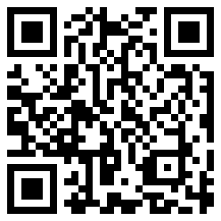

### Is this activity too hard?

* Help at home by putting rubbish in the bin and things that can be recycled in the recycling bin.

### Is this activity too easy?

* Take photos or draw pictures of the rubbish you picked up when you were out and about. Use these to make a story. Share your story with someone.

## Playdough maths - Part 2

Learning goal: Children use materials to learn about number and counting.

You will need playdough to do this activity. If needed, follow this recipe.

**Ingredients**

* 2 cups plain flour
* 4 tablespoons cream of tartar
* 2 tablespoons cooking oil
* 1 cup salt
* food colouring
* 2 cups hot water

**Method:**

1. Mix all dry ingredients together.

2. Add oil to the mixture.

3. Slowly add the hot water and mix until the consistency is ready to knead.

4. Knead the dough, adding more flour or water if needed.

5. Add a few drops of food colour.

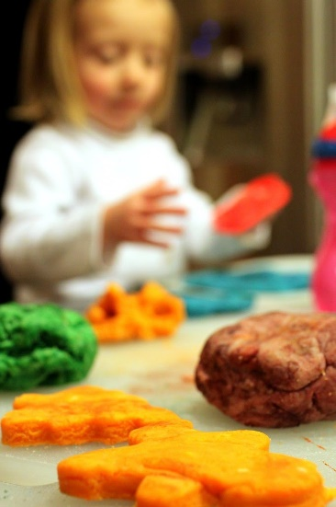

["46/366 Playdough (homemade)"](https://www.flickr.com/photos/9544139@N05/6884254351) by [MCA / Mike Allyn](https://www.flickr.com/photos/9544139@N05) is licensed under [CC BY 2.0](https://creativecommons.org/licenses/by/2.0/?ref=ccsearch&atype=rich)

1. Make these things with the playdough:

* 4 things that you might pack in a lunchbox
* 3 pieces of furniture
* 2 people from your family
* 1 item of your choice.

1. How many things did you make all together?

### Is this activity too hard?

Use the playdough to make:

* 3 balls and 2 snakes
* something of your own choice.

### Is this activity too easy?

* Roll out your playdough so it is flat. Use small objects such as sticks or plastic toys to push shapes into the playdough.
* Arrange the shapes so they are in a repeating pattern. Count how many shapes you used altogether.

## Take a break

Here are some things you might like to do:

* have a drink of water and a healthy snack
* play or have a rest
* go to the toilet and wash your hands.

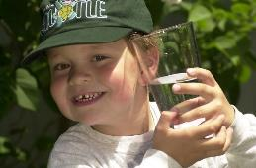

["Boy with glass of water, 2000"](https://www.flickr.com/photos/24256351@N04/4493850909) by [Seattle Municipal Archives](https://www.flickr.com/photos/seattlemunicipalarchives/) is licensed under [CC BY 2.0](https://creativecommons.org/licenses/by/2.0/?ref=ccsearch&atype=rich)

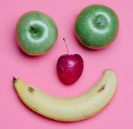

[Smile made of ripe fruits](https://www.pexels.com/photo/smile-made-of-ripe-fruits-5946078/) by [Any Lane](https://www.pexels.com/@any-lane?utm_content=attributionCopyText&utm_medium=referral&utm_source=pexels), [pexels.com](https://www.pexels.com/)



Photo by [Andrea Piacquadio](https://www.pexels.com/@olly?utm_content=attributionCopyText&utm_medium=referral&utm_source=pexels). [pexels.com](https://www.pexels.com/)

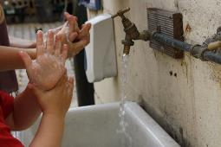

["Washing hands"](https://www.flickr.com/photos/37205550@N00/7917857524) by [magnusfranklin](https://www.flickr.com/photos/37205550@N00/with/7917857524/) is licensed under [CC BY-NC 2.0](https://creativecommons.org/licenses/by-nc/2.0/?ref=ccsearch&atype=rich)

## Simon says

Learning goal: Children understand and use positional language.

Ask someone to play 'Simon says' with you. You will need a chair.

1. One person gives instructions for the other to follow, starting with 'Simon says'. The instructions should include words that tell the person 'where' to be, for example, Simon says:

* sit **on** the chair
* lay in **front** of the chair
* hide **under** the chair
* stand **behind** the chair
* sit **beside** the chair.

1. Swap roles, so the other person gives the instructions to be followed.

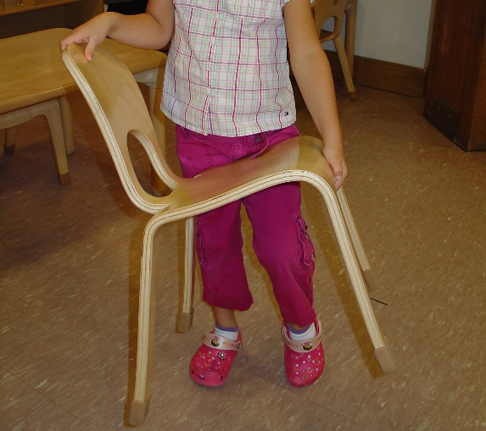

[This photo](https://www.montessorialbum.com/montessori/index.php?title=File:Chair_carry_2.JPG) by Unknown Author is licensed under [CC BY-SA-NC](https://creativecommons.org/licenses/by-nc-sa/3.0/)

### Is this activity too hard?

* Play the game using hand positions, for example:
* Simon says put your hands on your head.
* Simon says put your hands behind your back.
* Simon says put your hands in front of your eyes.
* Play a game with only 2 or 3 different instructions, for example:
* Simon says stand in front of the chair.
* Simon says stand behind the chair.
* Simon says sit on the chair.

### Is this activity too easy?

* Include an extra game rule that when the person giving the instructions doesn't start the instruction with 'Simon says', the instruction should not be followed.
* Go outside and give more detailed instructions, for example, Simon says:
* stand under the smallest tree
* lay on top of the table
* sit beside the back fence.

## Shared story: When Frank was four

Learning goal: Children recognise their own growth and achievement.

Watch the video and listen to the story via this QR code. If you can’t access the story, start at step 1.

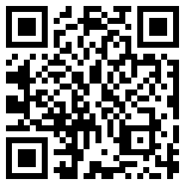



[Baby Sleeping on White Cotton](https://www.pexels.com/photo/baby-sleeping-on-white-cotton-161709/) by Pixabay, pexels.com

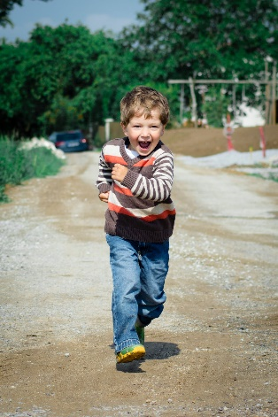

[Boy Wearing Red, Brown, and White Stripe Sweater Running Photo](https://www.pexels.com/photo/boy-wearing-red-brown-and-white-stripe-sweater-running-photo-1104007/) by Luna Lovegood, pexels.com



[Woman in White Blazer Holding Book](https://www.pexels.com/photo/woman-in-white-blazer-holding-book-5211463/) by Max Fischer, pexels.com

1. Talk with someone in your family about what you could do when you were 1, 2 and 3.
2. How old are you now? What can you do?
3. What can you do this year that you couldn't do last year?
4. What do you think you will be able to do when you are 5? What about when you are 6 or 7?

### Is this activity too hard?

* Look at photos of yourself at 1, 2, 3 and now. Discuss with someone and celebrate the things that you have learnt to do each year.

### Is this activity too easy?

* Make a book using these sentences:
  + When I was 1 I could ... (draw or write one thing you could do at one).
  + When I was 2 I could ....
  + When I was 3 I could ....
  + Now I am 4 I can ....
  + When I am 5 I will be able to ....

## Extra learning activities

Develop literacy concepts through the story ‘Room on the broom’ via this QR code. If you can’t listen to the story, choose a favourite story from home and have someone in your home follow the activity below.

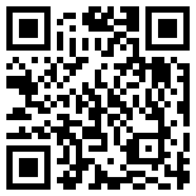

Encourage your child/children to help retell the story by making the characters with playdough or puppets using drawings attached to a stick or cardboard. As the story is retold, place emphasis on the rhyming words, explaining that words that rhyme end with the same sound.

**© State of New South Wales (Department of Education), 2021**

The copyright material published in this document is subject to the Copyright Act 1968 (Cth) and is owned by the NSW Department of Education or, where indicated, by a party other than the NSW Department of Education.

Copyright material available in this document is licensed under a Creative Commons Attribution 4.0 International (CC BY 4.0) licence.

See <https://education.nsw.gov.au/about-us/copyright>for further details.

