This booklet belongs to:

Week O – Friday

Day at a glance:
 | Responding to feelings | Pressing and preserving flowers | Stretching for relaxation | Explore a tree | Water flows down
Estimated time | 10 mins | 30 mins | 10 mins | 30 mins | 45 mins
Resources required |  | Flowers, large book, container |  | Tape measure, magnifying glass, crayon, paper

Responding to feelings
Learning goal: Children think about how they respond to different feelings.
Watch the video via the QR code and copy the actions. If you can’t access the video, start at step 2.
1. What did the dinosaur do when it was:
- angry
- frightened
- happy
- sad
- tired?
2. What do you do when you are:
- angry
- frightened
- happy
- sad
- tired
- hungry?

Is this activity too hard?
- Pause the video after each dinosaur feeling so you can talk about it with someone.

Is this activity too easy?
- What other feelings might the dinosaur have?
- What might the dinosaur do when it feels each of these feelings?

Pressing and preserving flowers
Learning goal: Children are curious participants in their learning.
Fresh flowers look lovely in a vase. Eventually though, they will dry and the petals will fall off. Did you know that you can preserve flowers?
1. Read the book about pressing flowers via this QR code. If you can’t access the book, start at step 2.
2. Ask an adult to help you pick some flowers.
3. Pick enough to use some for preserving, and some to keep in a vase at home.
4. Follow these instructions to preserve some of the flowers:
- Choose the flowers you would like to press. Lay them between two pieces of paper.
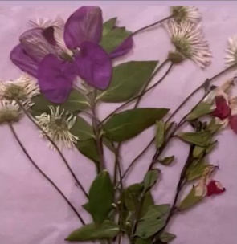
- Place the flowers and paper in the middle of a thick book.
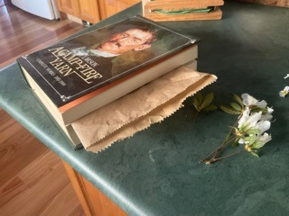
- Add more heavy books for pressing.
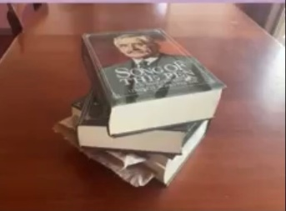
- After four weeks, compare the flowers in the vase to the ones you pressed. What do you notice?

Stretching for relaxation
Learning goal: Children use stretching and balancing activities to recharge and relax.
Stretching makes our muscles feel nice and loose. It is a good way to warm up before exercise, or to cool down after exercise. Watch the video and copy each stretch. If you can’t access the video, follow some of the suggestions below.
Suggestions:
- reach your arms up high towards the sky
- reach down low and touch your toes
- stretch your legs out and bend your body to one side
- then the other
- move your head slowly from one side to the other
- relax on the floor.

Is this activity too hard?
- Try one or two stretches from the video. Watch the video again on another day and do a couple more stretches.

Is this activity too easy?
- Stretch each morning or afternoon as a part of your daily routine.

Take a break
Here are some things you might like to do:
- have a drink of water and a healthy snack
- play or have a rest
- go to the toilet and wash your hands.
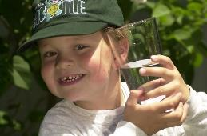
"Boy with glass of water, 2000" by Seattle Municipal Archives is licensed under CC BY 2.0
Smile made of ripe fruits by Any Lane, pexels.com
Photo by Andrea Piacquadio. pexels.com
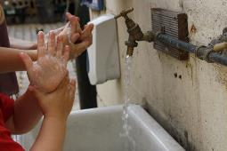
"Washing hands" by magnusfranklin is licensed under CC BY-NC 2.0

Explore a tree
Learning goal: Children develop skills of investigation.
Watch the video via this QR code. If you can’t access the video, start at step 1.
- Pick a tree you would like to investigate and draw.
- Use a tape measure to measure how tall it is. Measure around the trunk of the tree.
- Use a magnifying glass to look carefully at the tree's leaves.
- Use a crayon to create a bark rubbing.
- Draw a picture of the tree
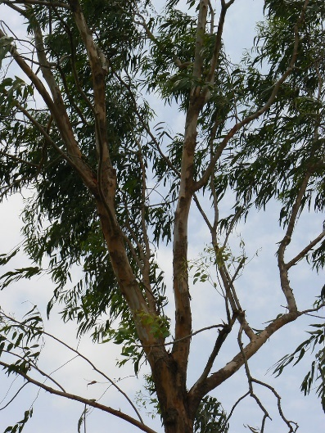
"Eucalyptus tree" by Dinesh Valke is licensed under CC BY-SA 2.0

Water flows down
Learning goal: Children explore properties of the natural world.
Watch the video via this QR code. If you can’t access the video, go to step 1.
- Go outside with an adult and find somewhere you can make your own river. An area of dirt or a sandpit would work well.
- Use a garden trowel or stick to make a path for water to follow.
- Pour water gently onto the ground.
- Watch where the water flows. What did you notice?
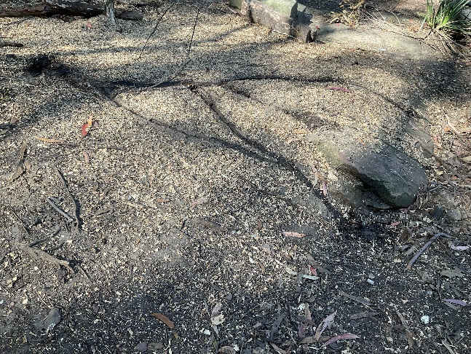
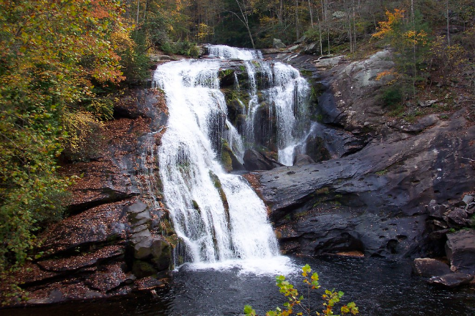
"Ocoee River System, Tennessee" by beshagidt is licensed under CC BY-ND 2.0

Is this activity too hard?
- Find a little slope and gently pour water at the top. Watch where the water flows.

Is this activity too easy?
- Use your trowel along with stones, banked up mud, or items from nature to build a pathway for the water. Build features such as dams, lakes, streams, islands and water falls.

Extra learning activities
Develop literacy concepts through story “We're going on a bear hunt” via this QR code. If you can’t access the activity, choose a story book and see the family tips below to support literacy development.
Family tip:
Adults talking about pictures, asking questions and encouraging young children to talk about what they have seen and heard develops oral language skills which support literacy and numeracy skills.
© State of New South Wales (Department of Education), 2021
The copyright material published in this document is subject to the Copyright Act 1968 (Cth) and is owned by the NSW Department of Education or, where indicated, by a party other than the NSW Department of Education.
Copyright material available in this document is licensed under a Creative Commons Attribution 4.0 International (CC BY 4.0) licence.
See https://education.nsw.gov.au/about-us/copyright for further details.

