This booklet belongs to:

Week N – Wednesday

Day at a glance:
 | Shadows | Celebrate | Be a scientist | Eating healthy food | Jigsaw puzzles
Estimated time | 15 minutes | 30 minutes | 15 minutes | 20 minutes | 15 minutes
Resources required | Torch, small toys or objects |  |  |  | Something to draw with and on, scissors

Shadows
Learning goal: Children experiment to create shadows of different sizes and shapes
Watch the video, ‘Play School Science Time: Shadows’, via this QR code. If you can’t watch the video, start at step 1.
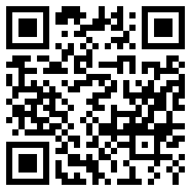
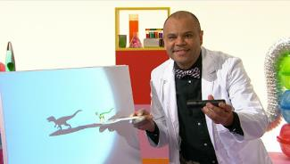
Image from the Play School Science Time: Shadows
- Find a blank section of a wall.
- Turn the light off and close the curtains or blinds.
- Hold different toys or objects and then shine the torch on them to make a shadow.

Is this activity too hard?
- Ask someone to hold the object for you, as you shine the torch. What do you see?
- When you are outside next, observe shadows on the ground and against buildings.

Is this activity too easy?
- Think about how you make shadows of different shapes and sizes? Test your ideas.
- Find an object that will create a spiky, sharp shadow.
- Find an object that will create a round shadow.

Celebrate
Learning goal: Children broaden their understanding of different celebrations.
Children all around the world celebrate different things. Celebrations are a time for people to happily come together for something important or a special life event.
- Listen to Mary and Ruth discussing how their families celebrate Christmas via this QR code. If you can’t listen to the conversation, talk with someone in your home about the things your family celebrates.
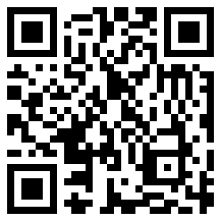
- Watch a second video to see children from all around the world dancing and singing via this QR code. Join in with the singing or copy the dance actions.
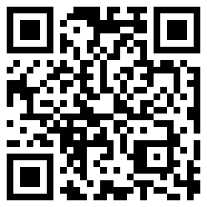
If you can’t watch the video, look at the images below and think how children celebrate different things across the world.
Children celebrating with musical instruments
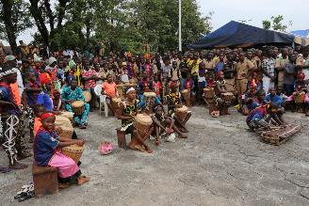
"Children celebrating #bednet distribution in Guinea" by unicefguinea is licensed under CC BY-NC 2.0
Celebrating Christmas
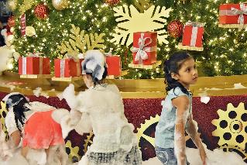
"Tanglin Mall" by chooyutshing is licensed under CC BY-NC-SA 2.0
Celebrating Eid
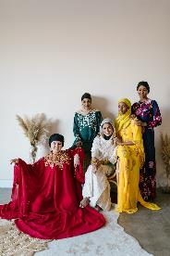
Photo by RODNAE Productions under Pexels License
Celebrating Diwali
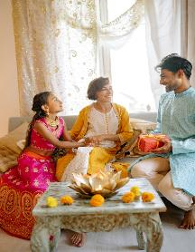
Photo by Yan Krukov under Pexels License

Is this activity too hard?
- What things do you like to celebrate?

Is this activity too easy?
- Draw a picture of your favourite celebration.
- Ask a friend what their family celebrates. Is this the same or different to what your family celebrates?

Be a scientist
Learning goal: Children communicate their observations.
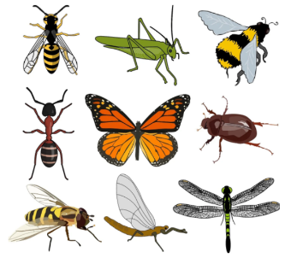
Image by ArtsyBee, under Pixabay License
- What do you notice about these amazing insects?
- How many insects are there?
- What colours can you see?
- What do these insects have in common?
- How are these insects different?

Is this activity too hard?
- Talk with someone about what you see in the picture.

Is this activity too easy?
- Go outside and look for insects. Write or draw a list of the insects that you see.

Take a break
Here are some things you might like to do:
- have a drink of water and a healthy snack
- play or have a rest
- go to the toilet and wash your hands.
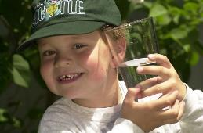
"Boy with glass of water, 2000" by Seattle Municipal Archives is licensed under CC BY 2.0
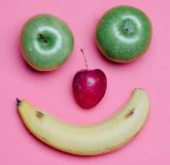
Smile made of ripe fruits by Any Lane, pexels.com
Photo by Andrea Piacquadio. pexels.com
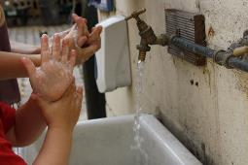
"Washing hands" by magnusfranklin is licensed under CC BY-NC 2.0

Eating healthy food
Learning goal: Children show an increasing understanding of healthy food choices.
Listen to the story, ‘The Very Hungry Caterpillar’, via this QR code. If you can’t listen to the story, look at the healthy foods below and start at step 1.
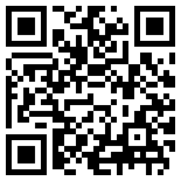
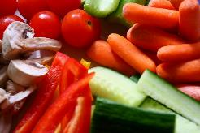
"Vegetables" by Martin Cathrae is licensed under CC BY-SA 2.0
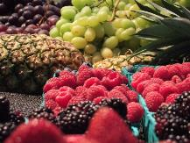
"fruit" by plumandjello is licensed under CC BY-SA 2.0
- We feel better when we eat healthy food. Think about the salad and vegetables you like to eat. These might include:
- lettuce
- tomato
- carrot
- capsicum
- cucumber
- snow peas.
- Ask someone to help you make a salad out of your favourite healthy foods.

Is this activity too hard?
- Taste 3 different vegetables. Which do you like best?

Is this activity too easy?
- Look for a salad recipe to prepare.

Jigsaw puzzles
Learning goal: Children problem solve to complete a jigsaw.
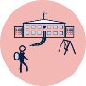
Jigsaw puzzles are a great activity to help you prepare for school. When you complete a puzzle you are problem solving, using your concentration and learning about maths.
Choose one or more of the following things to do:
- Do a jigsaw puzzle if you have one.
- Make your own puzzle by cutting a cardboard picture (such as from a cereal box) into 6 pieces.
- Complete one of these online puzzles via this QR code, if you have access.
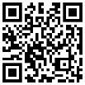
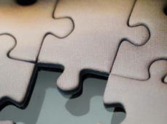
"Jigsaw puzzle (detail)" by James E. Petts is licensed under CC BY-SA 2.0

Extra learning activities
Develop literacy concepts with the story “The Gruffalo” via this QR code. If you can’t access the QR code, choose a story you like to read with someone in your home. You can talk about what happened in the beginning, middle and the end of the story. You could even make up a different ending.
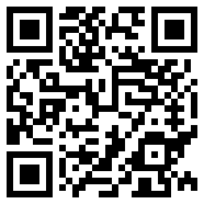
© State of New South Wales (Department of Education), 2021
The copyright material published in this document is subject to the Copyright Act 1968 (Cth) and is owned by the NSW Department of Education or, where indicated, by a party other than the NSW Department of Education.
Copyright material available in this document is licensed under a Creative Commons Attribution 4.0 International (CC BY 4.0) licence.
See https://education.nsw.gov.au/about-us/copyright for further details.

