This booklet belongs to:

Week N – Thursday

Day at a glance:
 | Fire stafey | Would you rather? | Make a junkyard robot | Learning new skills - Part 2 | Story telling
Estimated time | 20 mins | 10 mins | 40 mins | 15 mins | 10 minutes
Resources required |  |  | Cereal box, egg carton, 4 toilet rolls or cardboard rolls, scissors, tape or glue

Fire Safety
Learning goal: Children learn to stay safe in the event of a fire.
Watch the video Kids Fire Safety Awareness via the QR code and do what the fire fighters say. If you can’t watch the video, go to step 1, and practice the steps with an adult so you know how to be safe if there is a fire.
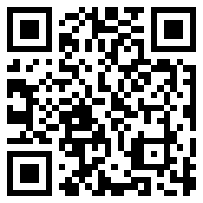
- Practice being safe one more time:
- get down low and go, go, go outside to safety
- stop, drop, cover your face and roll around
- say the emergency phone number - 000
- with an adult, run outside to your emergency meeting place
- remember, fire fighters are our friends!

Is this activity too hard?
- Talk with someone about what you could do in an emergency.

Is this activity too easy?
- Draw a map that shows how to get from inside your house to your emergency meeting place outside.

Would you rather?
Learning goal: Children develop speaking and listening skills.
- Watch the video about imagination via this QR code and follow the instructions to answer each question. If you can’t watch the video, go to step 2. Even if you don’t really like either option, in this game, you have to pick one!
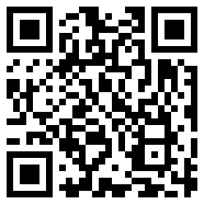
- Think about:
- Would you rather be able to fly or be invisible?
- Would you rather be an actor or a singer?
- Would you rather have a pet panda or a pet zebra like in the photos below?
- Would you rather eat pizza for every meal or eat ice cream for every meal?
- Would you rather be the fastest person in the world or be able to freeze time?
- Would you rather be 10 years older or 4 years younger?
- Would you rather control the weather or have the ability to talk to animals?
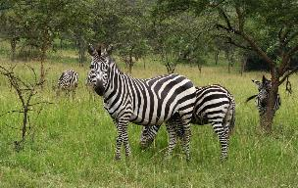
"Zebra" by snarglebarf is licensed under CC BY-SA 2.0
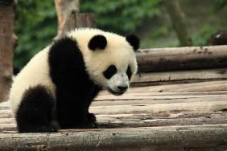
"Panda" by George Lu is licensed under CC BY 2.0
- Give 3 reasons for your choice.

Is this activity too hard?
- Answer only the questions, without giving reasons why you chose the option you did.

Is this activity too easy?
- Make up some of your own 'would you rather?' questions to ask people.

Make a junkyard robot
Learning goal: Children learn to follow detailed instructions.
1. Watch this story Carlos’ Robots Go to Mars! Via this QR code. If you can’t watch, go to step 4.
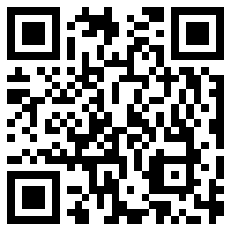
- Find what you need to make a robot:
- a cereal box for the robot's body
- an egg carton for the robot's head
- 4 toilet rolls for the robot's arms and legs
- scissors and masking tape.
- Watch the video ‘Art Bites – Operation Art’ via this QR code and follow the instructions to make a robot. If you can’t access the video, go to step 4.
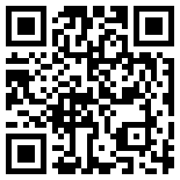
- Stick two toilet rolls to the bottom of the cereal box by using masking tape or glue.
- Check that your robot can stand up.
- Attach the egg carton to the other side of the cereal box tape or glue.
- Decorate your robot with paint or pencils or paste things on.
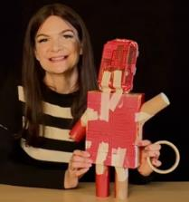

Take a break
Here are some things you might like to do:
- have a drink of water and a healthy snack
- play or have a rest
- go to the toilet and wash your hands.

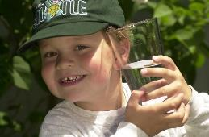
"Boy with glass of water, 2000" by Seattle Municipal Archives is licensed under CC BY 2.0
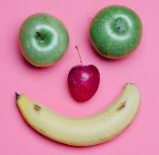
Smile made of ripe fruits by Any Lane, pexels.com
Photo by Andrea Piacquadio. pexels.com
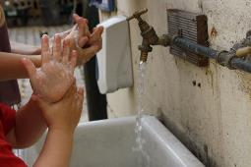
"Washing hands" by magnusfranklin is licensed under CC BY-NC 2.0

Learning new skills - Part 2
Learning goal: Children take considered risks and cope with frustration.
- Listen to some children talking about trying new things via this QR code. If you can’t listen, go to step 3.
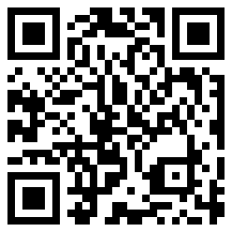
- Listen to Tash talking about learning new things via this QR code.
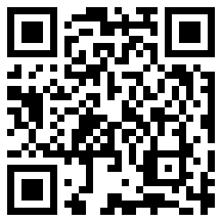
- Think about what you would like to learn:
- Why do you want to learn it?
- What equipment will you need?
- How do you feel about learning this new thing?
- Is this new thing safe to try?
- Who will need to help you?
- How much do you think you will need to practice?
- Try the new activity.
Image owned by the NSW Department of Education under the Copyright Act 1968 (Cth)

Story telling
Learning goal: Children learn about world languages through story telling.
Stories are told all over the world. There are roughly 6,500 languages spoken in the world, and each one has unique and special stories. 'The lightning and thunder' is a story from Nigeria, in Africa.
1. Listen to the story told in English via this QR code. If you can’t listen, ask someone in your home to tell you a story.
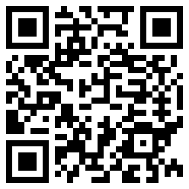
2. Listen to the story again, this time told in Hausa, a Nigerian language via this QR code. If you can’t listen, ask someone in your home to tell you a story.
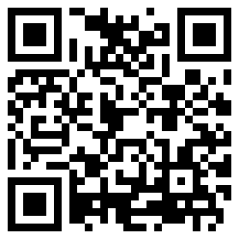

Extra Learning activities
Visit real animals, go to a fire station, and explore faraway places when you take these virtual field trips via the QR code.
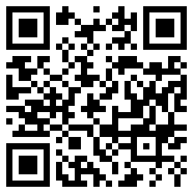
© State of New South Wales (Department of Education), 2021
The copyright material published in this document is subject to the Copyright Act 1968 (Cth) and is owned by the NSW Department of Education or, where indicated, by a party other than the NSW Department of Education.
Copyright material available in this document is licensed under a Creative Commons Attribution 4.0 International (CC BY 4.0) licence.
See https://education.nsw.gov.au/about-us/copyright for further details.

