This booklet belongs to:

Week N - Friday

Day at a glance:
 | What can you see? | Camouflage | Home technology hunt | Ribbons | Safety helpers
Estimated time | 10 mins | 15 mins | 15 mins | 10 mins | 15 mins
Resources required |  | Something to draw with and on |  | Ribbon tied to a ruler or a stick

What can you see?
Learning goal: Children focus their mind and body to notice things.
Watch the video via this QR code and follow the instructions. If you can’t access the video, you can look at the photos from the video below.
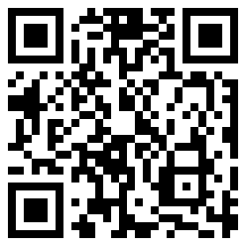
- Answer the following questions as you watch the video or look at the photos below:
- How many pelicans can you see?
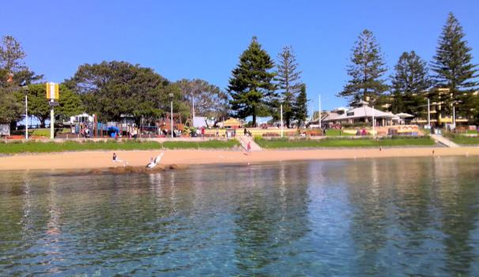

- How many kayaks can you see?
- How many boats can you see on the horizon?
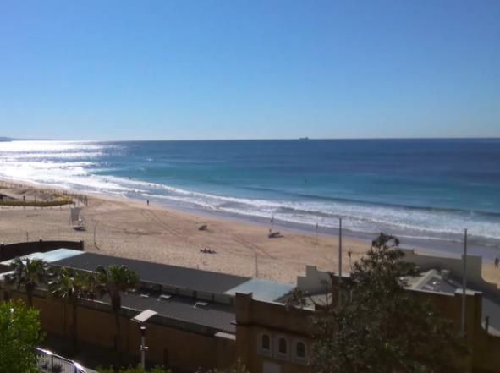

Is this activity too hard?
- What can you see near you?

Is this activity too easy?
- Go outside. As well as noticing what you can see, what can you hear and smell?

Camouflage
Learning goal: Children explore ideas and theories about camouflage.
Many animals have evolved to protect themselves by blending into their landscape. This is called camouflage. It is very difficult to see animals who are camouflaged.
- Listen to the book ‘Camouflage’ by Ruth Garlick’ via this QR code. If you can’t access the book, find pictures from the book below and start at step 3.
- As you listen and look at the pictures, find the animal in each photograph and notice how it is camouflaged.
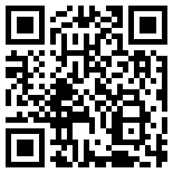
- Talk to someone about why some animals need camouflage. What might happen if they could be easily seen?
- Draw one of the animals in the book, showing how they blend into the landscape.
- Ask someone to try and find the camouflaged animal in your drawing.
Sand crab
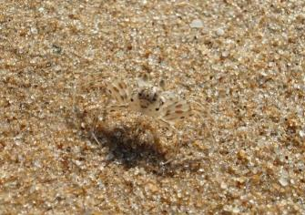
“Crab or sand?” by Ana Sofia Guerreirinho under CC BY-ND 2.0
Stick insect
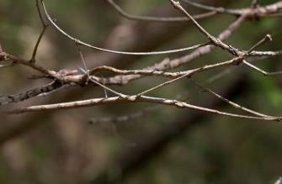
“Spot the stick insect” by Peter Ostergaard under CC BY-NC 2.0

Is this activity too hard?
- Enjoy the story with someone, looking for the animals in the book together.

Is this activity too easy?
- Find a picture on the internet or in a book of a camouflaged animal.

Home technology hunt
Learning goal: Children identify the everyday uses of technology.
- We use machines to help us do things that would take a long time or use a lot of energy.
Microwaves help us by heating up food.
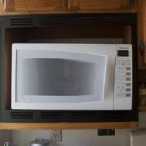
"Microwave" by ewen and donabel is licensed under CC BY 2.0
Dishwashers help us by washing our dishes.
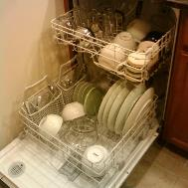
"Dishwasher" by brownpau is licensed under CC BY 2.0
Drills help us by making holes.
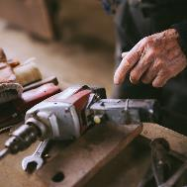
"The old man takes an electric drill. Close up of arm and drill." by shixart1985 is licensed under CC BY 2.0
Lawnmowers help us by cutting grass.
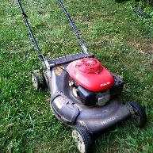
"Lawnmower!" by beautyredefined is licensed under CC BY-NC-SA 2.0
- Look around your home for other machines.
- How does each machine help you and your family?

Is this activity too hard?
- Say the name of each of the machines in the pictures.

Is this activity too easy?
- Take a photo of each of the machines you find. Explain to someone how each helps save time or energy.

Take a break
Here are some things you might like to do:
- have a drink of water and a healthy snack
- play or have a rest
- go to the toilet and wash your hands.
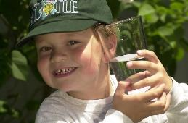
"Boy with glass of water, 2000" by Seattle Municipal Archives is licensed under CC BY 2.0
Smile made of ripe fruits by Any Lane, pexels.com
Photo by Andrea Piacquadio. pexels.com
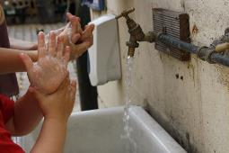
Photo by Andrea Piacquadio. pexels.com

Ribbons
Learning goal: Children develop physical coordination.
- Watch each video via the QR codes below and copy the actions with a ribbon attached to a stick or a ruler. If you can’t access the videos, you can look at the pictures below and use your ribbon to twirl around and make patterns in the air.
Ribbon circles
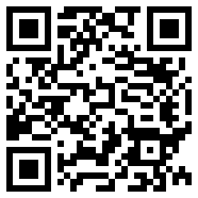
Ribbon floor twirls
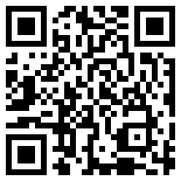
Ribbon spirals
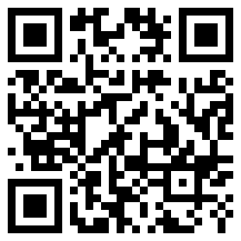

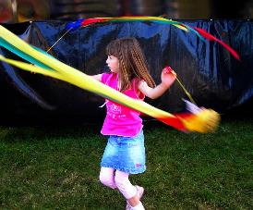
"Jo twirls ..." by Dave ® is licensed under CC BY-NC-SA 2.0
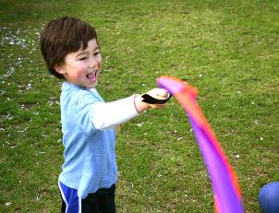
"Ribbon Swirl" by Dominic's pics is licensed under CC BY 2.0

Is this activity too hard?
- Make the ribbon move your own way.

Is this activity too easy?
- Make the ribbon move:
  - fast
  - slow
  - in flowing curves
  - in pointy lines.
- Create a ribbon dance.

Safety helpers
Learning goal: Children identify people in the community who can help them.
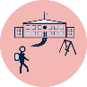When you start school, you will be spending less time with your family. It is important to know which grown-ups you can talk to if you need help or if you are feeling unsafe. These people are your 'safety helpers'.
- Watch the video about recognising safe people via this QR code. If you can’t access, go to step 2.
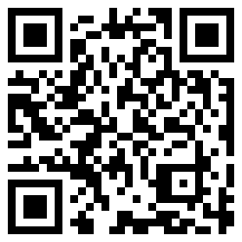
- Trace your hand.
- On each finger, draw or ask someone to write the name of one safety helper. Remember, a safety helper is a grown-up you can talk to if you need help or don't feel safe.
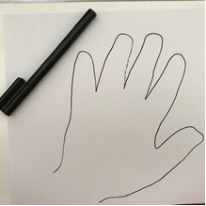

Extra learning activities
Develop literacy concepts through the story ‘Bear and Chook’ via this QR code. If you can’t access the QR code, choose a story you like to read with someone in your home. You can talk about what happened in the beginning, middle and the end of the story. You could even make up a different ending.
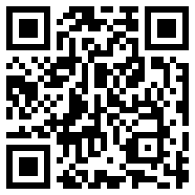
© State of New South Wales (Department of Education), 2021
The copyright material published in this document is subject to the Copyright Act 1968 (Cth) and is owned by the NSW Department of Education or, where indicated, by a party other than the NSW Department of Education.
Copyright material available in this document is licensed under a Creative Commons Attribution 4.0 International (CC BY 4.0) licence.
See https://education.nsw.gov.au/about-us/copyright for further details.

