This booklet belongs to:

Week M– Wednesday

Day at a glance:
 | Shared story | Aboriginal cultural knowledge | Origami | Gymnastics | Listening to bird song
Estimated time | 15 mins | 15-20 mins | 10 mins | 10 mins | 10-15 mins
Resources required |  | Bark and natural materials | Square piece of paper | Twirling ribbon, small bean bag | Something to draw with and on

Shared story- The silly seabed song
Learning goal: Children experience joy through story, rhyme and song.
- Listen to the story 'The silly seabed song' by Aura Parker, via this QR code. If you can’t listen to the story, go to step 4.
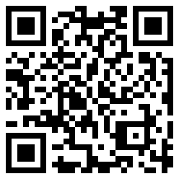
- Can you remember the song from the story? Try singing it.
- What actions could you add to the song?
- Does anyone sing a bedtime song to help you go to sleep?

Is this activity too hard?
- Listen to the story and move to the song.
- Listen to the story a second time and join in the song.

Is this activity too easy?
- Tell someone what parts of the story you thought were funny and why.
- Make up some more words to the song in the story.

Aboriginal cultural knowledge
Learning goal: Children explore Aboriginal cultural knowledge through creative arts.
- Watch the video about Annette Sax making collage on bark via this QR code. If you can’t access the video, start at step 2.
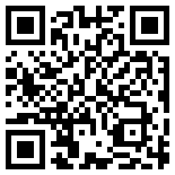
Annette Sax is a Taungurung woman. In the video, she creates collages using oak bark, gum leaves and gum nuts. She uses a piece of bark that she collects from the ground and tells us that traditionally her ancestors would take bark from trees to make a canoe. They would not chop down the tree, they would only take the bark. In her collage she uses emu feather because emu was very important for her people. It was used for meat and the feathers were used for head dresses.
- Go for a walk outside with an adult.
- Try to find a piece of bark on the ground.
- What else can you find in nature that you might be able to use to create your own collage on bark?
- Once you have collected your natural materials, create your own collage using glue to paste the materials on the bark. If you can't find bark, then use a piece of paper or cardboard.
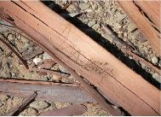
This photo by unknown author is licensed under CC BY-SA-NC.
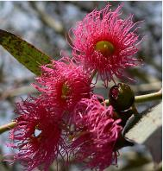
This photo by unknown author is licensed under CC BY-SA-NC.
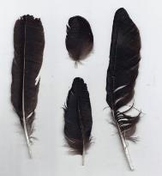
This photo by unknown author is licensed under CC BY-SA.
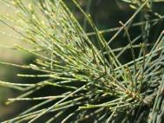
This photo by unknown author is licensed under CC BY 3.0.

Is this activity too hard?
- Collect some bark or other natural materials from outside.
- Look at, touch and smell the items that you find.

Is this activity too easy?
- Tell someone a story about your artwork.

Origami
Learning goal: Children use a high level of concentration, creativity and spatial awareness.
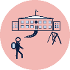Making origami can help you practice your concentration skills, which you need for school. It also requires you to fold paper in different ways, which helps you learn math skills.
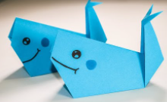
Image still from Easy origami for kids (3 April 2020) 'Whale step by step '[video], YouTube, accessed 15 September 2021.
- Watch the video (without starting to fold) via this QR code. If you can’t watch, you can see what you can create from folding paper in half and in half again. You could decorate with pencils.
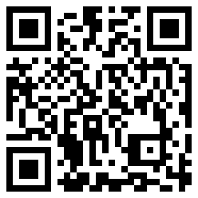
- After watching, lay your paper out and follow the instructions to make a whale.
- Pause and replay the video if you need to.

Is this activity too hard?
- Have someone demonstrate each step for you.
- Make two or three folds in the paper and pretend it is a whale.

Is this activity too easy?
- Use bigger or smaller paper to make a different sized whale.

Take a break
Here are some things you might like to do:
- have a drink of water and a healthy snack
- play or have a rest
- go to the toilet and wash your hands.

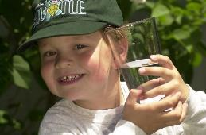
"Boy with glass of water, 2000" by Seattle Municipal Archives is licensed under CC BY 2.0
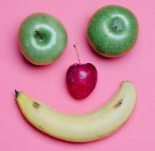
Smile made of ripe fruits by Any Lane, pexels.com
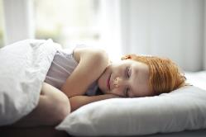
Photo by Andrea Piacquadio. pexels.com
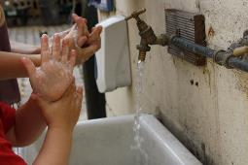
"Washing hands" by magnusfranklin is licensed under CC BY-NC 2.0

Listening to bird song
Learning goal: Children build awareness and appreciation of the natural world.
Birds sing to communicate with each other.
- Listen to the different bird sounds in the podcast via this QR code. If you can’t listen, go to step 3.
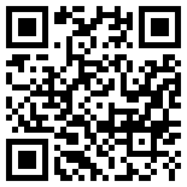
- Try and copy the sounds that the birds are making.
- How many different birds do you hear in your neighbourhood?
- Draw a picture of your favourite bird and ask someone to write on the drawing what they might be saying.

Gymnastics
Learning goal: Children engage in gymnastic rhythm and movement.
- Watch the gymnastic video via the QR code and join in. If you can’t access the video, start at step 2.
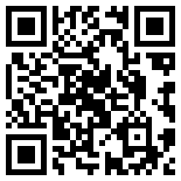
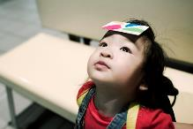
"Head Skill" by Jay Hsu - Chen Chieh is licensed under CC BY-NC-ND 2.0
- Find a small bean bag or a zip lock bag with rice in it and see if you can balance it on your head, foot, shoulder and elbow.
- See where else you can balance the bean or rice bag.

Is this activity too hard?
- Try to balance on one foot without the bean bag. Now balance on the other foot.
- Sit on a chair and balance the beanbag on your foot or hand.

Is this activity too easy?
- Invent your own activities to do with a beanbag and then challenge someone to do them.

Extra learning activities
Do firefighters ever get scared? Watch the video via this QR code to find out. If you can’t access the code, talk to someone in your home about firefighters. What can you find out?
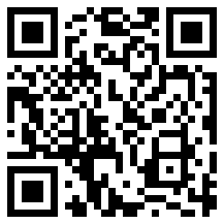
© State of New South Wales (Department of Education), 2021
The copyright material published in this document is subject to the Copyright Act 1968 (Cth) and is owned by the NSW Department of Education or, where indicated, by a party other than the NSW Department of Education.
Copyright material available in this document is licensed under a Creative Commons Attribution 4.0 International (CC BY 4.0) licence.
See https://education.nsw.gov.au/about-us/copyright for further details.

