This booklet belongs to:

Week M– Tuesday

Day at a glance:
 | Fun exercises | Longer and shorter | A song in Japanese | Birdie and the fire | Make a pizza
Estimated time | 15 mins | 15 mins | 10 mins | 15 mins | 45 mins
Resources required |  | Leaves, something to draw with and on. |  |  | Knife, chopping board, cooking tray

Fun exercises - Part 2
Learning goal: Children engage in complex movement patterns
- Watch the video via this QR code, and do the actions. If you can’t watch, put on music that you like and do exercises such as star jumps and running on the spot.
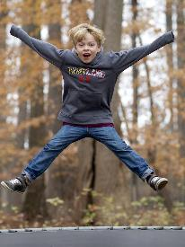
"Jump... Jump... Shot - Day 5 of 50 Project" by Au Kirk is licensed under CC BY 2.0
- Answer the following questions after doing the exercises:
- Are you puffed?
- Is your heart beating harder?
- Do you feel thirsty?
- What movements did you find easy to do?
- What movements did you find hard to do?

Is this activity too hard?
- Do only some of the exercises.
- Put on music and move your body.

Is this activity too easy?
- Design a routine that combines 3 – 4 different exercises.

Longer and shorter
Learning goal: Children learn about length and to sort by length.

- Collect leaves from your yard or a park.
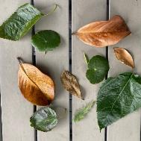
- Line the leaves up from shortest to longest. Make sure all the stems of the leaves are lined up, like in the photo.
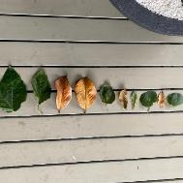
- Answer the following questions:
- Which leaf is the longest?
- Which leaf is the shortest?
- Are any leaves of an equal length?

Is this activity too hard?
- Hold two leaves together and say which is the longest shortest.

Is this activity too easy?
- Line up leaves of the same length, end to end to use as a 'leaf ruler'.
- How many leaves long is your foot?
- How many leaves long is your favourite book?

A song in Japanese
Learning goal: Children become aware of world languages through song.
Songs are sung in different languages all over the world.
1. Listen to the video via this QR code and copy the Japanese words. If you can’t access the video, talk with someone in your home about songs they may know in other languages.
2. These are the Japanese words Ethan sings, written in two different ways. What do you notice about the writing?
Kanji:
頭 肩 膝 足 膝 足 頭 肩 膝 足 膝 足 に 目と耳と唇と鼻。 頭 肩 膝 足 膝 足。
Hiragana:
あたま、かた、ひざ、あし、ひざ、あし、あたま、かた、ひざ、あし、ひざ、あし に めと みみと くちと はな。あたま、かた、ひざ、あし、ひざ、あし

Is this activity too hard?
- Copy Ethan to do the actions of the song.

Is this activity too easy?
- Do you know any others songs in a language other than English? Is so, choose one to sing now.

Take a break
Here are some things you might like to do:
- have a drink of water and a healthy snack
- play or have a rest
- go to the toilet and wash your hands.
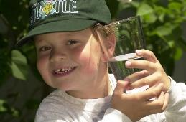
"Boy with glass of water, 2000" by Seattle Municipal Archives is licensed under CC BY 2.0
Smile made of ripe fruits by Any Lane, pexels.com
Photo by Andrea Piacquadio. pexels.com
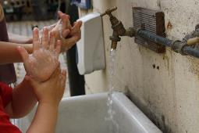
Smile made of ripe fruits by Any Lane, pexels.com

Story time - Birdie and the fire
Learning goal: Children learn to deal with sad or scary situations.
- Watch the video about bush fires via this QR code. If you can’t access the video, start at step 2.
- Talk to someone about the following questions:
- Have you seen a firefighter or a fire truck?
- Did you find it loud or scary?
- Has there ever been a fire near your house or preschool? How did it make you feel?
- Who can you go to for help if you are feeling scared or worried about something?
- Look at the pictures below and tell someone how they make you feel.

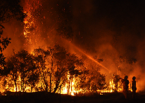
"Cessnock Bush Fire 18-01-2013" by Quarrie Photography is licensed under CC BY-NC-ND 2.0
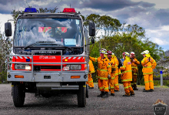
"Cliff Drive Bushfire - 1/11/2014" by Quarrie Photography is licensed under CC BY-NC-ND 2.0
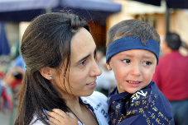
"Sometimes ninjas feel scared" by ssalonso is licensed under CC BY-NC-SA 2.0

Is this activity too hard?
- Think about a time that you have felt scared. What did you do to feel safe again?

Is this activity too easy?
- Draw a picture of a time in your life where you have felt scared. What expression do you have on your face?

Make a pizza
Learning goal: Children experiment to create a tasty pizza.
What you need:
- pizza bases (or flat bread)
- tomato-based sauce
- vegetable and meat toppings
- shredded cheese.
What to do:

      - Preheat oven to about 200 degrees.
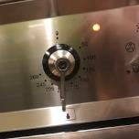
      - Put the pizza bases on a tray.
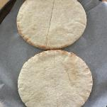
      - Spread the sauce over the pizza bases.
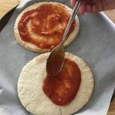
      - Cut up some meat and vegetables toppings
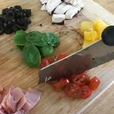
- Think about a combination of toppings that will be yummy. Add 2-3 toppings to one half of the pizza (or one base if small). Add a different 2-3 toppings to the other half or pizza base.
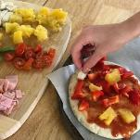
- Sprinkle cheese over the top.
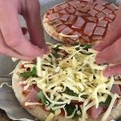
- Cook at 200 degrees for about 10-15 minutes.
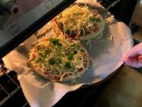
- Before you taste the cooked pizza, predict which combination of toppings will taste the best. Were you right?
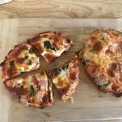

Is this activity too hard?
- Taste each of the toppings before they are put on the pizza. Which do you think tastes the best?

Is this activity too easy?
- Which other topping combinations could you use to make a pizza?
- Give your pizzas a name, for example, Pineapple Paradise Pizza

Extra learning activities
Little Yarns is a podcast series for young children to listen to with their family. It explores the diverse languages, stories and Countries of Indigenous Australia. You can access the podcasts via this QR code. If you can’t access the podcasts, talk with someone about languages and stories of Aboriginal Australia.
© State of New South Wales (Department of Education), 2021
The copyright material published in this document is subject to the Copyright Act 1968 (Cth) and is owned by the NSW Department of Education or, where indicated, by a party other than the NSW Department of Education.
Copyright material available in this document is licensed under a Creative Commons Attribution 4.0 International (CC BY 4.0) licence.
See https://education.nsw.gov.au/about-us/copyright for further details.

