This booklet belongs to:

Week M – Thursday

Day at a glance:
 | How tall are penguins? | What our body needs | Shared story | Can you guess? | Knowing important names
Estimated time | 10 mins | 5 mins | 5-10 mins | 5 mins | 5-10 mins
Resources required | Ruler, cardboard, something to draw on and with, scissors |  | Something to draw with and on |  | Something to write with and on

How tall are penguins?
Learning goal: Children explore the features of animals.
1. Watch the video about penguins via this QR code. If you can’t watch, you can look at the picture of a little penguin below and start at step 2.
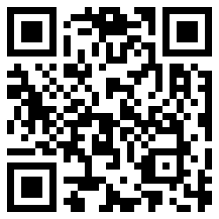
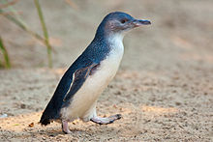
“Little penguin at the Melbourne Zoo” from Fir0002/Flagstaffotos, CC BY-NC
2. A little penguin is about 30 cm tall. This is about the length of a ruler.
3. Draw a 30 cm tall little penguin or print and cut out this penguin (PDF 70KB).
4. Cut your penguin out.
5. Lay down on the floor and use your cut out penguin to measure how many little penguins tall you are.

Is this activity too hard?
- Draw a tall penguin and a short penguin

Is this activity too easy?
- Ask someone to measure your height using the ruler or a tape measure.
- The emperor penguin is 110 –130 cm tall.
- Is this taller or shorter than you?

What our body needs
Learning goal: Children recognise and communicate their body's needs.
Our body can be hot or cold which can feel uncomfortable. We need to make decisions about how to help our body if we are feeling too hot or too cold.
1. How can you cool yourself down when you are feeling hot?
2. How can you warm yourself up when you are feeling cold?
3. Tell someone if you think the things in the pictures below would help warm you up or cool you down.
blanket
Image by Katrina S, pixabay.com
drink
Image by jarmoluk, pixabay.com
fan
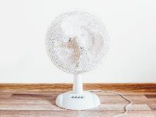
Image by StockSnap, pixabay.com
swim
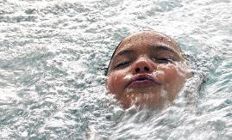
Image by eLaba, pixabay.com
hot chocolate
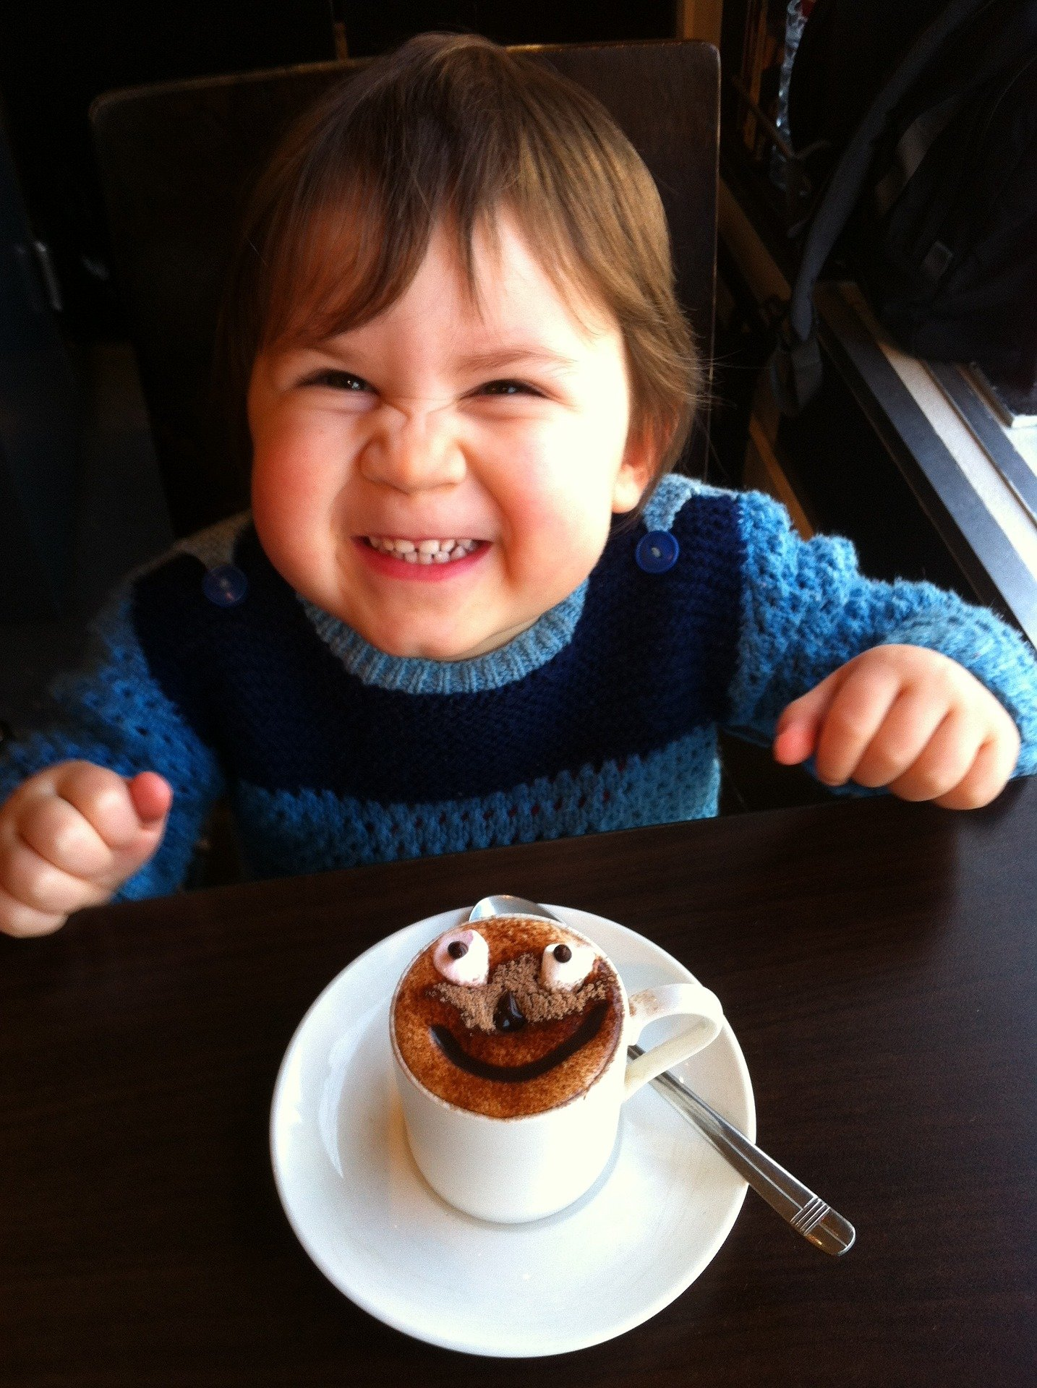
Image by elizadean, pixabay.com
beanie
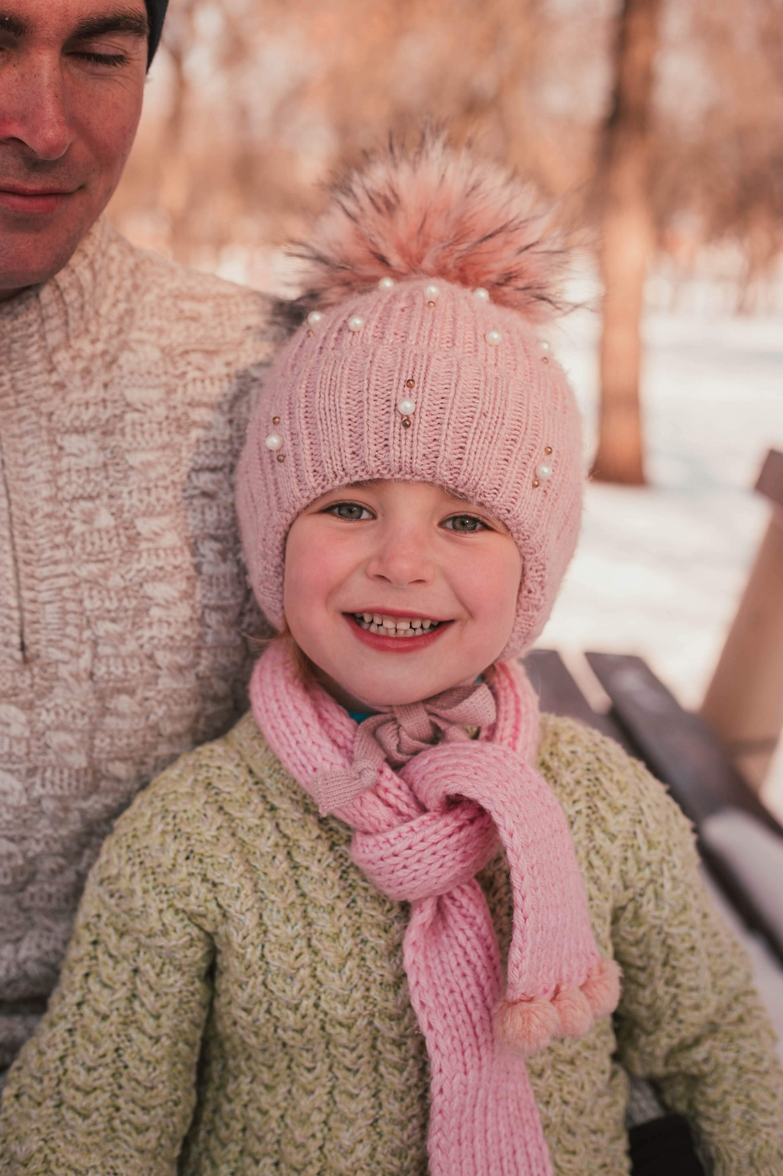
Image by kovaleshk , pixabay.com

Some ideas for cooling down:
- Have a drink of cold water.
- Take off your jumper if you are wearing one.
- Sit in the shade or go inside.
- Have a cool bath or shower.
- Go for a swim with someone.
- Eat some ice.
- Sit down and rest.
- Turn a fan on.

Some ideas for warming up:
- Wrap a blanket around you.
- Put a jumper and socks on.
- Have a warm drink of hot chocolate or soup.
- Stay inside.
- Have a warm shower or bath.
- Snuggle close to someone.
- Wear a beanie or gloves.
- Run around.

Is this activity too hard?
- Do you prefer feeling hot or cold?

Is this activity too easy?
- Ask someone to look at their phone to see what the temperature is today. Are you feeling warm, cold or, just right?

Shared story- Thelma the unicorn
Learning goal: Children have a positive view of themselves and their own identity.
- Watch the video about a special unicorn via this QR code. If you can’t watch, go to step 2.
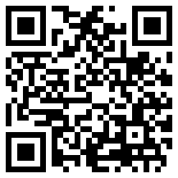
Imagen de Joyce Liu en Pixabay
2. Do you ever wish that you could be something or someone else?
3. Draw a picture of yourself doing something that you love to do.

Is this activity too hard?
- Tell someone what it is that makes you special.

Is this activity too easy?
- Talk to someone about all the things about yourself that you are most proud of and why.

Take a break
Here are some things you might like to do:
- have a drink of water and a healthy snack
- play or have a rest
- go to the toilet and wash your hands.
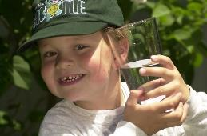
"Boy with glass of water, 2000" by Seattle Municipal Archives is licensed under CC BY 2.0
Smile made of ripe fruits by Any Lane, pexels.com
Photo by Andrea Piacquadio. pexels.com
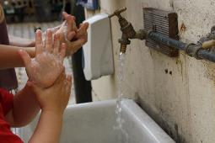
"Washing hands" by magnusfranklin is licensed under CC BY-NC 2.0

Can you guess?
Learning goal: Children use adjectives to describe what they see.
Ask someone to play 'Can you guess?' with you.
How to play
This game is like 'I spy', but you must use 3 words to describe something you see. The other person listens carefully and uses the 3 words as clues to guess what it is you see.
Here are some examples:
- Can you guess what I can see? It is sharp, long and silver. It is a fork.
- Can you guess what I can see? It is red, shiny and round. That's right, it is an apple.
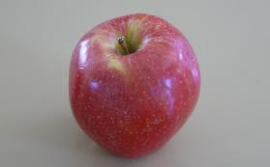
"Apple" by idpams is licensed under CC BY 2.0
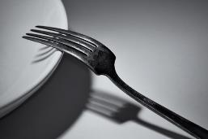
"Jack's Mother's Fork Still Life - Hommage to Andre Kertesz's 1928 Fork Photograph" by diana_robinson is licensed under CC BY-NC-ND 2.0

Is this activity too hard?
- Pick an object in your home. Think of a word to describe the object

Is this activity too easy?
- Instead of 3 words, give only 2 and see if the person can guess the object you see.

Knowing important names
Learning goal: Children learn their full names and names of family members.
At school you will need to know your full name, which is your first and last name. It is also helpful to know the full names of your family members.
1. Ask someone to tell you the full name of each person in your family. Practice saying these names.
2. Ask someone to write down the full name of each person in your family.
3. Practice writing your full name.
'Crop kid sitting on floor and writing in notebook' by Sarah Dietz from pexels.com

Is this activity too hard?
- Practice saying your last name.
- Practice tracing the first letter of your name.

Is this activity too easy?
- Practice writing the full names of everyone in your family.

Extra Learning activities
Practice your counting skills with ‘Numberblocks - How to count’ via this QR code. If you can’t access the code, one of the activities included in the extra activity is below.
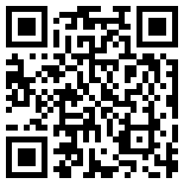
Shape hunt
- what shapes can you find in your house that have 3 corners? Draw pictures of your discoveries!
- what shapes can you find in your house that have 4 sides and 4 corners? Draw pictures of your discoveries!
© State of New South Wales (Department of Education), 2021
The copyright material published in this document is subject to the Copyright Act 1968 (Cth) and is owned by the NSW Department of Education or, where indicated, by a party other than the NSW Department of Education.
Copyright material available in this document is licensed under a Creative Commons Attribution 4.0 International (CC BY 4.0) licence.
See https://education.nsw.gov.au/about-us/copyright for further details.

