This booklet belongs to:

Week M – Monday

Day at a glance:
 | All about me | Playdough maths | Making baking soda ice cubes | Active games | Wanda visits the doctor
Estimated time | 20 mins | 20 mins | 20 mins | 30 mins | 45 mins
Resources required | Something to draw with and on | Play dough | Mixing bowl, baking soda, ice cube tray, vinegar, food colouring |  | Soft toy, book or journal

All about me
Learning goal: Children identify a strong sense of self.
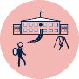
Starting school can be hard. If you are feeling good about yourself, you will be better able to cope with all the new things at school.
- Draw a picture to match each of these statements:
- This is what I am good at.
- This is what I love to do.
- This is what I need help with.
- This is how I help other people.
- This is what I like to investigate.
- This is what I have figured out.

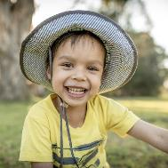
Image owned by the NSW Department of Education under the Copyright Act 1968 (Cth)
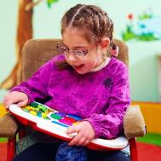
Image owned by the NSW Department of Education under the Copyright Act 1968 (Cth)

Playdough maths
Learning goal: Children demonstrate an increasing understanding of numeracy concepts
You will need playdough to do this activity. If needed, follow the instructions via this QR code to make it.
If you can’t access the recipe, simple playdough can be made with:
- 2 cups flour
- 3/4 cup salt
- food colouring.
Bind together and knead until ready.
- Choose one or more of these things to make with playdough.
Make a heart.
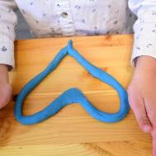
"playdough" by montessori toolkit is licensed under CC BY 2.0
Make a face with 3 eyes, 2 mouths and 6 pieces of hair.
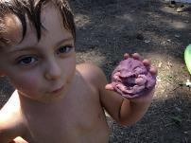
"Playdough" by premasagar is licensed under CC BY-NC 2.0

Make a cylinder.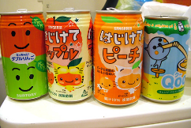
"Kawaii cans" by nyaaa is licensed under CC BY-NC-SA 2.0
Make 3 snakes all the same length.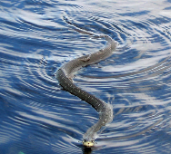
"grass-snake close up" by andnef is licensed under CC BY-NC-ND 2.0
Make then stack small balls from biggest to smallest.
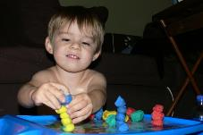
"playdough stacks" by lleugh is licensed under CC BY-NC-SA 2.0
Make a pea pod. Put 4 peas inside the pod and one outside.
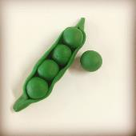
"#prayer #playdough #dyo14" by @markheybo is licensed under CC BY 2.0

Is this activity too hard?
- Make playdough balls by rolling playdough between your fingers.
- Count how many balls you made.

Is this activity too easy?
- What other 2D shapes can you make? Tell someone the name of each shape and how many sides it has.

Make baking soda ice cubes
Learning goal: Children learn about chemical reactions and experiments.
What you need:
- water
- mixing bowl
- 5 tablespoons baking soda
- ice cube tray
- food colour (optional)
- vinegar
What to do:
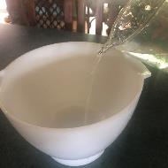
- Pour some water into a mixing bowl.
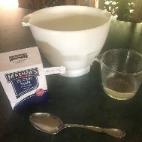
- Add 5 tablespoons of baking soda and mix together.
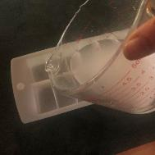
- Pour the mixture into an ice cube tray.
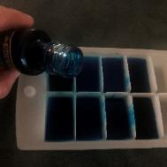
- Place a few drops of food colour into each square (optional)
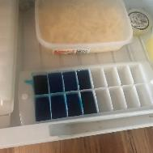
- Place the tray in the freezer.
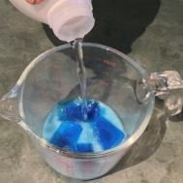
- Place the frozen ice cubes in a container and pour vinegar over them.
7. What happened when you poured the vinegar over the ice cubes? Why do you think this happened?
If you were not able to do this experiment, but would like to see what happens when the vinegar is poured over the ice cubes, watch this video.

Take a break
Here are some things you might like to do:
- have a drink of water and a healthy snack
- play or have a rest
- go to the toilet and wash your hands.
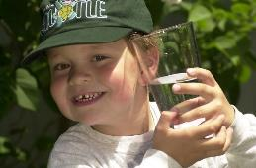
"Boy with glass of water, 2000" by Seattle Municipal Archives is licensed under CC BY 2.0
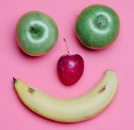
Smile made of ripe fruits by Any Lane, pexels.com
Photo by Andrea Piacquadio. pexels.com
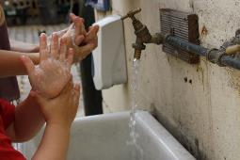
"Washing hands" by magnusfranklin is licensed under CC BY-NC 2.0

Active games
Learning goal: Children learn games are a way to be active.
Watch the movie about physical movement and exercise via this QR code. If you can’t watch the movie, you can start at step 1.
- Ask someone to play one of these fun, active games with you:
- play on the park equipment
- play hide and seek
- throw a ball or frisbee
- play cricket
- walk a dog
- kick a soccer ball
- kick a football.

Is this activity too hard?
- Participate in an active game that meets your ability.

Is this activity too easy?
- Add some rules and/or scoring to your game.

Wanda visits the doctor
Learning goal: Children visit and engage with places in their local community.
Watch the video of Wanda the wanderer visiting the doctor and chemist via this QR code. If you can’t watch the video, you can start at step 3.
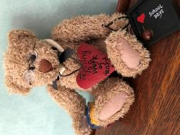
- Take your own travel buddy with you to special places in your community.
- Take pictures, or when you are back home do drawings in your journal, of you and your buddy on your adventure.
- Ask someone to write about your adventure in your journal. You can tell them what to write.
- Let your teachers know what you and your buddy have been up to when you get back to preschool or daycare.

Extra learning activities
Learn to count through song and story with Five little ducks #2 via this QR code. If you can’t access the resource, you can find the words of the song below which includes counting actions.
Five little ducks ‘Five little ducks’ (action song)
Five little ducks went out one day (hold up five fingers)
Over the hills and far away (hold arm across body and tuck fingers behind shoulder on the opposite side of the body)
Mother Duck said, ‘Quack, quack, quack, quack’ (use other hand to make a Mother Duck beak; open and close hand to quack)
But only four little ducks came back. (bring first hand back to the front with four fingers showing) (continue until no little ducks came back)
Poor Mother Duck went out one day,
Over the hills and far away, Mother Duck said ‘Quack, quack, quack, quack’ And all of those five little ducks came back.
© State of New South Wales (Department of Education), 2021
The copyright material published in this document is subject to the Copyright Act 1968 (Cth) and is owned by the NSW Department of Education or, where indicated, by a party other than the NSW Department of Education.
Copyright material available in this document is licensed under a Creative Commons Attribution 4.0 International (CC BY 4.0) licence.
See https://education.nsw.gov.au/about-us/copyright for further details.

