This booklet belongs to:

Week M – Friday

Day at a glance:
 | Let's count | Reusing old or broken things | Shared story | Learn Auslan | Staying safe on the internet
Estimated time | 10 mins | 15 mins | 20 mins | 10 mins | 15 mins
Resources required | Something to draw with and write on, paint, paintbrush

Let’s count
Learning goal: Children make mathematical observations.
- Watch the video ‘Hooray for fish’ via this QR code. If you can’t access the video, start at step 5.
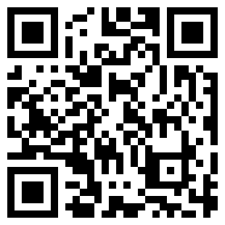
- Watch the video again and count how many fish Little Fish met on her journey.
- Each time Little Fish meets a new fish, draw a small line or a tick on a piece of paper.
- When the story is finished, count all the lines or ticks you drew to find out how many fish altogether.
- Paint your own fish. Think about making your fish with:
- straight or curved stripes- can you do four straight lines with a wiggly line in between? How many altogether?
- big or small spots- count them, can you make two groups of spots the same?
- a group of fish friends- can you draw different fish as a group of friends?

Is this activity too hard?
- While you listen to the story:
  - call out every time you see a fish
  - say what colour the fish is
  - say what type of pattern it has on its body, such as stripes or spots.

Is this activity too easy?
- Was it easy or hard to count all the fish?
- How else could you count the fish instead of drawing the lines or ticks?

Reusing things
Learning goal: Children learn about reusing things as part of environmental responsibility.
When something is old or broken, most people throw it away. But old or broken things can often be used again.
- Listen to the story ‘I like to reuse’ or ask someone to read it to you, via this QR code. If you can’t listen to the story, look at the pictures below and talk about them with someone in your home.
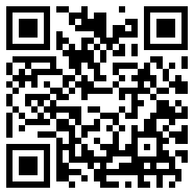

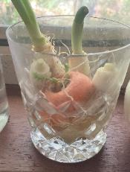
I can use this chipped glass to grow vegetable cuttings.
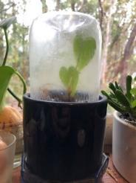
I can use the bottom of a used drink bottle to create a terrarium.
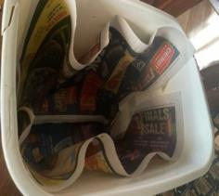
I can use old newspaper to line the bin.
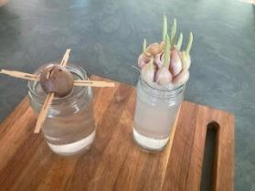
I can use old jars to sprout vegetables
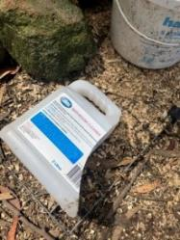
I can use an old container as a garden scoop.
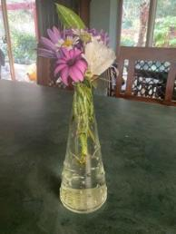
I can use an old jar as a vase.
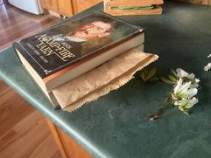
I can use a book to press flowers.
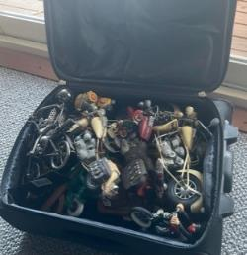
I can use an old suitcase to store toy cars in.

- Look around your home. What things can you see that have been reused?
- Find something that is old, broken or unwanted.
- Think of a way to re-use it and give your item a new life.
- Tell someone what you did and talk about what they could re-use.

Is this activity too hard?
- Make a collage or construction using reused materials such as scrap paper, boxes, catalogues or wrapping paper.

Is this activity too easy?
- Make a record of things you have reused. Draw or photograph each item before and after you have reused it.

Shared story - Possum magic
Learning goal: Children consider ways they can keep themselves safe.
- Watch the video of the story 'Possum Magic' via this QR code. If you can’t watch the video, you can start at step 4.
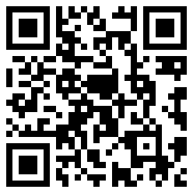
- Think about:
- Why did Grandma Poss make Hush invisible?
- What would be good about being invisible?
- How would being invisible be hard?
- How else could Grandma Poss keep Hush safe?
- How do you keep yourself safe:
- outside in the sun
- crossing the road
- playing at the park
- travelling in a car?
4. Draw a picture of yourself being safe.

Is this activity too hard?
- As you go about your day, talk with someone about the things you do to keep safe.

Is this activity too easy?
- Make a poster that reminds other children how to be safe, for example, put your seat belt on, wear a hat or hold an adults hand to cross the road.

Take a break
Here are some things you might like to do:
- have a drink of water and a healthy snack
- play or have a rest
- go to the toilet and wash your hands.
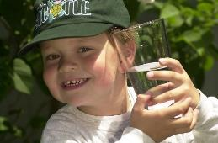
"Boy with glass of water, 2000" by Seattle Municipal Archives is licensed under CC BY 2.0
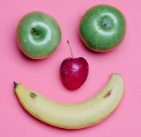
Smile made of ripe fruits by Any Lane, pexels.com
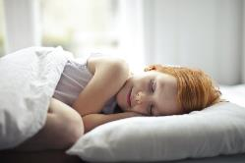
Photo by Andrea Piacquadio. pexels.com
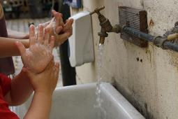
"Washing hands" by magnusfranklin is licensed under CC BY-NC 2.0

Learn Auslan - school, help
Learning goal: Children learn there are a range of ways to interact with others.
Auslan is a language where people make signs with their hands to represent words.
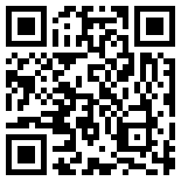
- Watch the video via this QR code to see how to say 'school' in Auslan. If you can’t access look at the pictures below (images are stills from the video).
- Use your hands to copy the sign five times.
school
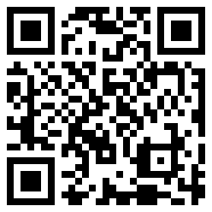
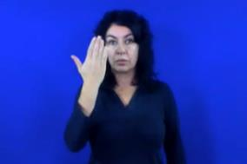
Hold your hand out flat near the side of your face.
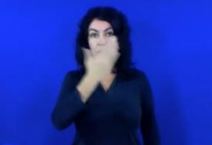
Wave it across the front of your face twice, keeping your hand flat.
- Watch the video to see how to say 'help' in Auslan, via this QR code. If you can’t access, look at the pictures below (images are stills from the video).
- Use your hands to copy the sign five times.

help
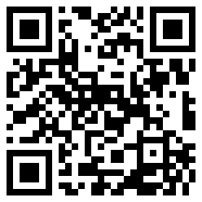
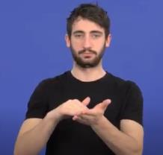
Hold the tips of your fingers in the palm of your other hand.
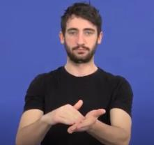
Move your hands forward, keeping them the same.

Is this activity too hard?
- Replay the video to keep practicing.
- Ask someone to help you learn the sign from the pictures.

Is this activity too easy?
- Try to use the sign words in a sentence.

Staying safe on the internet
Learning goal: Children develop an awareness of online safety.
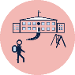When you start school you may use a computer which is connected to the internet. It is important that you follow your teacher's instructions to stay safe online.
- Choose one or both of the videos below about internet safety to watch via the QR codes. If you can’t watch the videos, start at step 2.

Swoosh, glide and rule number 5- Auslan (a story about internet safety)
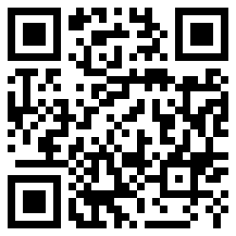
Internet safety tips
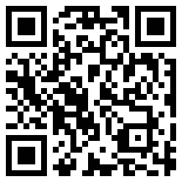
- Do you have rules at home for using devices?
- Talk to someone about how you are going to keep yourself safe when using the internet at school.

Extra learning activities
For families, read e-Safety Early Years: Online safety for under 5s (PDF 5881 KB) via this QR code. If you can’t access the code, some information from the PDF is copied below on safe television watching.
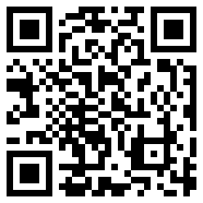
Common Sense Media (commonsensemedia.org) provides age-based reviews of TV shows, online channels and streaming services. You can find good television content for children under 5 years at these providers:
- ABC Kids — abc.net.au/abckids
- CBeebies — cbeebies.com
- PBS Kids — pbskids.org
© State of New South Wales (Department of Education), 2021
The copyright material published in this document is subject to the Copyright Act 1968 (Cth) and is owned by the NSW Department of Education or, where indicated, by a party other than the NSW Department of Education.
Copyright material available in this document is licensed under a Creative Commons Attribution 4.0 International (CC BY 4.0) licence.
See https://education.nsw.gov.au/about-us/copyright for further details.

