This booklet belongs to:

Week L – Wednesday

Day at a glance:
 | Recycling | Fizzy water | Auskick at home – part 2 | Asking for help at school | Making fruit sticks
Estimated time | 15 mins | 15 mins | 30 mins | 10 mins | 20 mins
Resources required |  | Clear fizzy water, glass, small objects such as beads, coins | Football |  | Cutting board, knife, skewers, fruit

Recycling
Learning goal: Children consider the impact of rubbish on the natural environment.
- Listen to the story about recycling via this QR code. If you can’t listen, go to step 3.
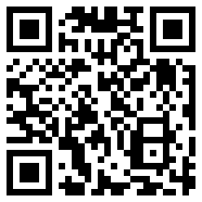
- Think about the ways that Amy, Salem and their preschool friends tried to help the earth.
- How do you help recycle at home?
- If you attend preschool or daycare, what is recycled there?
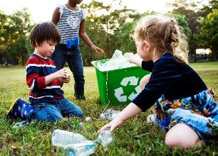
Image owned by the NSW Department of Education under the Copyright Act 1968 (Cth)​

Is this activity too hard?
- Help at home to put containers which can be recycled into the right bin.

Is this activity too easy?
- What does each coloured lid on your big bins at home mean?

Fizzy water
Learning goal: Children demonstrate curiosity as they experiment.
"bubbles" by dana_h79 is licensed under CC BY-NC-ND 2.0
What you need:
- sparkling water (or any clear, fizzy drink)
- small objects, for example, sultana, bead, lolly, sesame seed, coin, cotton wool
- a clear drinking glass.
What to do:
- Pour the fizzy drink into the glass.
- Drop each object into the cup, one at a time. Before you drop each in, predict what will happen:
  - Will there be more or less bubbles?
  - Will the object sink or float?
  - Will the object move or stay still?
- Observe what happens to each object after you drop it in.

Is this activity too hard?
- Ask someone to drop the objects in for you to watch.

Is this activity too easy?
- For each object you dropped in, draw a picture to show what happened.

Auskick at home - part 2
Learning goal: Children develop ball handling skills.
Watch the video via this QR code, and join Joel Selwood doing some warm ups and learning to handball a football. If you can’t watch you can practice throwing a football to someone or at a target.
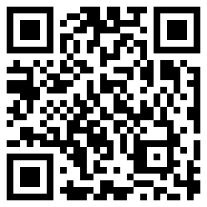
This Photo by Unknown Author is licensed under CC BY-SA

Is this activity too hard?
- Practice handballing a balloon or a soft ball.

Is this activity too easy?
- Like Joel says in the video, move the target further away.
- Practice handballing to someone else.

Take a break
Here are some things you might like to do:
- have a drink of water and a healthy snack
- play or have a rest
- go to the toilet and wash your hands.
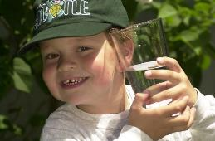
"Boy with glass of water, 2000" by Seattle Municipal Archives is licensed under CC BY 2.0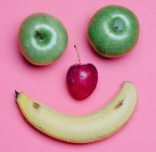
Smile made of ripe fruits by Any Lane, pexels.com
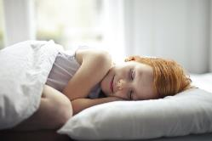
Photo by Andrea Piacquadio. pexels.com
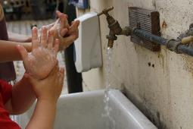
"Washing hands" by magnusfranklin is licensed under CC BY-NC 2.0

Asking for help at school
Learning goal: Children learn how to ask for help at school.
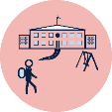There will be times you need to ask for help while you are at school. Teachers, other adults and your friends will help you.
Watch the social story via this QR code. If you can’t watch, talk with someone in your home about asking for help at school, and how you use your hand and wait.
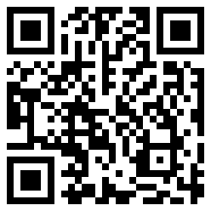

Making fruit sticks
Learning goal: Children engage with a recipe to create a healthy snack.
What you need:
- fruit
- wooden skewers or ice cream sticks
- chopping board
- knife
- plate.
What to do:
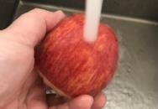
- Wash the fruit.
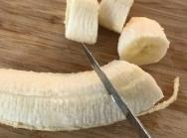
- Cut the fruit into small pieces.
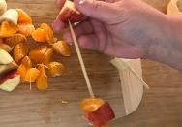
- Thread the fruit onto the skewers, making patterns.
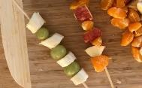
- Enjoy eating your healthy snack.

Is this activity too hard?
- Try a fruit that you don't usually eat.
- Select the fruit and have someone thread on skewers for you.
- Cut up or peel fruit to make a fruit salad.

Is this activity too easy?
- Use numbers and drawings to record the recipe on paper.

Extra learning activities
For families, the video via this QR code shares tips on how to prepare your child for starting school. If you can’t access the code, you can look through the tips from the Department of Education’s website.
.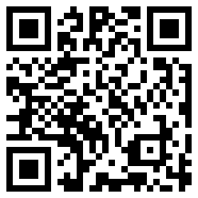
Mini checklist: Getting ready for primary school
- Write down the date your child will start school and keep it in your diary – or even on the fridge.
- Make sure your child can use the toilet independently – including urinals for boys – and practise good hand-washing techniques.
- Write your child’s name on all their school things and involve your child in organising them and recognising their name.
- Make sure your child’s name is not visible on the outside of anything they’ll be wearing to and from school.
- Help your child prepare at home by practising some of the skills they'll use at school.
© State of New South Wales (Department of Education), 2021
The copyright material published in this document is subject to the Copyright Act 1968 (Cth) and is owned by the NSW Department of Education or, where indicated, by a party other than the NSW Department of Education.
Copyright material available in this document is licensed under a Creative Commons Attribution 4.0 International (CC BY 4.0) licence.
See https://education.nsw.gov.au/about-us/copyright for further details.

