This booklet belongs to:

Week L – Tuesday

Day at a glance:
 | Making your name | Make a treasure box | Matching colours in nature | Beach safety and lifeguards | Bird beaks are just right
Estimated time | 10 mins | 30 mins | 45 mins | 30 mins | 10 mins
Resources required | Optional- tray, salt, food colouring, something to draw with and on | Empty box, coloured paper, tape, pictures, glue, scissors

Making your name
Learning goal: Children practice forming letters using different mediums.
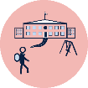
As you work through each school day, you will need to write your name a lot of times. It's fun to practice forming the letters of your name.
Choose one or more ways to make your name:
- Trace your name using textas, pencils or crayons.
- Look at your name and then copy it using paint.
- Make your name with your finger in a tray of coloured salt or shaving cream.
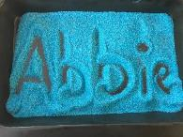
You can access how to make coloured salt or sand via this QR code. If you can’t access, use another method listed above.
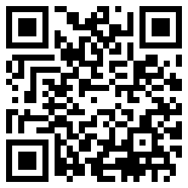

Is this activity too hard?
- Say or sign your name.
- Ask someone to write your name in big letters for you to trace with your finger.
- Make the first letter of your name.

Is this activity too easy?
- Make your surname also.
- Make the names of people in your family and any pets.

Make a treasure box
Learning goal: Children identify things that are special to them.
What you need:
- a small box or shoe box
- paper of different colours
- pictures cut from magazines or catalogues
- glue
- scissors.
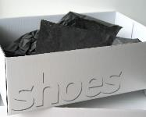
"shoebox" by How can I recycle this is licensed under CC BY 2.0
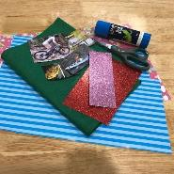
What to do:
- Decorate the box with the paper and pictures.
- Collect special things that are important to you, for example:
- small toys
- pictures
- photos
- things you have made or drawn
- items you have collected from nature.
- Put your special things in your treasure box.
- Tell someone about the things in your treasure box and why each is important to you.

Is this activity too hard?
- Show someone your favourite things.
- Tell someone about your favourite toy and why it is your favourite toy.
- Share the experience of eating your favourite food with someone.

Is this activity too easy?
- Create a theme for your treasure box so all of the items are related, for example a colour or animal theme.

Matching colours in nature
Learning goal: Children develop observation skills and respect for the natural environment.
- Watch the video via this QR code and follow the instructions to find colours in nature. If you can’t access the video, go to step 2.
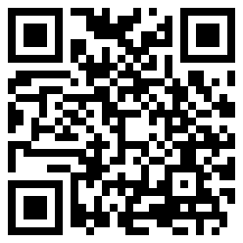
- Collect some things from nature such as leaves, twigs, stones and pebbles.
- Group them together into matching colours.
- Can you match these colours to other things around you?
- Maybe there is a leaf that looks a bit yellow that matches something in your home.

Is this activity too hard?
- Collect some leaves. Sort the leaves into 2 or 3 groups according to colour.

Is this activity too easy?
- Research the names for the different shades, tints, tones and hues of the colours e.g. purple, mauve, lilac and violet. Where might you see these colours in nature?

Take a break
Here are some things you might like to do:
- have a drink of water and a healthy snack
- play or have a rest
- go to the toilet and wash your hands.
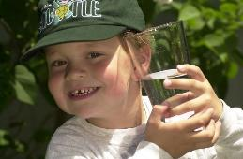
"Boy with glass of water, 2000" by Seattle Municipal Archives is licensed under CC BY 2.0
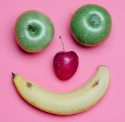
Smile made of ripe fruits by Any Lane, pexels.com
Photo by Andrea Piacquadio. pexels.com
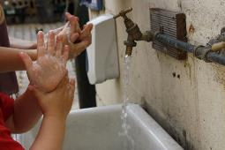
"Washing hands" by magnusfranklin is licensed under CC BY-NC 2.0

Beach safety and lifeguards
Learning goal: Children understand how they can keep themselves safe on the beach.
- Watch the video about lifeguards via this QR code. If you can’t watch, go to step 2.
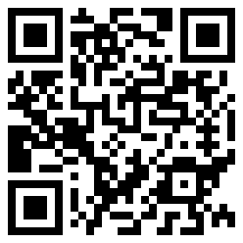
- Lifeguards help keep us safe on the beach. Have you ever seen a lifeguard working on a beach?
- What are some of the things lifeguards do?
- What equipment do lifeguards use?
- Watch the video about keeping yourself safe at the beach via this QR code. If you can’t watch, talk to someone about how you can keep safe on the beach.
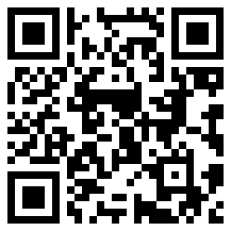

Bird beaks are just right
Learning goal: Children use skills of observation and enquiry.
- These are some of the foods birds eat. Each bird’s beak is just the right shape for catching or collecting and eating the food it eats.
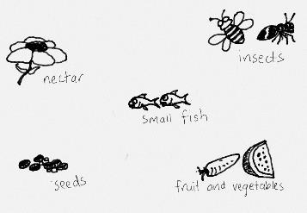
- Look closely at the shape of each bird's beak.
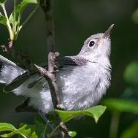
"Maybe a blue-gray gnatcatcher" by ibm4381 is licensed under CC BY 2.0
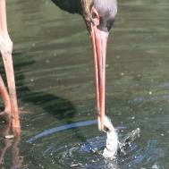
"Bird Catching Fish" by tattiehowker is licensed under CC BY-ND 2.0
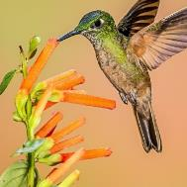
"Fawn-breasted Brilliant (F)" by Andy Morffew is licensed under CC BY 2.0
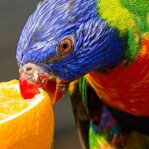
"Rainbow Lorikeet (Explored)" by mdalmuld is licensed under CC BY 2.0
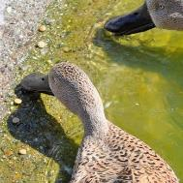
"Red Shoveler (Anas platalea) ducks eating food pellets" by warriorwoman531 is licensed under CC BY-ND 2.0
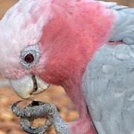
"Feeding Galah" by jeans_Photos is licensed under CC BY 2.0
- Describe the shape of each beak using describing words such as long, short, thin, wide, sharp, pointy or curved.
- Which beak is good for reaching into flowers to drink nectar?
- Which beak is good for catching insects?
- Which beak is good for plucking small fish out of the water?
- Which beak is strong enough to break the shells of seeds or tear into fruit and vegetables?
- Which beak is good for eating from the ground?

Is this activity too hard?
- Point to each bird’s beak and then the food you think that type of bird eats

Is this activity too easy?
- Research which birds eat fish. What do these birds have in common?
- Research which birds drink nectar. What do these birds have in common?

Extra learning activities
Learn about position and direction through song and story with Teddy bear, teddy bear via this QR code. If you can’t access, go to the song below.
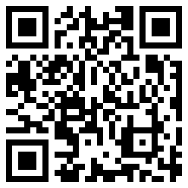
Teddy bear, teddy bear (action song - follow directions in the words)
Teddy bear, teddy bear, turn around;
Teddy bear, teddy bear, touch the ground;
Teddy bear, teddy bear, jump up high;
Teddy bear, teddy bear, touch the sky!
Teddy bear, teddy bear, bend down low;
Teddy bear, teddy bear, touch your toes;
Teddy bear, teddy bear, turn out the light;
Teddy bear, teddy bear, say good night!
Family tip: Engaging with position and direction to support learning
Encourage your child/children to help with some simple household chores. Support them by using the language of position, direction and movement. For example:
- sweeping the floor – under the couch, between the chairs, backwards and forwards, side to side
- washing dishes – under the water, wash the inside, drain upside down, pull out the plug
- cleaning the windows/mirror – rub around in a circle, wipe across and down, all around the edge.
© State of New South Wales (Department of Education), 2021
The copyright material published in this document is subject to the Copyright Act 1968 (Cth) and is owned by the NSW Department of Education or, where indicated, by a party other than the NSW Department of Education.
Copyright material available in this document is licensed under a Creative Commons Attribution 4.0 International (CC BY 4.0) licence.
See https://education.nsw.gov.au/about-us/copyright for further details.

