This booklet belongs to:

Week L – Thursday

Day at a glance:
 | Bounce the ball | Dice fun | Make a necklace | Learning someone's phone number | Wanda visits places in the community
Estimated time | 5 mins | 10 mins | 5-10 mins | 15-20 mins | 15-30 mins
Resources required | Large ball | Dice |  | Blu tack or tape, paper plates, stickers | A soft toy, something to draw on and write with

Ball play
Learning goal: Children develop coordination and ball handling skills.
- Hold a large ball in two hands.
- Push it down towards the ground to make it bounce.
- As the ball rises up, push it down again with your two hands.
- Play the song via this QR code and bounce your ball to the beat. If you can’t listen, play a favourite song and bounce to the beat.

Is this activity too hard?
- Play with a ball while you listen to a song.

Is this activity too easy?
- Try bouncing two balls at the same time (one in each hand).

Dice fun
Learning goal: Children understand how a dice works
Dice are small cubes that have a different number of spots on each side. When you roll a dice, it will stop moving. The dots on top are the ones that we check when playing a game.
- Look at the dice in the image below. Count how many dots are on the top of each one.
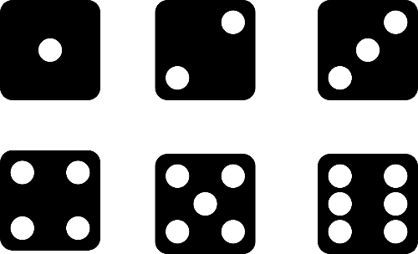
Image licensed under Pixabay
- Find some dice at home (you might find one in a board game).
- Use the dice to:
- play a game with someone or
- take turns guessing what number the dice will show before you roll it.

Is this activity too hard?
- Ask someone to count each side of the dice with you.

Is this activity too easy?
- Roll two dice and count how many dots there are altogether. Keep going and see what the biggest number is that you roll.

How to make a necklace
Learning goal: Children learn about Aboriginal culture.
Watch the video via this QR code, and see how Annette Sax makes a traditional Indigenous necklace. Annette is a Taungurung woman. She shares how to make an Indigenous necklace like the Aboriginal people from Victoria traditionally made. If you can’t watch, have someone in your home read through the information below to explore this Aboriginal artist.
In Yorta Yorta (Bangerang) language the word for necklace is djagoga.
- How do you say necklace in your home language?
- Practice saying 'djagoga'
- Tell someone some things you learnt from Annette in the video.
Information from the video
Annette Sax shares how to make an Indigenous necklace like the Aboriginal people from Victoria used to make traditionally. When they visited someone else’s camp, they would give the necklace as a gift. In Yorta Yorta (Bangerang) language the word for necklace is djagoga.
Annette shares connection with the natural materials on Taungurung Country. She-oak was used by Aboriginal men to make different types of boomerangs and spears. Gum leaves were used for medicine.

Is this activity too hard?
- Have someone model the word 'djagoga' and try to say some of the sounds.
- Collect some native leaves, nuts and flowers. Put them in a vase.

Is this activity too easy?
- Collect some of the items that Annette uses in the video and follow the instructions to make a necklace.

Take a break
Here are some things you might like to do:
- have a drink of water and a healthy snack
- play or have a rest
- go to the toilet and wash your hands.
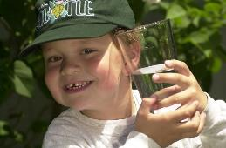
"Boy with glass of water, 2000" by Seattle Municipal Archives is licensed under CC BY 2.0
Smile made of ripe fruits by Any Lane, pexels.com
Photo by Andrea Piacquadio. pexels.com
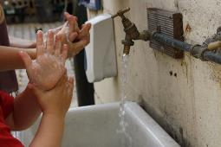
"Washing hands" by magnusfranklin is licensed under CC BY-NC 2.0

Learning someone’s phone number
Learning goal: Children remember a significant phone number.
Learning someone's phone number is important for your safety, especially when you go to school. It's good to know the phone number of an adult who can help you if you need them.
- Ask someone in your house to help you make a pretend phone to stick on the wall.
- Find 12 paper plates.
- Write each number 0-9 on the back of each paper plate.
- You will need to make two more with the star and the hash key.
- Using blu tack or tape, attach the plates to a wall in the same way as a smart phone screen.
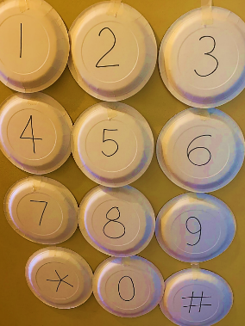
- Ask someone for the phone number to learn and get them to write it down or call it out to you.
- As each number is called, touch the right button (plate) that is on your wall.
- After a few practices, stick some stickers just above the numbers as you say them.
- If you can, leave the pretend phone on the wall so you can repeat the number and memorise it.

Is this activity too hard?
- Lay the plates out on the floor to practice, and use your hands or feet to learn the number.
- Begin with the first three numbers of the phone number.

Is this activity too easy?
- Try remembering the phone number as a song.
- Remember a second person's phone number.

Wanda visits places in the community
Learning goal: Children visit and engage with places in their local community.
- Watch the video of Wanda visiting some community gardens, a street library and a crop and swap via this QR code. If you can’t watch, start at step 2.
- Take your own travel buddy with you to special places in your community.
- Take pictures, or when you are back home do drawings in your journal, of you and your buddy on your adventure.
- Ask someone to write about your adventure in your journal.
- Let your teachers know what you and your buddy have been up to when you get back to preschool or daycare.
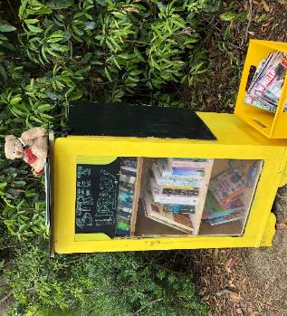
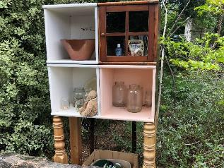
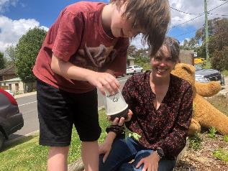
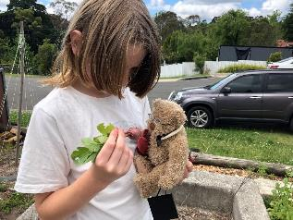
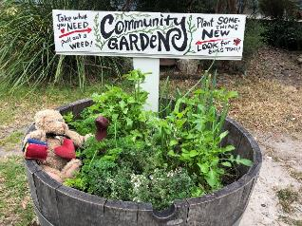

Is this activity too hard?
- Take a picture of your travel buddy with someone in the community.

Is this activity too easy?
- Ask an adult to help you video or photograph someone you meet in the community with your travel buddy.
- Ask the community member some questions about what they do at the special place.

Extra Learning activities
- Download the Smiling Mind app via the QR code to access free meditation programs for children. If you can’t access the QR code, you can try some of the following mindfulness activities:
  - mindful posing – standing in poses like superman or wonder woman
  - senses – pay attention to the world around you using smell, sight, hearing, taste and touch
  - safari – go for a walk outside and look for as many birds and insects on the ground in and in the trees around you.
- There is also a guide for parents and carers to create a mindful home for your family. You will need to fill out your details to get your guide.
© State of New South Wales (Department of Education), 2021
The copyright material published in this document is subject to the Copyright Act 1968 (Cth) and is owned by the NSW Department of Education or, where indicated, by a party other than the NSW Department of Education.
Copyright material available in this document is licensed under a Creative Commons Attribution 4.0 International (CC BY 4.0) licence.
See https://education.nsw.gov.au/about-us/copyright for further details.

