This booklet belongs to:

Week L – Monday

Day at a glance:
 | Butterfly breathing | Engineering nests | Auskick at home – part 1 | The Kindergarten day | Putting things in order
Estimated time | 5 mins | 30 mins | 10 mins | 15 mins | 10 mins
Resources required |  | Natural materials for making a nest | Football

Butterfly breathing
Learning goal: Children demonstrate capacity to understand their emotions and self-regulate.
- Learn a breathing technique by watching the video via this QR code. If you can’t watch, go to step 5.
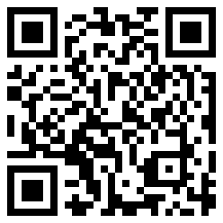
- Follow the video to practice butterfly breathing.
- How did it make you feel?
- Try using butterfly breathing when you're feeling angry or worried.
- Another breathing activity is to lay on your back with your hands on your tummy. Breathe in deeply so that your hands move up with your tummy and breathe slowly out feeling your hands go down slowly with your breath.

Is this activity too hard?
- Take some big deep breaths, breathing in through your nose and out through your mouth.

Is this activity too easy?
- Create an artwork of a butterfly or you. Hang it somewhere as a reminder to do your butterfly or tummy breathing.

Engineering nests
Learning goal: Children explore bird nests and experiment with ways to build one.
- Birds make nests to keep their eggs and chicks safe.
- What do you know about nests?
- What are they built from?
- Look at these pictures of nests.
- Can you tell what each bird used to build their nest?
- What shape is each nest?
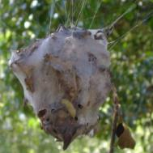
"Rainspider Nest (Palystes castaneus)" by Jaxon Rice is licensed under CC BY-SA 2.0
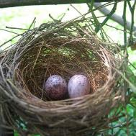
"Bird Nest" by Sikachu! is licensed under CC BY-NC-ND 2.0
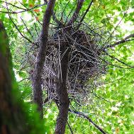
"Crow's Nest Make Out of Hangers" by Bracus Triticum is licensed under CC BY-NC 2.0
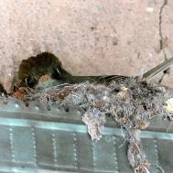
"Nesting Western Flycatcher" by Bandelier National Monument is licensed under CC BY-NC 2.0
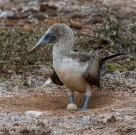
"Blue-footed Booby Nest" by Andy Morffew is licensed under CC BY 2.0
- Look for things to build a nest with. You might want to use:
- grass
- leaves
- bark
- twigs
- paper
- fabric
- wool
- twine
- cotton balls.
- Think about the shape you will make your nest and how it will hold together.
- Watch the video to see some children building nests via this QR code. If you can’t watch, create your own nest and share how you did it with someone in your home.
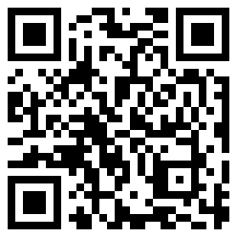

Is this activity too hard?
- Make a round nest out of clay or playdough.
- Make some round eggs to sit inside your nest.

Is this activity too easy?
- Nests are usually round. Why do you think this is? Experiment making different shapes nests from playdough. Which shape makes it better for the eggs to sit in safely?

Auskick at home - part 1
Learning goal: Children learn stretches and exercises that support physical health.
Watch the video via this QR code, to join Katie Brennan doing some footy stretches and exercises. If you can’t watch, do some stretches to warm up and practice throwing a football with someone in your home.
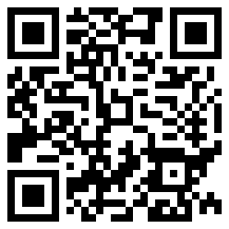

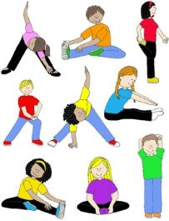
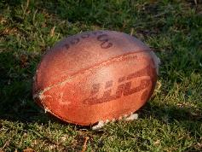
"An Australian Rules Football" by mikecogh is licensed under CC BY-SA 2.0

Is this activity too hard?
- Make yourself as:
  - tall as you can
  - wide as you can
  - flat as you can
  - small as you can.

Is this activity too easy?
- After you have warmed up, practice some football passes and kicks.

Take a break
Here are some things you might like to do:
- have a drink of water and a healthy snack
- play or have a rest
- go to the toilet and wash your hands.
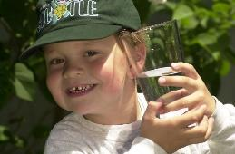
"Boy with glass of water, 2000" by Seattle Municipal Archives is licensed under CC BY 2.0
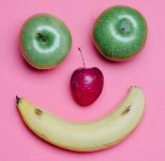
Smile made of ripe fruits by Any Lane, pexels.com
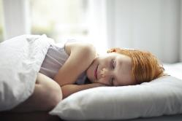
Photo by Andrea Piacquadio. pexels.com
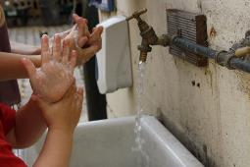
"Washing hands" by magnusfranklin is licensed under CC BY-NC 2.0

The Kindergarten day
Learning goal: Children learn what to expect in a typical Kindergarten day.
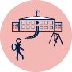At school, the day is organised a bit differently to what you might be used to at preschool or daycare. You will do lots of different learning activities inside your classroom, as well as go outside to eat and play. Sometimes you will go with your class to an assembly, the library or outside to play sport.
- Watch the video about a day in Kindergarten via this QR code. If you can’t watch it, talk with someone in your home about the first day of school. Go to step 3 and share your ideas.
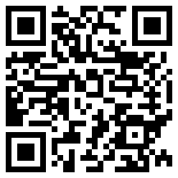
- Talk with someone about what you saw the children doing.
- Which activities are you looking forward to doing in Kindergarten?
- Which activities are you worried about?

Putting things in order
Learning goal: Children sequence everyday events.
Making toast
- Look at these pictures. They show the steps to make toast.
- If you have a printer, print the pictures via this QR code and then cut each out. Next, put them in order to show how to make toast.
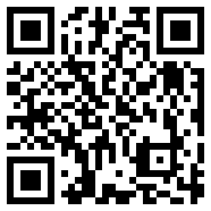
- If you don't have a printer or access to the code, point to each picture in order.
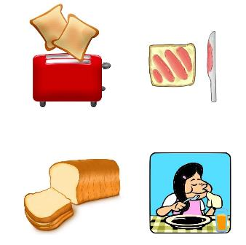
Stages of a plant's growth
- Look at these pictures. They show the stages of a plant growing.
- If you have a printer, print the pictures via this QR code and then cut each out. Next, order them in to show how a plant grows.
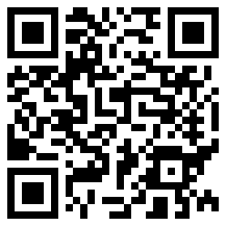
- If you don't have a printer or access to the code, point to each picture in order.
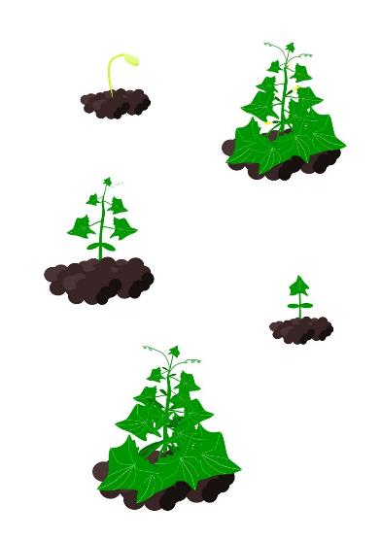

Is this activity too hard?
- Talk with someone about how you brush your teeth. What do you do first? What do you do next? What do you do last?

Is this activity too easy?
- What do you do that has many steps? (for example, brushing your teeth, getting dressed). Draw a picture of each step, cut them out and mix them up for someone to put in the correct order.

Extra learning activities
For families, access the Digital lunchbox website for links to engaging and creative learning activities for all ages. If you can’t access the QR code, an example of some family learning activities included visits together to museums, art galleries, community events, arts and culture experiences.
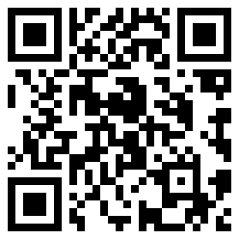
© State of New South Wales (Department of Education), 2021
The copyright material published in this document is subject to the Copyright Act 1968 (Cth) and is owned by the NSW Department of Education or, where indicated, by a party other than the NSW Department of Education.
Copyright material available in this document is licensed under a Creative Commons Attribution 4.0 International (CC BY 4.0) licence.
See https://education.nsw.gov.au/about-us/copyright for further details.

