This booklet belongs to:

Week K – Wednesday

Day at a glance:
 | Cooking scones | Counting leaves | Being sun safe at school | Following a routine | Dance
Estimated time | 45 mins | 10 mins | 10 mins | 15 mins | 15 mins
Resources required | Baking tray, mixing bowl | Leaves, pegs

Cooking scones
Learning goal: Children follow a recipe to make scones.
What you need:
- 3 cups self-raising flour
- 1 tablespoon sugar
- ½ cup butter
- 1 cup milk.
What to do:
- Preheat oven to 220 degrees (or 200 for fan forced).
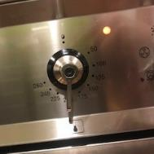
- Add the flour and sugar to the mixing bowl.
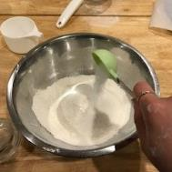
- Cut the butter into small pieces.
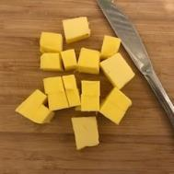
- Add the butter to the bowl and squish it into the flour.
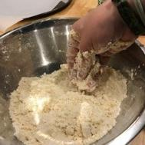
- Pour in the milk and mix all the ingredients together.
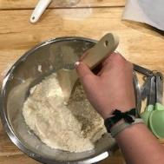
- Kneed the mixture to make a sticky dough.
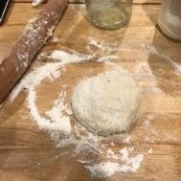
- Roll the dough out.
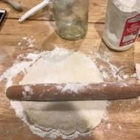
- Press shapes into the dough.
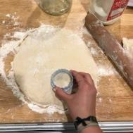
- Put the shapes on a baking tray.
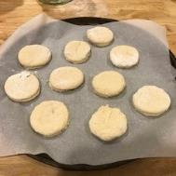
- Put the tray in the oven and cook for 20 minutes.
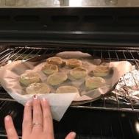
- Enjoy the scones.
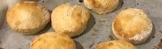

Is this activity too hard?
- Help with the measuring and mixing.

Is this activity too easy?
- Make another batch of scones, this time substituting some of the ingredients for others:
  - instead of butter, use margarine, coconut oil, canola or olive oil
  - instead of milk, use cream, oat milk, water or lemonade.
- Find and make a recipe for flavoured scones, for example cheese, pumpkin or date scones.

Counting leaves
Learning goal: Children count using one to one correspondence.
We count things one by one to see how many there are altogether. Practice counting with this activity:
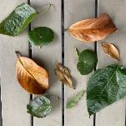
- Collect 10 leaves from outside (or make ten leaves from paper).
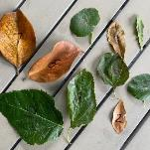
- Write a number on each leaf, from 1 - 10. Ask for help if you need it.
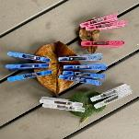
- Clip pegs onto each leaf, to match the number written on it.
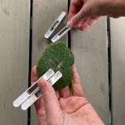
- After you have finished, remove each peg, counting aloud as you take it off.

Is this activity too hard?
- Collect a bunch of leaves or handful of small toys. Count them one by one to see how many you have altogether.

Is this activity too easy?
- Collect another 10 leaves, write numbers 11-20 on them and clip pegs to match the written number.

Sun safety at school
Learning goal: Children learn about sun safety and the importance of wearing a hat.
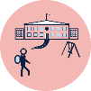
You will need to wear a hat at school each day, as part of your school uniform.
- Watch the SunSmart video via this QR code to remind you how to be sun safe. If you can’t watch, go to step 4.
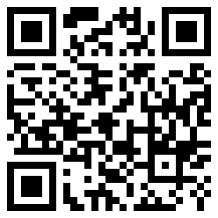
- Sing along with the song.
- Do you remember the 5 key messages? One was to slap on a hat.
- Just as you may have a new school shirt or socks, you will have a school hat that is part of your new uniform.
- Do you know what your new school hat looks like? Is it the same as in this photo?
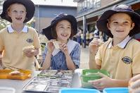
Image owned by the NSW Department of Education under the Copyright Act 1968 (Cth)​
- Remember to put it in your school bag everyday so you are sun safe!

Take a break
Here are some things you might like to do:
- have a drink of water and a healthy snack
- play or have a rest
- go to the toilet and wash your hands.
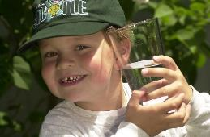
"Boy with glass of water, 2000" by Seattle Municipal Archives is licensed under CC BY 2.0
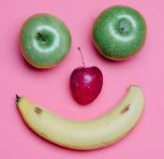
Smile made of ripe fruits by Any Lane, pexels.com
Photo by Andrea Piacquadio. pexels.com
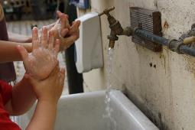

"Washing hands" by magnusfranklin is licensed under CC BY-NC 2.0

Following a routine
Learning goal: Children follow routines and transition smoothly between activities.
- When you go to preschool or daycare you might see a visual timetable or routine. This shows what happens each day.
- Draw a visual timetable to show the order you do things each morning. What do you do first? What do you do second? If you need some ideas, look at the picture below.
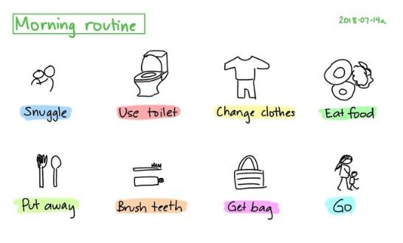
This Photo by Unknown Author is licensed under CC BY 3.0
- Put your timetable on your fridge or a wall to help you remember what you need to do each morning, without needing to be reminded.

Is this activity too hard?
- Take photos of the things you do each day. Print these and put them in order to create your own visual timetable.

Is this activity too easy?
- Make a timetable for your bedtime routine, for example, eat dinner, listen to a story, have a bath.

Dance - NetSetGO
Learning goal: Children engage in increasingly complex movement and coordination through dance.
Watch the video via the QR code and join in dancing. If you can’t watch, you can play your favourite music from home and enjoy dancing.
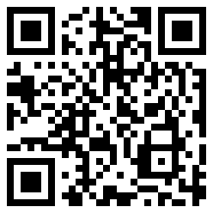

Extra learning activities
Be inspired by the art of Kandinsky as you explore shape through song and art. Here is a painting by Kandinsky using bright colours and rows of symbols. It looks a bit like written music.
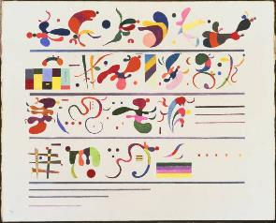
Kandinsky - Succession,1935 (Wikimedia Commons).

You can access the related activities via this QR code. If you can’t access, you can go to the activity below.
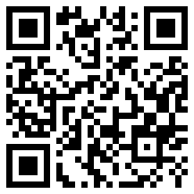
Activity
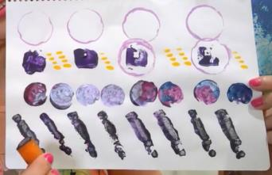
- Create a painting using different shapes from around the house.
  - You can try bottle tops, fork, cut apple or potato, corks and other small things that will press into paint, or that you can paint and press on the paper.
- What’s the most unusual object you found to print with?
© State of New South Wales (Department of Education), 2021
The copyright material published in this document is subject to the Copyright Act 1968 (Cth) and is owned by the NSW Department of Education or, where indicated, by a party other than the NSW Department of Education.
Copyright material available in this document is licensed under a Creative Commons Attribution 4.0 International (CC BY 4.0) licence.
See https://education.nsw.gov.au/about-us/copyright for further details.
