This booklet belongs to:

Week K– Tuesday

Day at a glance:
 | Make a wind sculpture | Using the sick bay at school | Learning new skills | Alliteration animals | Make a pretend stew
Estimated time | 30 mins | 5 mins | 10 mins | 10 mins | 30 mins
Resources required | Long stick, vine and leaves |  |  |  | Big bowl, spoon, nature items

Make a wind sculpture
Learning goal: Children understand how natural materials can be used to observe the wind.
- Watch the video about wind via this QR code. If you can’t watch it, go to step 2.
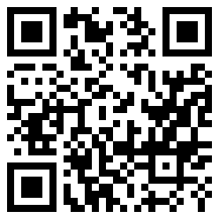
- Make a wind sculpture.
What you need:
- a stick
- large leaves
- vines or thick grasses.
What to do:
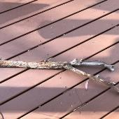
- Find a long, thick stick.
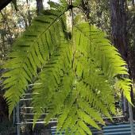
- Collect different kinds of leaves.
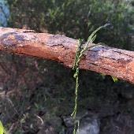
- Tie the vines or long grass onto the stick.
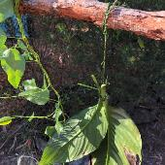
- Tie leaves onto the other end of the vines.
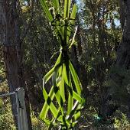
- Weave thick leaves and hang these from the stick.
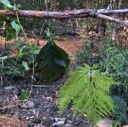
- Hang the stick so the leaves and vines blow in the wind.
If you don't have any leaves, make your sculpture by hanging strips of paper, fabric or ribbon from a ruler or stick.

Is this activity too hard?
- Collect some leaves or grass and throw them in the air. Watch how they float back to the ground.

Is this activity too easy?
- Observe the movement of natural things around you and describe how the wind moves them. Use interesting words such as dance, flutter and sway.

Using the sick bay at school
Learning goal: Children understand what will happen if they are sick or injured at school.
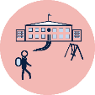
If you are sick or injured at school you might need to spend time in the sick bay. The sick bay is a small room for children to rest in.
- If you feel sick or hurt yourself at school, you need to tell a teacher.
- The teacher might ask a friend to walk with you to the school office.
- Someone working in the office will help you. They might take you to the sick bay.
- You will rest in the sick bay until you feel better or someone takes you home.
- If you go to preschool or daycare, what happens if you feel sick or hurt yourself?
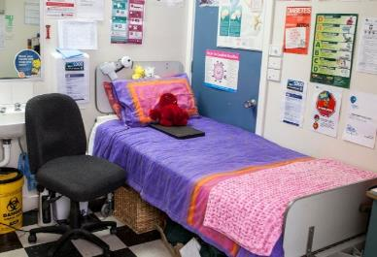
Meadowglen Public School

Learning new skills
Learning goal: Children persist when faced with challenges.
- Watch the video about learning to ride a bike via this QR code. If you can’t watch, go to step 3.
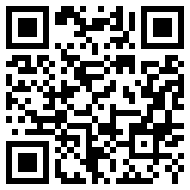
- The girl in the video was learning to ride her bike. She was scared but tried and tried until she could ride with her friends.
- Is there something you are learning to do?
- Was it hard the first time you tried?
- Have a go at trying again now.

Is this activity too hard?
- Think about something that you would like to learn how to do.
- Talk to someone about how you could learn that skill.

Is this activity too easy?
- Pick a new thing you would like to learn. Ask someone at home to help you get started.

Take a break
Here are some things you might like to do:
- have a drink of water and a healthy snack
- play or have a rest
- go to the toilet and wash your hands.
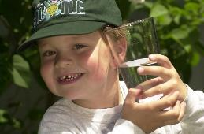
"Boy with glass of water, 2000" by Seattle Municipal Archives is licensed under CC BY 2.0
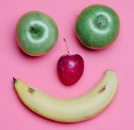
Smile made of ripe fruits by Any Lane, pexels.com
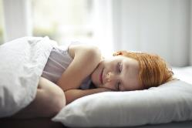
Photo by Andrea Piacquadio. pexels.com
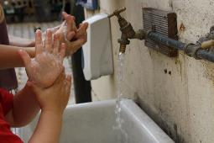
"Washing hands" by magnusfranklin is licensed under CC BY-NC 2.0

Alliteration activity
Learning goal: Children develop an awareness of sounds.
It is fun to name our pets and toys. We can make up silly names using alliteration. Alliteration is when words start with the same sound. Listen to these animal names.
Lizzie Lizard
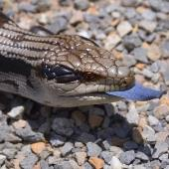
"Blue Tongue Lizard" by Rod Waddington is licensed under CC BY-SA 2.0
Dolly Dingo
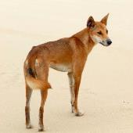
"Canis lupus dingo" by Sam Fraser-Smith is licensed under CC BY 2.0
Chris Crocodile
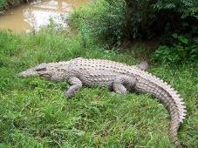
"Madagascar, crocodiles" by luc legay is licensed under CC BY-SA 2.0
Marty Magpie
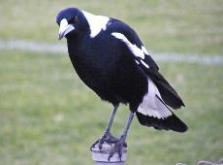
"MAGPIE" by NAPARAZZI is licensed under CC BY-SA 2.0

Make up some names for the animals below. Make sure each name is two words and that the two words start with the same sound.
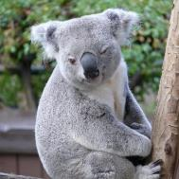
"Koala" by renedrivers is licensed under CC BY-NC-ND 2.0
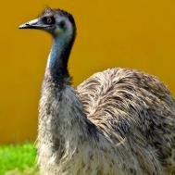
"emu" by Jon Bunting is licensed under CC BY 2.0
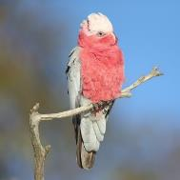
"Galah" by 0ystercatcher is licensed under CC BY-NC-SA 2.0
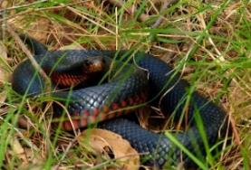
""Red-bellied Black Snake 090430-3377" by Tony Rodd is licensed under CC BY-NC-SA 2.0

Is this activity too hard?
- Say the name of each of the animals pictured.
- Have someone say the alliteration and copy them.

Is this activity too easy?
- Use alliteration to create names for your toys.

Make a pretend stew
Learning goal: Children participate in an inquiry-based experience.
Here are two videos to watch about making a stew. If you can’t watch them, go to the instructions below to make your own stew.
Watch the video via this QR code if you want to see a mouse cook a stew!
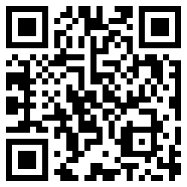
Watch the video via this QR code if you want to see some pirates cook a stew!
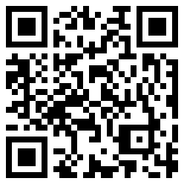
Make your own stew.
What you need:
- a big mixing bowl or cooking pot
- an outdoor area to "cook" in
- natural materials such as sand, dirt, leaves, small sticks, gumnuts, flowers or small stones.
What to do:
- Fill your cooking pot with water.
- Add in the ingredients you think will sink.
- Stir your stew.
- Add in the ingredients you think will float.
- Stir your stew again.
- Collect and add more ingredients if needed.
- Serve and pretend to eat your stew!

Is this activity too hard?
- Get a saucepan and spoon and do some pretend cooking.
- Use your hands to play in a sand pit or to explore natural materials.

Is this activity too easy?
- Use pictures and words to record the recipe for your stew.

Extra learning activities
Enjoy Play School story time about ‘Where the forest meets the sea’ via this QR code. If you can’t access, go to the activity below.
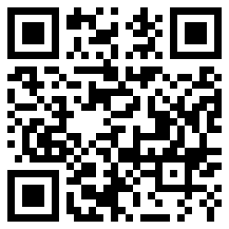
Literacy activities are available via this QR code. If you can’t access you can go to the activity below.
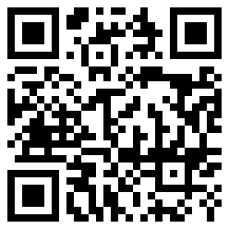
Activity
The story linked in the video is set in the Daintree Rainforest.
- Draw some of the things you might see in a rainforest.
- Talk with someone about rainforests and what makes them special.
- Think about a nature place that is special to you, and draw some of the things you see.
- How does it feel to be in this place?
- What are some ways to care for your special place?
© State of New South Wales (Department of Education), 2021
The copyright material published in this document is subject to the Copyright Act 1968 (Cth) and is owned by the NSW Department of Education or, where indicated, by a party other than the NSW Department of Education.
Copyright material available in this document is licensed under a Creative Commons Attribution 4.0 International (CC BY 4.0) licence.
See https://education.nsw.gov.au/about-us/copyright for further details.

