This booklet belongs to:

Week K – Thursday

Day at a glance:
 | Send a hug | Poetry | Sorting animals | Friends at school | Kookoo Kookaburra
Estimated time | 30 mins | 15 mins | 10 mins | 15 mins | 15 mins
Resources required | large paper, something to draw with, scissors, large envelope

Send a hug
Learning goal: Children feel connected to others.
Follow the instructions in the video via this QR code, to send a hug to someone. If you can’t access, follow the instructions below.

Create a hug

- Lay on a huge piece of paper (such as the back of wrapping paper) and ask for help to trace around your body from your waist up.
- Carefully use scissors to cut out your shape.
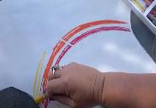
- Decorate your paper with paints, crayons and pencils.
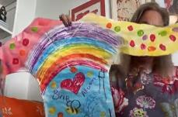
- When complete, leave to dry.
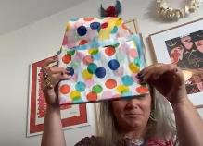
- Fold it carefully to fit into an envelope, ask someone for help if you need to.
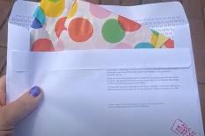
- With adult help, put your hug into a large envelope and seal the envelope when ready to post. You can access the video via this QR code. If you can’t access, go to step 7.

Send a hug
- Take it to the post office. You will need a stamp and the address of who you want to send the hug to.
- Place it in the red post box outside.
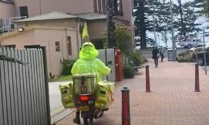
- The postman will deliver your hug to the address on the envelope.

Is this activity too hard?
- Ask someone to take a photo of you and to send it to someone you would like to give a hug to.

Is this activity too easy?
Write a letter to go with your hug:
- include the person's name
- write 'This is a hug from me.'
- sign your name.

Poetry
Learning goal: Children identify rhyming words in a poem.
- A poem is a piece of writing that shares ideas, emotions or a story. They often use rhyming words. Words that rhyme end with the same sound.
- Listen to the poem about a worm via this QR code. If you can’t listen, go to step 5.
- Replay the poem, this time listen out for the pairs of rhyming words.
- Say the rhyming words you heard in the poem (for example, wiggle/giggle, yard/hard, stop/flop).
- Think of a word that rhymes with each of these:
- dog
- hat
- sit.

Is this activity too hard?
- Listen to the poem with someone. Repeat the rhyming words together.
- Ask someone to say some rhyming words with you.

Is this activity too easy?
- Listen to the poem “There’s a crocodile in my lunchbox” via this QR code. Listen out for and say the rhyming words you heard. If you can’t listen, see how many rhyming words you can find in your home (shoe/blue, seat/sheet). Ask someone in your home to help.

Sorting animals
Learning goal: Children compare animals and categorise them by habitat.
- Look at these animals in the activity via this QR code. If you have access to a printer, print the animal pictures (PDF 1.8MB) and cut them out. If you do not have access to a printer or the QR code, go to step 2 and use the pictures below.
- Animals live in all kinds of homes. The area they live in is called their habitat.
- Point to and count the animals that live on a farm. How many?
- Point to and count the animals that live in the ocean. How many?
- Choose a different way to sort the animals into groups (for example, by colour, size or the way they move)
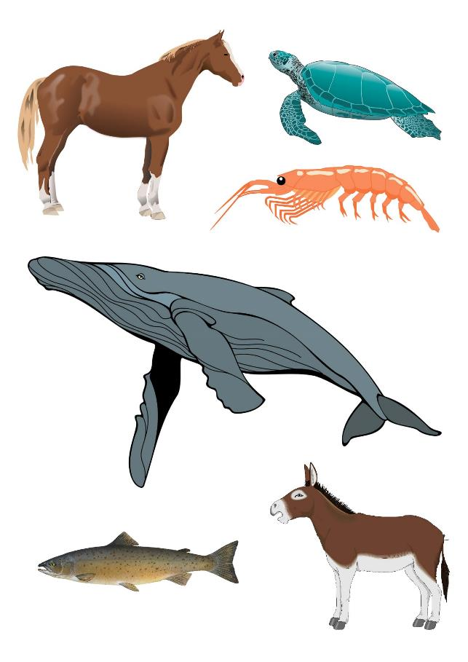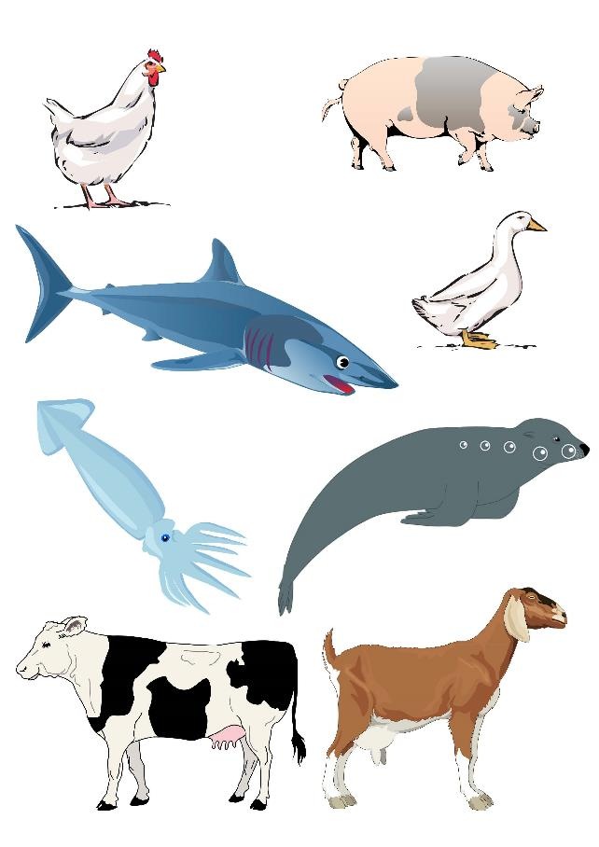

Is this activity too hard?
- Say the name of each of the animals.
- If you have small animal toys, sort these into groups based on where they live.

Is this activity too easy?
- Investigate what animals live in other habitats such as, forest, desert and polar regions.

Take a break
Here are some things you might like to do:
- have a drink of water and a healthy snack
- play or have a rest
- go to the toilet and wash your hands.
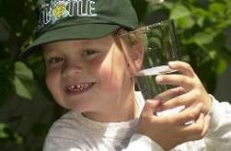
"Boy with glass of water, 2000" by Seattle Municipal Archives is licensed under CC BY 2.0
Smile made of ripe fruits by Any Lane, pexels.com
Photo by Andrea Piacquadio. pexels.com
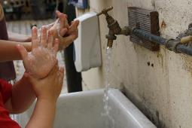
"Washing hands" by magnusfranklin is licensed under CC BY-NC 2.0

Friends at school
Learning goal: Children develop their understanding of how to be a good friend
When you go to school you will meet lots of new children. The ones you enjoy playing with will become your friends. Good friends have fun together and are kind to one another.
- Watch the video about friendship soup via this QR code. If you can’t watch, talk to someone in your home about what makes a good friend.
- What are some of the ingredients needed to make a friendship soup?
- Ask someone to explain any of the words in the video you didn't understand.
- When you think of your friends from home or preschool, what ingredients do you think of? Are they kind? Do you have fun with them? Do you trust them?
- How are you a good friend?
- At school, remember the ingredients in friendship soup to make new friends, and be a good friend to those you already know.

Kookoo Kookaburra
Learning goal: Children use their hearing to investigate bird behaviour.
- The kookaburra's laugh is how it communicates with other birds. Listen to these laughing kookaburras via this QR code. If you can’t listen, go to step 3.
- Are they really laughing? What do you think they are trying to say?
- Close your eyes. Can you hear any birds? What do you think the birds you hear look like? Now open your eyes. Can you see the birds making the sounds? What are the birds doing and what could they be talking about?
- Listen to the poem via this QR code for some ideas.

Is this activity too hard?
- Which animal noises do you know? Make each noise for someone to guess the animal.

Is this activity too easy?
- Ask an adult to borrow their phone to record different bird sounds.
- Listen to your recordings. What do you notice? Are they long or short sounds? Are they high or low pitched?

Extra Learning activities
Learn to count through song and story with the Five little ducks via this QR code. If you can’t access, go to the instructions below.
‘Five little ducks’ (finger rhyme)
Five little ducks went out one day (hold up five fingers)
Over the hills and far away (hold arm across body and tuck fingers behind shoulder on the opposite side of the body)
Mother Duck said, ‘Quack, quack, quack, quack’ (use other hand to make a Mother Duck beak; open and close hand to quack)
But only four little ducks came back. (bring first hand back to the front with four fingers showing) (continue until no little ducks came back)
Poor Mother Duck went out one day, Over the hills and far away, Mother Duck said ‘Quack, quack, quack, quack’
And all of those five little ducks came back.
Engaging with the counting to support learning
Step 1. When singing this rhyme hold your fingers up.
Step 2. As you drop a finger when each duck goes away, count each finger that is left and say the number of fingers left standing.
Step 3. How many ducks are left each time?
Step 4. After singing the song, put five fingers up and count each finger saying the number as they count.
© State of New South Wales (Department of Education), 2021
The copyright material published in this document is subject to the Copyright Act 1968 (Cth) and is owned by the NSW Department of Education or, where indicated, by a party other than the NSW Department of Education.
Copyright material available in this document is licensed under a Creative Commons Attribution 4.0 International (CC BY 4.0) licence.
See https://education.nsw.gov.au/about-us/copyright for further details.

