This booklet belongs to:

Week J – Thursday

Day at a glance:
 | Plan a mini garden | How do bees make honey? | At the end of the school day | Celebrating culture | Rainbow ritual
Estimated time | 30 mins | 15 mins | 15 mins | 10 mins | 20 mins
Resources required | Something to draw with and on |  |  |  | Optional paint and brush

Plan a mini garden
Learning goal: Children appreciate and care for natural and built environments.
- Watch the video of children making mini gardens via this QR code. If you can’t watch, go to step 2.
- Look at this plan for a mini garden. Notice it is drawn as though someone is looking at it from above, this is called 'bird's eye view'. The plants and other features have been labelled. This garden is for fairies and native creatures to play and live in. Native grasses provide shelter and protection for fairies and native animals.
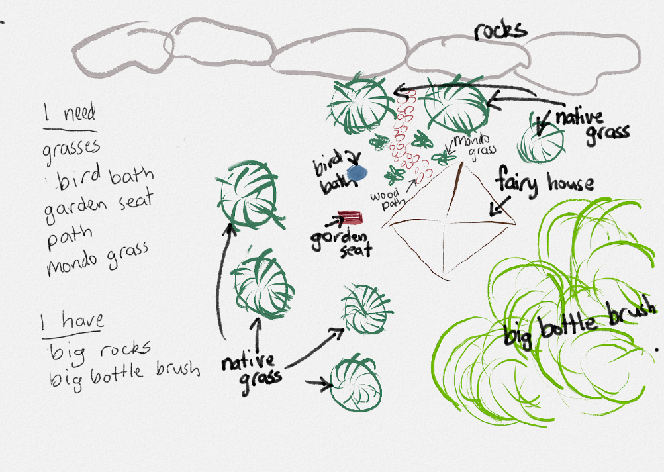
- Can you see the grasses in the plan? What else do you see in the plan?
- Plan your own mini garden on a piece of paper. As you plan your mini-garden, think about:
- what types of plants you will include
- where each plant will go
- what else you will include in your garden, for example, furniture, pathways, play equipment, statues.

Is this activity too hard?
- Look at a garden and talk with someone about what you can see.
- Look at pictures of different plants and pick the one you would most like to plant in a garden.

Is this activity too easy?
- Ask someone to help you write words on labels for each of the things in your plan. Try writing some yourself. Glue these onto your plan in the right place.

How do bees make honey?
Learning goal: Children engage with a range of texts and gain meaning from these.
We all love honey. How do you think bees make honey? Listen to this podcast via this QR code. If you can’t listen, talk about the photos below with someone in your home.
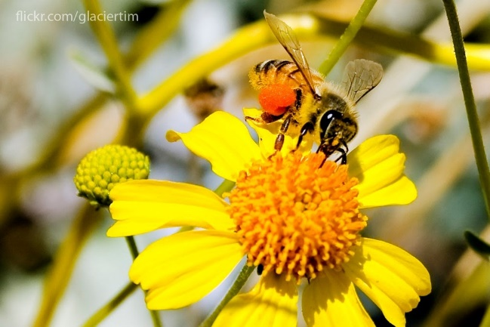
"Bee on flower" by Tim Shields BC is licensed under CC BY-NC 2.0
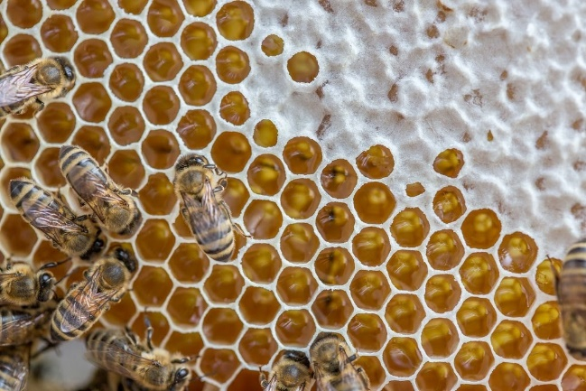
"Allagash Bee Hive has a new queen!" by Allagash Brewing is licensed under CC BY 2.0

Is this activity too hard?
- Ask your family to talk to you about how bees make honey.
- Taste some honey.

Is this activity too easy?
- Ask someone to help you research how bees make honey, then draw the sequence of how this happens.

At the end of the school day
Learning goal: Children develop an understanding of school routines.
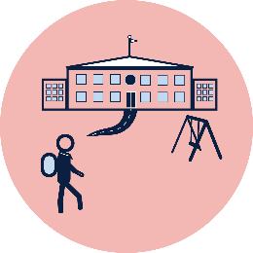
At the end of the school day, you will pack your bag and wait with your teacher to be collected.
Talk with your family about these things:
- What will you pack into your school bag at the end of the day?
- What will you do if you can't find all your things?
- You and your class will wait with your teacher till someone comes to collect you from school. It is important you stay with your teacher till they arrive. Who will collect you from your teacher after school?
- If your person is running late, who will collect you instead?
- Will you go to after school care? If so, one of the carers will collect you from your teacher.
- Will you catch a bus home from school? If so, your teacher will show you where to line up. A different teacher will look after the children waiting for a bus.
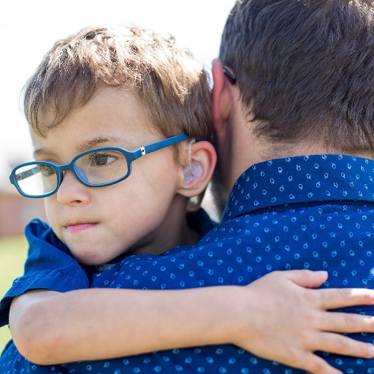
Image owned by the NSW Department of Education under the Copyright Act 1968 (Cth)
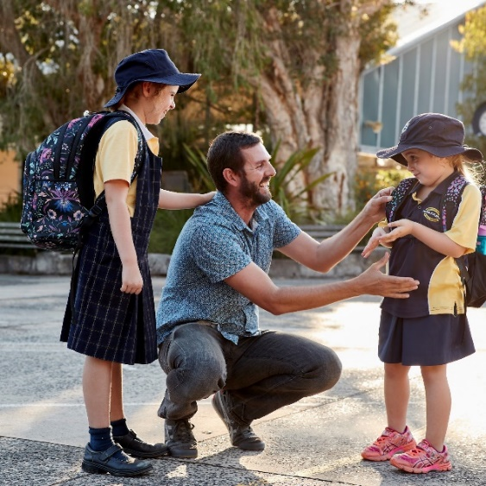
Image owned by the NSW Department of Education under the Copyright Act 1968 (Cth)

Take a break
Here are some things you might like to do:
- have a drink of water and a healthy snack
- play or have a rest
- go to the toilet and wash your hands.
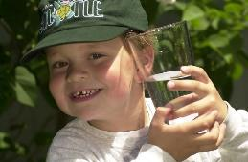
"Boy with glass of water, 2000" by Seattle Municipal Archives is licensed under CC BY 2.0
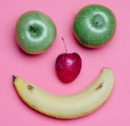
Photo by Any Lane from Pexels
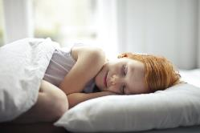
Photo by Andrea Piacquadio from Pexels
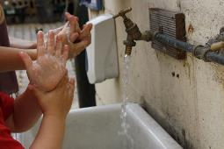
"Washing hands" by magnusfranklin is licensed under CC BY-NC 2.0

Celebrating culture
Learning goal: Children broaden their understanding of the world.
Watch the video and dance via the QR code. If you can’t listen, play a favourite song and clap along to the beat.
Notice how many children from different countries join in singing the song.

Is this activity too hard?
- Enjoy moving to the music.

Is this activity too easy?
- Ask someone to help you research songs from other cultures and note the different sounds from different places.

Rainbow ritual
Learning goal: Children enjoy moments of solitude to support their wellbeing.
- Find a comfortable spot to sit or lay down.
- Get ready to use your imagination.
- Watch the video via this QR code. If you can’t watch, go to step 6.
- Send an imaginary rainbow to someone you love.
- Do a painting or drawing with rainbow colours.
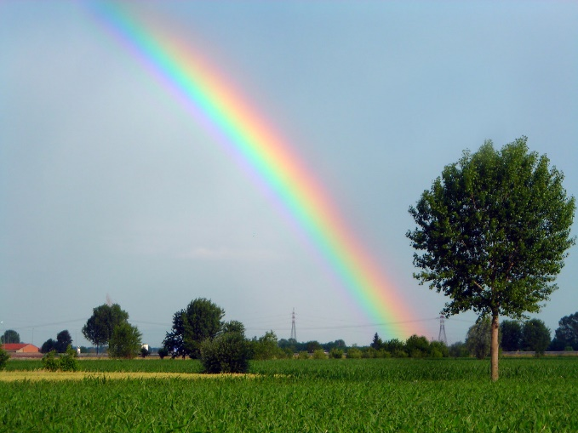
"Rainbow" by miri695 is licensed under CC BY-NC-SA 2.0

Extra Learning activities
For families, this video explains why free time to play is important for children. You can view via this QR code. If you can’t view the video, one of the key messages in it is to consider that children have time and space, with unrestricted movement to explore and play. A simple box added to a space provides for imagination and creativity, and we don’t always need to set up structured activities.
.
© State of New South Wales (Department of Education), 2021
The copyright material published in this document is subject to the Copyright Act 1968 (Cth) and is owned by the NSW Department of Education or, where indicated, by a party other than the NSW Department of Education.
Copyright material available in this document is licensed under a Creative Commons Attribution 4.0 International (CC BY 4.0) licence.
See https://education.nsw.gov.au/about-us/copyright for further details.

