This booklet belongs to:

Week J – Monday

Day at a glance:
 | What is Kindergarten like? | Singing | Make a campfire for fairies | Sing and sign | Shared story
Estimated time | 20 mins | 10 mins | 20 mins | 10 mins | 30 mins
Resources required | Something to draw and write with |  | Small twigs, stones |  | Paint, smooth rocks

What is Kindergarten like?
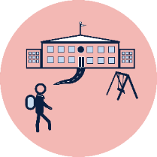
Learning goal: Children listen to their peers and reflect on their feelings related to starting school.
You can listen to other children talk about starting school via this QR code. If you can’t listen go to step 6.
- Listen to Wynn, Izzy, Sumedha, Alfie and Hugo share some tips about the first year of school.
- The children in the video talked about feeling nervous about not knowing anyone at school. Do you feel like this sometimes?
- Some of the children had friends they already knew. Some of the children talked about making new friends. Do you know anyone starting school with you?
- What are some of the things the children said they like about school?
- If you want to, listen to a story about a girl's first day at school. If you can’t listen, go to the next step.
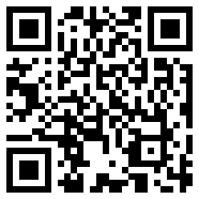
- Draw some of the things you are looking forward to when you start school

Is this activity too hard?
- Talk with someone about what you are looking forward to at school.

Is this activity too easy?
- Tell someone about your picture and ask them to add some writing to it, describing each of the things you have drawn.

Singing
Learning goal: Children explore their world and express themselves through song.
- Scan this QR code to sing along with Caitie about a walk outside. If you can’t listen, go to step 3.
- Imagine you can see all the things Caitie sings about.
- Imagine the things you can see when you go for a walk outside.

Is this activity too hard?
- Walk can you sing about inside your home?

Is this activity too easy?
- What are the things that Caitie sees?
- What else might you see on a walk outside?

Make a campfire for fairies
Learning goal: Children use natural materials to make a campfire for fairies.
Watch this video or follow the instructions below to make a campfire for fairies. If you can’t watch, go to the instructions below.
What you need:
- twigs or small sticks
- small stones
- charcoal (optional).
What to do:
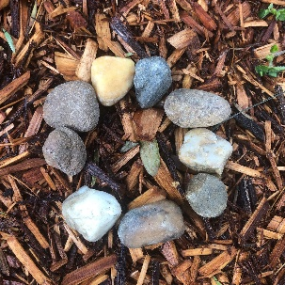
1. Arrange the stones in a circle.
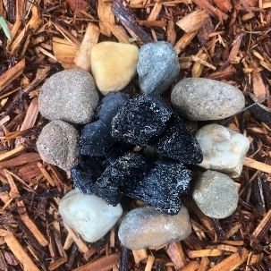
2. Put some charcoal in the centre of the stones (optional).
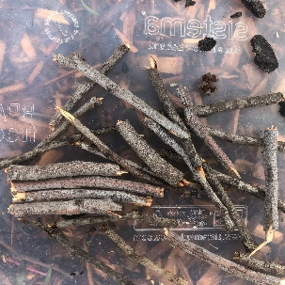
3. Break the twigs into smaller pieces (or fairy sized logs).
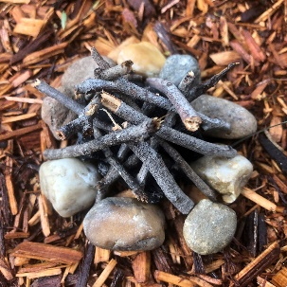
4. Arrange the thinner twigs inside the stones.
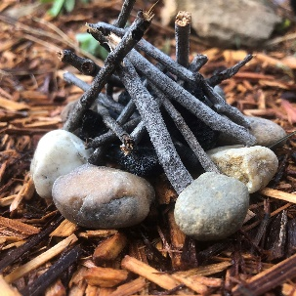
5. Add the thicker twigs.
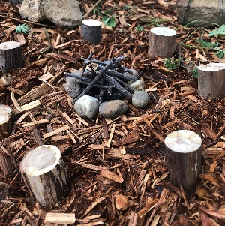
- Place sticks or stones around the campfire to make a yarning circle for fairies to sit and talk.

Is this activity too hard?
- Collect some twigs and stones and use them to create something.

Is this activity too easy?
- Draw a list of the things fairies might find useful to have around their campfire. Can any of these items be made from natural materials?

Take a break
Here are some things you might like to do:
- have a drink of water and a healthy snack
- play or have a rest
- go to the toilet and wash your hands
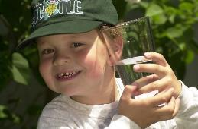
"Boy with glass of water, 2000" by Seattle Municipal Archives is licensed under CC BY 2.0
Photo by Any Lane from Pexels
Photo by Andrea Piacquadio from Pexels
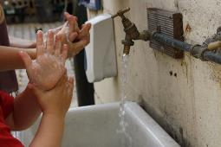
"Washing hands" by magnusfranklin is licensed under CC BY-NC 2.0

Sing and sign
Learning goal: Children recognise the need to use verbal and non-verbal language to communicate with others.
- Watch the video and listen to the song via this QR code. If you can’t listen, ask someone in your home if they know about signing.
- Did you notice the family signing the magic words, please and thank you?
- Practice signing the words for please and thank you, like in the video.

Is this activity too hard?
- Practice saying 'please' when you ask for something and 'thank you' when you receive something.
- Use keyword sign or visuals if that is how you communicate.

Is this activity too easy?
- Ask someone to help you search for the signs for other words, for example, hello and goodbye.

Shared story - Whoever you are
Learning goal: Children become aware of connections, similarities and differences between people.
- Listen to the story written and read by Mem Fox called “Whoever you are” via this QR code. It talks about being the same and different. If you can’t listen, go to step 4.
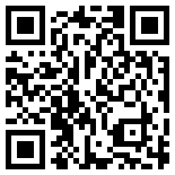
- Think about all the ways the story said that we are the same.
- Think about the ways the story said we may be different.
- Think about how people you know are like you and how they are different to you.
- Paint some people on rocks or on paper.
- Paint your people different sizes, shapes and colours.
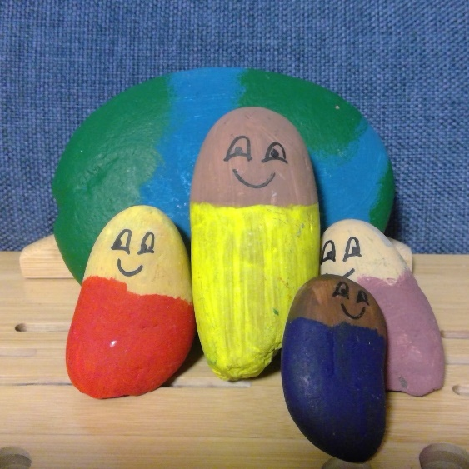

Is this activity too hard?
- Have someone help you paint or draw on two rocks. Are they different?

Is this activity too easy?
- When you have finished painting, explain to someone how your people are the same, but different.
- Tell someone about the story. Remember to tell them about the things that are the same about people and some things that make people different.
- Talk with someone about how you are the same and different to them.

Extra learning activities
Explore Auslan (Australian Sign Language) through the song 'I See Stars'. If you can’t watch, ask someone in your home if they know about Auslan and signing.
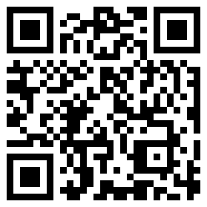
© State of New South Wales (Department of Education), 2021
The copyright material published in this document is subject to the Copyright Act 1968 (Cth) and is owned by the NSW Department of Education or, where indicated, by a party other than the NSW Department of Education.
Copyright material available in this document is licensed under a Creative Commons Attribution 4.0 International (CC BY 4.0) licence.
See https://education.nsw.gov.au/about-us/copyright for further details.

