This booklet belongs to:

Week J – Friday

Day at a glance:
 | Nature walk | Kangaroo tail | Picnic | Preparing for school mornings | Listening activity
Estimated time | 30 mins | 15 mins | 30 mins | 15 mins | 10 mins
Resources required |  | Something to draw with and on

Nature walk
Learning goal: Children use their senses to explore the natural environment.
- Ask someone to go for a walk with you in your local area, such as:
- around the streets where you live
- in a local park or nature reserve
- in the bush
- at the beach.
- As you walk, use your senses:
What do you see?
Look towards the sky as well as down on the ground.
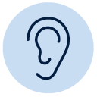
What can you hear?
You might be able to hear insects, birds or the wind.
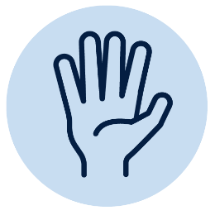
What can you feel or touch?
Is the sun warm on your skin? Is the ground rough or smooth?
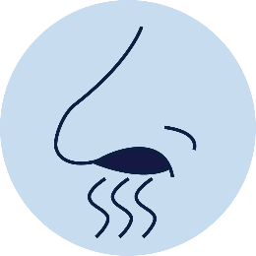
What can you smell?
Describe the smells. Can you smell leaves? Can you smell the earth or mud?
The Noticing nature walk webpage gives families more information about why this activity is good for children. You can access it via this QR code.
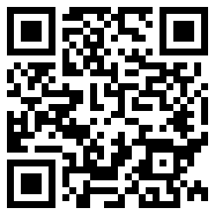

Is this activity too hard?
- Sit down on your walk and concentrate on just one sense at a time.

Is this activity too easy?
When you are back home, choose one of these activities:
- draw a picture of your walk
- write a story about your walk
- make a collage of things you collected on your walk.

Kangaroo tail
Learning goal: Children investigate how a kangaroo uses its tail.
Watch the video with a song about kangaroos via this QR code. If you can’t watch, find a picture of a kangaroo in your home or look at the photos below.
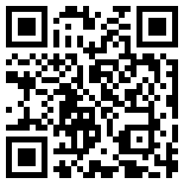
- Have you ever looked carefully at a kangaroo? Did you notice how small the kangaroo's front legs are?
- Draw a kangaroo.
- Compare your drawing to this photo. Did you draw very small front legs? Did you draw a long, thick tail?
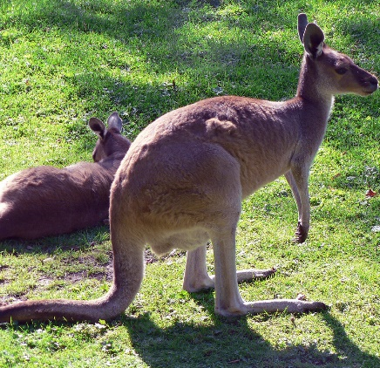
"Cool Kangaroo" by johnmuk is licensed under CC BY-NC-SA 2.0
- Watch the video via this QR code and notice how the kangaroos use their tails.
- Why do you think kangaroos hop?
- How do you think their tail helps them?
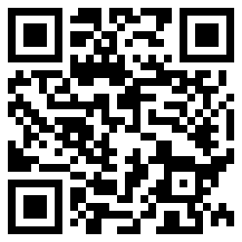
- Pretend to be a kangaroo by leaning forward slightly and sticking your bottom out. Now hop around like the kangaroo in the video. Is balancing hard? How would a tail help you?
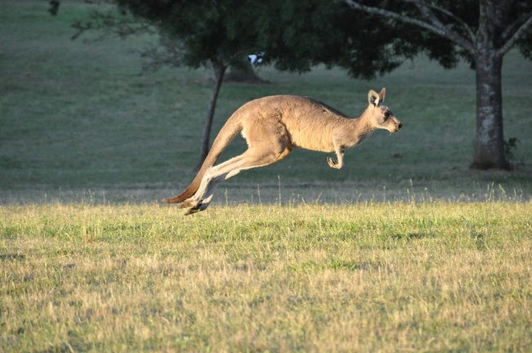
"Kangaroo in Flight" by Chris_Samuel is licensed under CC BY 2.0

Is this activity too hard?
- Look at more pictures of kangaroos and look at their tails.

Is this activity too easy?
- Think about other animals who have a tail and how their tail helps them (hint - ring-tailed possum, monkey, bird).

Picnic
Learning goal: Children recognise the contribution they make to shared activities.
- Watch the video about how to pack a picnic via this QR code. If you can’t watch, go to step 2.
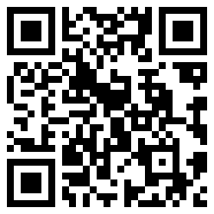
- Plan your own picnic.
- If you are able to have a real picnic, ask someone to help you plan:
- where you will have your picnic
- when you will have your picnic
- who will go on your picnic
- what you will eat.
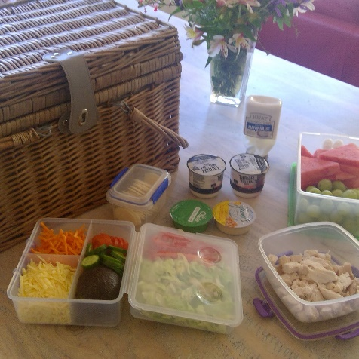
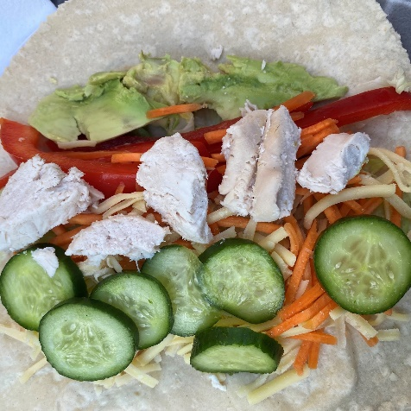
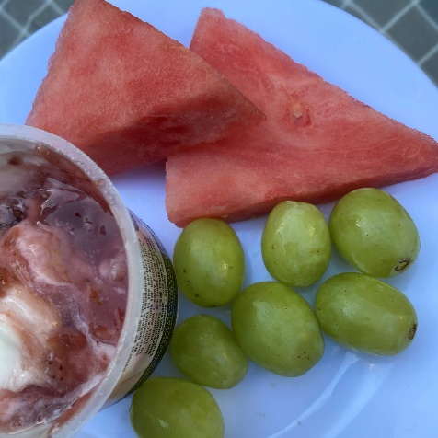
- If you aren't able to go on a real picnic, make a pretend picnic for your toys. Look at these photos for some ideas.
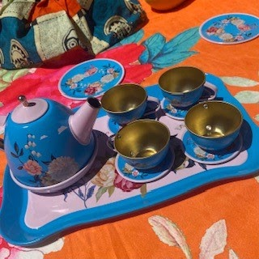
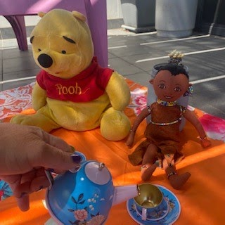
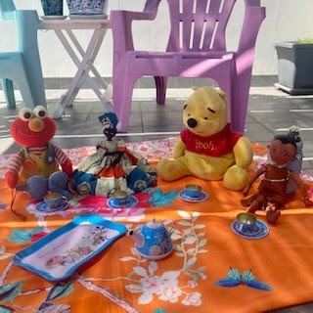

Is this activity too hard?
- If you are going on a real picnic, help pack the food into the picnic basket or container.
- If you are going to have a pretend picnic, get all your toys ready.

Is this activity too easy?
- Draw or write a list of the food you will take on your picnic.
- Design invitations for your picnic.

Take a break
Here are some things you might like to do:
- have a drink of water and a healthy snack
- play or have a rest
- go to the toilet and wash your hands.
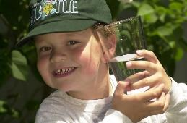
"Boy with glass of water, 2000" by Seattle Municipal Archives is licensed under CC BY 2.0
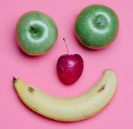
Photo by Any Lane from Pexels
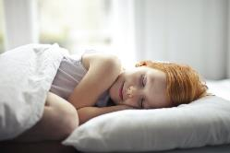
Photo by Andrea Piacquadio from Pexels
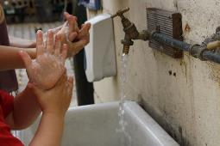
"Washing hands" by magnusfranklin is licensed under CC BY-NC 2.0

Preparing for school mornings
Learning goal: Children develop independence and self-help skills.
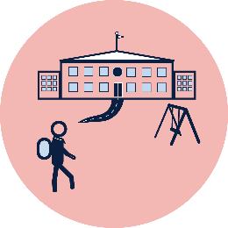
It is important to develop strong self-help skills as you grow and learn and move into school.
- Think about what you will need to do to each morning to get ready for school.
- What will you need help with? What will you be able to do on your own?
- What are some things you will be able to get ready the night before?
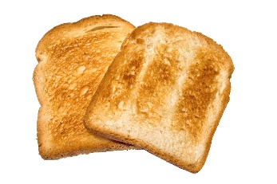
"Bread Toasts" by revedavion.com is licensed under CC BY-NC-SA 2.0
"Toothbrush" by nishantcm is licensed under CC BY-SA 2.0
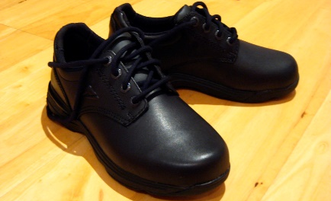
"School Shoes 2009" by Andrew Scott is licensed under CC BY-NC-SA 2.0

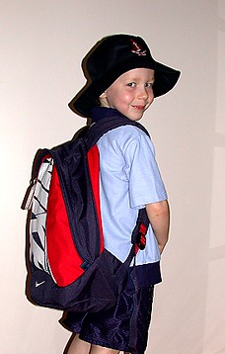
"My School Bag" by billh18 is licensed under CC BY-NC-SA 2.0

Is this activity too hard?
- Practice doing something that you will need to do each morning for school, for example, put your socks and school shoes on.

Is this activity too easy?
- Make a morning routine or timetable showing what you will do after you wake up each day to get ready for school, for example:
- eat a healthy breakfast
- get dressed
- brush teeth.

Listening activity
Learning goal: Children listen and respond to sounds.
- Play the video about animal sounds via this QR code. If you can’t listen, go to step 4.
- Listen to each sound in the video.
- Call out the name of the animal that makes each sound.
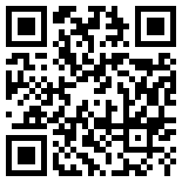
- Look at the pictures below and call out the noise that each animal makes.
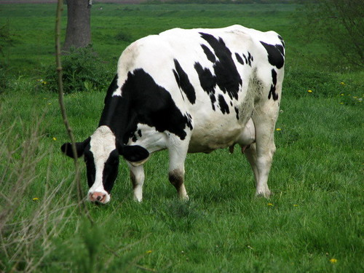
"Cow on Kegworth canal bridge" by Anna Briggs is licensed under CC BY-NC 2.0
"Duck." by Neil T is licensed under CC BY-SA 2.0
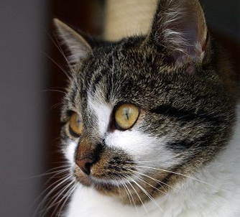
"Cat" by Lilithis is licensed under CC BY-SA 2.0

Is this activity too hard?
- Make your own animal sounds and ask someone to guess what they are.

Is this activity too easy?
- Record yourself making animal sounds and then play them for your family to guess.

Extra learning activities
Learn to stay safe with these Kids and Traffic Road safety songs via this QR code. If you can’t access, the lyrics to one of the songs is below.
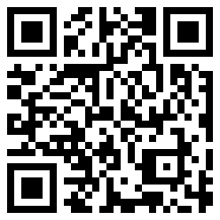
“I’m a little seatbelt”
(Sing to the tune “I’m a little teapot”)
I’m a little seatbelt in the car,
Before we go driving near or far,
Time to slip your arms in, there you are,
Buckle me up, now you’re a star.
© State of New South Wales (Department of Education), 2021
The copyright material published in this document is subject to the Copyright Act 1968 (Cth) and is owned by the NSW Department of Education or, where indicated, by a party other than the NSW Department of Education.
Copyright material available in this document is licensed under a Creative Commons Attribution 4.0 International (CC BY 4.0) licence.
See https://education.nsw.gov.au/about-us/copyright for further details.

