This booklet belongs to:

Week I – Wednesday

Day at a glance:
 | We're going on a bear hunt | The platypus | The school playground | Weather symbols | Sharing with others
Estimated time | 15 mins | 20 mins | 10 mins | 10 mins | 10 mins
Resources required | Something to draw with and on | Clay or playdough

We’re going on a bear hunt
Learning goal: Children respond to music and storytelling through movement and drama.
- Watch the video via this QR code and do the actions. If you can’t access the video, go to step 3.
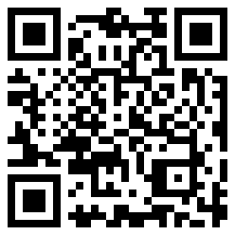
- Watch Tash on her bear hunt.
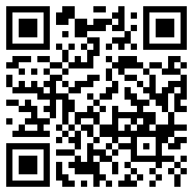
- Go on your own bear hunt. Look at these pictures to remember where to go.

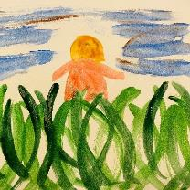
long, wavy grass
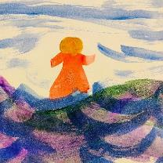
deep, cold river
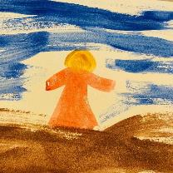
thick, oozy mud
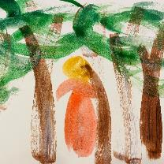
big, dark forest
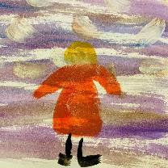
swirling, whirling snow storm
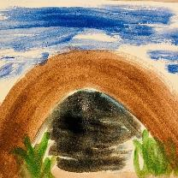
narrow, gloomy cave
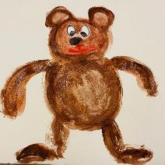
It's a bear!
- Draw or paint your favourite part of the bear hunt.

Is this activity too hard?
- Do as many of the actions as you can.
- Make a surprised face.
- Make a scared face.
- Growl like a bear.

Is this activity too easy?
- Draw a map showing where the family went on their bear hunt.

The platypus
Learning goal: Children learn facts about the platypus and make a hypothesis about its features.
1. Watch the video about a platypus via this QR code. If you can’t watch the video, go to step 2.
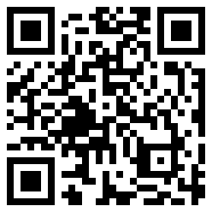
2. Think and talk about the platypus:
- What are its features?
- What's special about the platypus?
- How do you think the platypus' tail helps it to swim?
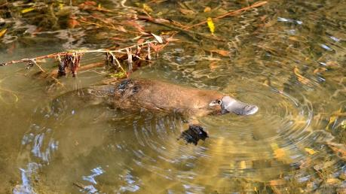
"File:Wild Platypus 4.jpg" by Klaus is licensed under CC BY-SA 2.0
3. Invent your own animal, by combining features of other animals. For example, the head of a tiger and the body of an emu.
4. Draw your creature or make it out of playdough.
5. Give your creature a name. Where does it live? What special features does it have?
Facts about the platypus
The platypus:
- lives in rivers and is a very good swimmer.
- uses its long claws to dig burrows in river beds.
- has a bill and webbed feet like a duck.
- lays eggs like a bird.
- produces milk to feed to its young.

Is this activity too hard?
- Tell someone your favourite thing about the platypus.

Is this activity too easy?
- What do you think the word 'streamlined' means? How is a platypus streamlined?

The school playground
Learning goal: Children reflect on the new experiences they will encounter at school.
When you start school you might find the playground is different from what you are used to.
1. Look at the photos below of school playgrounds.
2. Talk to someone about what you see in each photo.
3. Do you see anything in the photos that you already know about?
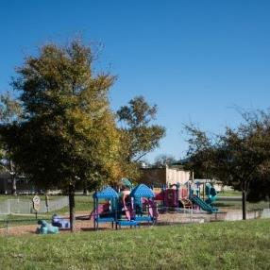
"School Playground" by dwight_parker is licensed under CC BY 2.0
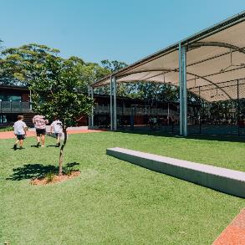
Image owned by the NSW Department of Education under the Copyright Act 1968 (Cth)
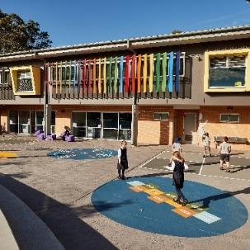
Image owned by the NSW Department of Education under the Copyright Act 1968 (Cth)
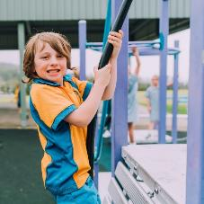
Image owned by the NSW Department of Education under the Copyright Act 1968 (Cth)
4. Have you seen your school playground? If so, draw some things you remember from your visit.
5. If you haven't visited, ask someone to help you look for a picture of it on the school's website.

Is this activity too hard?
- Think about the games you like to play.
- Tell someone what games you want to play in the playground at school.

Is this activity too easy?
- Design a school playground that includes fun activities and is safe.

Take a break
Here are some things you might like to do:
- have a drink of water and a healthy snack
- play or have a rest
- go to the toilet and wash your hands
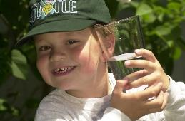
"Boy with glass of water, 2000" by Seattle Municipal Archives is licensed under CC BY 2.0
Photo by Any Lane from Pexels
Photo by Andrea Piacquadio from Pexels
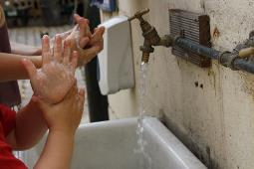
"Washing hands" by magnusfranklin is licensed under CC BY-NC 2.0

Weather symbols
Learning goal: Children explore symbols used to represent the weather.
1. Listen to this story about weather forecasting via this QR code. If you can’t listen, go to step 3.
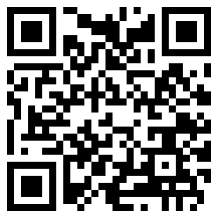
2. Weather forecasters or meteorologists forecast what the weather will be like. They use special equipment to help them and they also use symbols to tell us what they forecast the weather will be.
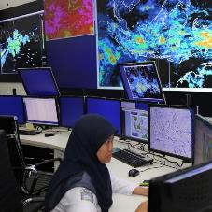
"Meteorologist at Indonesia Meteorological and Geophysical Agency, BMKG" by World Meteorological Organization is licensed under CC BY-NC-ND 2.0
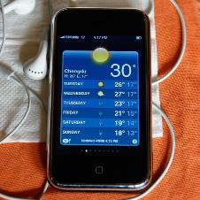
"iPhone Weather Forecast" by SoQ錫濛譙 is licensed under CC BY-NC-ND 2.0
3. Look at each of these weather symbols and say what you think each means.
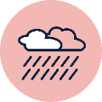
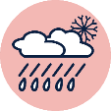

Is this activity too hard?
- What is the weather like today?
- Point to the symbol showing today's weather.

Is this activity too easy?
- Create a symbol that means it will snow.
- Create a symbol that means there will be a storm.
- Make a chart to record each day's weather. Under each day draw one or more symbols to show what the weather was like.

Sharing with others
Learning goal: Children develop an understanding of the importance of sharing.
Watch the video “Keeko: Episode 2- Sharing” via this QR code. If you can’t watch, go to step 2.
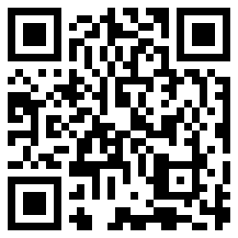
1. Keeko, bird and dog find a way to share the log and play together.
2. How do you feel when someone doesn't share with you?
3. What words can you use to ask someone to share?

Is this activity too hard?
- What are you good at sharing?
- What are you not so good at sharing?

Is this activity too easy?
- Why do you think it is important to share?

Extra learning activities
Explore a world of play and imagery with this drama and visual arts resource “When is a stick not a stick?” via this QR code. If you can’t access the online activity you can follow the steps below, taken from the online resource.
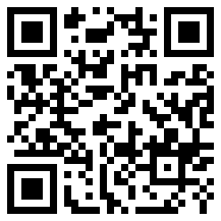
For this activity you will need a small stick that can fit on a piece of paper.
- Glue or tape your stick onto the paper.
- What will your stick become?
- Draw around your stick to turn it into something new.
- Colour in your creation
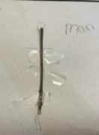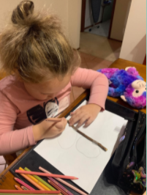
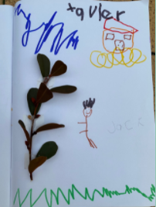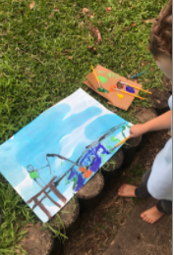
© State of New South Wales (Department of Education), 2021
The copyright material published in this document is subject to the Copyright Act 1968 (Cth) and is owned by the NSW Department of Education or, where indicated, by a party other than the NSW Department of Education.
Copyright material available in this document is licensed under a Creative Commons Attribution 4.0 International (CC BY 4.0) licence.
See https://education.nsw.gov.au/about-us/copyright for further details.

