This booklet belongs to:

Week I– Tuesday

Day at a glance:
 | Australian animals in Wiradjuri | Feeling calm at school | Charades | Shared story | Build a little house
Estimated time | 10 mins | 10 mins | 15 mins | 20 mins | 45 mins
Resources required |  |  |  |  | Sticks, string, leaves, long grass etc

Australian animals in Wiradjuri
Learning goal: Children learn about the languages of First Nations peoples.
Watch the video to learn the Wiradjuri words for Australian animals via this QR code. If you can’t watch the video, ask someone to help you learn the words written above the pictures in step 1.
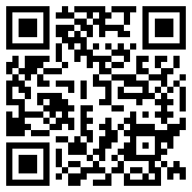
- Practice saying the names of these Australian animals in Wiradjuri, which is one of many Aboriginal languages.
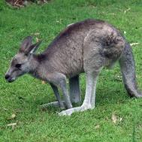
Bandha (barn-da)
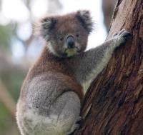
Naagun (nar-guun)
Photos by Unknown Author are licensed under CC BY-SA
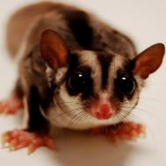
dilla-burra
(dil-u-bu-ra)
"Sugar Glider" by GarrettTT is licensed under CC BY-SA 2.0

Is this activity too hard?
- Pause the video and practice the words by repeating them.

Is this activity too easy?
- Find out the Aboriginal language of the Country you are on.
- Install and use the Wiradjuri dictionary app via this QR code, to learn more Wiradjuri language.
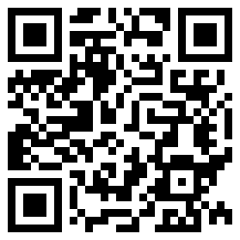

Feeling calm about school
Learning goal: Children develop skills of self-regulation.
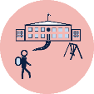
Sometimes you might feel worried about starting school.
Watch the video ‘Moodies: Anxious’ via this QR code, to learn a way to help you feel calm. If you can’t watch the video, you can start at step 1, with how you are feeling today.
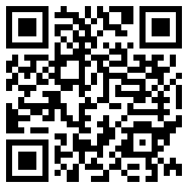
- In the video Rachael said she feels anxious today. How do you feel today?
- When you feel anxious, you might feel like you have a storm inside your tummy.
- Practice slow candle blowing.
- You can calm yourself by taking a slow breath in through your nose and then a gentle breath out, like you are blowing a candle.
- Remember, when you feel anxious you can take some slow candle breaths.

Charades
Learning goal: Children use drama to express themselves and make meaning.
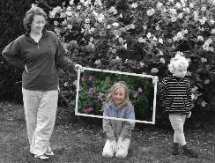
"Family playing 1" by pdam2 is licensed under CC BY 2.0
When you play charades you act something out and someone else has to guess what you are pretending to be or do. You are not allowed to talk to give any clues!
Follow the instructions below to play charades:
- Decide what type of thing you will be pretending to be or do. You could choose to be an animal or you could pretend to be doing something like brushing your teeth or playing a guitar.
- Don't tell anyone what you have chosen.
- Act out your idea and ask someone in your family to try to guess what you are or what you are doing.
- When they have guessed correctly, swap roles.

Is this activity too hard?
- As you play, make noises to give clues. For example, if you are pretending to be a dog, also make a barking sound.

Is this activity too easy?
- Play charades with friends or family using a video chat.
- Play a different game where you describe features of an animal one by one for someone else to guess the animal's name. For a tiger you might give clues such as, 'I am orange and have black stripes. I have whiskers and I live in the jungle'.

Take a break
Here are some things you might like to do:
- have a drink of water and a healthy snack
- play or have a rest
- go to the toilet and wash your hands
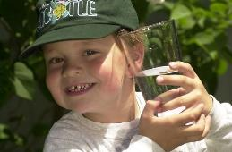
"Boy with glass of water, 2000" by Seattle Municipal Archives is licensed under CC BY 2.0
Photo by Any Lane from Pexels
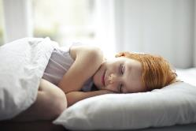
Photo by Andrea Piacquadio from Pexels
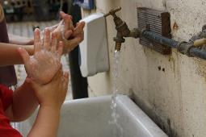
"Washing hands" by magnusfranklin is licensed under CC BY-NC 2.0

Shared story- The snow wombat
Learning goal: Children make meaning from a factual text.
- Watch the story video, via this QR code, about a wombat who finds snow everywhere, even on her own body. Wherever she looks, there is snow. If you can’t access you can go to step 3.
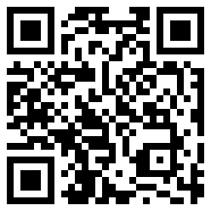
- Watch the video via this QR code, to see a wombat digging.
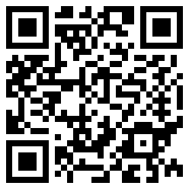
- Pretend to be a wombat digging a new burrow. Dig with your front legs and then push the soil away with your hind legs. Where is all that dirt going?
- Have a look at the shape of the wombat's claws in the photos. What do they remind you of?
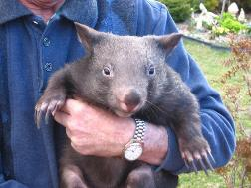
"Juvenile Wombat (Female)" by Denis Fox is licensed under CC BY-NC 2.0
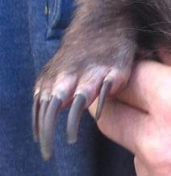
"Juvenile Wombat (Female)" by Denis Fox is licensed under CC BY-NC 2.0
Find someone in your home to read find out some more interesting wombat facts to you:
- Wombats are marsupial mammals, which means that they have a pouch for their young.
- Wombats are most closely related to koalas.
- A baby wombat is called a wombat pinkie when it is in the pouch and a joey when it has fur.
- Wombats can run almost as fast as Usain Bolt.
- A wombat’s pouch is the other way around to that of kangaroos and koalas, with the open side pointing towards their rear. Why do you think this is? (It has something to do with the fact that they do lots and lots of burrowing into the ground.

Is this activity too hard?
- Copy some of the actions you saw the wombat doing in the video.

Is this activity too easy?
- Tie a cloth bag to your tummy and dig in a sandpit or loose dirt. What happens to the dirt when you have the opening of the bag facing your front? What happens if the opening of the bag faces behind?

Make a fairy house
Learning goal: Children use natural materials to build a structure
Watch each of these three videos via the numbered QR codes, or follow the instructions below with pictures, to make a fairy house.
1.
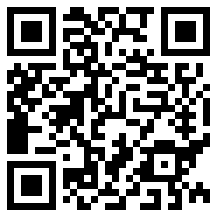
2.
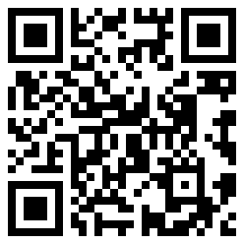
3.
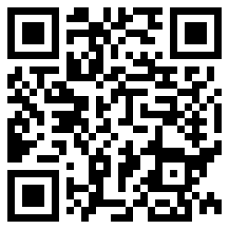
How to make a fairy house:
- Collect 15 sticks of about the same size. Try to find one that has a v shape at one end.
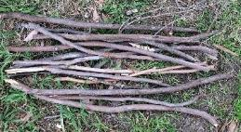
- Push the stick with the v shape into the ground. Lean three other sticks against it.
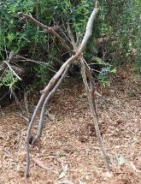
- Use string or natural twine to tie the tops of the sticks together.
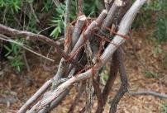
- Lean more sticks against the other ones. Place rocks at the bottom of the structure to help it stand up.
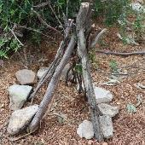
- Weave leaves, vines or grass in and out of the sticks. Keep working, this might take a while!
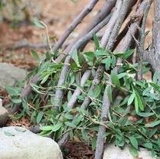
6. Well done, now you can play with your little house.
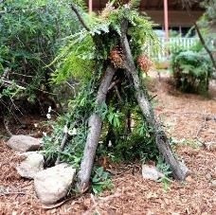

Extra learning activities
- Enjoy Play School story time, “The little red hen and the grains of wheat” via this QR code.
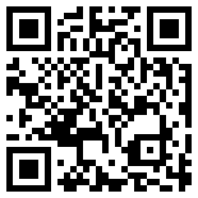
- Complete some literacy activities via this QR code.
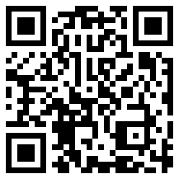
If you can’t access the QR codes, find a favourite story and read with someone in your home. At the end of the story, draw the beginning, the middle and the end of the story.
© State of New South Wales (Department of Education), 2021
The copyright material published in this document is subject to the Copyright Act 1968 (Cth) and is owned by the NSW Department of Education or, where indicated, by a party other than the NSW Department of Education.
Copyright material available in this document is licensed under a Creative Commons Attribution 4.0 International (CC BY 4.0) licence.
See https://education.nsw.gov.au/about-us/copyright for further details.

